Interactive Academic Portal
Linking College and Student Information Systems
A Technical Project Report
Submitted by: Parth Jani
PRN: 24070521241
Department of Computer Science & Engineering
Symbiosis Institute of Technology, Nagpur
Academic Batch: 2024–2028

Table of Contents
1. Executive Summary
2. Project Overview
3. Technical Architecture
4. Application Interface (Screenshot)
5. Features & Functionality
6. Code Walkthrough
7. Development Best Practices
8. Potential Enhancements
9. Conclusion

1. Executive Summary
This report provides a comprehensive technical overview of the Interactive Academic Portal, a modular, client-side web application developed using HTML5, CSS3, and JavaScript. The application demonstrates best practices in form validation, data synchronization, and modular JavaScript architecture through an Immediately Invoked Function Expression (IIFE) pattern.
The portal enables students to register their academic profile by linking global institutional settings (department and batch) with individual student details, while enforcing validation rules through regular expressions.
2. Project Overview
2.1 Objective
To design and develop a modular, client-side web application that seamlessly links global institutional profiles with dynamic, individual student data validation forms. The portal provides a user-friendly interface for students to register with their institution, validate data using regular expressions, and generate verified profile cards that display linked system information.
2.2 Key Features
- Global Institutional Profile Configuration with read-only institution name and dropdown controls
- Student Information Form with input fields for full name, PRN, institutional email, and semester
- Real-time form validation using RegEx patterns for PRN, email, and name
- Dynamic synchronization between global settings and active student profiles
- Responsive grid layout optimized for desktop and mobile devices
- Modular IIFE architecture for encapsulated state management and DOM manipulation

3. Technical Architecture
The application follows a standard three-tier front-end structure, separating content (HTML), presentation (CSS), and behaviour (JavaScript).
3.1 File Structure
File | Purpose
index.html | Defines the semantic page structure — PRN badge, configuration section, form, and output panel
styles.css | Defines the visual design — layout grid, colours, spacing, responsive breakpoints
script.js | Implements the application logic — validation, state management, and DOM rendering

3.2 HTML Structure Overview
The HTML document (index.html) is organised into four primary sections:
- PRN Identification Badge — displays the student's Permanent Registration Number at the top of the page
- Institutional Profile Configuration — read-only institution name plus dropdowns for department and academic batch
- Student Information Form — inputs for full name, PRN, institutional email, and semester, each with an associated error message element
- Linked System Output — a placeholder panel that is dynamically populated once the form is validated and submitted

3.3 CSS Design Overview
The stylesheet (styles.css) defines a set of reusable CSS custom properties (variables) for consistent theming, listed below:
Variable | Value | Purpose
--primary | #1e3a8a | Headers, buttons, PRN badge
--secondary | #2563eb | Hover states, focus outlines
--bg | #f8fafc | Page background
--error | #ef4444 | Validation error messages
--success | #22c55e | “Verified & Linked” status

The layout uses CSS Grid with a two-column structure on desktop screens, collapsing to a single column below a 768px viewport width for mobile responsiveness.
3.4 JavaScript Architecture Overview
The application logic (script.js) is encapsulated inside an Immediately Invoked Function Expression (IIFE), exposed globally as the AcademicPortal module. This prevents pollution of the global namespace and keeps internal state private.
The module maintains an internal state object with four properties: institution, department, batch, and student. It also validates input using three regular expressions, described in the code walkthrough section below.

4. Application Interface
The figure below shows the rendered application after a student has completed and submitted the registration form. The left panel contains the Institutional Profile Configuration and Student Information Form; the right panel displays the dynamically generated Linked System Output card.
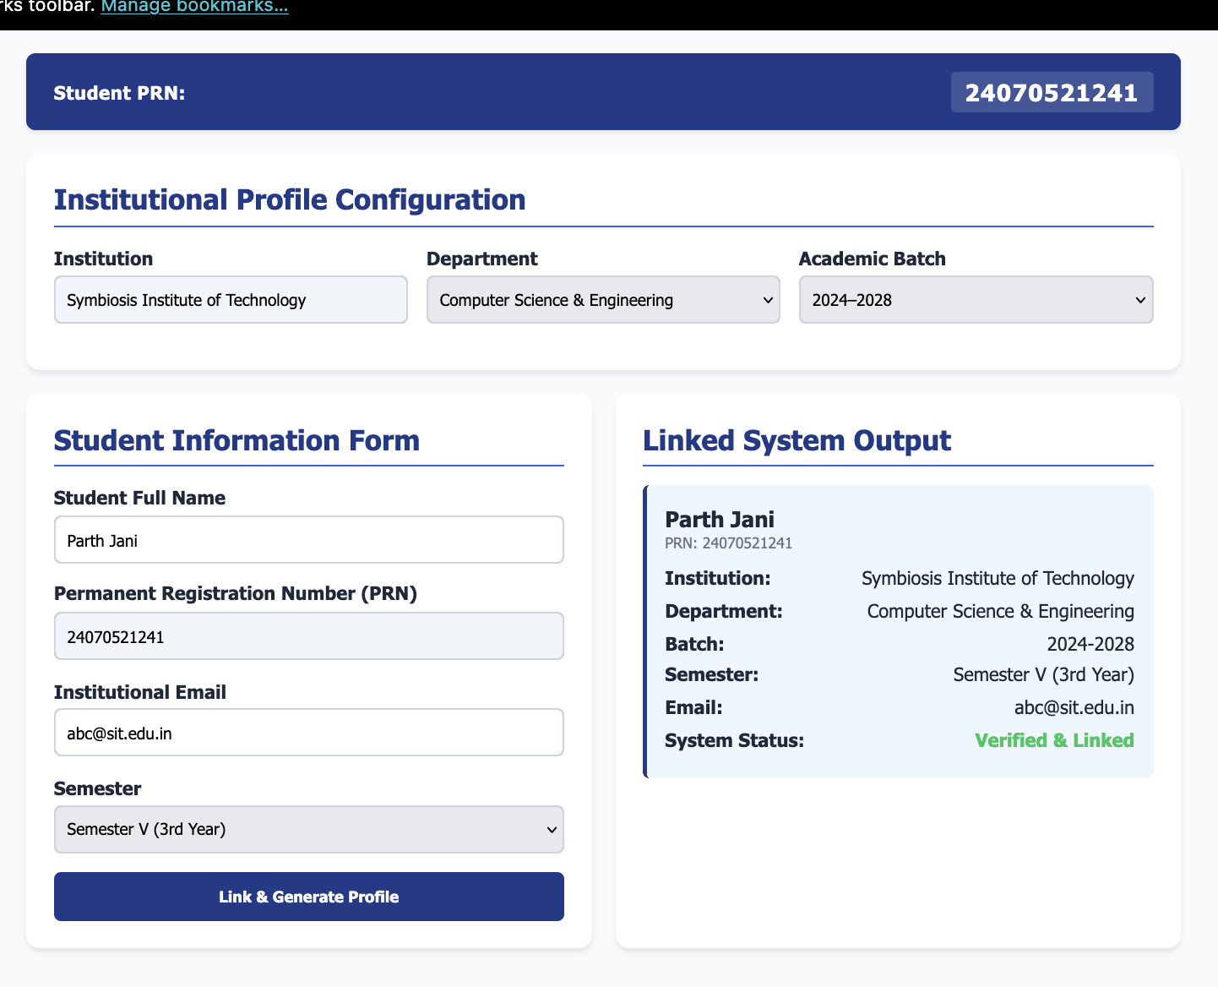
Figure 1: Interactive Academic Portal — completed student registration and linked output
As shown above, the PRN badge (24070521241) is displayed prominently at the top. The Institutional Profile Configuration section shows the Department set to “Computer Science & Engineering” and the Academic Batch set to “2024–2028”. Once the form is submitted with valid data, the Linked System Output panel renders a card summarising the student's institution, department, batch, semester, email, and a “Verified & Linked” status indicator.

5. Features & Functionality
5.1 Form Submission and Validation
When the user clicks “Link & Generate Profile”, the handleSubmission() method performs the following sequence:
- Prevents the default form submission using e.preventDefault()
- Validates the name, PRN, and email fields against their respective RegEx patterns
- Displays an error message beneath any field that fails validation
- If all fields are valid, stores the data in the module's internal student state object
- Calls renderLinkedProfile() to display the verified profile card

5.2 Dynamic Profile Rendering
The renderLinkedProfile() function builds an HTML template using the current state values and inserts it into the output panel. The rendered card includes the student's name, PRN, institution, department, batch, semester, email, and a status indicator reading “Verified & Linked”.
5.3 Synchronisation on Global Changes
If the Department or Academic Batch dropdown is changed after a profile has already been generated, the onchange handler invokes AcademicPortal.updateSystem(), which re-reads the dropdown values and immediately re-renders the profile card — ensuring the displayed information always reflects the current configuration.

6. Code Walkthrough
6.1 Validation Patterns
Three regular expressions enforce data quality on the client side before a profile can be generated:
const Patterns = {
prn: /^\d{11}$/,
email: /^[a-zA-Z0-9._%+-]+@[a-zA-Z0-9.-]+\.[a-zA-Z]{2,}$/,
name: /^[a-zA-Z\s]{3,}$/
};

- prn — requires exactly 11 numeric digits
- email — requires a standard local-part@domain.tld structure
- name — requires at least 3 alphabetic characters or spaces

6.2 Field Validation Function
A single reusable function tests any input against its pattern and toggles the corresponding error message:
const validateField = (input, pattern, errorEl) => {
const isValid = pattern.test(input.value.trim());
errorEl.style.display = isValid ? 'none' : 'block';
return isValid;
};

6.3 Form Submission Handler
The submit handler validates all three fields and only proceeds to render the profile if every field passes:
handleSubmission: (e) => {
e.preventDefault();

const isNameValid =
validateField(DOM.nameInput, Patterns.name, DOM.nameErr);
const isPrnValid =
validateField(DOM.prnInput, Patterns.prn, DOM.prnErr);
const isEmailValid =
validateField(DOM.emailInput, Patterns.email, DOM.emailErr);

if (isNameValid && isPrnValid && isEmailValid) {
state.student = {
name: DOM.nameInput.value.trim(),
prn: DOM.prnInput.value.trim(),
email: DOM.emailInput.value.trim(),
semester: DOM.semSelect.value
};
renderLinkedProfile();
}
}

6.4 Profile Rendering Function
The output card is generated using a template literal that interpolates the current state:
const renderLinkedProfile = () => {
DOM.outputBox.innerHTML = `
<div class="display-card">
<h3>${state.student.name}</h3>
<p class="prn-text">PRN: ${state.student.prn}</p>
<div class="display-row">
<span>Institution:</span>
<span>${state.institution}</span>
</div>
<div class="display-row">
<span>System Status:</span>
<span class="status-verified">Verified & Linked</span>
</div>
</div>
`;
};

7. Development Best Practices Demonstrated
- Modular architecture — the IIFE pattern prevents global namespace pollution
- DOM caching — element references are queried once and stored for reuse
- Separation of concerns — HTML for structure, CSS for presentation, JavaScript for behaviour
- Regular expression validation — client-side checks ensure data integrity before submission
- Responsive design — CSS Grid with a media query for mobile layouts
- Event-driven synchronisation — dropdown changes automatically update any rendered profile

8. Potential Enhancements
- Backend integration to persist student records in a database
- Authentication and session management for secure access
- Export functionality to download the generated profile as a PDF
- An administrator dashboard to review all submitted registrations
- Server-side validation as a complement to the existing client-side checks

9. Conclusion
The Interactive Academic Portal demonstrates a well-structured, client-side web application that balances functionality with usability. Through its modular JavaScript architecture, responsive CSS layout, and semantic HTML structure, the application provides a reliable foundation for student registration and profile management. The validation logic and dynamic synchronisation features illustrate sound front-end engineering practices suitable for further extension into a full-stack academic information system.

