Academic Scholarship Evaluation Matrix Engine
Automated Eligibility Decision Logic for Student Scholarships
A Technical Project Report
Submitted by: Parth Jani
PRN: 24070521241
Department of Computer Science & Engineering
Symbiosis Institute of Technology, Nagpur
Academic Batch: 2024–2028

Table of Contents
1. Executive Summary
2. Project Overview
3. Technical Architecture
4. Application Interface (Screenshot)
5. Decision Matrix Logic
6. Code Walkthrough
7. Development Best Practices
8. Potential Enhancements
9. Conclusion

1. Executive Summary
This report provides a comprehensive technical overview of the Academic Scholarship Evaluation Matrix Engine, a client-side decision-logic web application built using HTML5, CSS3, and JavaScript. The application accepts a student's academic score, annual family income, demographic category, and special quota status, then applies a tiered set of conditional business rules to instantly determine the student's scholarship eligibility, financial benefit, and support package.
The system demonstrates practical application of layered conditional logic, form validation, and dynamic, state-driven DOM rendering, simulating a real institutional scholarship disbursement workflow.
2. Project Overview
2.1 Objective
To design and implement a client-side decision-logic web application using HTML5, CSS3, and JavaScript conditional structures that parses academic scores, annual family income thresholds, and demographic parameters to determine a student's scholarship eligibility matrix state instantly.
2.2 Key Features
- Input Criteria Form: fields for CGPA, Annual Family Income, Category/Demographic Group, and Special Quota
- Validation Engine: enforces a valid numeric CGPA between 0.00 and 10.00, and a non-negative income value
- Four-Tier Decision Matrix: Full Waiver, Merit-Cum-Means Waiver, Academic Grant, and Ineligible outcomes
- Colour-Coded Result Card: visually distinguishes Approved, Partial, and Rejected outcomes
- Evaluated Parameter Summary: redisplays the submitted CGPA, income, and category for confirmation
- Modular IIFE architecture (ScholarshipEngine module) separating validation, decision logic, and rendering

3. Technical Architecture
The application follows a standard three-tier front-end structure, separating content (HTML), presentation (CSS), and behaviour (JavaScript).
3.1 File Structure
File | Purpose
ScholorshipEligibility.html | Defines the semantic page structure — PRN badge, application criteria form, and eligibility result panel
styles.css | Defines the visual design — layout grid, form styling, and colour-coded result states
script.js | Implements the evaluation logic — input validation, tiered decision rules, and result rendering

3.2 HTML Structure Overview
The HTML document (ScholorshipEligibility.html) is organised into three primary sections:
- PRN Identification Badge — displays the student's Permanent Registration Number at the top of the page
- Scholarship Application Criteria — a form collecting CGPA, annual family income, category, and special quota, each with associated error message elements where applicable
- Eligibility Matrix Result — a placeholder panel that is dynamically populated with a colour-coded outcome card once the form is evaluated

3.3 CSS Design Overview
The stylesheet (styles.css) defines a set of reusable CSS custom properties for consistent theming, and three result-state modifier classes:
Variable / Class | Value | Purpose
--primary | #1e3a8a | Headers, PRN badge, submit button
--success | #16a34a | Border/background for .approved result cards
--warning | #d97706 | Border/background for .partial result cards
--error | #ef4444 | Border/background for .rejected result cards, error text

The .matrix-card class uses a coloured left border (border-left) combined with a matching tinted background to give an immediate, at-a-glance visual signal of the evaluation outcome, without relying on colour alone — the status is also stated in text as “Approved”, “Partial Waiver”, or “Ineligible”.
3.4 JavaScript Architecture Overview
The application logic (script.js) is encapsulated inside an Immediately Invoked Function Expression (IIFE), exposed globally as the ScholarshipEngine module. The module cleanly separates three concerns: validateInputs() for form validation, evaluateCriteria() for the decision matrix, and renderResult() for DOM output, each of which is discussed in the sections that follow.

4. Application Interface
The figure below shows the rendered application after a student has submitted their application criteria. The left panel contains the Scholarship Application Criteria form; the right panel displays the dynamically generated Eligibility Matrix Result.
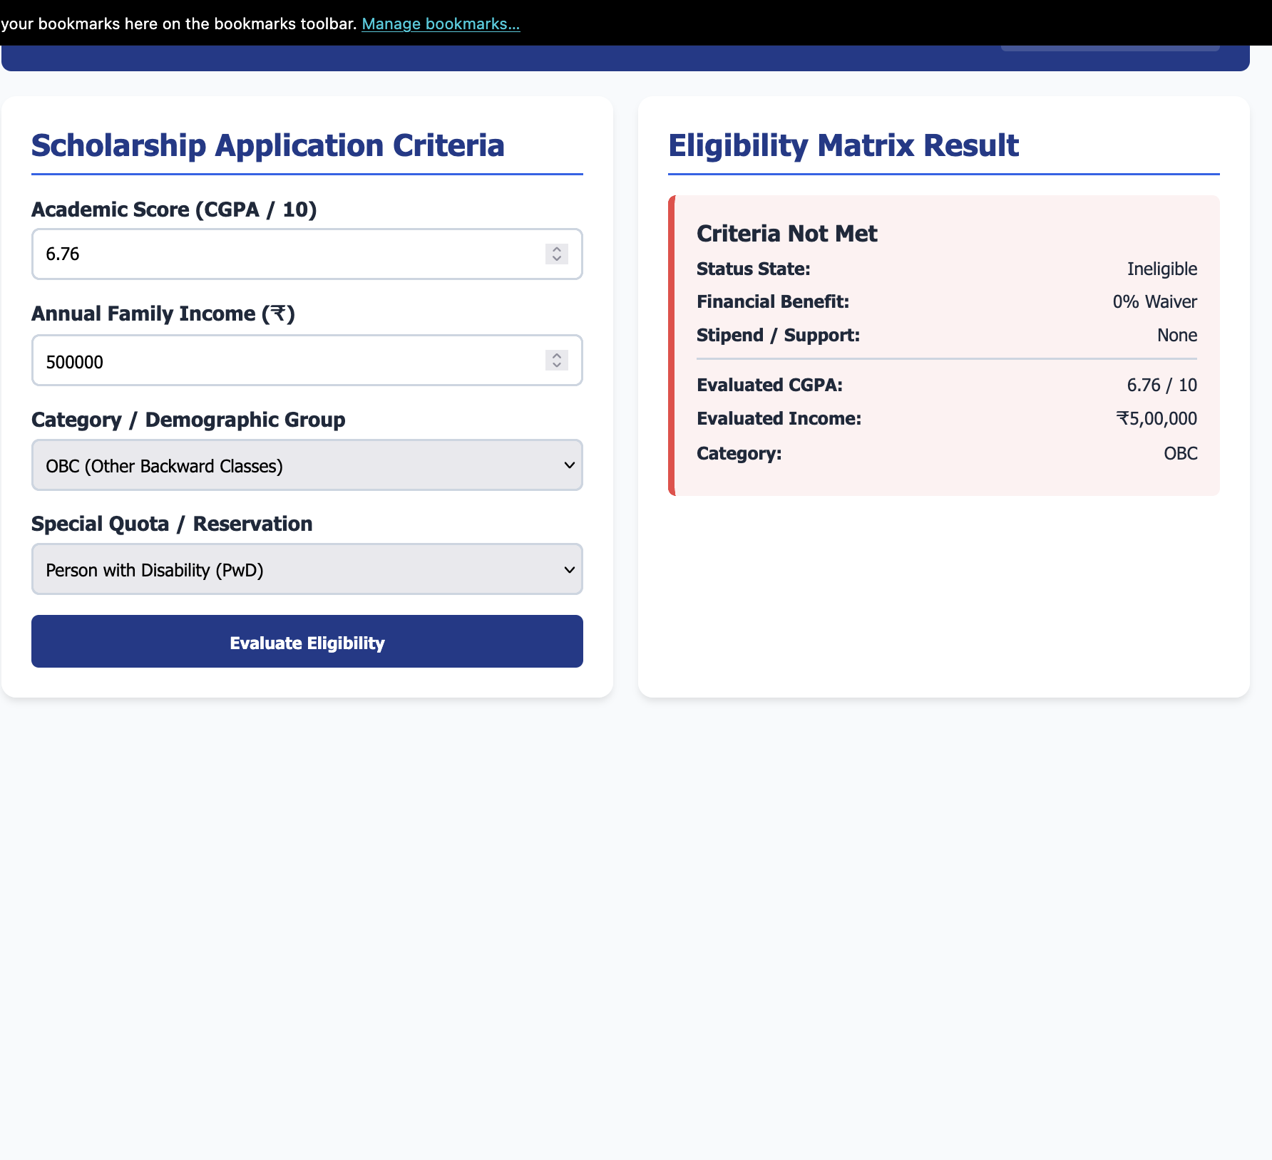
Figure 1: Scholarship Evaluation Matrix Engine — evaluated ineligible outcome
As shown above, the applicant entered a CGPA of 6.76, an annual family income of ₹5,00,000, category “OBC”, and special quota “Person with Disability (PwD)”. Since the CGPA of 6.76 falls below the minimum threshold of 7.5 required by every eligibility tier — including the PwD-linked Full Waiver rule, which additionally requires a CGPA of at least 8.5 — the engine returns an “Ineligible” outcome titled “Criteria Not Met”, with a 0% waiver and no stipend. The result card is rendered with a red left border and tinted background, and the submitted parameters are echoed back below the outcome for the applicant's confirmation.

5. Decision Matrix Logic
The evaluateCriteria() function applies four priority tiers in strict descending order. The first matching tier determines the outcome; lower tiers are not evaluated once a higher tier matches.
5.1 Tier 1 — 100% Full Merit Scholarship
Awarded to a student who satisfies any one of the following conditions:
- CGPA ≥ 9.0 AND Annual Income ≤ ₹3,00,000
- CGPA ≥ 8.5 AND Special Quota = Person with Disability (PwD)
- CGPA ≥ 8.5 AND Category = SC/ST AND Annual Income ≤ ₹5,00,000
Benefit: 100% tuition fee waiver plus a ₹5,000 per month allowance.
5.2 Tier 2 — 50% Merit-Cum-Means Scholarship
Awarded to a student who satisfies any one of the following conditions:
- CGPA ≥ 8.0 AND Annual Income ≤ ₹6,00,000
- CGPA ≥ 7.5 AND Category is OBC or Single Girl Child AND Annual Income ≤ ₹4,00,000
- Special Quota = Sports AND CGPA ≥ 7.5
Benefit: 50% tuition fee waiver plus standard library access.
5.3 Tier 3 — 25% Institutional Academic Grant
Awarded when CGPA ≥ 7.5 AND Annual Income ≤ ₹8,00,000, and neither of the two higher tiers has already matched.
Benefit: 25% tuition fee waiver; no additional stipend.
5.4 Tier 4 — Ineligible
Applied automatically whenever none of the above conditions are satisfied. The result state is “Ineligible”, titled “Criteria Not Met”, with a 0% waiver and no stipend.

6. Code Walkthrough
6.1 Input Validation
The validateInputs() function checks both the CGPA and income fields before the decision engine is invoked, and toggles the corresponding error messages:
const validateInputs = (cgpa, income) => {
let isValid = true;

if (isNaN(cgpa) || cgpa < 0 || cgpa > 10) {
DOM.cgpaErr.style.display = 'block';
isValid = false;
} else {
DOM.cgpaErr.style.display = 'none';
}

if (isNaN(income) || income < 0) {
DOM.incomeErr.style.display = 'block';
isValid = false;
} else {
DOM.incomeErr.style.display = 'none';
}
return isValid;
};

6.2 Tiered Decision Engine
The evaluateCriteria() function implements the four-tier matrix as a sequence of early returns, guaranteeing that only the highest applicable tier is ever reported:
const evaluateCriteria = (cgpa, income, category, quota) => {
// Priority Tier 1: 100% Full Fee Waiver
if ((cgpa >= 9.0 && income <= 300000) ||
(cgpa >= 8.5 && quota === 'Pwd') ||
(cgpa >= 8.5 && category === 'SC/ST' && income <= 500000)) {
return {
status: 'Approved',
title: 'Presidential Full Merit Scholarship',
waiver: '100% Tuition Fee Waiver',
stipend: '₹5,000 / Month Allowance',
cssClass: 'approved'
};
}

// Priority Tier 2: 50% Merit-Cum-Means Waiver
if ((cgpa >= 8.0 && income <= 600000) ||
(cgpa >= 7.5 && (category === 'OBC' ||
category === 'Single Girl Child') && income <= 400000) ||
(quota === 'Sports' && cgpa >= 7.5)) {
return {
status: 'Approved',
title: 'Merit-Cum-Means Scholarship',
waiver: '50% Tuition Fee Waiver',
stipend: 'Standard Library Access',
cssClass: 'approved'
};
}

// Priority Tier 3: 25% Academic Assistance
if (cgpa >= 7.5 && income <= 800000) {
return {
status: 'Partial Waiver',
title: 'Institutional Academic Grant',
waiver: '25% Tuition Fee Waiver',
stipend: 'None',
cssClass: 'partial'
};
}

// Tier 4: Ineligible
return {
status: 'Ineligible',
title: 'Criteria Not Met',
waiver: '0% Waiver',
stipend: 'None',
cssClass: 'rejected'
};
};

6.3 Result Rendering
The renderResult() function injects a template literal into the output panel, applying the result's cssClass to drive the colour-coded border and background:
const renderResult = (result, cgpa, income, category) => {
DOM.outputBox.innerHTML = `
<div class="matrix-card ${result.cssClass}">
<div class="result-title">${result.title}</div>
<div class="result-row">
<span>Status State:</span> <span>${result.status}</span>
</div>
<div class="result-row">
<span>Financial Benefit:</span> <span>${result.waiver}</span>
</div>
<div class="result-row">
<span>Evaluated CGPA:</span>
<span>${cgpa.toFixed(2)} / 10</span>
</div>
</div>
`;
};

7. Development Best Practices Demonstrated
- Modular architecture — the IIFE pattern (ScholarshipEngine) prevents global namespace pollution
- Separation of concerns — validation, decision logic, and rendering are implemented as three distinct functions
- Early-return priority matching — guarantees exactly one, highest-priority outcome is ever produced
- Defensive validation — isNaN() and range checks guard against invalid CGPA or income input
- Accessible status communication — outcome is conveyed through both colour and explicit text labels
- Localised number formatting — toLocaleString('en-IN') displays income using Indian numbering conventions

8. Potential Enhancements
- Backend integration to persist applications and evaluation outcomes in a database
- Document upload support for income certificates and category proof
- An administrator review workflow for borderline or disputed cases
- Configurable threshold values loaded from a server-side policy file rather than hard-coded constants
- Audit logging of every evaluation for institutional compliance and appeals

9. Conclusion
The Academic Scholarship Evaluation Matrix Engine demonstrates a clear, rule-based approach to automating a real institutional decision process. Through its layered conditional logic, defensive input validation, and colour-coded, state-driven result rendering, the application accurately reflects a multi-tier scholarship policy and provides a solid foundation for extension into a fully server-backed scholarship management system.

