Case Study 4
Modern Multi-Theme Task Manager & Interactive To-Do Application
Student PRN: 24070521241

1. Aim
To design and implement a decoupled, state-driven front-end web application using HTML5, CSS3 (CSS Custom Properties), and ES6+ JavaScript that supports task lifecycle management with dynamic runtime theme switching.

2. Technologies Used
- HTML5
- CSS3 (CSS Custom Properties & Responsive Layout)
- JavaScript (ES6+)

3. Features Implemented
- Dynamic theme switcher (Light, Dark Slate, Oceanic Blue).
- Task creation with description and priority selection.
- Priority-based colored indicators.
- Task completion using checkboxes.
- Individual task deletion.
- Filter tasks by All, Active, and Completed.
- Remaining active task counter.
- Purge Completed button.

4. Project Structure
File | Purpose
index.html | Defines the application structure and user interface.
style.css | Contains responsive layout, themes, and styling.
script.js | Implements task management, filtering, and theme switching logic.

5. Screenshots
Main User Interface:
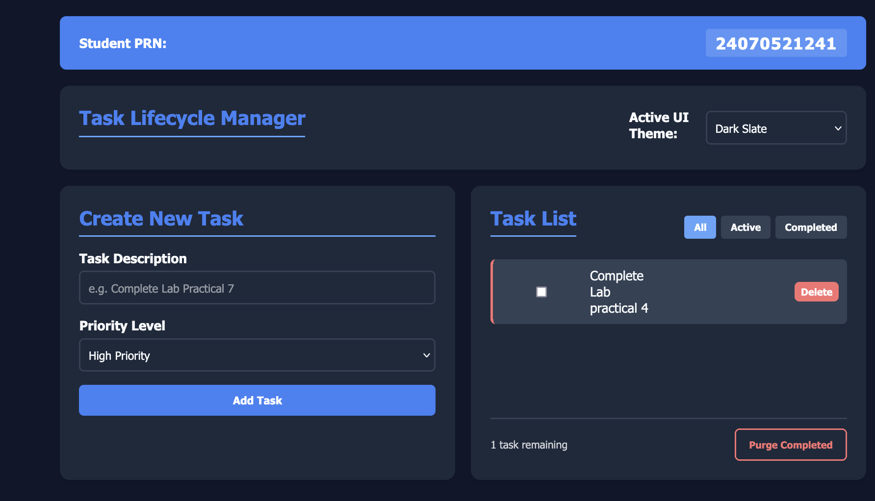
Figure 1: Modern Multi-Theme Task Manager Interface

6. Important HTML Snippet
<select id="themeSelect">
<option value="light">Light Mode</option>
<option value="dark">Dark Slate</option>
<option value="ocean">Oceanic Blue</option>
</select>

7. Important CSS Snippet
:root[data-theme="dark"]{
--bg:#0f172a;
--card-bg:#1e293b;
--text:#f8fafc;
}

8. Important JavaScript Snippet
themeSelect.addEventListener("change",()=>{
document.documentElement.setAttribute(
"data-theme", themeSelect.value);
});

9. Conclusion
The application successfully demonstrates modern front-end development concepts including state-driven task management, runtime theme switching, responsive design, DOM manipulation, event handling, and modular separation of HTML, CSS, and JavaScript.

