* Given Week 5-EX1
  + Create this structure (3-level scene node) [Tree base and Capsule base are the third level]
  + 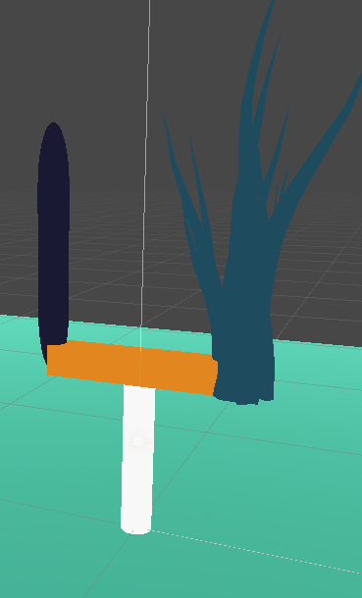

Base trunk 5 units in Y (Cylinder)

Bar center is (0, 5, 0) [Cube]

Tree base is (3, 0, 0) from Bar center

Capsule base is (-3, 0, 0) from Bar center

Design:

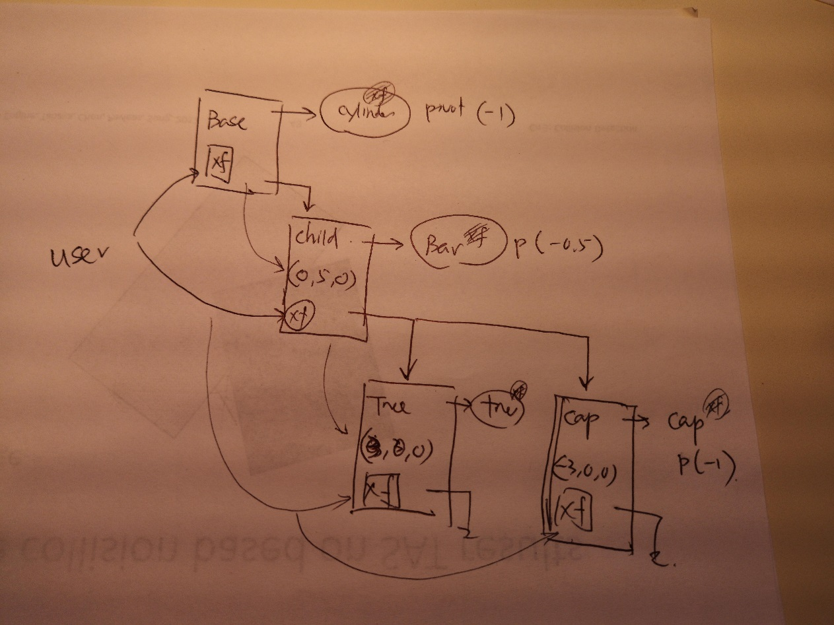

* Step 1:
  + Delete everything
* Step 2: The hierarchy
  + The hierarchy with SceneNodes
  + Base + Child
* Step 3: The Base
  + Cylinder as NodePrimitive
  + Drop Cylinder into base
  + Cylinder xform
    - Pivot (0, -1, 0)
    - Scale (1, 5, 1)
    - Translate(0, 1, 0)
  + **REMEMBER:**
    - **Drag Base into the World and the UI component in the MainCanvas**
* Step 4: The child
  + Cube bar
  + Drop cube into ChildNode