# 宋运翔 计算金融 2016141223037

对算法进行改进，使用马尔科夫，得到的计算结果相同，但是两次计算时间的对比如下：

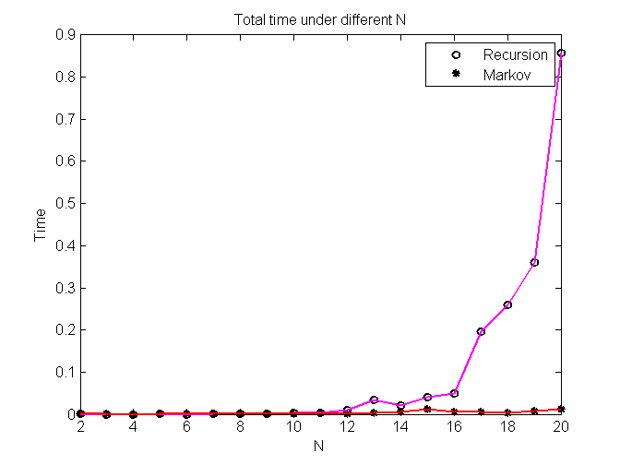

图1.1不同N时两种算法的时间对比

算法实现代码如下：

|  |  |
| --- | --- |
|  | import java.util.*; |
|  | import java.io.*;  import java.lang.*; |
|  | //状态矩阵类 |
|  | class Statematrix { |
|  | int row;//行 |
|  | int maxrow;//最大行数 |
|  | double [][] Data; |
|  | public Statematrix(int row, int maxrow) { |
|  | this.row = row; |
|  | this.maxrow=maxrow; |
|  | this.Data=new double[maxrow][3];//每个状态矩阵列数都为3 |
|  | } |
|  | public int getindex(double NewMax,double NewState){ |
|  | int index=0;//初始化索引 |
|  | for(int i=0;i<this.row;i++) |
|  | if(this.Data[i][0]==NewMax && this.Data[i][1]==NewState) |
|  | index=i; |
|  | return index; |
|  | } |
|  | //将状态添加入矩阵,[最大值,下一个状态值,期权价格] |
|  | public void addmatrix(double NewMax,double NewState){ |
|  | //利用变量判断该状态序列是否已经在状态矩阵中 |
|  | int flag=0; |
|  | if(this.row!=0) |
|  | flag=getindex(NewMax,NewState); |
|  | //将状态向量添加入矩阵 |
|  | if(flag==0){ |
|  | this.Data[this.row][0]=NewMax; |
|  | this.Data[this.row][1]=NewState; |
|  | this.Data[this.row][2]=NewMax-NewState; |
|  | //添加向量后，行数增加 |
|  | row++; |
|  | } |
|  | } |
|  | } |
|  |  |
|  | class Markov{ |
|  | public static void main(String[] args) { |
|  | //输入参数为现价S0，连续利率R，连续标准差sigma，总步数N，时间跨度t |
|  | double S0 = 1, R = 0.05, sigma = 0.2, t = 0.0833; |
|  | int N; |
|  | //定义输出字符串向量 |
|  | ArrayList<String>plotdata=new ArrayList<>(); |
|  | for(N=2;N<=20;N++) { |
|  | //二叉树参数 |
|  | double TimeA = System.currentTimeMillis(); |
|  | double sigmaN = Math.sqrt((sigma * sigma * t) / N); |
|  | double rN = Math.pow((1 + R), (t / N)) - 1; |
|  | double u = Math.exp(sigmaN); |
|  | double d = 1 / u; |
|  | double p = (1 + rN - d) / (u - d); |
|  | Statematrix[] States = new Statematrix[N + 1]; |
|  | //初始化状态向量[S0,S0,0] |
|  | States[0] = new Statematrix(1, 1); |
|  | States[0].Data[0][0] = S0; |
|  | States[0].Data[0][1] = S0; |
|  | States[0].Data[0][2] = 0; |
|  | //forward，产生状态(Sn;MN) |
|  | for (int i = 0; i < N; i++) { |
|  | States[i + 1] = new Statematrix(0,1000);//初始化下一阶状态矩阵 |
|  | for (int j = 0; j < States[i].row; j++) { |
|  | double OldMax = States[i].Data[j][0]; |
|  | double OldState = States[i].Data[j][1]; |
|  | //上升分支 |
|  | double NewupMax = Math.max(OldMax, u * OldState); |
|  | double NewupState = u * OldState; |
|  | States[i + 1].addmatrix(NewupMax, NewupState); |
|  | //下降分支 |
|  | double NewdownMax = Math.max(OldMax, d * OldState); |
|  | double NewdownState = d * OldState; |
|  | States[i + 1].addmatrix(NewdownMax, NewdownState); |
|  | } |
|  | } |
|  | //backward,计算价格 |
|  | for (int i = N - 1; i >= 0; i--) |
|  | for (int j = 0; j < States[i].row; j++) { |
|  | double OldMax = States[i].Data[j][0]; |
|  | double OldState = States[i].Data[j][1]; |
|  | double NewupMax = Math.max(OldMax, u * OldState); |
|  | double NewupState = u * OldState; |
|  | double v1, v2; |
|  | v1 = States[i + 1].Data[States[i + 1].getindex(NewupMax, NewupState)][2]; |
|  | double NewdownMax = Math.max(OldMax, d * OldState); |
|  | double NewdownState = d * OldState; |
|  | v2 = States[i + 1].Data[States[i + 1].getindex(NewdownMax, NewdownState)][2]; |
|  | States[i].Data[j][2] = (p * v1 + (1-p) * v2) / (1 + rN); |
|  | } |
|  | double TimeB=System.currentTimeMillis(); |
|  | double Time=(TimeB-TimeA)/1000; |
|  | //输出结果 |
|  | System.out.println("N="+N+"时，期权价格为："+States[0].Data[0][2]+",运算时间为："+Time+"s。"); |
|  | //将结果添加到输出序列 |
|  | plotdata.add(N+" "+States[0].Data[0][2]+" "+Time); |
|  | } |
|  | //考虑到java绘图并不美观，将计算数据输出到文本"plotdata.txt"中，用matlab绘图 |
|  | FileWriter fileWriter = null; |
|  | try { |
|  | fileWriter = new FileWriter("D:/Documents/GitHub/First/Financial-stochastic-analysis/Marplotdata.txt"); |
|  | int i=0; |
|  | while(i<19){//循环写入 |
|  | fileWriter.write(plotdata.get(i)+"\r\n");//写入 \r\n换行 |
|  | i++; |
|  | } |
|  | fileWriter.flush(); |
|  | fileWriter.close(); |
|  | } catch (IOException e) { |
|  | e.printStackTrace();} } } |