**Software Requirements Specification (SRS)**

**Active Park Assist 2**

**Authors: Cameron Rooks, Will McGee, Emilio Castillo, Claury Mejia, Yumo Wang**

**Customer: Eileen Davidson, Ford Motor Company**

**Instructor: Dr. Betty H.C. Cheng**

1. **Introduction**

This document provides the requirements for the Active Park Assist system, an automatic parking subsystem to be installed in future Ford vehicles. This document is intended for both the customer and the developers of the system, containing models to show the flow of the system through different scenarios as well as a link to a prototype interface for the system.

* 1. **Purpose**

This document establishes the basis for an agreement between the customer and the developers on what the Active Park Assist system is required to do as well as what it is not expected to do. The intended audience are developers and customers.

* 1. **Scope**

Our software system is an active park assist system. Our software allows a driver to park in a parking spot, picked out by our software and verified by the driver, without having to control their own car.

It will create less error when parking and takes stress away from the driver when driving in very densely populated cities. The system will only conduct parking and will not leave a parking spot for the user.

Our system will communicate with an on-board set of sensors and cameras to perform the parking maneuvers. This information will be communicated through a C.A.N. network within the car.

* 1. **Definitions, acronyms, and abbreviations**
* APA - Active Park Assist
* HW - Hardware
* SW - Software
* HMI - Human Machine Interface
* ACU - Actuation Unit
* Brake Control - The system which controls the brakes
* Powertrain Management - The system that allows us to adjust the movement speed of the car during a maneuver
* Steering Control - The system that allows us to steer the car
* C.A.N.- Controller Area Network
* User - The operator of the car
* Park Control Subsystem - System to control the gearshift
  1. **Organization**

Section 2 is intended as a high level look at what this project entails for the system. This includes product functionality, user characteristics, system constraints, assumptions made about the HW, SW, environment and user interactions, and the apportioning of the requirements.

Section 3 presents a list of specific requirements of the APA using a hierarchical numbering scheme.

Section 4 describes the specification portion of the requirements document, providing different diagrams explaining the bridge between the application domain and the machine domain. This section includes the use-case, class/domain, sequence and state diagrams.

Section 5 introduces the prototype in terms of system functionality, explains how to run the prototype and different scenarios using the system.

Section 6 provides the reader with a list of references for more information.

Section 7 provides the point of contact for any further use of this document.

1. **Overall Description**

This section describes the overall functionality of the system.  It will detail the context of the system, and explain how specific user characteristics will play a role.  The system functionality will also be summarized in this section, specifying the major functions the software will perform.  There are a number of different types of constraints the system faces, and those will be described in this section along with assumptions for the system.

* 1. **Product Perspective**

The APA is intended to be an autonomous feature that takes control of the vehicle once it is activated. The system executes the maneuver, taking the necessary steps and measurements to park the vehicle with minimal interaction required from the user. The overall goal is to improve already integrated technology and add new functionality and features to provide the user with the safety needed.

The APA system is formed by its integration with other subsystems: Brake Control, Steering Control, Park Control, Powertrain Management, Vehicle Position and the HMI.

The user interacts with the system through the HMI in which the user activates the Park Assist in order to initiate the search of a spot to park. Cameras in the front and back of the vehicle detect available parking spots while Ultrasonic sensors are used to measure the space available between vehicles in which the user can park and shares the information obtained with the user by displaying the parking spot’s rendering in the HMI.

The Park Control Subsystem receives the input from the user through the HMI and consults the Vehicle Position to start the maneuver and give instruction to the rest of subsystems.

Brake Control, Steering Control and Powertrain Management are manipulated by the Park Control Subsystem to complete the trajectory of the vehicle into the parking spot.

The system provides a very simple, intuitive and easy to navigate interface allowing the user to get used to it quickly. Once the Park Assist is activated the user will be able to select the parking mode, verify a spot for parking, cancel the maneuver, and with a limited amount of time to park the user will be allowed to extend the time or cancel parking. If any failures or a manual abort were to occur, messages will be displayed in the screen to the user.

Each subsystem has its own unique ACU and all communicate through C.A.N. network, which is vulnerable due to its simple messages and likely they should be encrypted in the context of security and safety. The system should check for “fresh” messages as a common attack is a spam of repeated messages.

* 1. **Product Functions**

The main functionality of the Active Park Assist system is the feature that allows a vehicle to automatically park itself.  The system functions for both parallel and perpendicular types of parking spaces, and will require some driver interaction.  To activate the system’s functionality, the driver will hit a button on the SYNC interface, and the system will activate.  The system will begin identifying potential available parking spots, and will ask the driver to verify the spot once found.  Ultrasonic sensors on the sides of the vehicle, along with cameras in the front and back of the vehicle, will allow the system to detect potential parking spots and objects. If the identified spot is verified by the driver, the system will take over the driving of the vehicle and park itself in the spot.  The cameras and sensors will continue to be used during the automatic parking function of the system to ensure the vehicle does not hit anything unintentionally.  Software will detect when the parking process function is complete, and will shift the vehicle into park as well as alerting the driver that the system has completed its task.  Other system functionality includes the ability to detect obstacles in the path of the vehicle during the parking process, and the ability for the driver to abort the system during the parking process by pressing the brake.

* 1. **User Characteristics**

The user for this system is a legal driver of a Ford vehicle. The driver is expected to understand what a legal parking spot is and what spots are illegal to park in, despite the system offering such a potential spot. The user is also expected to remain in the car during use of the system, as well as to be aware of their surroundings. For example, the user starts the system with nearby available spots, being mindful of the changes regarding parking and obstructions in the nearby area, so as to maximize the proper use of the APA system.

* 1. **Constraints**
* The detectors should be highly reliable and work properly during the maneuver.
* The actuators should be able to accurately carry out the instructions issued by controller.
* There shouldn’t be any kind of additional objects attached to any part of the vehicle.
* The system shouldn’t suffer from any kind of 3th party attack.
* Any system critical to the use of this system must be available
  1. **Assumptions and Dependencies**
* There are available parking spaces in the area when the system is activated
* The driver will select the type of parking to search for, correctly
* The driver will not have control of the vehicle during maneuvers
* The sensors will read in information, in real time, to perform a parking maneuver
* The driver should abort the system manually should a mistake be made during initiation
* The hardware (sensors/brakes/etc.) should be functional and undamaged
* Once the maneuver begins, the driver will no longer have need to control the car
* The user will verify that the parking spot chosen by our system is legitimate
  1. **Apportioning of Requirements**

Future versions of the APA will include a feature to account for objects attached to the vehicle that changes the overall size of the vehicle, such as a bike rack. The user will be able to input those objects’ dimensions

Sensors will detect moving objects distinctively from non-moving objects. This will allow the system to differentiate between objects. Sensors will detect objects smaller than a stick and variations in the road.

In vehicle architecture because each subsystem has its unique ACU in which all communicate though C.A.N. network, the system is vulnerable to attacks, thus in future versions it is likely that the messages that it produces will be encrypted as a measurement against hackers. Also, in addition to a verify button on the HMI, the system will be able to detect that there is a driver in the seat as a security measurement.

1. **Specific Requirements**
2. The system requires a method for the driver to verify the initiation of the parking maneuver, proving it was not the result of a 3rd party attack, such as a sensor in the seat detecting a person in the car, interacting with the interface to initiate the system, etc.
3. The system must be activated by the driver via visual display
   1. The driver must physically select the type of parking to perform (parallel or perpendicular)
4. The system will use embedded systems such as ultrasonic sensors and cameras to identify the parking spot, and its availability
   1. The driver must verify the system’s analysis of the parking spot before it can be performed
5. The system must be able to detect obstacles that appear during the maneuver and react to them by stopping the car, such as people, children, small animals and objects large enough to damage the car.
6. The system can be cancelled and return control to the driver at any time by tapping the brake.
   1. When the maneuver has ended via the brake being pressed or the process is aborted, a notification will display through the HMI
7. The system will use both forward and reverse to perform the parking
   1. The driver does not need to participate in the parking performed by our system
8. At the end of the maneuver, the car will be put into the parked gear
9. Any sensor failures shall be detectable and prevent the system from being used
10. **Modeling Requirements**

Use Case Diagram - Active Park Assist System

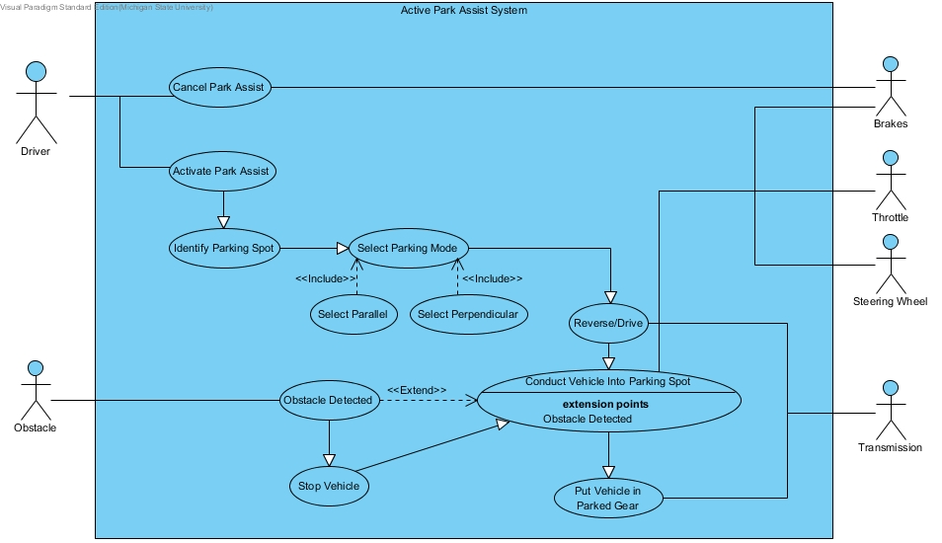

Use Case Templates

|  |  |
| --- | --- |
| **Use Case:** | Activate Park Assist |
| **Actors:** | Driver |
| **Description:** | The user activates the system through the HMI. |
| **Type:** | Primary |
| **Includes:** | None |
| **Extends:** | None |
| **Cross-refs:** | Requirements 2 |
| **Use cases:** | None |

|  |  |
| --- | --- |
| **Use Case:** | Cancel Park Assist |
| **Actors:** | Driver, Brakes |
| **Description:** | The user can cancel the maneuver at any moment by pressing the brakes. |
| **Type:** | Secondary |
| **Includes:** | None |
| **Extends:** | None |
| **Cross-refs:** | Requirements 5, 5-1 |
| **Use cases:** | None |

|  |  |
| --- | --- |
| **Use Case:** | Identify Parking Spot |
| **Actors:** | Driver |
| **Description:** | Once the HMI identifies an available spot, the user is able to verify it.. |
| **Type:** | Primary |
| **Includes:** | None |
| **Extends:** | None |
| **Cross-refs:** | Requirements 1 |
| **Use cases:** | None |

|  |  |
| --- | --- |
| **Use Case:** | Select Parking Mode |
| **Actors:** | Driver |
| **Description:** | The user proceeds to select the parking mode (parallel or perpendicular). Once the parking mode is selected the park control subsystem takes control of the vehicle and transmission shifts to reverse/drive and conducts the vehicle to the parking spot |
| **Type:** | Primary |
| **Includes:** | None |
| **Extends:** | None |
| **Cross-refs:** | Requirements 1 and 3 |
| **Use cases:** | None |

|  |  |
| --- | --- |
| **Use Case:** | Reverse/Drive |
| **Actors:** | Transmission |
| **Description:** | Once the parking mode is selected the park control subsystem takes control of the vehicle and transmission shifts to reverse/drive and conducts the vehicle to the parking spot |
| **Type:** | Primary |
| **Includes:** | None |
| **Extends:** | None |
| **Cross-refs:** | Requirements 6 and 6.1 |
| **Use cases:** | None |

|  |  |
| --- | --- |
| **Use Case:** | Conduct Vehicle Into Parking Spot |
| **Actors:** | Brakes, Throttle and Steering Wheel |
| **Description:** | Once the parking mode is selected the park control subsystem takes control of the vehicle and transmission shifts to reverse/drive and conducts the vehicle to the parking spot. |
| **Type:** | Primary |
| **Includes:** | Obstacle Detected |
| **Extends:** | None |
| **Cross-refs:** | Requirements 6 and 6.1 |
| **Use cases:** | Reverse/Drive |

|  |  |
| --- | --- |
| **Use Case:** | Put Vehicle in Parked Gear |
| **Actors:** | Transmission |
| **Description:** | When the vehicle is completely parked the transmission then shifts to parked gear. |
| **Type:** | Primary |
| **Includes:** | None |
| **Extends:** | None |
| **Cross-refs:** | Requirements 7 |
| **Use cases:** | None |

|  |  |
| --- | --- |
| **Use Case:** | Obstacle Detected |
| **Actors:** | Obstacle |
| **Description:** | Obstacles are detected and shown in the screen, if an obstacle is detected the vehicle stops. |
| **Type:** | Primary |
| **Includes:** | None |
| **Extends:** | None |
| **Cross-refs:** | Requirements 4 |
| **Use cases:** | Obstacle Detected |

|  |  |
| --- | --- |
| **Use Case:** | Stop Vehicle |
| **Actors:** | Steering Wheel, Brakes |
| **Description:** | If an obstacle is detected the vehicle stops.. |
| **Type:** | Secondary |
| **Includes:** | None |
| **Extends:** | None |
| **Cross-refs:** | Requirements 4 |
| **Use cases:** | None |

Class Diagram - Active Park Assist System

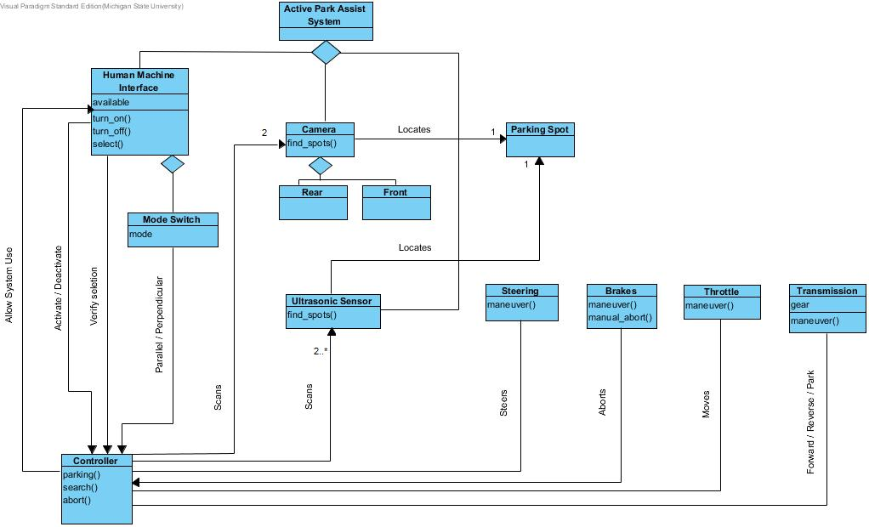

**Active Park Assist System:** Overall system, composed of the HMI, ultrasonic sensors and cameras

**Human Machine Interface:** Interface between driver and controller, composed of mode switch

* *available*: Boolean based on speed being under 5 MPH, which if True, the system is allowed to active
* *turn_on*: activates system process, changes display to mode switch for selection
* *turn_off*: returns display back to standard menu, either due to abort or completion
* *select*: receive user validation that the given parking spot is where the system should park

**Mode Switch:** controls the type of parking the system must conduct

* *mode*: the selected mode of parking style (perpendicular or parallel)

**Controller:** receiver of all sensor input, which it utilizes to send out actions to other parts of the system. Connected to cameras and ultrasonic sensors, and links to vehicle faculties needed for the parking maneuver

* *search*: calls on all sensors to send input to locate nearby spots that are possible for the vehicle to park in, given the size of the vehicle
* *parking*: maneuver into chosen parking spot using associated vehicle faculties
* *abort*: stop the parking maneuver, place vehicle in park, and turn off the HMI display and return to the standard menu

**Camera:** Visual sensors used to find parking spots, composed of Front and Rear camera

* *find_spots*: sends visual sensor data to controller to help identify parking spots

**Ultrasonic Sensor:** radar sensor for detecting spaces for parking

* *find_spots*: sends radar sensor data to controller to help identify parking spots

**Parking Spot:** object that refers to zone that can fit the vehicle, found via the sensors

**Steering:** external steering system that receives commands from controller during the parking process

* *maneuver:* steer vehicle along the path to selected parking spot

**Brakes:** external braking system that receives commands from controller during the parking process. Also can trigger an abort if pedal is engaged during maneuver

* *maneuver:* control and reduce speed during the parking process
* *manual_abort*: if pedal is engaged during parking, tell the controller to abort

**Throttle:** external throttle system that receives commands from controller during the parking process

* *maneuver:* controls and increases speed during the parking process

**Transmission:** external gear-shift system that receives commands from controller during the parking process

* *gear:* the current gear of the vehicle (Forward, Reverse, or Park)
* *maneuver:* changes gears in accordance with the trajectory to the parking spot

Sequence Diagram - Active Park Assist System

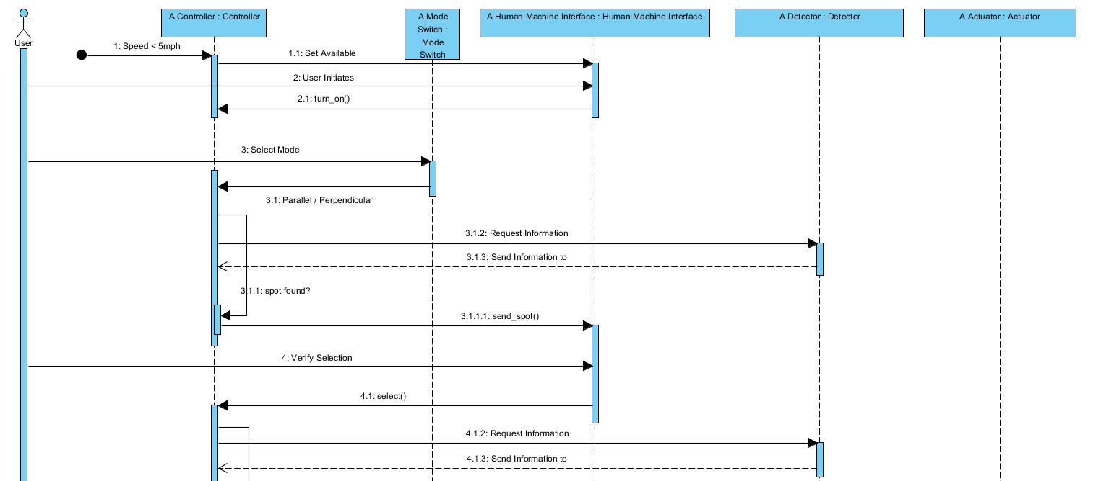

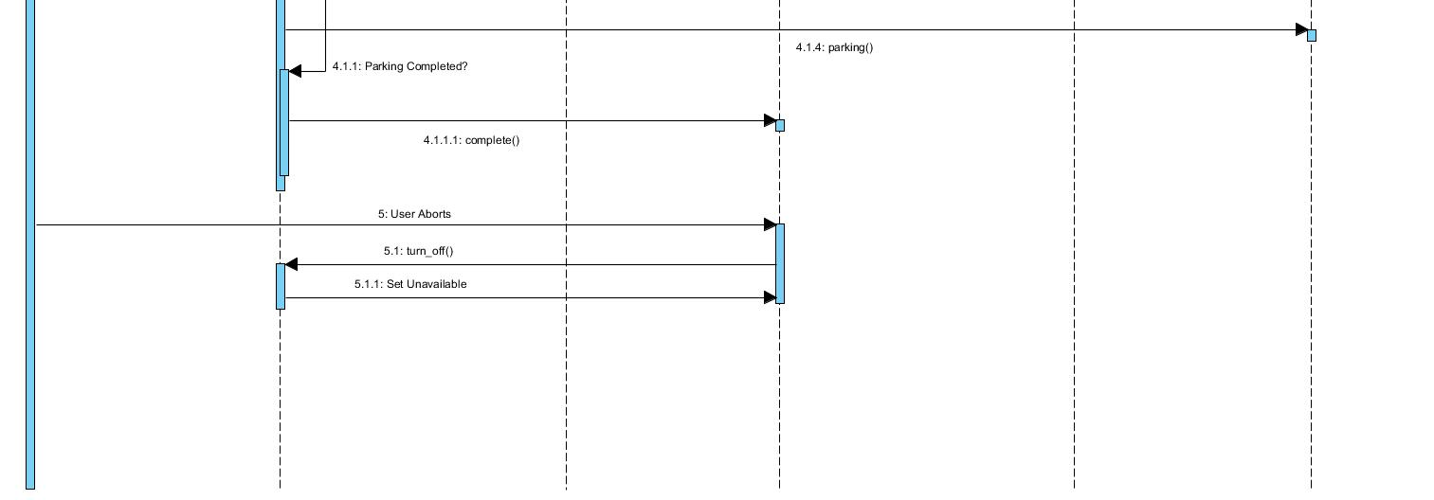

This is a general case where the system successfully maneuvers the vehicle into the user selected parking spot.

State Diagram - Active Park Assist System

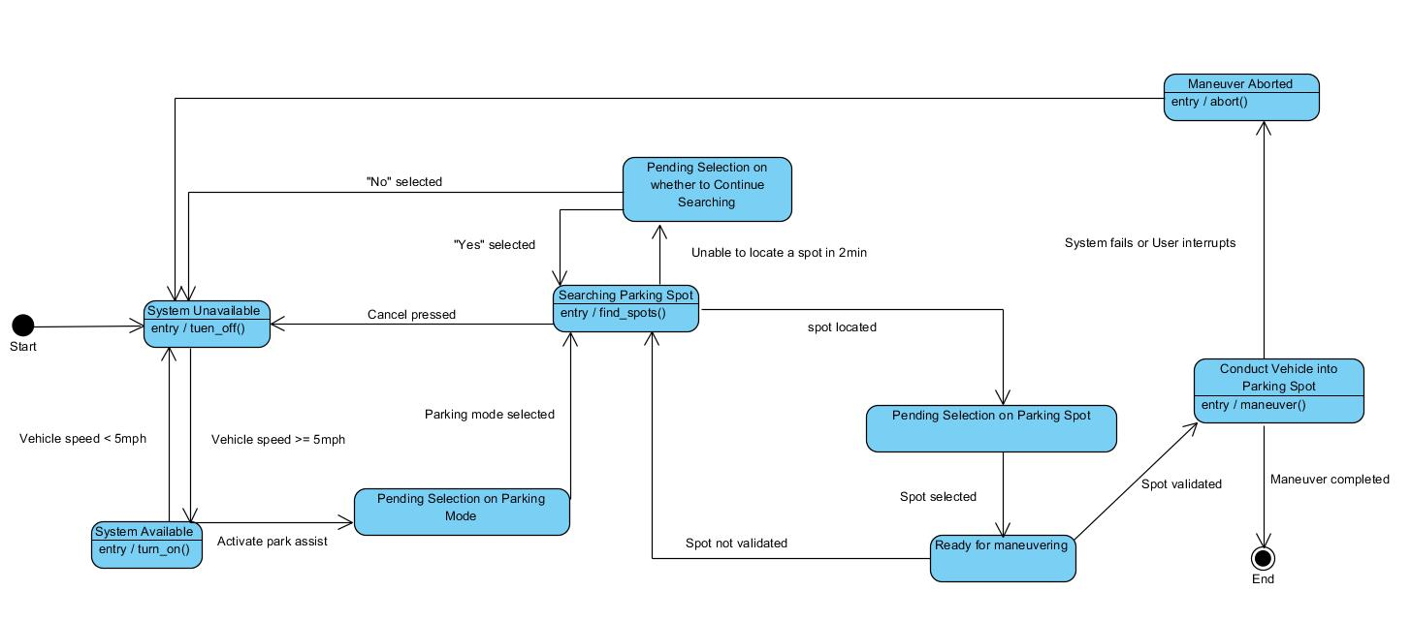

**System unavailable:** In this state, the system is inactive, until the speed of vehicle less than 5 mph.

**System available:** In this state, the system is idle, The user can initiate a searching at any time, unless the speed of vehicle exceeds 5 mph.

**Pending selection on parking mode:** In this state, the system is waiting for user’s selection on whether to search a parallel or a perpendicular spot.

**Searching parking spot:** While in this state, the system invokes the detectors to search nearby available parking spot.

**Pending on selection whether to continue searching:** In this state, the system is waiting for user’s selection on whether to continue searching.

**Pending selection on parking spot:** In this state, the system is waiting for user’s choice whether to park into the spot which is currently provided.

**Conducting vehicle into parking spot:** In this state, the system is automatically maneuvering the vehicle into the parking spot, based on the information provided by controller.

**Maneuver aborted:** In this state, the system ceases to maneuver and becomes deactivated.

1. **Prototype**

The APA prototype will show exactly how a user will interact with the system, while demonstrating what function the system will be performing during that action. It will show an interactive SYNC interface, that will be similar to the interface used on current SYNC enabled Ford vehicles. The user of the prototype will be able to run the system by pressing a button to activate Active Park Assist. The interface will then be a live simulation of what would happen if the user was using this in an actual vehicle. The user can select a type of parking spot, and the prototype will demonstrate that the system will begin looking for that type of parking spot. The prototype will then have interfaces that the user can interact with, and show different interfaces based on the user interaction until the simulation is complete, or the system is aborted.

* 1. **How to Run Prototype**

To run the Prototype V1, an internet connection and modern browser is all that is needed. The prototype can be found through the team’s website[1] under the *About* tab. The link will open up to the visual presentation made through “Prezi”. No account is needed to use this service, simply click through the presentation with the arrow keys on screen, and the slides have detailed descriptions for the actions on screen. No additional plugins or configuration settings are needed.  
Prototype V1: https://prezi.com/7rydocluq21p/prototype-apa-2/#.

* 1. **Sample Scenarios**

The driver of the car wishes to park and slows to a speed under 5 mph near some available parking spots. Being below the maximum speed threshold of 5 mph, the button to activate the system is now active on-screen to touch. After the driver presses it to activate the APA system, the driver is prompted to choose the type of parking: parallel or perpendicular. Depending on the selection, the ultrasonic sensors and cameras are used to automatically locate nearby parking spots, up to a duration of two minutes.

After locating a spot, the driver sees a rendering of the spot and must validate it by pressing a button on the display. Or, if the spot is not preferable, the driver may select to be offered another spot. This continues until a spot is chosen or there are no spots left in the nearby area, in which the driver is prompted to continue or exit the system.

Once a spot is chosen, the system maneuvers the vehicle into the spot, stopping for any obstacles that may appear in the path. During this maneuver, the driver may press the brake pedal to stop the maneuver and abort the system, otherwise the system completes the parking, leaving the car in park and notifying the driver that the process has been completed, after which it will close.

1. **References**
2. C. Rooks, C. Mejia, E. Castillo, Y. Wang, and W. McGee. *Active Park Assist.* Michigan State University, 21 October. 2016. Web. “www.cse.msu.edu/~cse435/Projects/F2016/Groups/APA2/web/about.html”.
3. **Point of Contact**

For further information regarding this document and project, please contact **Prof. Betty H.C. Cheng** at Michigan State University (chengb at cse.msu.edu). All materials in this document have been sanitized for proprietary data. The students and the instructor gratefully acknowledge the participation of our industrial collaborators.