ATSLab internship report – draft 2

Subject: Analyzing the factors influencing the opening of direct long-haul flights on the Transatlantic market.

Table of Contents
I) Data used 2
II) Analysis of how routes were opened in the past 3
II.A) Evolution of the number of routes from 2000 to 2023 3
II.B) Waterfall graph detailing the variation of the number of routes 4
II.C) Contribution of new routes to seats offer 6
II.D) Opening route duration 8
II.E) Outcomes for opening routes operating fewer than 3 years 9
Appendix 1 11

I) Data used

Schedule data: A dataset spanning from 2000 to 2023, organized by year and directional airport pair, including the operating carrier and aircraft information. It contains the number of seats, flights, and flight hours for each route. Note that aircraft data is missing for some flights between 2000 and 2008.
City metrics: Data aggregated at the metropolitan level, covering the years 2010 to 2015. It includes population figures, household income per capita (reported both in local currency and USD 2015), and other relevant city attributes. Some entries may have incomplete information.
Airport metrics: A dataset detailing various characteristics of airports, such as geographical information (time zone, world region, is island), technical specifications (number of runways, elevation in feet, length of the longest runway), and proximity metrics to the nearest major city (distance in kilometers, driving distance, driving time).
Fleet lookup: A reference table listing aircraft by ICAO/IATA codes, including seat capacity estimates, manufacturer, internal size classification, ATI size classification, global model names, payload capacities, and engine types.
Airport lookup: A mapping table that links airport codes to airport names, countries, regions, and geographic coordinates (latitude and longitude).
Airport rating: Google rating and number of reviews, scrapped data on the 19/08/2025.

World bank database: Dataset extracted from the World Bank containing various metrics at a country and yearly level. Including population, economic, energy, infrastructure, labor, geographic and tourism information. Some fields may contain missing values.

II) Analysis of how routes were opened in the past
By routes, I mean airport pair regardless of the airline/carrier on it. Routes will be considered directional (i.e., JFK → CDG is not the same as CDG → JFK), unless otherwise specified.

In the following section, all graphs will be divided into three categories (which I will call sub market after): INTER, INTRA_EUR and INTRA_US. INTER refers to international routes between the US and Europe, while INTRA_EUR and INTRA_US refer to domestic routes within Europe and within the US, respectively. I decided to keep these three view in order to check whether trends in the domestic markets may influence the international market.

Note: Some of the graphs may not be directly tied to the main objective of analyzing the factors, but I felt it was worthwhile to look at how routes were opened to spot potential patterns and build some intuition.

II.A) Evolution of the number of routes from 2000 to 2023
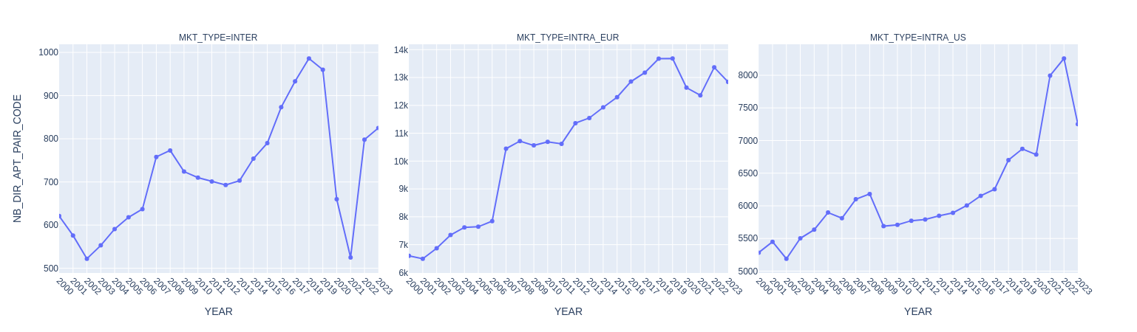
Figure 1: Evolution of the number of routes between 2000 and 2023

The graphs above show the evolution of the number of routes by sub market between 2000 and 2023. Focusing on the international view, we can see that it is quite sensitive to major crisis (9/11, subprime, covid) represented by a decline in the number of routes offered. However, in each case, the market recovered within a few years.

In the absence of crisis, the number of routes increases steadily. For example, the 2012-2019 period seems to be a good period to do more analysis. Between 2006 and 2007, there was a sharp increase in both the international market and the domestic Europe. This increase is likely linked to the Open Skies Agreement (signed in 2007 and in applied in 2008), which allowed airlines more operational freedom. And for Europe specifically, the rise can be also driven by the expansion of low cost carriers during that period.

Zoom on the international market depending on the direction (EUR→US or US→EUR)

For the international market, I wanted to assess whether there is any asymmetry depending on the direction of travel. In terms of the number of routes, the graph below suggests that volumes are generally balanced in both directions. However, some differences occurred in 2002 and 2006. The gap in 2002 may be explained by bilateral restrictions combined with the post-9/11 downturn in the U.S., which reduced the number of Americans traveling abroad (I suppose). As for 2006, the difference could be linked to U.S. airlines anticipating the Open Skies agreement, while the sharp increase between 2006 and 2007 likely reflects the response of European airlines to this agreement (not sure about that).

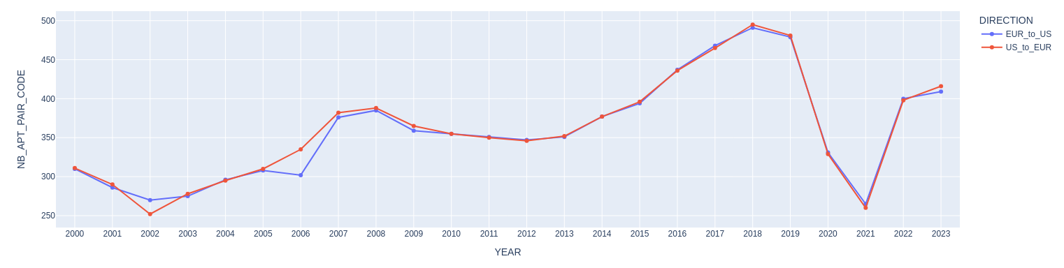
Figure 2: Evolution of the number of routes depending on the direction for the international sub market

Finally, I wanted to check whether, in general, an airport pair is offered in both directions. The graph below shows the number of routes available in only one direction (as indicated by the color). In the past, specifically in 2002, 2006, and 2010, there was some asymmetry, although it was relatively minor compared with the total number of routes. Since 2011, however, the situation appears to have stabilized, with very little asymmetry, indicating that most routes are now offered in both directions (considering only the existence of the service, not its frequency).

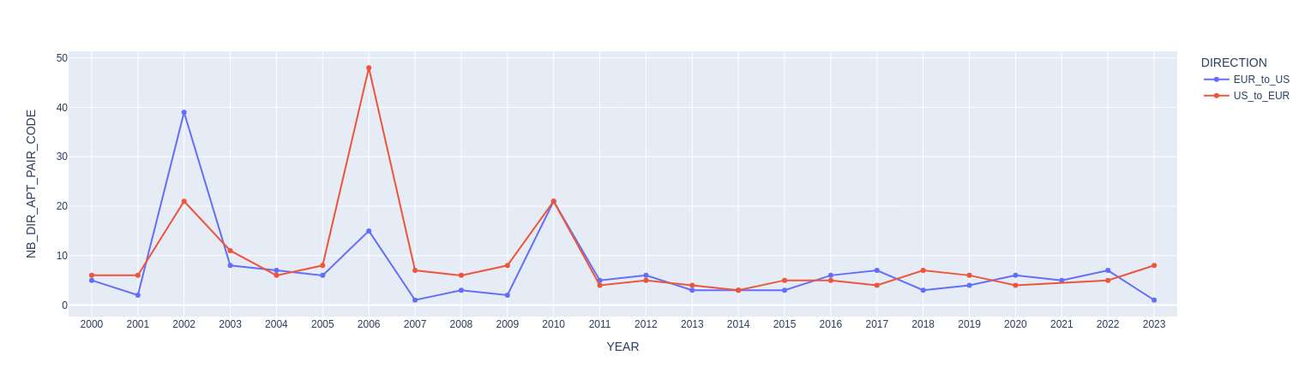
Figure 3: Number of routes existing in one direction only for the international sub market

II.B) Waterfall graph detailing the variation of the number of routes

To analyze changes in the number of routes, I classified them into 4 categories:
- OPENING_RTE : routes that have never existed before.
- REOPENING_RTE : routes that operated in the past but not in the previous year (or longer).
- ENDING_RTE : routes that have closed permanently.
- BREAK_RTE : routes that will not operate the following year but will reopen in the future.
This visualization is intended to assess whether route openings and closures are dynamics or remain relatively statics over time.

Zoom on the international sub market
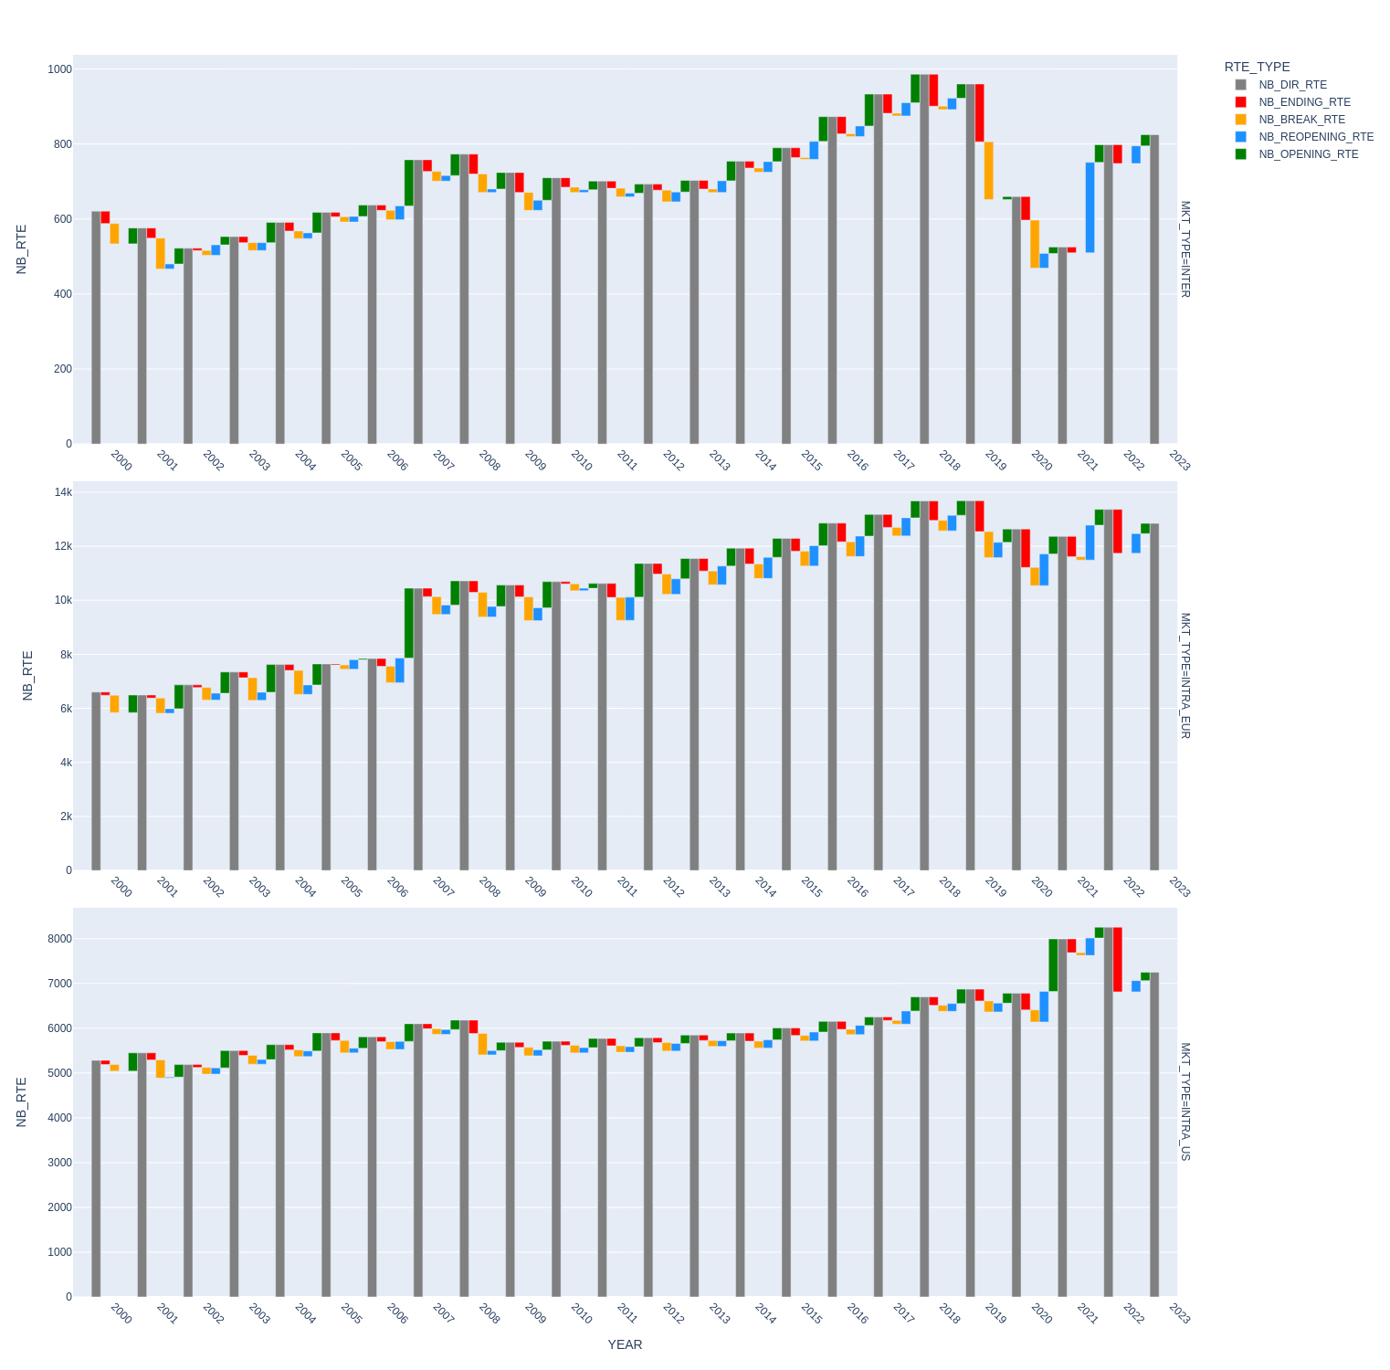

Figure 4 : waterfall chart showing the route count dynamics in the international sub market

Looking at the graph above, we can see that route openings and closures tend to be more dynamic during periods of crisis or major events (such as the 2007 launch), but generally remain fairly stable. Between 2002–2005 and 2012–2019, variations were neither sudden nor particularly significant, representing less than 10% of total routes in most cases. Another pattern is that variation tends to grow over time: right after a crisis, changes are limited, but as time passes, more openings and closures occur. For example, in the 2012–2019 period, the number of changes was low at the start but increased toward the end. Finally, the number of routes taking a temporary break is lower than those ending permanently, suggesting that when a route is discontinued it is generally not reintroduced in the future.

Zoom on the other sub market
Figure 5 : waterfall chart showing the route count dynamics in the European and the American sub market
For both the European market (first figure) and the American market (second figure), the trends are similar to those observed in the international sub market. Both appear less sensitive to crises, showing little or no change during such periods. In the European market, the impact of low-cost carrier expansion is visible between 2006 and 2007.
In the American market, variations are very steady and consistent over the years, with similar volumes of route openings, closures, reopenings, and breaks. These represent only a small share of the total number of routes, indicating that this market (at least in terms of connectivity, regardless of airline competition) is mature.
The European market shows slightly larger variations, though still far from representing the majority of routes. Unlike the international sub market, route breaks and reopenings are more dynamic here and occur in roughly equal proportions to openings and closures. Moreover, this dynamic has remained stable over time, without the gradual increase seen in the international market.
Note: The sharp increase in route openings in 2020 for the American market is likely due to some data errors, which need further investigation.

II.C) Contribution of new routes to seats offer

From the previous graphs, we saw that, in terms of the number of routes, variations represent only a small share. It is also interesting to examine the market in terms of seats: how many seats do newly introduced routes add over time?
The graphs below show, for each year, the proportion of seats by the route’s opening year (grouped), normalized by year (a non-normalized view is provided further below). For example, all seats on routes opened between 2001 and 2005 are shown in orange.
One key observation is that new routes contribute a larger share of seats than they do for number of routes. In the international and European sub markets, 70% of seats are on routes established in 2000 or earlier, while the remaining 30% come from new routes. In contrast, in the American sub market, only about 10% of seats are attributable to new routes. This confirms the previous observation (waterfall one), just as numbers of route openings and closures were relatively stable, the seat capacity associated with these changes is also fairly steady and does not represents a major share.
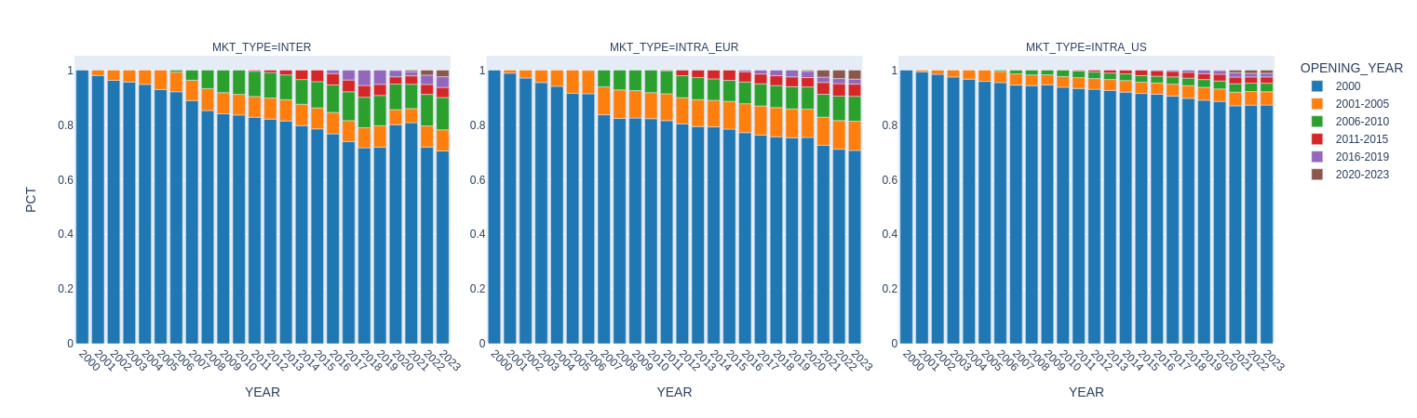
Figure 6: percentage of seats introduced by newly opened routes, grouped by opening year bin

If we focus on newly opened routes only, we observe that their share of total seats remains fairly constant over time. This means that once new seats are introduced, their proportion relative to the total does not change much. Looking at the non-normalized view, we can see a global consolidation or increase in seat numbers over time, but because this growth occurs across all the routes, the relative share stays constant.
Another point is that, although new routes contribute around 30% of total seats, not all years contribute equally. For instance, in the international and European markets, routes opened between 2001 and 2010 account for about 20% of seats. Over time, the share of seats offered by newly opened routes gradually decreases. This likely reflects market maturity, where route openings are no longer the main driver of growth. This pattern is even more pronounced in the American market.

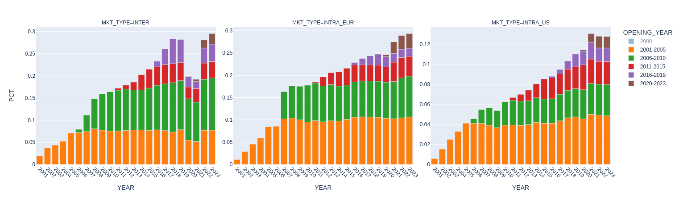
Figure 7: zoom of figure 6

View non-normalized
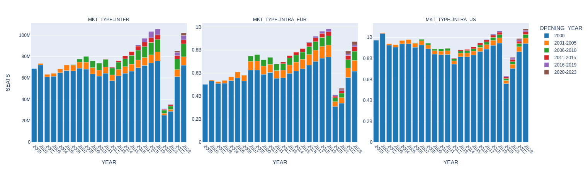
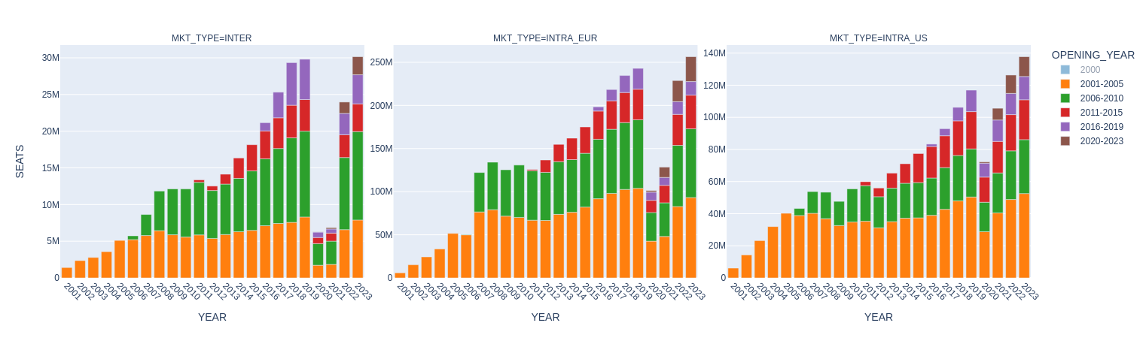
Figure 8: seats introduced by newly opened routes, grouped by opening year bin

Figure 9: zoom of figure 8

II.D) Opening route duration

One important aspect to consider is the duration of newly opened routes. In some cases, airports or countries offer temporary price-reduction (for example, in the UK or Norway) lasting one, two, or three years. These measures aim to stimulate the market and encourage the launch of new routes. However, some of these routes may not remain in operation in the long term.
The graph below shows the distribution of the number of routes according to the number of consecutive years they remain open after their initial launch. By “number of years for the first opening,” I mean the count of consecutive years during which a newly opened route stays active.
I have excluded data from 2020 onwards due to the strong impact of COVID-19, which could bias the results. I did not exclude other crises (maybe I should).
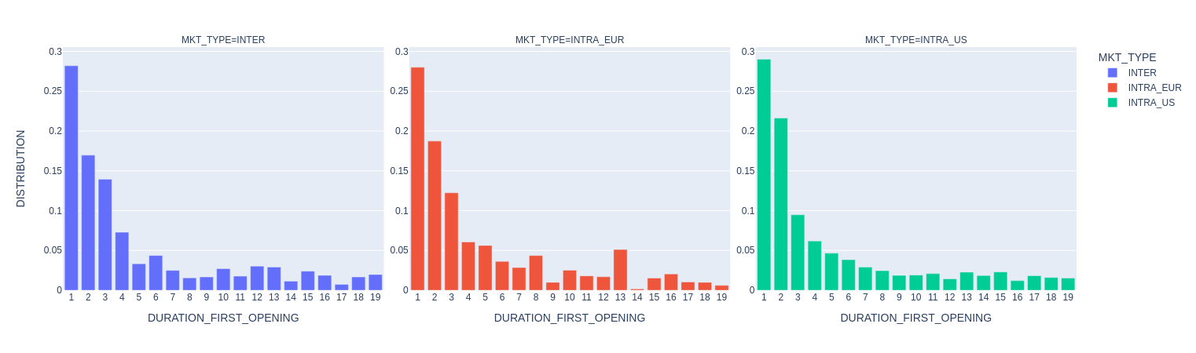
It’s important to be aware of edge effects. For instance, a route opened in 2019 would appear to have only one year of consecutive operation, simply because of the time window considered. However, since such cases represent a small share of total routes, I chose (very arbitrarily) to keep them in the analysis.
Figure 10: distribution of newly opened routes by the duration of their first launch
The distributions are similar across all sub markets. They show a decreasing trend, partly influenced by the edge effect. However, the strong concentration on the left indicates that most first openings last only one, two, or three years, and it becomes increasingly rare for routes to remain open longer. This pattern may be linked to the temporary price-reduction mentioned earlier, or to airlines testing new routes and evaluating their long-term viability.
One surprising observation concerns long-haul routes, particularly in the international market. I initially assumed these were more complex to launch, leading airlines to think twice before committing. The presence of a noticeable trial-and-error effect in this segment was therefore unexpected (if it is a trial-and-error effect).

From a cumulative perspective (graph below), we see that around 60% of routes remain active for no more than three years during their first opening, regardless of the sub market.
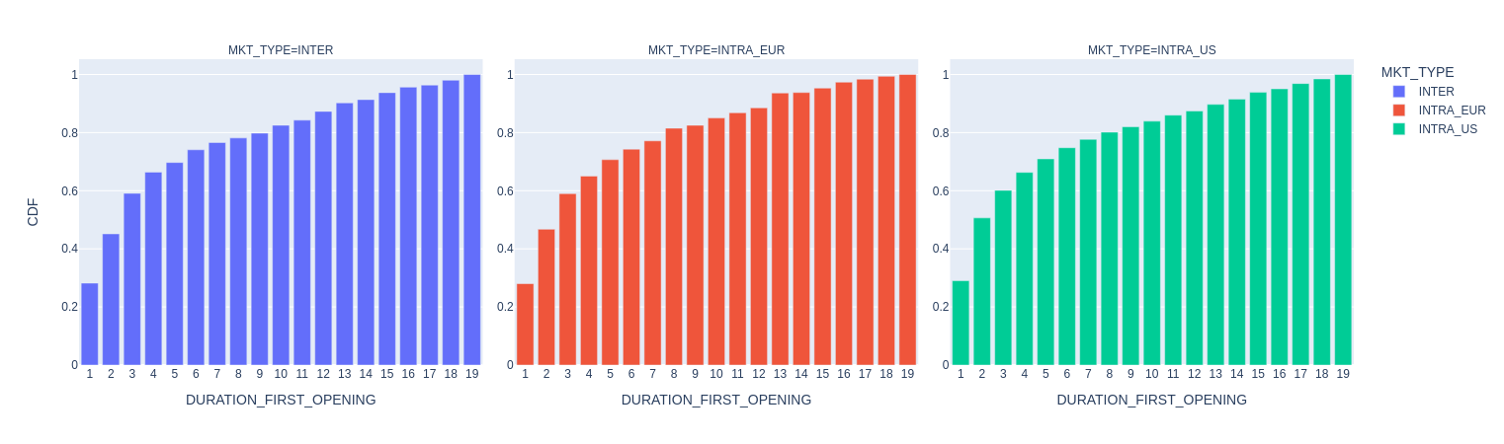
Figure 11: cumulative distribution of newly opened routes by the duration of their first launch
Some links:
- https://avinor.no/contentassets/75e2fbe873a14ebba0bbbffd771f1088/avinor-guidelines-startup-aid.pdf → aid from Avinor airports in Norway
- https://assets.publishing.service.gov.uk/media/5a7e37bbe5274a2e8ab469a3/draft-protocol-start-up-aid.pdf → aid in the UK

II.E) Outcomes for opening routes operating fewer than 3 years

As previously explained, we know that 60% of new routes close within their first three years of operation. The next question is: when these short-lived routes close, do they reopen later, or do they close permanently?
The graph below focuses on routes whose first operating period lasted up to three years. For these, we distinguish between two cases: the route was permanently closed and the route was paused and later reopened.
To avoid bias, the analysis uses only data from 2000 to 2019, excluding the COVID period. We also exclude this time the last three years of the dataset (2017–2019) so as not to misclassify routes whose status is still uncertain (not consistent with the previous part I need to check that).
Looking at the normalized results, in both the international and American sub markets, just over 60% of routes that lasted up to three years for their first opening were discontinued permanently afterward. In contrast, in the European sub market, the share is roughly balanced between permanent closures and later reopenings.

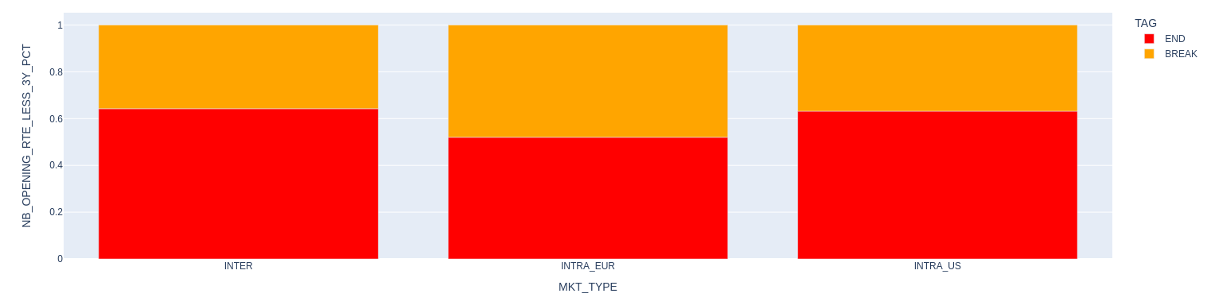
Figure 12: outcome (end/pause) of newly opened routes lasting up to 3 years
This suggests that the European market is more flexible in adjusting its route network, with a greater tendency to pause and later reopen routes compared with other sub markets.
The key takeaway is that most newly opened routes do not last long on their first attempt, and in the international market, more than half of them will never reopen afterward. This analysis is based on the number of routes, not their seats offer. Maybe that different perspective could show different patterns, as we’ve seen before.

View non-normalized
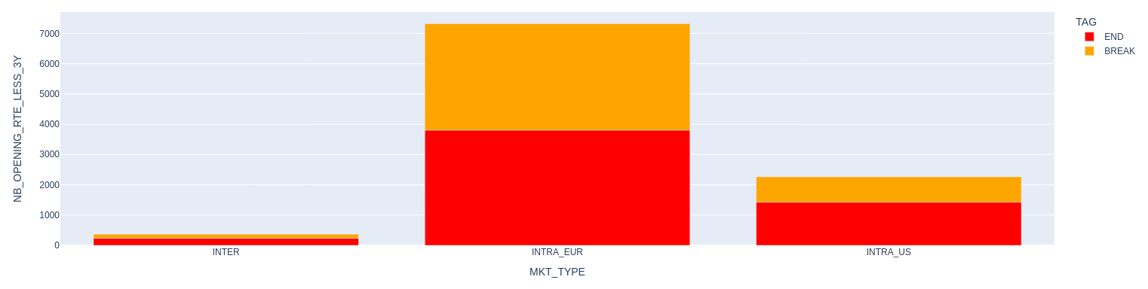
Figure 13: outcome (end/pause) of newly opened routes lasting up to 3 years, non-normalized view

In short:
- Mature markets see relatively few new route openings.
- The share of seats introduced by newly opened routes decrease over time.
- When they do open, they often don’t last, especially for the international sub market.

Add part yearly view seats share and the part on the airline (just as an intuition) and maybe a part on the aircraft

III) Analysis of the relationship between airports metrics and new route openings
In this section, I aim to examine whether there is any correlation between the airports metrics table and the opening of new routes. From now on, I will focus only on the international sub market.

III.A) Data processing and description of the metrics

III.A.1) Description of the airports metrics
By airports (code), we have several metrics derived from two data files. More specifically, our focus is on the following data:
- From the airports metrics table:
  - APT_CITY_DRIVE_DIST_KM: driving distance (in km) from the airport to the nearest major city.
  - APT_CITY_DRIVE_TIME_H: driving time (in hours) from the airport to the nearest major city.
  - NB_RUNWAYS: total number of runways at the airport.
  - ELEV_FT: airport elevation above sea level (in feet).
  - IS_ISLAND: boolean indicating whether the airport is on an island.
  - TIME_ZONE_2016: airport’s time zone.
- From the airports ratings table:
  - RATING: Google rating of the airport.

Self note: why 2016 ?

III.A.2) Data enhancing: route grouping and derived indicators
From the scheduled table, I group the data by directional routes and create several boolean indicators:
- IS_OPENING: identifies whether the route is newly opened.
- IS_SHORT_OPENING: boolean indicating if the route is newly opened and its first opening/launch lasted less than 3 years.
- IS_LONG_OPENING: boolean indicating if the route is newly opened and its first opening/launch lasted strictly more than 3 years.
- IS_ENDING: boolean indicating if the route has ended (it no longer exists in 2023).
The metrics from the airports metrics/ratings tables are then joined to this grouped dataset, with suffixes _A and _B to distinguish between APT_CODE_A and APT_CODE_B.
In addition, I add three categorical tags and three aggregate columns for future analyzes:
- TAG_DURATION_OPENING: classifies routes as long opening, short opening, or no opening, depending of the duration of the first launch.
- TAG_END_WITHOUT_COVID: indicates whether a newly opened route ended before 2019 / strictly before 2020 (before COVID), whether it still exists, or whether it was never an opening.
- TAG_END_WITH_COVID: indicates whether a newly opened route ended, whether it still exists, or whether it was never an opening. Based on the 2000-2023 period.
- ROUTE_DRIVE_DIST_KM: sum of the driving distances for airports A and B.
- ROUTE_DRIVE_TIME_H: sum of the driving times for airports A and B.
- ROUTE_RATING: sum of the ratings for airports A and B.

The distinction between before and after COVID is made to account for the incomplete recovery of air traffic and to reduce edge cases. I kept both view to compare (just in case).

Note: in this grouping, all routes are weighted equally. Factors such as seat capacity or number of flights are not considered. It is an appropriate choice ? Open question.
Self note: the column naming aren’t very self explained, can find better names.

III.A.3) Data volume checking
Before running any analysis, I first examine the data volume to check whether the classes (regardless of tag) are balanced.
IS_OPENING | COUNT
True | 1063
False | 621
Table 1: number of routes depending on the tag IS_OPENING
In 2000, 621 routes were already in operation and during the next 20 years, 1063 routes were newly open. This does not imply that they all lasted. It simply means that 1063 route combinations were tested.

TAG_DURATION_OPENING | COUNT
No opening | 621
Short opening | 640
Long opening | 423
Table 2: Number of routes depending on TAG_DURATION_OPENING
Looking at the duration of the first opening/launch, we observe that among the 1063 routes tested, 423 lasted strictly more than three year (about 40%). This matches the results from the previous section, indicating a stronger dynamic of short-lived route openings compared to long-lived ones.

TAG_END | COUNT with COVID | COUNT without COVID
New route still existing | 459 | 542
New route stopped existing | 604 | 521
Old route still existing | 366 | 411
Old route stopped existing | 255 | 210
Table 3: Number of routes depending on TAG_END_WITH/WITHOUT_COVID
Old route refer to those already in operation in 2000 (the 621 routes), while new route are those newly opened (logic). To recall, the distinction with/without COVID refers to how route endings are counted. For the without COVID case, a route is consider ended if the end date is strictly before 2020 and any closing after that is not included.
For the old routes, 411 out of 621 were still active in 2019, and 366 remained in 2023. This means that over 60% of the network of 2000 was still in place two decades later.
For the new routes, the situation differs: before COVID, the split between routes that stopped to exist and those that continued was roughly balanced. After COVID, however, the gap widened, with significantly more routes ending. This suggests that a newly opened route has roughly a 50% chance of remaining active over time (although survive may not be the most precise term here, since we are evaluating at fixed reference years).

All tags have a well-balanced number of data points. We can do analysis (yeah).

Note: For all tags, I choose (arbitrarily again) to keep 2000 as a “reference” year to compare how it the indicators of the newly opened routes differs from an reference point. An idea to explore will be to do the analysis with another grouping, for example before/after 2010 and not 2000 vs the rest.
Self note: maybe that subsection need to be in the second section.

III.B) analysis (change that title)

III.B.1) Methods/visualization
For the analysis, I will focus on the distribution across three tags:
- IS_OPENING: basic, to check for differences between newly opened and non-new routes.
- TAG_DURATION_OPENING : to check whether short versus long first openings show distinct trends.
- TAG_END_WITHOUT_COVID : to compare routes that continued versus those that ended, while deliberately excluding COVID-related effects (arbitrary choice).
For the visualization, I will use:
- Histograms and boxplots of the metrics, to capture their distribution across groups. I will examine the distributions for both airports (A ans B) to check if there are any divergences/asymetry.
- Heatmaps/cross tables combining metrics from airport A and airport B, to analyze pattern at route level rather than at the individual airport level
For the moment 26/08, I don’t use any statical test. Which can be a good thing to have confirmation/or not about the intuition that the graphs can gave. If I didn’t do it, in appendix I will write about few test that can be interesting to do.

Also I will not include every graph in the report, if interested take a look at the notebook directly

III.B.2) Airport to city drive distance

III.B.3) Airport to city drive time

III.B.4) Airport elevation

III.B.5) Number of runways

III.B.6) Google ratings

III.B.7) Google ratings

III.B.8) Is island

III.B.9) Time zone ?

III.C) In short/ key messages (change that title)

IV) Analysis of the relationship between country level metrics and new routes openings (metropolitan ?)
to do analysis

V) Potential routes
both ways filter
would be best to have a score by routes with the density but don’t have time to implement it
VI) further work idea

III) Analysis of the relationship between city metrics and new route openings
In this section, I aim to examine whether there is any correlation between the city metrics table and the opening of new routes.

III.A) Data processing and preliminary limitations

III.A.1) Description of the table
As explained before the city metrics table contains data aggregated at the metropolitan level, covering the years 2010 to 2015 and some entries may have incomplete information.
More specifically, our focus is on the following data:
- POPU: the population of the metropolitan area,
- INC_LC: household income per capita in local currency,
- INC_USD2015: household income per capital in USD2015,
- IS_GLOBAL_HUB*: boolean indicating if the metropolitan area is a global hub,
- IS_DOMESTIC_HUB*: boolean indicating if the metropolitan area is a domestic hub,
- IS_CAPITAL: boolean indicating if the metropolitan area includes a capital,
- IS_SPECIAL**: boolean indicating if a metropolitan area is special (cultural/tourism/economic).

*: The classification is based on judgment and/or external lists of airports considered to be hubs rather than any specific metric.
**: Same here, internal classification not based on any specific metric.

What’s a metropolitan area ?
A metropolitan area is a large urban region comprising a major city and its surrounding areas, including suburbs and nearby towns, that are economically and socially connected. It's essentially a city and its "greater neighborhood".
Example of metropolitan area:
- New York/Newark/New Haven/Islip/East Farmingdale/Westchester County/Morristown/Newburgh
- Chicago
- London/Southend-On-Sea/Cambridge
Some links:
- https://en.wikipedia.org/wiki/Metropolitan_area
- https://en.wikivoyage.org/wiki/Metropolitan_area_airport_codes

III.A.2) Data selection/enhancing

Since we have the econometric data only from 2010 to 2015 we will focus the analysis on that period.
Not a long period to do an analysis especially if sometimes routes don’t open for a long time (less than 3 years) but at least, that year period seams ok without crisis. Even if we can see the recovery of the subprime crisis during 2010/2011 (when looking at the number of route in part I.A)

And in that section I only kept the international market and not the domestic which represent (check the number of routes and the seats for that period)

Concerning modification of the dataset, I convert the inc usd2015 to usd2019 since it’s the unit of reference used by ATSLab. From different sources, I found a coefficient of inflation of 1.08 between 2015 and 2019 ( https://www.bls.gov/data/inflation_calculator.htm

I also add columns to the city metrics table:
- EVO_POPU: the percentage of evolution of the population between two years.
- EVO_INC_LC : the percentage of evolution of the household income in local currency
- EVO_INC_USD2019 : the percentage of evolution of the household income in usd 2019

Note: the evolution (that I add) is more of a projection of how it will evolve rather than how much it evolve. Why ? to check the potential “market”/ population, make more sense to me if we want to plan the opening of a route. I don’t deny that I can be useful to check how much it evolve also to check if the past view have an importance. But since I’m not working a lot of years (6 years of econometric data) I prefer not the reduce (by filtering) my dataset to much. Because even if I have data from 2010 to 2015, I can’t have the evolution for 2015 (don’t have the data of 2016) so that year is filter out. (and it will has been the same for 2010 if I check how it evolves).

Example of how I compute the evolution :
    - evo_popu for 2010 = 100*(popu 2011 – popu 2010)/ popu 2010.

I keep both the household income in local currency and in usd2019 to see if there is any difference. Basically, I try to enhanced the dataset as much as possible without deleting many data and see which one are useful at the end.

I then merge the city metrics table to both airport A and airport B to have the two view. As we saw before our dataset is pretty symmetrical so I expected the results to be symmetrical also. By symmetrical, I mean the correlation/results of a kpi of airport A should be the same the same kpi of airport B. since we have directional airport and in the previous part we check that generally we have both direction, then we’re supposed to have symmetrical data. (I don’t know if that’s clear, in case just ask me for precision)

We will go more into details in the next part (precise which one) but I apply a logarithm function for the population and the household income in local currency, to have a more representative scale / less compressed scale.

subsection on what I filter out ?
I also filter the airports pairs where the information was incomplete (need to check the volume of that)

And the last filter that I’ve done is on the airport pair which open between 2010 and 2014 but are not in their opening year. For example a route opened in 2010 and existing in 2011 and 2012 also, I filter out the row from 2011 and 2012. Why ? To avoid double counting/ imprecise data (le terme c’est pas vraiment imprecis à revoir cette partie). More precision on the next subsection (do link)

I also add different tagging to do the analysis for example:
- IS_OPENING: boolean specifying if a route opening
- IS_SHORT_OPENING: boolean specifying if it’s a route opening and last up to 3 years in a row open
- IS_LONG_OPENING: boolean specifying if it’s a route opening and last more than 3 years in a row open

I made a distinction between short and long opening due to the short opening effect observed in the previous part (do link) and to check if there is different dynamics/driver to these two groups.

Note: It can be interesting to do the same (data preparation) for the closing route. Andrew intuition, to compare if there is a cross dynamic between opening route/closing route. (ask for more precision)

Useful ? Maybe in the next section to recall before doing stat analysis
We have at the end 2 groups (3 maybe):
- route opening
- and route already open before 2010

Need to be another subsection ?
On a complete different note (not very related to the study), but it’s not very convenient to have the data in a wide format rather than a long format (especially for the year and also for the apt ). So few data manipulation need to be done
what I mean by wide and long format

also I precise that now but I rename the columns of all the dataframe to have an easier manipulation/standardized naming.

III.A.3) Limitations: granularity and class imbalance

The first limitation that comes to mind is a granularity mismatch. Our data is available at the metropolitan area level, yet our analysis aims to identify correlations at the airport level. For example, consider the routes CDG–JFK and CDG–a smaller airport within the New York metropolitan area: the econometric data would be identical for both, since they belong to the same metropolitan region. As a result, when new routes open between metropolitan areas already connected by at least one existing route, the data will not sufficiently discriminate between our two groups (new openings versus already existing routes), potentially leading to weak conclusions.
One possible way to address this issue is to redefine what constitutes a new route. Specifying that it occurs only when two metropolitan areas are connected for the first time, rather than two individual airports. However, in the transatlantic market, which is already mature and dense, this definition would likely produce very few new routes, and thus an insufficient dataset for meaningful analysis.

The second limitation concerns the size of our sample. The tables below show the number of new route openings compared to the total number of routes.

IS_OPENING | count | %
true | 186 | 5.65
false | 3104 | 94.35

Overall, new routes account for slightly less than 6% of the sample. This is a very small proportion, resulting in highly unbalanced (asymmetric) groups. Combining this sample size limitation with the granularity issue described earlier makes training a model on this data far from ideal (although I still plan to give it a try).

Tables for short and long openings
IS_SHORT_OPENING | count | %
true | 186 | 5.65
false | 3104 | 94.35

IS_LONG_OPENING | count | %
true | 186 | 5.65
false | 3104 | 94.35

III.B) Descriptive statistic

check other market
east and middle
cost of operation (can’t have output of ABM)
check gdp
more route candidate than reality
which one will be successful or not
add more spatial data

Andrew comments:
zoom example route difference
be careful on the scale
statement not obvious II.C) third paragraph
precise that service is better to look at rather routes ??

Don’t remember that
link between number of seats and cities characteristic
link with the frequency

report
code
analysis
To do next week:
- write report about apt metrics analysis
- write appendix about data scrapping
- enhanced first part with andrew comment and the missing plot, and maybe the volume of data can be in that section too
- make comment about not having fairs/economic faisability about the routes ? Like how much will it cost/fuel etc…

- appendix about statistical tools that can be used but don’t really work here
- comment about can’t model but can filter → link with the logistic regression
- part about what can be done next → non linear relationship (I only did linear and didn’t really cross info) maybe give piste de reflexion
- mettre message clé par graph
- write something about the number of connexion by airport, is it always the same airports where the route open or not, about the global hub/local/ etc…
- write technique genre first find difference or not if not put threshold (density + score is better)

- check if new connection are from the same metropolitan → consolidation vs expansion

To do if time:
- maturity formula andrew
- scrapped data for states usa ?

- curfew
- airport capacities

Short cut of the network or expand the network itineraries

TODO today:
- scrapped usa data
- make notebook statistical test / write that part

- note can’t do (directly) the analysis cities metrics and potential route because the data are yearly

- pour le cities metrics processing il faut forcement comparer vis à vis d’une année de reférence soit on le fait chaque année (mais pas forcement beaucoup de donnée (le premier problème que j’ai eu) soit on fixe l’année donc 2000 ou 2010 dans ce cas là et on observe ce qu’il se passe), option 2 meilleure par example là j’ai 20% des données qui sont des openings alors qu’à la base j’en avais à peine 5 %
si option 2 il faut peut etre regarder des KPIS plus evolutif par example les evolutions sur 1/2/3 ans toujours en partant d’une base year 2010
en même temps c’est chelou de pas comparer year par year ?
Aaaaaaaah je sais pas peut etre faire une combinaison année par année genre chaque route, chaque année avec les données qui evoluent ? Car il ne faut pas zapper cette dimension temporelle ou alors à une année fixe on fait une analyse idk

qu'est ce que j'essaye de montrer ?

- on suppose que le XLR peut ouvrir de nouvelle route sur le marché transaltlantic mais je suis pas convaincue par ça car marché déjà mature (en terme de route)
- ce que je veux essayer de montrer c'est toute les routes qui existent déjà
- montrer celle qui ont fermé, celle qui ont déjà ouvert et celle qui peuvent ouvrir et parmis celle qui peuvent ouvrir je veux checker le range et si c'est pertinent ? --> pour cela il faudrait faire un lien avec le apt metric ou le dataset que j'ai construit

Appendix 1
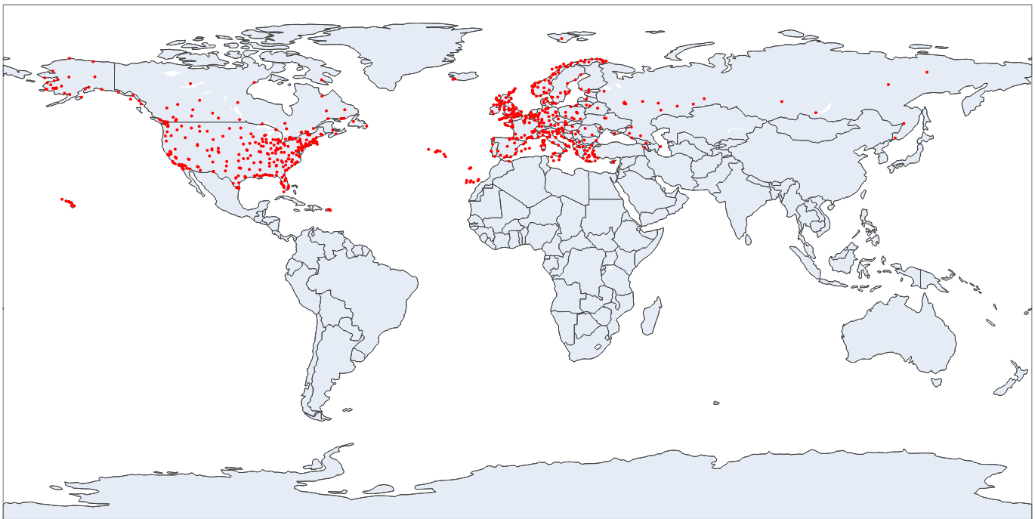
Just a world map with the airports I’m working with, in order to identify what is included in the European and American (more precisely North American) sub markets.

Appendix 2
data error maybe can be useful (so apt code a == apt code b) and also the flt dep and flt arr ?

