# Goal

To demonstrate how semantic technologies can be used to streamline data from EDAC to Lifemapper

# Semantic Infrastructure

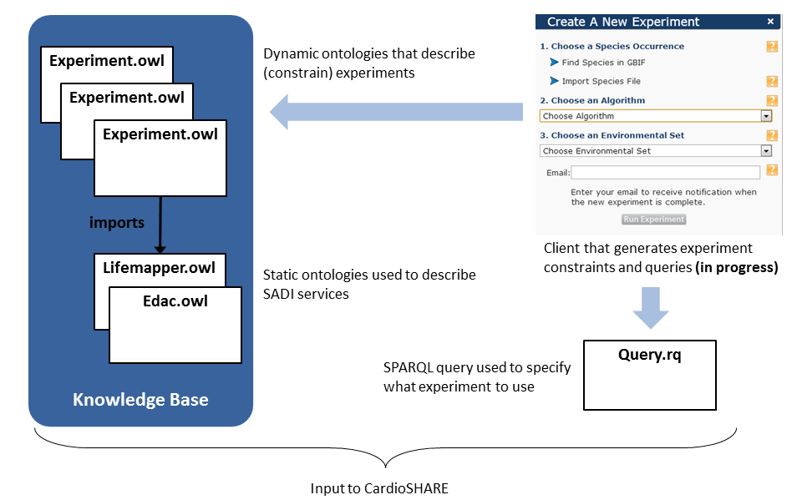

# Experiment.owl

An experiment in ELSeWeb is an ontology that specifies:

* Species occurrence set
* Lifemapper modeling algorithm to employ
* Environmental Scenario Layerset

In particular, the layerset is a stack of EDAC (or any) WCS coverage data. An experiment specifies the “relevant” data layers using OWL restrictions, for example data that:

* is sourced from MODIS or PRISM
* is of type Fractional Snow Cover or Minimum Temperature Normals
* has a certain spatial region (e.g., between -109 and -106 longitude)
* has a certain duration (e.g., between December 1981 and December 2010)

# Demo Experiments

## Experiment Example: MODIS **Data**

Experiment Description:

* **Location:** <https://raw.github.com/nicholasdelrio/ELSeWeb/master/documents/semantic-web/rdf/ontology/experiments/experiment-1-v3.owl>
* **Algorithm:** BIOCLIM
* **Occurrence Set ID:** 4024107
* **Scenario Layers:**
  + Layer1: (hasDuration some Duration1) and (hasSource value MODIS)
    - Duration1:
    - (hasEndDate value "06/18/2002"^^string)
    - and (hasStartDate value "06/18/2002"^^string)
  + Layer2: (hasRegion some Region2) and (hasSource value MODIS)
    - Region2:
    - (hasLeftLongitude some double[>= -108.0])
    - and (hasLowerLatitude some double[>= 34.0])
    - and (hasRightLongitude some double[<= -104.0])
    - and (hasUpperLatitude some double[<= 39.0])
  + Layer3: (hasDuration some Duration3) and (hasSource value MODIS)
    - Duration3:
    - (hasEndDate value "07/13/2002"^^string)
    - and (hasStartDate value "07/13/2002"^^string)
  + Layer4: (hasDuration some Duration4) and (hasSource value MODIS)
    - Duration3:
    - (hasEndDate value "07/29/2002"^^string)
    - and (hasStartDate value "07/29/2002"^^string)
  + Layer5: (hasDuration some Duration5) and (hasSource value PRISM)
    - Duration5:
    - (hasEndDate value "12/01/2010"^^string)
    - and (hasStartDate value "12/01/1981"^^string)
* **Initiation query:** <https://raw.github.com/nicholasdelrio/ELSeWeb/master/documents/semantic-web/sparql/query-experiment-1-v3.rq>

# Running an ELSeWeb Experiment

1. Login to Lifemapper to get session cookie (<http://lifemapper.org/login>)
2. Choose an experiment
3. Copy the initiation query
4. Paste the query into the ELSeWeb cardioSHARE instance (<http://iw.cs.utep.edu/cardioSHARE-elseweb-v3/>)
5. Click Run
6. On the results segment of the query execution, click on the “modelURL” link

# Viewing Provenance through Web-Probe

Due to the amount of automation (e.g., service discovery and invocation) in the ELSeWeb system, scientists may need to scrutinize Lifemapper model results though analyzing the associated provenance.

Web-Probe (<http://iw.cs.utep.edu/Web-Probe>) is a provenance visualization tool currently specialized for Proof Markup Provenance (PML2) (<http://inference-web.org/wiki/Main_Page>) but is rapidly being adapted to Prov (<http://www.w3.org/TR/prov-primer/>). The following procedure describes how to view an ELSeWeb PML2 provenance trace in Web-Probe.

1. Copy the URI of an ELSeWeb provenance trace (<http://iw.cs.utep.edu:8080/visko-web/output/visko-query-05320572892703112.owl#query>)
2. Navigate to Web-Probe(<http://iw.cs.utep.edu/Web-Probe>)
3. Paste the provenance URI in Web-Probe’s text field
4. Click “Lookup”
5. You will be presented with the SPARQL query that initiated the ELSeWeb service composition.
6. From there, you have access to the artifact that resulted from executing the service pipeline.
7. If you click on the artifact square below the query, you are presented with a tree of the provenance trace. This tree-view is known as the “Global View” because you see the trace in its entirety.