# Goal

To demonstrate how semantic technologies can be used to streamline data from EDAC to Lifemapper

# Semantic Infrastructure

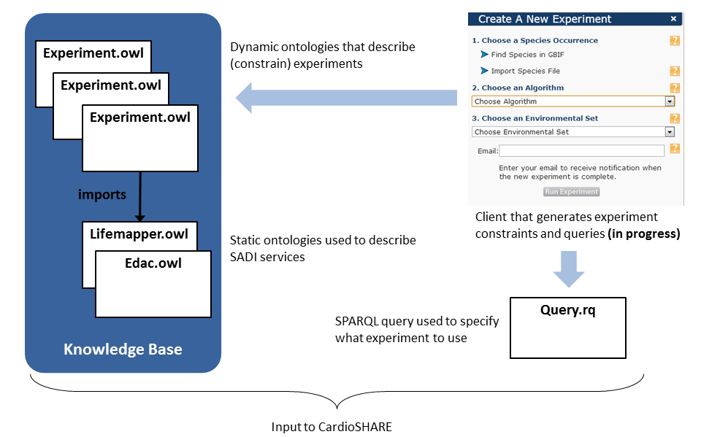

# Experiment.owl

An experiment in ELSeWeb is an ontology that specifies:

* Species occurrence set
* Lifemapper modeling algorithm to employ
* Environmental Scenario Layerset

In particular, the layerset is a stack of EDAC (or any) WCS coverage data. An experiment specifies the “relevant” data layers using OWL restrictions, for example data that:

* is sourced from MODIS or PRISM
* is of type Fractional Snow Cover or Minimum Temperature Normals
* has a certain spatial region (e.g., between -109 and -106 longitude)
* has a certain duration (e.g., between December 1981 and December 2010)

# Demo Experiments

## Experiment Example: MODIS **Data**

Experiment Description:

* **Location:** <https://raw.github.com/nicholasdelrio/ELSeWeb/master/documents/semantic-web/rdf/ontology/experiments/experiment-1.owl>
* **Algorithm:** BIOCLIM
* **Occurrence Set ID:** 4024107
* **Scenario Layers:** any data sourced from MODIS (e.g., hasSource value MODIS)
* **Initiation query:** <https://raw.github.com/nicholasdelrio/ELSeWeb/master/documents/semantic-web/sparql/query-experiment-1.rq>

## Experiment Example: PRISM Data

Experiment Description:

* **Location:** <https://raw.github.com/nicholasdelrio/ELSeWeb/master/documents/semantic-web/rdf/ontology/experiments/experiment-2.owl>
* **Algorithm:** BIOCLIM
* **Occurrence Set ID:** 4024107
* **Scenario Layers:** any data sourced from PRISM (e.g., hasSource value PRISM)
* **Initiation query:** <https://raw.github.com/nicholasdelrio/ELSeWeb/master/documents/semantic-web/sparql/query-experiment-2.rq>

## Experiment Example: MODIS Data within a given region

Experiment Description:

* **Location:** <https://raw.github.com/nicholasdelrio/ELSeWeb/master/documents/semantic-web/rdf/ontology/experiments/experiment-3.owl>
* **Algorithm:** BIOCLIM
* **Occurrence Set ID:** 4024107
* **Scenario Layers:** any data that is sourced from MODIS and falls within a certain region (e.g., (hasLeftLongitude some int[>= -108]) and (hasLowerLatitude some int[>= 34]) and (hasRightLongitude some int[<= -104]) and (hasUpperLatitude some int[<= 39])and (hasSource value MODIS)
* **Initiation query:** <https://raw.github.com/nicholasdelrio/ELSeWeb/master/documents/semantic-web/sparql/query-experiment-3.rq>

## Experiment Example: Minimum Temperature Normals

Experiment Description:

* **Location:** <https://raw.github.com/nicholasdelrio/ELSeWeb/master/documents/semantic-web/rdf/ontology/experiments/experiment-4.owl>
* **Algorithm:** BIOCLIM
* **Occurrence Set ID:** 4024107
* **Scenario Layers:** any data that is of type MinTemperatureNormals (e.g., equivalentClass MinTemperatureNormals)
* **Initiation query:** <https://raw.github.com/nicholasdelrio/ELSeWeb/master/documents/semantic-web/sparql/query-experiment-4.rq>

# Running an Experiment

1. Login to Lifemapper to get session cookie ([http://lifemapper.org/login](https://bluprd0512.outlook.com/owa/redir.aspx?C=fn17A768WUWUooblFwFk3rHeN-GI7c8IBqAWhedTLGnivXrTfnR9tccp9e0ev9xN9mTFVGkq3WY.&URL=http%3a%2f%2flifemapper.org%2flogin))
2. Choose an experiment
3. Copy the initiation query
4. Paste the query into the ELSeWeb cardioSHARE instance (<http://iw.cs.utep.edu/cardioSHARE/>)
5. Click Run
6. On the results segment of the query execution, click on the “modelURL” link

# Automated Composition

The path from EDAC data to Lifemapper is not direct and requires some intermediate transformations of EDAC data before it can be consumed by Lifemapper.

EDAC WCS data properties:

* WCS Data encoded as MIME Multipart Message
* XML Metadata + TIFF payload
* Binary data

Lifemapper scenario data requirements:

* TIFF data passed by reference or value

Implications:

* EDAC WCS data must be passed through a service that first extracts the WCS response TIFF payload
* Based on the Lifemapper service ingestion requirements (<https://raw.github.com/nicholasdelrio/ELSeWeb/master/documents/semantic-web/rdf/ontology/lifemapper-v2.owl>), cardioSHARE automatically injects a payload extractor service between the EDAC data provider services and Lifemapper