PROGRAMMING IN JAVA
ASSIGNMENT 5 – CO5
DATA PERSISTENCE ENGINEERING – FILES AND DATABASES
Student Name | J. Roopa Sai Divya
Register Number | 192524140
Course | Programming in Java
Course Outcome | CO5 – Java I/O and JDBC
Total Marks | 50
GitHub Repository | https://github.com/roopajallu814-arch/CSA09-192524140_Roopa-JAVA

INTRODUCTION
Data persistence is the process of storing information so that it remains available even after a program terminates. Java provides several ways to store data, including text files, binary files, buffered streams, object serialization and relational databases using JDBC.
This assignment explains how to select suitable storage methods, protect data, improve performance and manage large amounts of information efficiently.
Test environment for the outputs: All programs were compiled and run with OpenJDK 21. The database programs used a local MariaDB 10.11 server with the MariaDB Connector/J 2.7.6 driver and the same jdbc:mysql://localhost:3306/… URLs given in the assignment. The console screenshots show the real output captured from those runs. The timings were measured on that machine, so they will differ on another computer.
Task | Title | Marks
A1 | Design a File Format | 7 (K4)
A2 | Don't Read What You Don't Need | 5 (K4)
A3 | Discover the Data-Access Design Pattern | 5 (K4)
A4 | What Should Be Serialized? | 4 (K4)
A5 | Design for Correctness and Safety | 4 (K4)
B1 | Implement and Instrument the File Store | 7 (K4)
B2 | Engineer an Adversarial Input | 5 (K4)
B3 | Statement vs PreparedStatement vs Batch | 8 (K4)
B4 | Final Engineering Decision | 5 (K5)

PART A – PERSISTENCE DESIGN AND PSEUDOCODE

TASK A1 – DESIGN A FILE FORMAT
7 Marks | K4 – Analyse
Title: Transport Office Bus-Pass Records

A1.1 – Represent the Record
The transport office stores bus-pass information such as pass ID, student register number, student name, route number, boarding stop, validity date and amount paid.

(a) Delimited Text File Format
Each record is stored as one line. The fields are separated using a comma delimiter.
Field order:
Field | Data type | Example
Pass ID | String | P1001
Register Number | String | 192524140
Student Name | String | Roopa Sai Divya
Route Number | Integer | 12
Boarding Stop | String | Main Gate
Validity Date | Date | 2027-03-31
Amount Paid | Double | 4500.00

Example text record:
P1001,192524140,Roopa Sai Divya,12,Main Gate,2027-03-31,4500.00

Handling names containing delimiters:
If a student's name contains a comma, the value should be enclosed in double quotes, for example:
P1002,192524141,"Sai, Kumar",7,Bus Stop,2027-03-31,3800.00

A proper CSV parser should be used to handle quoted delimiters and escaped quotation marks. Simple split(",") is not sufficient for general CSV data.

(b) Binary File Format Using DataOutputStream
The binary file stores the fields in a fixed sequence using DataOutputStream.
Order | Field | Method
1 | Pass ID | writeUTF()
2 | Register Number | writeUTF()
3 | Student Name | writeUTF()
4 | Route Number | writeInt()
5 | Boarding Stop | writeUTF()
6 | Validity Date | writeUTF()
7 | Amount Paid | writeDouble()

Java Program – BinaryPass.java
import java.io.*;

public class BinaryPass {

public static void main(String[] args) {

try (DataOutputStream out =
new DataOutputStream(
new FileOutputStream("passes.dat"))) {

out.writeUTF("P1001");
out.writeUTF("192524140");
out.writeUTF("Roopa Sai Divya");
out.writeInt(12);
out.writeUTF("Main Gate");
out.writeUTF("2027-03-31");
out.writeDouble(4500.00);

System.out.println("Pass record saved");

} catch (IOException e) {
System.out.println(e.getMessage());
}
}
}

Java Program – ReadBinaryPass.java (reads the record back to verify the file)
import java.io.*;

public class ReadBinaryPass {

public static void main(String[] args) {

try (DataInputStream in =
new DataInputStream(
new FileInputStream("passes.dat"))) {

System.out.println("Pass ID : " + in.readUTF());
System.out.println("Register No : " + in.readUTF());
System.out.println("Student Name : " + in.readUTF());
System.out.println("Route Number : " + in.readInt());
System.out.println("Boarding Stop : " + in.readUTF());
System.out.println("Validity Date : " + in.readUTF());
System.out.println("Amount Paid : " + in.readDouble());

} catch (IOException e) {
System.out.println(e.getMessage());
}
}
}

Output:
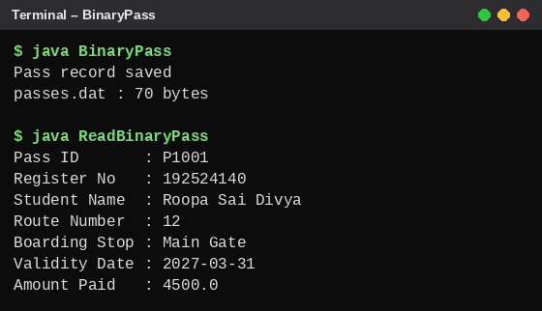
Figure A1.1 – Binary record written and read back
Result: The bus-pass record is stored in binary format using DataOutputStream and is read back correctly in the same field order.

A1.2 – Design the Operations

1. Add a New Pass
ALGORITHM AddPass
BEGIN
OPEN the pass file in append mode
READ pass ID, register number, name,
route number, boarding stop,
validity date and amount

VALIDATE all input fields

IF the data is valid THEN
FORMAT the fields as one delimited record
WRITE the record to the file
WRITE a new line
DISPLAY "Pass added successfully"
ELSE
DISPLAY "Invalid pass details"
END IF

CLOSE the file
END

2. Find a Pass by Pass ID
ALGORITHM FindPass(passID)
BEGIN
IF the pass file does not exist THEN
DISPLAY "File not found"
RETURN
END IF

OPEN the file using BufferedReader

WHILE a line can be read
PARSE the line into fields

IF the record is damaged THEN
SKIP the record
ELSE IF the first field equals passID THEN
DISPLAY the pass details
CLOSE the file
RETURN
END IF
END WHILE

DISPLAY "Pass not found"
CLOSE the file
END

3. List All Passes on a Given Route
ALGORITHM ListByRoute(routeNumber)
BEGIN
OPEN the file using BufferedReader
SET found = FALSE

WHILE a line can be read
PARSE the line into fields

IF the record contains the correct number of fields THEN
IF the route number matches routeNumber THEN
DISPLAY the pass details
SET found = TRUE
END IF
END IF
END WHILE

IF found = FALSE THEN
DISPLAY "No passes found for this route"
END IF

CLOSE the file
END

Stream classes used and their purpose:
Stream class | Purpose
FileReader | Reads character data from a text file
FileWriter | Writes character data to a text file
BufferedReader | Reads text efficiently, line by line
BufferedWriter | Writes text efficiently using a buffer
FileInputStream | Reads raw binary data
FileOutputStream | Writes raw binary data

Explanation: BufferedReader and BufferedWriter are suitable for delimited text records because they support efficient line-based reading and writing. FileInputStream and FileOutputStream are suitable for binary data.

A1.3 – Design for Damaged Data

1. Damaged Line
- Check whether each line contains the expected seven fields.
- Validate numeric values such as route number and amount.
- Skip damaged records and continue reading the file.
- Record the damaged line number for later correction.

2. Missing File
- Check whether the file exists before reading.
- If it does not exist, display a clear error message.
- For a new file, create it when adding the first pass.

3. Incomplete Write Due to Power Failure
- Write new records to a temporary file first when replacing the complete file.
- Flush and close the file before replacing the original.
- Use an atomic file move where the file system supports it.
- For stronger durability, force file data to storage using FileChannel.force(true).
- For append-only records, use checksums or record validation to detect incomplete final records.

Alternative Concept and Complexity Analysis
If RandomAccessFile with fixed-length records is used, each record occupies the same number of bytes.
RandomAccessFile file =
new RandomAccessFile("passes.dat", "rw");

long recordSize = 200;

file.seek(5 * recordSize);

For record index 5, the program directly moves to its location using seek().
Feature | Delimited text file | Fixed-length RandomAccessFile
Find by ID | O(n) scan | O(1) seek only when record index is known
Add a record | O(1) append | O(1) append
List by route | O(n) scan | O(n) scan without an index
Storage | Variable length | Fixed length
Space usage | Less padding | May waste space due to padding

Important: Finding a pass by ID is not automatically O(1) just because RandomAccessFile is used. If the ID is not mapped to a record index, the program still needs an O(n) search. A separate index or hash map is required for direct ID lookup.
Conclusion: A delimited text file is simple to read and maintain. A fixed-length random-access file is useful when records have known positions and direct record access is required.

TASK A2 – DON'T READ WHAT YOU DON'T NEED
5 Marks | K4 – Analyse

A2.1 – Predict the Cost
A program reads a 50 MB attendance file one byte at a time using FileInputStream.read().
Calculation:
50 MB = 50 x 1024 x 1024
= 52,428,800 bytes

Therefore, the program performs approximately 52,428,800 read calls when it reads one byte per call, followed by one final call that detects end-of-file.
Reasons for slow execution:
- Each call to read() involves method-call overhead.
- Repeated small reads are inefficient.
- The program performs millions of operations.
- Buffering reduces the number of underlying read operations.

A2.2 – Redesign Using Buffering
Aim: To count the number of lines in a file using a buffered input stream.
Java Program – BufferedLineCounter.java
import java.io.*;

public class BufferedLineCounter {

public static void main(String[] args) {

long lines = 0;

try (BufferedInputStream in =
new BufferedInputStream(
new FileInputStream("attendance.txt"))) {

int data;

while ((data = in.read()) != -1) {

if (data == '\n') {
lines++;
}
}

System.out.println("Number of lines: " + lines);

} catch (IOException e) {
System.out.println("Error: " + e.getMessage());
}
}
}

Explanation:
- FileInputStream reads bytes from the file.
- BufferedInputStream stores a block of bytes in memory.
- The program processes the buffered data.
- The number of underlying file-read operations is reduced.
For a 50 MB file and an illustrative 8 KB buffer:
52,428,800 / 8,192 = 6,400

Approximately 6,400 buffer fills are needed, instead of over 52 million one-byte read calls. Actual operating-system calls may differ because of the Java runtime and operating-system caching.

A2.3 – When Buffering Does Not Help
Buffering may give little benefit when the program reads a very small file only once or when the input source already provides buffered data.
It may also provide limited benefit when processing is dominated by another operation, such as a slow network request.

Alternative Concept and Complexity Analysis
If Files.readAllLines() is used, the complete file is loaded into memory as a list of strings.
Java Program – ReadAllLinesDemo.java
import java.nio.file.*;
import java.io.IOException;
import java.util.List;

public class ReadAllLinesDemo {

public static void main(String[] args) throws IOException {

List<String> lines =
Files.readAllLines(Path.of("attendance.txt"));

System.out.println("Number of lines: " + lines.size());
}
}

Output (both programs run on a 10,000-line attendance.txt):
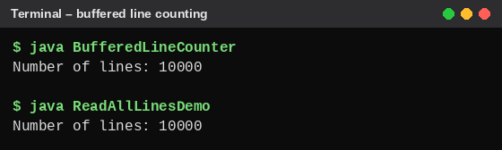
Figure A2.1 – Line count using BufferedInputStream and Files.readAllLines()
Approach | Time complexity | Extra memory
Buffered stream | O(n) | O(b), where b is buffer size
Files.readAllLines() | O(n) | O(n), where n is file size

Comparison for a 50 MB file:
- Buffered reading processes the file in small blocks and uses less memory.
- Files.readAllLines() loads all lines into memory, which can require significantly more than 50 MB because of string and list-object overhead.
Conclusion: Buffered streams are suitable for large files because they reduce memory usage. Files.readAllLines() is suitable for small files when the entire content needs to be accessed at once.

TASK A3 – DISCOVER THE DATA-ACCESS DESIGN PATTERN
5 Marks | K4 – Analyse

A3.1 – Identify the Common Pattern
The three classes StudentDB, CourseDB and MarksDB perform similar database operations.
Common steps:
- Open a database connection.
- Create an SQL query.
- Execute the query.
- Read the ResultSet.
- Convert database rows into Java objects.
- Close the connection and resources.
Parts that differ:
- Table names.
- Column names.
- SQL queries.
- Java object types.
- Primary-key fields.
- Data conversion logic.
Problem: Repeating the same database code in different classes increases code duplication and makes maintenance difficult.

A3.2 – Design a Generic Data-Access Interface
A Data Access Object (DAO) separates database operations from business logic.
Generic DAO Interface – Dao.java
import java.util.List;

public interface Dao<T, K> {

void insert(T obj);

T findById(K id);

List<T> findAll();

void update(T obj);

void delete(K id);
}

Student Class – Student.java
public class Student {

private int id;
private String name;
private String department;

public Student(int id, String name, String department) {
this.id = id;
this.name = name;
this.department = department;
}

public int getId() {
return id;
}

public String getName() {
return name;
}

public String getDepartment() {
return department;
}
}

Student DAO – StudentDao.java
import java.sql.*;
import java.util.*;

public class StudentDao implements Dao<Student, Integer> {

private Connection con;

public StudentDao(Connection con) {
this.con = con;
}

public void insert(Student s) {

String sql =
"INSERT INTO student(id, name, department) VALUES (?, ?, ?)";

try (PreparedStatement ps = con.prepareStatement(sql)) {

ps.setInt(1, s.getId());
ps.setString(2, s.getName());
ps.setString(3, s.getDepartment());

ps.executeUpdate();

} catch (SQLException e) {
e.printStackTrace();
}
}

public Student findById(Integer id) {

String sql = "SELECT * FROM student WHERE id = ?";

try (PreparedStatement ps = con.prepareStatement(sql)) {

ps.setInt(1, id);

try (ResultSet rs = ps.executeQuery()) {

if (rs.next()) {
return new Student(
rs.getInt("id"),
rs.getString("name"),
rs.getString("department")
);
}
}

} catch (SQLException e) {
e.printStackTrace();
}

return null;
}

public List<Student> findAll() {

List<Student> list = new ArrayList<>();

String sql = "SELECT * FROM student";

try (Statement st = con.createStatement();
ResultSet rs = st.executeQuery(sql)) {

while (rs.next()) {

list.add(new Student(
rs.getInt("id"),
rs.getString("name"),
rs.getString("department")
));
}

} catch (SQLException e) {
e.printStackTrace();
}

return list;
}

public void update(Student s) {

String sql =
"UPDATE student SET name=?, department=? WHERE id=?";

try (PreparedStatement ps = con.prepareStatement(sql)) {

ps.setString(1, s.getName());
ps.setString(2, s.getDepartment());
ps.setInt(3, s.getId());

ps.executeUpdate();

} catch (SQLException e) {
e.printStackTrace();
}
}

public void delete(Integer id) {

String sql = "DELETE FROM student WHERE id=?";

try (PreparedStatement ps = con.prepareStatement(sql)) {

ps.setInt(1, id);
ps.executeUpdate();

} catch (SQLException e) {
e.printStackTrace();
}
}
}

For a complete application, database exceptions should normally be propagated to the service layer instead of only printing stack traces. This example demonstrates the DAO interface and its implementation.
Test Program – StudentDaoDemo.java
import java.sql.*;
import java.util.*;

public class StudentDaoDemo {

static void show(String title, List<Student> list) {
System.out.println(title);
for (Student s : list) {
System.out.println(" " + s.getId() + " | "
+ s.getName() + " | " + s.getDepartment());
}
}

public static void main(String[] args) throws Exception {

try (Connection con = DriverManager.getConnection(
"jdbc:mysql://localhost:3306/college",
"root", "your_password")) {

con.createStatement().executeUpdate("DELETE FROM student");

Dao<Student, Integer> dao = new StudentDao(con);

dao.insert(new Student(101, "Ravi", "CSE"));
dao.insert(new Student(102, "Priya", "ECE"));
dao.insert(new Student(103, "Roopa", "AIDS"));

show("After insert (findAll):", dao.findAll());

Student s = dao.findById(102);
System.out.println("findById(102): " + s.getName()
+ ", " + s.getDepartment());

dao.update(new Student(102, "Priya Sharma", "IT"));
Student u = dao.findById(102);
System.out.println("After update : " + u.getName()
+ ", " + u.getDepartment());

dao.delete(101);
show("After delete(101):", dao.findAll());

System.out.println("findById(999): " + dao.findById(999));
}
}
}

Output:
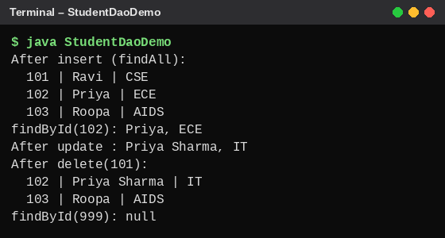
Figure A3.1 – Insert, find, update, delete and findAll through the DAO

A3.3 – Map Objects to Tables
Student Java object and database table:
Java field | Database column | Data type | Key
id | id | INT | Primary Key
name | name | VARCHAR(100) | —
department | department | VARCHAR(50) | —

SQL table:
CREATE TABLE student (
id INT PRIMARY KEY,
name VARCHAR(100),
department VARCHAR(50)
);

Explanation: Each Java object represents one row in the database table. Java fields are mapped to corresponding table columns. The id field uniquely identifies each student and acts as the primary key.

Alternative Concept and Complexity Analysis
If SQL statements were written directly inside service or GUI classes, database logic would be spread throughout the application.
Feature | Generic DAO | SQL in GUI/service classes
SQL location | Centralised in DAO classes | Spread across classes
Maintenance | Easier | More difficult
Code reuse | High | Low
Testing | Easier to test separately | GUI and database logic are mixed
Column rename | Usually changes are concentrated in DAO/mapping code | Every affected query may need changes

Time complexity: Both approaches have approximately the same database-operation complexity. For example, finding a student by a primary key with an index is typically O(log n) in a B-tree index, depending on the database implementation.
Space complexity: Both approaches use approximately O(1) extra application space for a single-row operation, excluding the returned object and database-driver buffers. A findAll() operation uses O(n) space if all n objects are loaded into a list.
Conclusion: The DAO pattern improves maintainability, separation of concerns and code reuse without changing the fundamental database-operation complexity.

TASK A4 – WHAT SHOULD BE SERIALIZED?
4 Marks | K4 – Analyse

A4.1 – Decide What to Persist
The Hostel object contains a list of Room objects. Each Room contains a list of Resident objects. The object graph is:
Hostel
|
|-- List of Rooms
|
|-- Room 1
| |-- Resident 1
| |-- Resident 2
|
|-- Room 2
|-- Resident 3

When the Hostel object is serialized, Java serializes the reachable objects in the object graph, provided that every non-transient object referenced in the graph is serializable.
Fields that should be transient:
Field | Transient? | Reason
Hostel room list | No | Required to restore hostel data
Resident name | No | Required student information
Register number | No | Identifies the resident
Password | Yes, preferably do not serialize it | Sensitive authentication information
Database Connection | Yes | Live connections cannot be meaningfully restored from a serialized file

Java Program – HostelDemo.java (Resident, Room, Hostel and a test main)
import java.io.*;
import java.util.*;

class Resident implements Serializable {

private static final long serialVersionUID = 1L;

String name;
String registerNo;

transient String password;
transient ConnectionPlaceholder connection;

Resident(String name, String registerNo, String password) {
this.name = name;
this.registerNo = registerNo;
this.password = password;
this.connection = new ConnectionPlaceholder();
}
}

class ConnectionPlaceholder {
// Represents a live external resource.
}

class Room implements Serializable {

private static final long serialVersionUID = 1L;

int number;
List<Resident> residents = new ArrayList<>();

Room(int number) {
this.number = number;
}
}

class Hostel implements Serializable {

private static final long serialVersionUID = 1L;

String name;
List<Room> rooms = new ArrayList<>();

Hostel(String name) {
this.name = name;
}
}

public class HostelDemo {

public static void main(String[] args) throws Exception {

Hostel = new Hostel("Boys Hostel A");

Room r1 = new Room(1);
r1.residents.add(new Resident("Arun", "192311001", "secret1"));
r1.residents.add(new Resident("Ravi", "192311002", "secret2"));

Room r2 = new Room(2);
r2.residents.add(new Resident("Meena", "192311003", "secret3"));

hostel.rooms.add(r1);
hostel.rooms.add(r2);

try (ObjectOutputStream out = new ObjectOutputStream(
new FileOutputStream("hostel.ser"))) {
out.writeObject(hostel);
}

System.out.println("Hostel serialized to hostel.ser");

try (ObjectInputStream in = new ObjectInputStream(
new FileInputStream("hostel.ser"))) {

Hostel h = (Hostel) in.readObject();

System.out.println("Hostel name: " + h.name);

for (Room : h.rooms) {
System.out.println("Room " + room.number);

for (Resident r : room.residents) {
System.out.println(" " + r.name + " | "
+ r.registerNo
+ " | password=" + r.password
+ " | connection=" + r.connection);
}
}
}
}
}

The password should be managed through a secure authentication system, preferably stored as a salted password hash in a database rather than stored in plain text.
Note: The example uses ConnectionPlaceholder only to demonstrate the transient field concept. In a real application, use transient java.sql.Connection connection;.
Output:
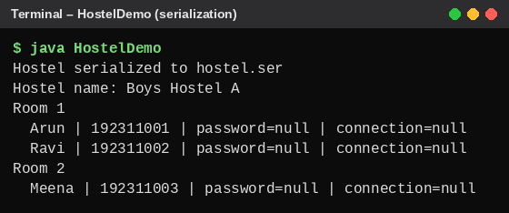
Figure A4.1 – After deserialization the transient password and connection are null

A4.2 – Plan for Change
When a new phone-number field is added to the Resident class, older serialized files may still be readable if the class maintains a compatible serialVersionUID.
private static final long serialVersionUID = 1L;

String phoneNumber;

When an old serialized object is read:
- The new field does not exist in the old file.
- Java assigns the default value to the new field.
- For a String, the default value is null.
- The program can assign a suitable default value after deserialization.
Purpose of serialVersionUID:
- It identifies the version of a serializable class.
- If the sender and receiver have incompatible serial version IDs, Java may throw InvalidClassException.
- Keeping the same ID allows some compatible class changes, but it does not guarantee that every structural change is safe.

Alternative Concept and Complexity Analysis
If CSV or JSON is used instead of Java serialization:
Feature | Java Serialization | CSV/JSON
Format | Binary object format | Text format
File size | Often compact, but includes serialization metadata | Depends on text and field names
Save time | O(n) | O(n)
Load time | O(n) | O(n), including parsing
Readability | Not human-readable | Human-readable
New field | Requires class-version compatibility | Can often handle missing fields with defaults
Language support | Mainly Java-specific | Supported by many languages

Here, n represents the number of residents.
Conclusion: Java serialization is convenient for restoring Java object graphs. JSON is more suitable for long-term data exchange and compatibility with other programming languages.

TASK A5 – DESIGN FOR CORRECTNESS AND SAFETY
4 Marks | K4 – Analyse

A5.1 – Transaction Design
Problem: A student transfers ₹500 from a hostel wallet to a canteen wallet. Both updates must succeed together.
ALGORITHM TransferMoney
BEGIN
CONNECT to database

DISABLE auto-commit

TRY
READ hostel wallet balance

IF hostel balance is less than 500 THEN
DISPLAY "Insufficient balance"
ROLLBACK transaction
RETURN
END IF

SUBTRACT 500 from hostel wallet

ADD 500 to canteen wallet

COMMIT transaction

DISPLAY "Transfer successful"

CATCH database error
ROLLBACK transaction
DISPLAY "Transfer failed"

FINALLY
CLOSE database connection
END

Explanation:
- setAutoCommit(false) starts a transaction controlled by the application.
- The first update subtracts ₹500 from the hostel wallet.
- The second update adds ₹500 to the canteen wallet.
- commit() permanently saves both updates.
- rollback() cancels both updates if an error occurs.
Java Program – WalletTransfer.java
import java.sql.*;

public class WalletTransfer {

public static void main(String[] args) {

String debit =
"UPDATE wallet SET balance = balance - 500 WHERE id = 1";

String credit =
"UPDATE wallet SET balance = balance + 500 WHERE id = 2";

try (Connection con =
DriverManager.getConnection(
"jdbc:mysql://localhost:3306/college",
"root",
"your_password")) {

con.setAutoCommit(false);

try (Statement st = con.createStatement()) {

st.executeUpdate(debit);
st.executeUpdate(credit);

con.commit();

System.out.println("Transfer successful");

} catch (SQLException e) {

con.rollback();

System.out.println("Transfer failed");
}

} catch (SQLException e) {
System.out.println(e.getMessage());
}
}
}

Java Program – WalletTransferFail.java (the second update deliberately contains a wrong column name)
import java.sql.*;

public class WalletTransferFail {

public static void main(String[] args) {

String debit =
"UPDATE wallet SET balance = balance - 500 WHERE id = 1";

// Deliberate error: wrong column name in the second update
String credit =
"UPDATE wallet SET balanse = balance + 500 WHERE id = 2";

try (Connection con =
DriverManager.getConnection(
"jdbc:mysql://localhost:3306/college",
"root",
"your_password")) {

con.setAutoCommit(false);

try (Statement st = con.createStatement()) {

st.executeUpdate(debit);
st.executeUpdate(credit);

con.commit();

System.out.println("Transfer successful");

} catch (SQLException e) {

con.rollback();

System.out.println("Transfer failed - rolled back");
}

} catch (SQLException e) {
System.out.println(e.getMessage());
}
}
}

Output:
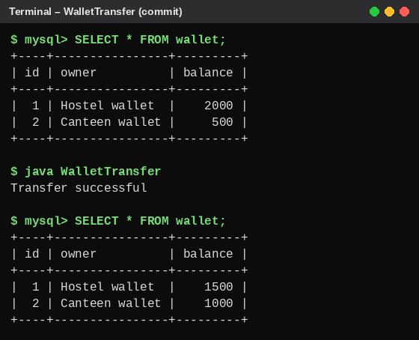
Figure A5.1 – Successful transfer: balances change from 2000/500 to 1500/1000
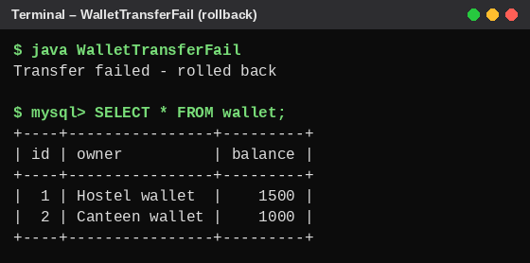
Figure A5.2 – Failed transfer: rollback leaves the balances unchanged

A5.2 – Injection Analysis
Unsafe SQL query:
String sql =
"SELECT * FROM users WHERE id='" + id +
"' AND pwd='" + pwd + "'";

Problem: The query directly joins user input into SQL. A crafted input can change the meaning of the query.
For example, a test-only username and password input could be:
ID: ' OR '1'='1' --
Password: anything

The resulting SQL can be manipulated so that the password condition is bypassed, depending on the database's SQL comment syntax and query construction.
Safe redesign using PreparedStatement – SafeLogin.java
import java.sql.*;

public class SafeLogin {

public static void main(String[] args) {

String sql =
"SELECT * FROM users WHERE id = ? AND pwd = ?";

try (Connection con =
DriverManager.getConnection(
"jdbc:mysql://localhost:3306/college",
"root",
"your_password");

PreparedStatement ps = con.prepareStatement(sql)) {

ps.setString(1, "' OR '1'='1' --");
ps.setString(2, "anything");

try (ResultSet rs = ps.executeQuery()) {

if (rs.next()) {
System.out.println("Login successful");
} else {
System.out.println("Invalid login");
}
}

} catch (SQLException e) {
System.out.println(e.getMessage());
}
}
}

Output:
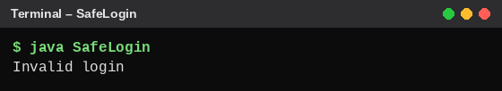
Figure A5.3 – The crafted input is rejected: "Invalid login"
Explanation: PreparedStatement treats user inputs as parameter values rather than SQL commands. Therefore, the crafted input is treated as ordinary text and does not change the query structure.
In a real application, passwords should be stored as salted password hashes and verified using a suitable password-hashing library, not compared as plain text.

Alternative Concept and Complexity Analysis
If the two wallet updates use separate auto-commit statements, the first update may succeed while the second fails. For example, the hostel wallet decreases by ₹500, the program crashes before updating the canteen wallet, and the money is lost from the application's account records.
Feature | Single transaction | Two independent updates
Correctness | Both updates succeed or fail together | Partial updates are possible
Failure handling | Rollback restores the original state | Manual recovery may be required
Time | Includes transaction-management overhead | May have lower transaction overhead
Safety | High | Lower

Both designs execute two update statements, so their basic database work is similar. A transaction adds coordination, logging and commit/rollback overhead, but protects data consistency.
Conclusion: A single database transaction is the correct choice because it ensures that money is neither lost nor created if one update fails.

PART B – IMPLEMENTATION AND EXPERIMENTAL INVESTIGATION

TASK B1 – IMPLEMENT AND INSTRUMENT THE FILE STORE
7 Marks | K4 – Analyse

B1.1 – Validate the Implementation
Aim: To implement a bus-pass file store that supports adding, finding and listing bus-pass records, while skipping damaged records.
Java Program – PassStore.java
import java.io.*;
import java.nio.file.*;
import java.util.*;

public class PassStore {

private final Path file;

PassStore(Path file) {
this.file = file;
}

public void add(
String passId,
String regNo,
String name,
int route,
double amount) throws IOException {

try (BufferedWriter w =
Files.newBufferedWriter(
file,
StandardOpenOption.CREATE,
StandardOpenOption.APPEND)) {

w.write(String.join(",",
passId,
regNo,
name,
String.valueOf(route),
String.valueOf(amount)
));

w.newLine();
}
}

public String[] find(String passId) throws IOException {

try (BufferedReader br =
Files.newBufferedReader(file)) {

String line;

while ((line = br.readLine()) != null) {

String[] fields = line.split(",", -1);

if (fields.length != 5) {
continue;
}

try {
Integer.parseInt(fields[3]);
Double.parseDouble(fields[4]);
} catch (NumberFormatException e) {
continue;
}

if (fields[0].equals(passId)) {
return fields;
}
}
}

return null;
}

public void listByRoute(int route) throws IOException {

try (BufferedReader br =
Files.newBufferedReader(file)) {

String line;
boolean found = false;

while ((line = br.readLine()) != null) {

String[] fields = line.split(",", -1);

if (fields.length != 5) {
continue;
}

try {
int recordRoute =
Integer.parseInt(fields[3]);

Double.parseDouble(fields[4]);

if (recordRoute == route) {
System.out.println(
Arrays.toString(fields)
);

found = true;
}

} catch (NumberFormatException e) {
continue;
}
}

if (!found) {
System.out.println("No passes found");
}
}
}

public static void main(String[] args) throws IOException {

Path f = Files.createTempFile("passes", ".csv");

PassStore store = new PassStore(f);

store.add("P1001", "192311001", "Arun", 12, 4500);

Files.writeString(
f,
"P1002,DAMAGED LINE\n",
StandardOpenOption.APPEND
);

store.add("P1003", "192311003", "Divya", 7, 3800);

System.out.println(
Arrays.toString(store.find("P1003"))
);

System.out.println(
Arrays.toString(store.find("P1002"))
);

System.out.println("Passes on route 7:");

store.listByRoute(7);

Files.delete(f);
}
}

Output:
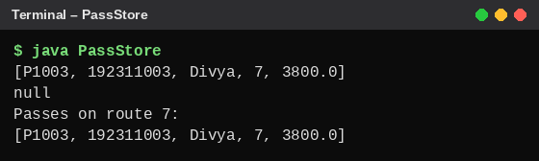
Figure B1.1 – PassStore output (the damaged P1002 line is skipped)
Explanation of TODO 1:
- BufferedReader reads the file line by line.
- split(",", -1) separates the fields and preserves empty fields.
- fields.length != 5 identifies records with an incorrect number of fields.
- Invalid numeric values are skipped.
- If the pass ID matches, the record is returned.
- If no matching record exists, the method returns null.
Why does the damaged line for P1002 not stop the search?
The damaged line contains only two fields instead of five. The condition fields.length != 5 identifies it as an invalid record. The continue statement skips that line and moves to the next record. Therefore, the search continues and can find P1003.

B1.2 – Compare with Your Design
Part A design | Implementation
Read the file line by line | Uses BufferedReader
Separate fields | Uses split(",", -1)
Check damaged records | Checks field count and numeric values
Search by pass ID | Uses equals()
Handle missing pass | Returns null
Close the file | Uses try-with-resources

Explanation: The implementation follows the Part A design. Additional numeric validation was included to detect damaged route and amount fields.

B1.3 – Measure the Effect of Buffering
Aim: To compare the time required to count lines using unbuffered and buffered input streams.
Java Program – BufferBenchmark.java
import java.io.*;
import java.nio.file.*;

public class BufferBenchmark {

static long countUnbuffered(String file)
throws IOException {

long lines = 0;

try (FileInputStream in =
new FileInputStream(file)) {

int ch;

while ((ch = in.read()) != -1) {
if (ch == '\n') {
lines++;
}
}
}

return lines;
}

static long countBuffered(String file)
throws IOException {

long lines = 0;

try (BufferedInputStream in =
new BufferedInputStream(
new FileInputStream(file))) {

int ch;

while ((ch = in.read()) != -1) {
if (ch == '\n') {
lines++;
}
}
}

return lines;
}

public static void main(String[] args)
throws IOException {

String file = "attendance.txt";

long start = System.nanoTime();
long a = countUnbuffered(file);
long end = System.nanoTime();

double unbufferedTime =
(end - start) / 1_000_000.0;

start = System.nanoTime();
long b = countBuffered(file);
end = System.nanoTime();

double bufferedTime =
(end - start) / 1_000_000.0;

System.out.println("Unbuffered lines: " + a);
System.out.println("Buffered lines: " + b);

System.out.println(
"Unbuffered time: " + unbufferedTime + " ms"
);

System.out.println(
"Buffered time: " + bufferedTime + " ms"
);
}
}

Output:
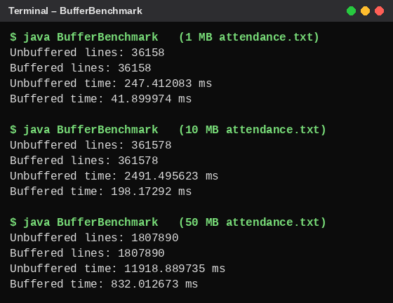
Figure B1.2 – Benchmark results for 1 MB, 10 MB and 50 MB files
Measurement table (measured values):
File size | Unbuffered time (ms) | Buffered time (ms)
1 MB | 247.4 | 41.9
10 MB | 2,491.5 | 198.2
50 MB | 11,918.9 | 832.0

Interpretation: Buffered input was faster for every file size: about 6 times faster for 1 MB, 13 times for 10 MB and 14 times for 50 MB. The unbuffered time grows almost in proportion to the file size because every byte needs its own read() call. Actual results depend on the computer, Java version, file system and cache state.

B1.4 – Measure Growth
The time required to find a pass is measured as the number of records increases. The worst case was used: the pass being searched is the last record in the file.
Java Program – SearchGrowth.java
import java.io.*;
import java.nio.file.*;

public class SearchGrowth {

public static void main(String[] args) throws IOException {

int[] sizes = {1000, 10000, 50000, 100000};

System.out.println("Records | Search time (ms)");
System.out.println("----------+-----------------");

for (int n : sizes) {

Path f = Files.createTempFile("growth", ".csv");

try (BufferedWriter w = Files.newBufferedWriter(f)) {
for (int i = 1; i <= n; i++) {
w.write("P" + i + ",19231" + i
+ ",Student" + i + ",12,4500.0");
w.newLine();
}
}

PassStore store = new PassStore(f);

// Worst case: search for the last record
String last = "P" + n;

for (int w = 0; w < 5; w++) {
store.find(last); // warm-up runs
}

long start = System.nanoTime();
for (int r = 0; r < 20; r++) {
store.find(last);
}
double ms = (System.nanoTime() - start) / 20 / 1_000_000.0;

System.out.printf("%-9d | %.3f%n", n, ms);

Files.delete(f);
}
}
}

Output:
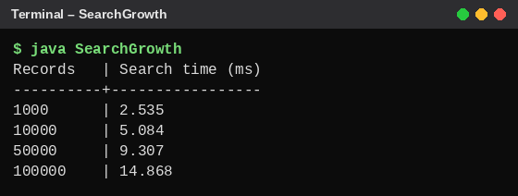
Figure B1.3 – Search time for 1,000 to 100,000 records
Number of records | Search time (ms)
1,000 | 2.5
10,000 | 5.1
50,000 | 9.3
100,000 | 14.9

Interpretation: The file-search method scans records sequentially. Therefore, the time required to search increases as the number of records increases. Each value is the average of 20 searches after 5 warm-up searches. The growth is not perfectly linear at small sizes because fixed costs such as opening the file and JVM optimisation are a large part of a short search.

Alternative Concept and Complexity Analysis
If the file is loaded into a HashMap<String, String[]>, records can be searched using their pass IDs.
HashMap<String, String[]> passMap = new HashMap<>();

passMap.put("P1001",
new String[]{"P1001", "192311001", "Arun", "12", "4500"});

String[] result = passMap.get("P1001");

Approach | Time for q searches on n records | Extra memory
Sequential file search | O(q × n) worst case | O(1) search memory
HashMap after loading | O(n + q) expected | O(n)

Conclusion: Sequential search is suitable for small files. A HashMap is more suitable when the same records are searched repeatedly because it provides expected O(1) lookup after the initial O(n) loading.

TASK B2 – ENGINEER AN ADVERSARIAL INPUT
5 Marks | K4 – Analyse

B2.1 – Unsafe Login and Safe Login
Aim: To demonstrate how SQL injection can bypass an unsafe login query and how PreparedStatement prevents the query structure from being changed by user input.
Test database:
CREATE DATABASE security_test;

USE security_test;

CREATE TABLE users (
id VARCHAR(50),
pwd VARCHAR(100)
);

INSERT INTO users VALUES
('roopa', 'java123'),
('divya', 'pass123');

Unsafe login – UnsafeLogin.java (a line that prints the generated SQL was added)
import java.sql.*;

public class UnsafeLogin {

public static void main(String[] args) {

String id = "' OR '1'='1' -- ";
String pwd = "wrong";

try (Connection con =
DriverManager.getConnection(
"jdbc:mysql://localhost:3306/security_test",
"root",
"your_password");

Statement st = con.createStatement()) {

String sql =
"SELECT * FROM users WHERE id='" +
id + "' AND pwd='" + pwd + "'";

System.out.println("SQL sent: " + sql);

ResultSet rs = st.executeQuery(sql);

if (rs.next()) {
System.out.println("Login successful");
} else {
System.out.println("Invalid login");
}

} catch (SQLException e) {
System.out.println(e.getMessage());
}
}
}

Safe login using PreparedStatement – SafeLogin.java
import java.sql.*;

public class SafeLogin {

public static void main(String[] args) {

String id = "' OR '1'='1' -- ";
String pwd = "wrong";

String sql =
"SELECT * FROM users WHERE id=? AND pwd=?";

try (Connection con =
DriverManager.getConnection(
"jdbc:mysql://localhost:3306/security_test",
"root",
"your_password");

PreparedStatement ps = con.prepareStatement(sql)) {

ps.setString(1, id);
ps.setString(2, pwd);

ResultSet rs = ps.executeQuery();

if (rs.next()) {
System.out.println("Login successful");
} else {
System.out.println("Invalid login");
}

} catch (SQLException e) {
System.out.println(e.getMessage());
}
}
}

Output:
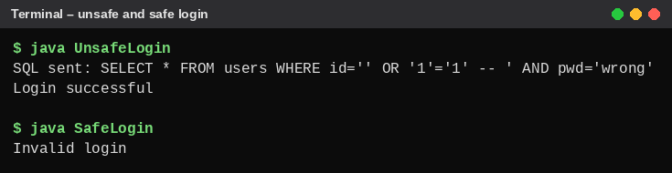
Figure B2.1 – Unsafe login is bypassed; safe login rejects the same input
The crafted input changes the condition of the SQL query. The OR '1'='1' expression makes the condition true, while the comment marker ignores the remaining part of the query (the password check). The printed SQL shows this.

B2.2 – Test Damaged Bus-Pass Files
Create a file named damaged_passes.csv with these records:
P1001,192311001,Arun,12,4500
P1002,DAMAGED LINE
P1003,192311003,Divya,7,invalid
P1004,192311004,Ravi,10,3500
(empty line)

- A normal record.
- A record with an incorrect number of fields.
- A record with a non-numeric amount.
- A valid record.
- An empty line.
Java Program – DamagedFileTest.java (uses the B1 validation logic)
import java.io.*;
import java.nio.file.*;

public class DamagedFileTest {

public static void main(String[] args) throws IOException {

try (BufferedReader br =
Files.newBufferedReader(Path.of("damaged_passes.csv"))) {

String line;
int n = 0;

while ((line = br.readLine()) != null) {

n++;

if (line.isBlank()) {
System.out.println("Line " + n
+ ": SKIPPED (empty line)");
continue;
}

String[] f = line.split(",", -1);

if (f.length != 5) {
System.out.println("Line " + n + ": SKIPPED ("
+ f[0] + " - wrong number of fields)");
continue;
}

try {
Integer.parseInt(f[3]);
Double.parseDouble(f[4]);
System.out.println("Line " + n + ": ACCEPTED ("
+ f[0] + ")");
} catch (NumberFormatException e) {
System.out.println("Line " + n + ": SKIPPED ("
+ f[0] + " - invalid number)");
}
}
}
}
}

Output:
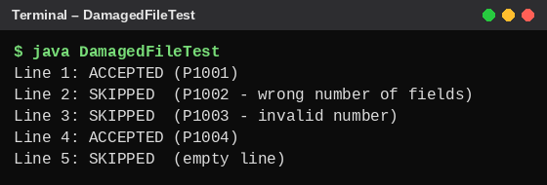
Figure B2.2 – Damaged-record test
Record | Problem | Observed behaviour
P1001 | None | Accepted
P1002 | Wrong number of fields | Skipped
P1003 | Invalid amount | Skipped
P1004 | None | Accepted
Empty line | No fields | Skipped

B2.3 – Explain the Results
- The unsafe login accepts crafted input because user data is joined directly into the SQL query.
- The safe login rejects the same input because PreparedStatement treats it as a parameter value.
- The damaged record test demonstrates the importance of validating the number of fields.
- The invalid amount test demonstrates the need for numeric validation.
- The empty-line test demonstrates the importance of handling blank records without terminating the search.

Alternative Concept and Complexity Analysis
Another approach is to escape quote characters or validate user input using regular expressions before creating SQL.
if (!id.matches("[a-zA-Z0-9_]+")) {
System.out.println("Invalid ID");
}

However, input validation alone does not replace parameterized SQL. Escaping rules may be incomplete or database-specific, and regular expressions can fail to cover every possible SQL injection pattern.
Approach | Time cost | Security
String concatenation | O(n) to build query | Unsafe
Regex validation | O(n) validation plus query processing | Additional protection, but not sufficient alone
PreparedStatement | Parameter binding plus query execution | Recommended

Conclusion: PreparedStatement is the preferred solution because it separates SQL commands from user-supplied data.

TASK B3 – STATEMENT VS PREPAREDSTATEMENT VS BATCH
8 Marks | K4 – Analyse

B3.1 – Create the Database Table
SQL Program – bus_pass.sql
CREATE DATABASE buspass_db;

USE buspass_db;

CREATE TABLE bus_pass (
pass_id VARCHAR(20) PRIMARY KEY,
reg_no VARCHAR(20) NOT NULL,
name VARCHAR(100) NOT NULL,
route_no INT NOT NULL,
amount DOUBLE NOT NULL
);

Explanation: The bus_pass table stores the pass ID, register number, student name, route number and amount paid. The pass ID is the primary key.

B3.2 – Insert Records Using Three Approaches

Method 1: Statement
Statement st = con.createStatement();

String sql =
"INSERT INTO bus_pass VALUES " +
"('P1001','192311001','Arun',12,4500)";

st.executeUpdate(sql);

Method 2: PreparedStatement
String sql =
"INSERT INTO bus_pass VALUES (?, ?, ?, ?, ?)";

PreparedStatement ps = con.prepareStatement(sql);

ps.setString(1, "P1002");
ps.setString(2, "192311002");
ps.setString(3, "Divya");
ps.setInt(4, 7);
ps.setDouble(5, 3800);

ps.executeUpdate();

Method 3: PreparedStatement with Batch
String sql =
"INSERT INTO bus_pass VALUES (?, ?, ?, ?, ?)";

PreparedStatement ps = con.prepareStatement(sql);

for (int i = 1; i <= 10; i++) {

ps.setString(1, "P" + (1100 + i));
ps.setString(2, "19231100" + i);
ps.setString(3, "Student" + i);
ps.setInt(4, 12);
ps.setDouble(5, 4500);

ps.addBatch();
}

ps.executeBatch();

Note: The batch IDs start from P1101 (not P1001) so that they do not clash with the primary keys already inserted by Methods 1 and 2.
Complete test program – InsertMethods.java
import java.sql.*;

public class InsertMethods {

public static void main(String[] args) throws Exception {

try (Connection con = DriverManager.getConnection(
"jdbc:mysql://localhost:3306/buspass_db",
"root", "your_password")) {

con.createStatement().executeUpdate("DELETE FROM bus_pass");

// Method 1: Statement
Statement st = con.createStatement();

String sql1 =
"INSERT INTO bus_pass VALUES " +
"('P1001','192311001','Arun',12,4500)";

st.executeUpdate(sql1);
System.out.println(
"Method 1 (Statement) : 1 row inserted");

// Method 2: PreparedStatement
String sql2 =
"INSERT INTO bus_pass VALUES (?, ?, ?, ?, ?)";

PreparedStatement ps = con.prepareStatement(sql2);

ps.setString(1, "P1002");
ps.setString(2, "192311002");
ps.setString(3, "Divya");
ps.setInt(4, 7);
ps.setDouble(5, 3800);

ps.executeUpdate();
System.out.println(
"Method 2 (PreparedStatement) : 1 row inserted");

// Method 3: PreparedStatement with Batch
PreparedStatement pb = con.prepareStatement(sql2);

for (int i = 1; i <= 10; i++) {

pb.setString(1, "P" + (1100 + i));
pb.setString(2, "19231100" + i);
pb.setString(3, "Student" + i);
pb.setInt(4, 12);
pb.setDouble(5, 4500);

pb.addBatch();
}

int[] counts = pb.executeBatch();
System.out.println("Method 3 (Batch) : "
+ counts.length + " rows inserted");
}
}
}

Output and verification using SELECT:
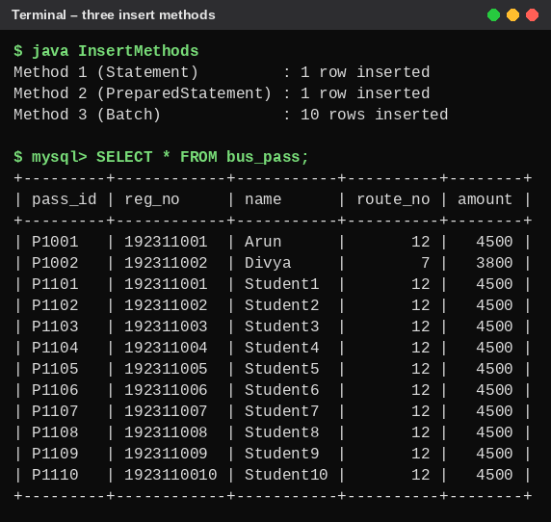
Figure B3.1 – Three insert methods and SELECT * FROM bus_pass
Verify column types using ResultSetMetaData – MetadataDemo.java
import java.sql.*;

public class MetadataDemo {

public static void main(String[] args) {

try (Connection con =
DriverManager.getConnection(
"jdbc:mysql://localhost:3306/buspass_db",
"root",
"your_password");

Statement st = con.createStatement();

ResultSet rs = st.executeQuery(
"SELECT * FROM bus_pass")) {

ResultSetMetaData md = rs.getMetaData();

for (int i = 1; i <= md.getColumnCount(); i++) {

System.out.println(
md.getColumnName(i) + " : " +
md.getColumnTypeName(i)
);
}

} catch (SQLException e) {
System.out.println(e.getMessage());
}
}
}

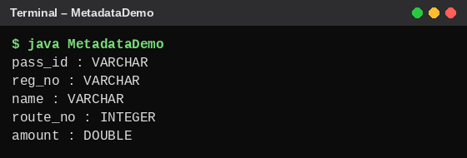
Figure B3.2 – Column names and types from ResultSetMetaData
Column | Expected type | Observed type
pass_id | VARCHAR | VARCHAR
reg_no | VARCHAR | VARCHAR
name | VARCHAR | VARCHAR
route_no | INT | INTEGER (name used by this driver for INT)
amount | DOUBLE | DOUBLE

B3.3 – Increase the Data Size
The time required to insert 1,000, 10,000 and 100,000 records was measured using the three approaches. A fourth column was added: the same batch inserted inside one transaction with a single commit (the approach used by PassLoader in B3.4).
Java Program – InsertBenchmark.java
import java.sql.*;

public class InsertBenchmark {

static final String URL = "jdbc:mysql://localhost:3306/buspass_db";

static void clear(Connection con) throws SQLException {
con.createStatement().executeUpdate("TRUNCATE TABLE bus_pass");
}

static double withStatement(Connection con, int n) throws SQLException {
clear(con);
long t = System.nanoTime();
Statement st = con.createStatement();
for (int i = 1; i <= n; i++) {
st.executeUpdate("INSERT INTO bus_pass VALUES ('P" + i
+ "','R" + i + "','Student" + i + "',12,4500)");
}
return (System.nanoTime() - t) / 1_000_000.0;
}

static double withPrepared(Connection con, int n) throws SQLException {
clear(con);
long t = System.nanoTime();
PreparedStatement ps = con.prepareStatement(
"INSERT INTO bus_pass VALUES (?, ?, ?, ?, ?)");
for (int i = 1; i <= n; i++) {
ps.setString(1, "P" + i);
ps.setString(2, "R" + i);
ps.setString(3, "Student" + i);
ps.setInt(4, 12);
ps.setDouble(5, 4500);
ps.executeUpdate();
}
return (System.nanoTime() - t) / 1_000_000.0;
}

static double withBatch(Connection con, int n) throws SQLException {
clear(con);
long t = System.nanoTime();
PreparedStatement ps = con.prepareStatement(
"INSERT INTO bus_pass VALUES (?, ?, ?, ?, ?)");
for (int i = 1; i <= n; i++) {
ps.setString(1, "P" + i);
ps.setString(2, "R" + i);
ps.setString(3, "Student" + i);
ps.setInt(4, 12);
ps.setDouble(5, 4500);
ps.addBatch();
if (i % 1000 == 0) {
ps.executeBatch();
}
}
ps.executeBatch();
return (System.nanoTime() - t) / 1_000_000.0;
}

static double withBatchTransaction(Connection con, int n)
throws SQLException {
clear(con);
con.setAutoCommit(false);
long t = System.nanoTime();
PreparedStatement ps = con.prepareStatement(
"INSERT INTO bus_pass VALUES (?, ?, ?, ?, ?)");
for (int i = 1; i <= n; i++) {
ps.setString(1, "P" + i);
ps.setString(2, "R" + i);
ps.setString(3, "Student" + i);
ps.setInt(4, 12);
ps.setDouble(5, 4500);
ps.addBatch();
if (i % 1000 == 0) {
ps.executeBatch();
}
}
ps.executeBatch();
con.commit();
double ms = (System.nanoTime() - t) / 1_000_000.0;
con.setAutoCommit(true);
return ms;
}

public static void main(String[] args) throws Exception {

int[] sizes = {1000, 10000, 100000};

try (Connection con = DriverManager.getConnection(
URL, "root", "your_password")) {

// warm-up so that class loading is not measured
withStatement(con, 200);
withPrepared(con, 200);
withBatch(con, 200);
withBatchTransaction(con, 200);

System.out.printf("%-8s | %-14s | %-22s | %-10s | %-18s%n",
"Records", "Statement (ms)", "PreparedStatement (ms)",
"Batch (ms)", "Batch + commit (ms)");
System.out.println("---------+----------------+------------------------"
+ "+------------+--------------------");

for (int n : sizes) {
double a = withStatement(con, n);
double b = withPrepared(con, n);
double c = withBatch(con, n);
double d = withBatchTransaction(con, n);
System.out.printf(
"%-8d | %-14.0f | %-22.0f | %-10.0f | %-18.0f%n",
n, a, b, c, d);
}

clear(con);
}
}
}

Output:
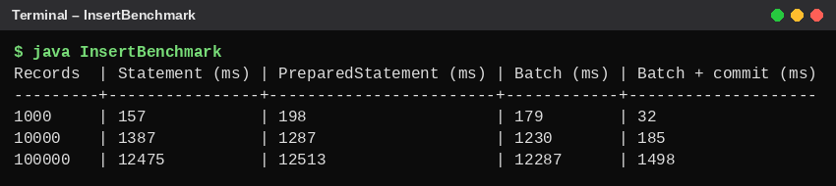
Figure B3.3 – Insert timings for 1,000, 10,000 and 100,000 records
Measurement table (measured values):
Records | Statement (ms) | PreparedStatement (ms) | Batch (ms) | Batch in one transaction (ms)
1,000 | 157 | 198 | 179 | 32
10,000 | 1,387 | 1,287 | 1,230 | 185
100,000 | 12,475 | 12,513 | 12,287 | 1,498

Observations:
- With auto-commit ON, Statement, PreparedStatement and plain Batch took almost the same time. On a local database the time is dominated by committing every row, not by query parsing or network round trips.
- Grouping the batch inside one transaction (a single commit) was about 8 times faster for 100,000 rows (1,498 ms against 12,287 ms).
- PreparedStatement still matters for safety: it prevents SQL injection and allows parameter binding, even when it is not faster on this machine.
- On a remote database server, batching would also reduce network round trips, so its advantage would be larger than measured here.

B3.4 – Complete the PassLoader Program
Java Program – PassLoader.java
import java.sql.Connection;
import java.sql.PreparedStatement;
import java.sql.SQLException;
import java.util.List;

public class PassLoader {

public static int loadAll(
Connection con,
List<String[]> passes) throws SQLException {

String sql =
"INSERT INTO bus_pass" +
"(pass_id, reg_no, name, route_no, amount) " +
"VALUES (?, ?, ?, ?, ?)";

boolean oldAutoCommit = con.getAutoCommit();

con.setAutoCommit(false);

try (PreparedStatement ps =
con.prepareStatement(sql)) {

int n = 0;

for (String[] p : passes) {

// TODO 1: Set parameters and add to batch

ps.setString(1, p[0]);
ps.setString(2, p[1]);
ps.setString(3, p[2]);
ps.setInt(4, Integer.parseInt(p[3]));
ps.setDouble(5, Double.parseDouble(p[4]));

ps.addBatch();

n++;

if (n % 1000 == 0) {
ps.executeBatch();
}
}

ps.executeBatch();

// TODO 2: Commit and return the number of rows

con.commit();

return n;

} catch (SQLException | RuntimeException e) {

// TODO 3: Roll back all inserted rows

try {
con.rollback();
} catch (SQLException rollbackError) {
e.addSuppressed(rollbackError);
}

throw e;

} finally {

con.setAutoCommit(oldAutoCommit);
}
}
}

Explanation of the TODO sections:
- TODO 1: Assigns the five values, adds each record to the batch and executes every 1,000 records.
- TODO 2: commit() makes the inserted records permanent and return n gives the number of loaded records.
- TODO 3: rollback() removes the changes made in the current transaction when an error occurs.

Test Failure Half-Way Through
The test creates ten records where record 5 has an invalid amount, calls PassLoader.loadAll(con, passes) on an empty table, and then counts the rows. It then repeats the load with the amount corrected.
Java Program – TestPassLoader.java
import java.sql.*;
import java.util.*;

public class TestPassLoader {

static int count(Connection con) throws SQLException {
try (ResultSet rs = con.createStatement()
.executeQuery("SELECT COUNT(*) FROM bus_pass")) {
rs.next();
return rs.getInt(1);
}
}

public static void main(String[] args) throws Exception {

List<String[]> passes = new ArrayList<>();

for (int i = 1; i <= 10; i++) {

String amount =
(i == 5) ? "invalid" : "4500";

passes.add(new String[]{
"P" + (1000 + i),
"19231100" + i,
"Student" + i,
"12",
amount
});
}

System.out.println(
"Test records created: " + passes.size()
);

System.out.println(
"Record 5 contains an invalid amount"
);

try (Connection con = DriverManager.getConnection(
"jdbc:mysql://localhost:3306/buspass_db",
"root", "your_password")) {

con.createStatement().executeUpdate("TRUNCATE TABLE bus_pass");

System.out.println("Rows before load: " + count(con));

try {
PassLoader.loadAll(con, passes);
System.out.println("Load completed");
} catch (Exception e) {
System.out.println("Load failed : " + e);
}

System.out.println("Rows after failed load: " + count(con));

// Same data with a valid amount
passes.get(4)[4] = "4500";
int loaded = PassLoader.loadAll(con, passes);
System.out.println("Valid load, rows loaded: " + loaded);
System.out.println("Rows after valid load: " + count(con));

con.createStatement().executeUpdate("TRUNCATE TABLE bus_pass");
}
}
}

Output:
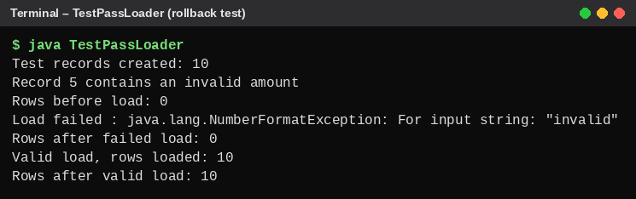
Figure B3.4 – Failed load leaves 0 rows; the corrected load inserts 10 rows
Observed behaviour:
- Record 5 has an invalid amount.
- Double.parseDouble() throws NumberFormatException.
- The catch block executes rollback().
- No inserted records from this transaction remain in the table (COUNT(*) is 0).
- After correcting the amount, all 10 rows are loaded and committed.
Important: The database table must use a transactional storage engine such as InnoDB for rollback to work. Also, executeBatch() may execute earlier batches, but they remain uncommitted until the final commit, so rollback can undo them.

B3.5 – Auto-Commit vs Transaction
Feature | Auto-commit ON | Single transaction
Saving | Each statement is committed separately | All rows committed together
Failure halfway | Earlier inserts may remain | All inserts can be rolled back
Correctness | Partial data may remain | All-or-nothing behaviour
Performance | May be slower for many inserts due to repeated commits | Often faster for large imports

Failure demonstration with auto-commit ON – AutoCommitDemo.java
import java.sql.*;

public class AutoCommitDemo {

public static void main(String[] args) throws Exception {

try (Connection con = DriverManager.getConnection(
"jdbc:mysql://localhost:3306/buspass_db",
"root", "your_password")) {

con.createStatement().executeUpdate("TRUNCATE TABLE bus_pass");

// Auto-commit ON (default): each insert is saved at once
PreparedStatement ps = con.prepareStatement(
"INSERT INTO bus_pass VALUES (?, ?, ?, ?, ?)");

try {
for (int i = 1; i <= 10; i++) {

ps.setString(1, "P" + (1000 + i));
ps.setString(2, "19231100" + i);
ps.setString(3, "Student" + i);
ps.setInt(4, 12);

String amount = (i == 5) ? "invalid" : "4500";
ps.setDouble(5, Double.parseDouble(amount));

ps.executeUpdate();
}
} catch (NumberFormatException e) {
System.out.println("Failure at record 5: "
+ e.getMessage());
}

try (ResultSet rs = con.createStatement()
.executeQuery("SELECT COUNT(*) FROM bus_pass")) {
rs.next();
System.out.println("Auto-commit ON -> rows left in table: "
+ rs.getInt(1));
}

con.createStatement().executeUpdate("TRUNCATE TABLE bus_pass");
}
}
}

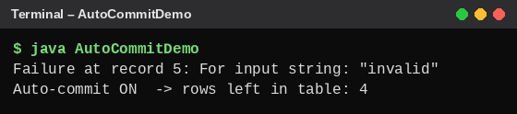
Figure B3.5 – With auto-commit ON, 4 rows remain after the failure at record 5
With auto-commit ON, the four records inserted before the failure remain in the table (Figure B3.5). With a single transaction, rollback removed all records (Figure B3.4). The performance row is confirmed by Figure B3.3.

Alternative Concept and Complexity Analysis
Alternative 1: Multi-row INSERT
INSERT INTO bus_pass
(pass_id, reg_no, name, route_no, amount)
VALUES
('P1001','192311001','Arun',12,4500),
('P1002','192311002','Divya',7,3800);

Alternative 2: MySQL LOAD DATA
LOAD DATA LOCAL INFILE 'passes.csv'
INTO TABLE bus_pass
FIELDS TERMINATED BY ','
LINES TERMINATED BY '\n'
(pass_id, reg_no, name, route_no, amount);

Comparison:
Feature | PreparedStatement batch | Multi-row INSERT | LOAD DATA
Main purpose | Insert records in batches | Insert multiple rows in one SQL statement | Bulk file import
Performance | Good | Good | Often very efficient for large imports
Memory | O(b) for a batch of b records | O(n) if all n rows are built in one statement | Depends on streaming and server implementation
Validation | Easy to validate each row in Java | Requires SQL-side or prior validation | Requires import validation and error handling
Flexibility | High | Moderate | Best for structured bulk imports

Time complexity: All approaches must process n records, so the basic data-processing work is O(n). Actual elapsed time depends on network round trips, database parsing, indexing, logging and transaction settings.
Conclusion:
- PreparedStatement batch is suitable for controlled Java-based imports.
- Multi-row INSERT is useful for smaller groups of records.
- LOAD DATA is suitable for very large, well-formatted file imports.

TASK B4 – FINAL ENGINEERING DECISION
5 Marks | K5 – Evaluate

B4.1 – Implement a Practical Migration Strategy
Aim: To migrate bus-pass records from a text file into a MySQL database using batch processing and transactions.
Migration workflow:
Start
|
v
Read Existing Pass File
|
v
Validate Each Record
|
+---- Invalid Record ----> Add to Failure Report
|
v
Add Valid Record to Batch
|
v
Execute Batch of 1000
|
v
Commit Transaction
|
v
Display Migration Summary
|
v
End

Java Program – PassMigration.java
import java.io.*;
import java.sql.*;
import java.util.*;

public class PassMigration {

public static void main(String[] args) {

String fileName = "passes.csv";

List<String[]> valid = new ArrayList<>();
List<String> failed = new ArrayList<>();

// Read and validate the file

try (BufferedReader br =
new BufferedReader(new FileReader(fileName))) {

String line;
int lineNumber = 0;

while ((line = br.readLine()) != null) {

lineNumber++;

String[] p = line.split(",", -1);

if (p.length != 5) {
failed.add("Line " + lineNumber +
": Incorrect field count");
continue;
}

try {

Integer.parseInt(p[3]);
Double.parseDouble(p[4]);

if (p[0].isBlank() ||
p[1].isBlank() ||
p[2].isBlank()) {

throw new IllegalArgumentException();
}

valid.add(p);

} catch (Exception e) {

failed.add("Line " + lineNumber +
": Invalid data");
}
}

} catch (IOException e) {

System.out.println("File error: " + e.getMessage());
return;
}

// Insert valid records into database

String url =
"jdbc:mysql://localhost:3306/buspass_db";

try (Connection con =
DriverManager.getConnection(
url, "root", "your_password")) {

int loaded = PassLoader.loadAll(con, valid);

System.out.println(
"Records migrated: " + loaded
);

} catch (Exception e) {

System.out.println(
"Migration failed: " + e.getMessage()
);
}

// Display failed records

System.out.println("Failed records:");

for (String error : failed) {
System.out.println(error);
}

System.out.println(
"Total invalid records: " + failed.size()
);
}
}

Example input file – passes.csv
P1001,192311001,Arun,12,4500
P1002,192311002,Divya,7,3800
P1003,192311003,Ravi,10,3500
P1004,DAMAGED LINE
P1005,192311005,Meena,5,invalid

Output (actual run on an empty bus_pass table):
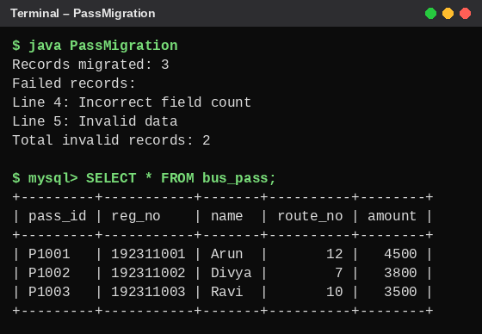
Figure B4.1 – Migration summary and the rows now stored in the database

B4.2 – Inspect the Database
DatabaseMetaData provides information about the database and JDBC driver.
Java Program – DatabaseInfo.java
import java.sql.*;

public class DatabaseInfo {

public static void main(String[] args) {

try (Connection con =
DriverManager.getConnection(
"jdbc:mysql://localhost:3306/buspass_db",
"root",
"your_password")) {

DatabaseMetaData md = con.getMetaData();

System.out.println(
"Database: " +
md.getDatabaseProductName()
);

System.out.println(
"Database Version: " +
md.getDatabaseProductVersion()
);

System.out.println(
"Driver: " +
md.getDriverName()
);

System.out.println(
"Driver Version: " +
md.getDriverVersion()
);

ResultSet rs =
md.getTables(null, null, "%",
new String[]{"TABLE"});

System.out.println("Tables:");

while (rs.next()) {
System.out.println(
rs.getString("TABLE_NAME")
);
}

rs.close();

} catch (SQLException e) {
System.out.println(e.getMessage());
}
}
}

Output:
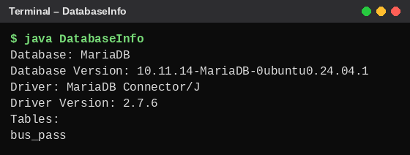
Figure B4.2 – Database and driver information
This run used a MariaDB server and the MariaDB driver. On a MySQL server with MySQL Connector/J, the same program prints "MySQL" and "MySQL Connector/J" together with the installed version numbers.
Explanation: Database metadata is useful when an application is moved to another server because it helps identify the database product, version, JDBC driver and available tables. This information helps developers check compatibility and diagnose configuration problems.

B4.3 – Production Decision
The university transport office will serve 12 campuses with 100 times the current number of passes and several counters operating at the same time.
Comparison of storage methods:
Feature | Text file | Serialization | Relational database
Storage format | Human-readable text | Binary Java objects | Structured tables
Searching | Sequential scanning | Object loading or custom indexing | Indexed SQL queries
Concurrent access | Requires additional locking | Requires additional coordination | Supports transactions and concurrent access
Data safety | Requires careful file handling | Version compatibility is important | Transactions and constraints
Scalability | Limited for concurrent operations | Limited for shared multi-user access | Suitable for large multi-user systems
Data sharing | Difficult | Difficult | Centralised access

Recommended solution: Relational Database using MySQL
Reasons:
- A database supports multiple counters accessing records concurrently.
- Primary keys and unique constraints prevent duplicate passes.
- Transactions protect records from partial updates.
- Indexes make pass-ID searching efficient.
- JDBC allows Java applications to access the database.
- Database metadata helps with server migration and compatibility.
- Centralised storage allows all 12 campuses to access the same data.

Alternative Concept and Complexity Analysis
If each campus stores its own serialized file:
- Each campus has a separate data file.
- To search across all campuses, the application must inspect all 12 files.
- Concurrent updates need file locking or another coordination mechanism.
- Duplicate pass IDs across campuses require additional checking.
- Sharing and synchronising data becomes difficult.
Feature | Separate serialized files | Shared relational database
Search across all campuses | O(N) total scan without indexes | Indexed lookup, typically O(log N)
Storage | Sum of all 12 files | Centralised database storage
Concurrent counters | Requires custom coordination | Database concurrency control
Data consistency | Difficult to maintain | Transactions and constraints
Maintenance | Separate file management | Centralised administration

Here, N represents the total number of bus-pass records across all campuses.
Final Decision: A relational database is the best option for the expanded transport office because it provides centralised storage, efficient searching, transaction safety and concurrent access. Text files can still be used for importing and exporting data, but they should not be the primary production storage system.

