PROGRAMMING IN JAVA
ASSIGNMENT 3 (CO3)
Exception Handling, Multithreading, Synchronization and Concurrency

Detail | Information
Student Name | J. Roopa Sai Divya
Register Number | 192524140
Course | Programming in Java
Assignment | Assignment 3 – CO3
Questions | Q1 to Q7 (50 Marks)
GitHub Link | https://github.com/roopajallu814-arch/CSA09-192524140_Roopa-JAVA

Contents
- Q1 – ATM Failure Handling Using Exception Handling (6 Marks)
- Q2 – Custom Exceptions in an Online Examination Portal (7 Marks)
- Q3 – Resource Management and Debugging (7 Marks)
- Q4 – Thread Creation and Life Cycle (7 Marks)
- Q5 – Race Condition in Cinema Seat Booking (6 Marks)
- Q6 – Deadlock and Inter-Thread Communication (7 Marks)
- Q7 – Concurrent Fault-Tolerant Result Processor (10 Marks)

Q1 – ATM Failure Handling Using Exception Handling (6 Marks)

Aim
To develop a Java ATM withdrawal program using exception handling to handle invalid inputs, negative amounts, insufficient balance and missing files.

Introduction / Concepts
- try: Contains code that may cause an exception.
- catch: Handles the exception.
- finally: Executes cleanup code after try/catch processing.
- throw: Explicitly throws an exception.
- Checked exception: Checked by the compiler.
- Unchecked exception: Occurs at runtime.
Throwable hierarchy
Throwable
|
-----------------
| |
Error Exception
|
------------------
| |
IOException RuntimeException
|
InputMismatchException
Failure classification
Failure | Exception | Type
Letters instead of numbers | InputMismatchException | Unchecked
Negative withdrawal | IllegalArgumentException | Unchecked
Insufficient balance | Custom exception | Checked
Missing card-reader file | FileNotFoundException | Checked

Algorithm
Step 1: Start the program and set the initial balance to 5000.
Step 2: Read the account number (int) and the withdrawal amount (double).
Step 3: If the amount is less than or equal to 0, throw IllegalArgumentException.
Step 4: If the amount is greater than the balance, throw InsufficientBalanceException.
Step 5: Check that cardreader.txt exists; otherwise throw FileNotFoundException.
Step 6: Deduct the amount from the balance and display the account number, cash withdrawn and remaining balance.
Step 7: Handle every failure with its own catch block (specific before general).
Step 8: In the finally block print "ATM transaction completed." and close the Scanner.
Step 9: Stop.

Java Program
Filename: ATM.java
import java.io.*;
import java.util.*;

class InsufficientBalanceException extends Exception {
InsufficientBalanceException(String message) {
super(message);
}
}

public class ATM {
public static void main(String[] args) {

Scanner sc = new Scanner(System.in);
double balance = 5000;

try {
System.out.print("Enter account number: ");
int account = sc.nextInt();

System.out.print("Enter withdrawal amount: ");
double amount = sc.nextDouble();

if (amount <= 0) {
throw new IllegalArgumentException(
"Amount must be positive");
}

if (amount > balance) {
throw new InsufficientBalanceException(
"Insufficient balance");
}

File file = new File("cardreader.txt");

if (!file.exists()) {
throw new FileNotFoundException(
"Card-reader file not found");
}

balance = balance - amount;

System.out.println("Account Number: " + account);
System.out.println("Cash Withdrawn: " + amount);
System.out.println("Remaining Balance: " + balance);

} catch (InputMismatchException e) {
System.out.println("Enter numbers only.");

} catch (IllegalArgumentException e) {
System.out.println(e.getMessage());

} catch (InsufficientBalanceException e) {
System.out.println(e.getMessage());

} catch (FileNotFoundException | SecurityException e) {
System.out.println("Card-reader file error: "
+ e.getMessage());

} catch (Exception e) {
System.out.println("Unexpected error: "
+ e.getMessage());

} finally {
System.out.println("ATM transaction completed.");
sc.close();
}
}
}

Input
Create an empty file named cardreader.txt in the program's working folder to test a successful withdrawal. Account number: 12345, Withdrawal amount: 1000.

Output
Test 1 – Valid transaction
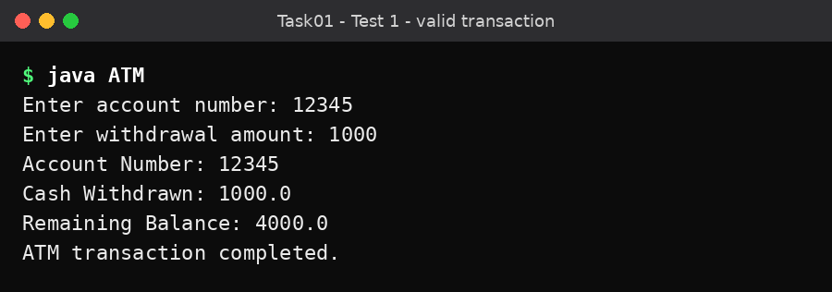
Figure 1.1 – Valid transaction
Test 2 – Invalid input (abc entered for account number)
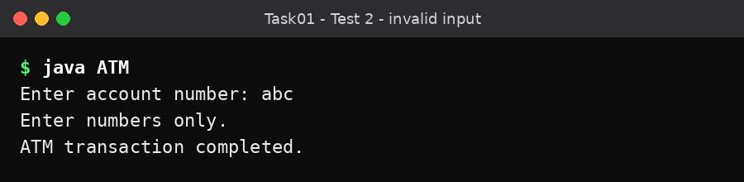
Figure 1.2 – Invalid input
Test 3 – Negative amount
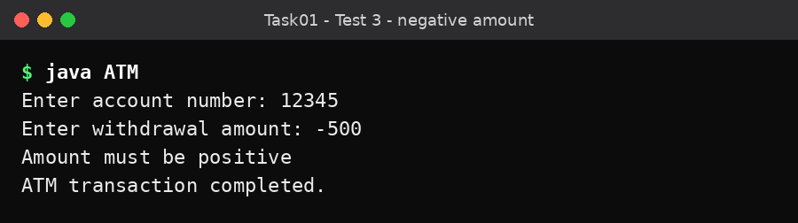
Figure 1.3 – Negative amount
Test 4 – Insufficient balance
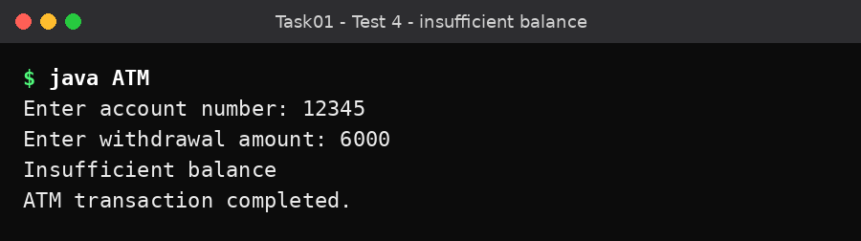
Figure 1.4 – Insufficient balance
Test 5 – Missing file (cardreader.txt removed)
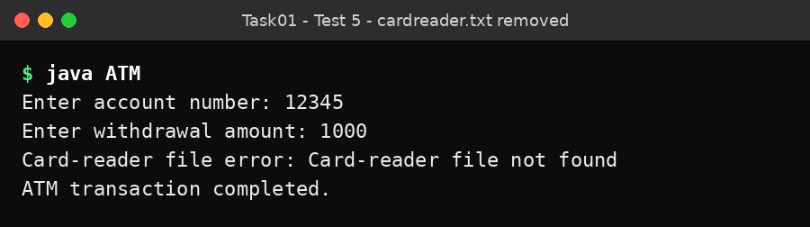
Figure 1.5 – Missing card-reader file
Test | Input | Result
Invalid input | abc for account number | Enter numbers only.
Negative amount | -500 | Amount must be positive
Insufficient balance | 6000 | Insufficient balance
Missing file | Remove cardreader.txt | Card-reader file error: Card-reader file not found

Explanation
Specific catch blocks should be placed before general catch blocks. Otherwise, the compiler may report unreachable catch blocks.
The finally block is used for cleanup. It normally executes whether an exception occurs or not, but it is not guaranteed if the JVM terminates abruptly.
Question: Is one catch(Exception e) sufficient? No. A single general catch block does not provide separate handling for different failures. Specific catch blocks provide clearer error messages and better debugging.
Alternative without exceptions: Use Scanner.hasNextInt() and hasNextDouble() to validate input before processing. Error codes can be returned for invalid inputs.

Conclusion
The ATM program handles invalid input, negative withdrawal, insufficient balance and missing files using Java exception handling.

Q2 – Custom Exceptions in an Online Examination Portal (7 Marks)

Aim
To implement user-defined exceptions and exception propagation in an online examination portal.

Introduction / Concepts
Custom exceptions are created by extending the Exception or RuntimeException class. They help represent application-specific errors, for example: exam window closed, student not registered, submission file too large and submission storage failure.
Exception hierarchy
Exception
|
ExamException
|
SubmissionStorageException

Algorithm
Step 1: Create ExamException by extending Exception, with a constructor that accepts a cause.
Step 2: Create SubmissionStorageException by extending ExamException.
Step 3: In Storage.save(), check the file size. If it is greater than 500 KB, generate an IOException ("Disk quota exceeded").
Step 4: Catch the IOException and wrap it inside SubmissionStorageException, preserving it as the cause.
Step 5: In main(), call save() for two files and catch ExamException.
Step 6: Print the error message and the original cause using getCause().
Step 7: Stop.

Java Program
Filename: StorageDemo.java
import java.io.IOException;

class ExamException extends Exception {

ExamException(String message) {
super(message);
}

ExamException(String message, Throwable cause) {
super(message, cause);
}
}

class SubmissionStorageException extends ExamException {

SubmissionStorageException(String message, Throwable cause) {
super(message, cause);
}
}

class Storage {

void save(String fileName, long sizeKb)
throws SubmissionStorageException {

try {
if (sizeKb > 500) {
throw new IOException("Disk quota exceeded");
}

System.out.println("Saved " + fileName);

} catch (IOException e) {

throw new SubmissionStorageException(
"Could not store " + fileName, e);
}
}
}

public class StorageDemo {

public static void main(String[] args) {

Storage storage = new Storage();

try {
storage.save("answer01.pdf", 120);
storage.save("answer02.pdf", 800);

} catch (ExamException e) {

System.out.println("Error: " + e.getMessage());

if (e.getCause() != null) {
System.out.println(
"Cause: " + e.getCause().getMessage());
}
}
}
}

Input
No keyboard input. The program uses two files: answer01.pdf (120 KB) and answer02.pdf (800 KB).

Output
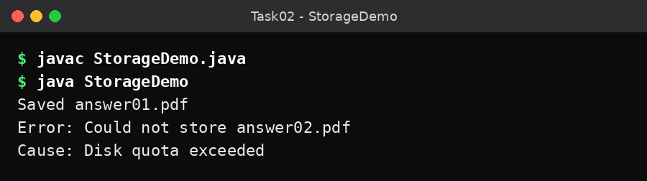
Figure 2.1 – Output of StorageDemo.java

Explanation
- ExamException is a user-defined checked exception.
- SubmissionStorageException extends ExamException.
- The storage class checks the file size.
- If the file size is greater than 500 KB, an IOException is generated.
- The IOException is wrapped inside SubmissionStorageException.
- The original exception is preserved using e as the cause.
Question: What happens if the cause is not preserved? The original error information will be lost. getCause() returns null if no cause was provided.
Question: Why should the storage layer throw a meaningful custom exception? It hides low-level storage details and provides a meaningful error to the controller or user interface. The application can handle storage errors without depending directly on internal file-system errors.
Checked and unchecked exceptions
Checked exception | Unchecked exception
Checked by compiler | Checked at runtime
Must be handled or declared | Handling is not compulsory
Example: IOException | Example: NullPointerException
Suitable for recoverable external failures | Suitable for programming errors or invalid states

Conclusion
Custom exceptions and exception chaining were implemented successfully. The program preserves the original cause and displays meaningful error messages.

Q3 – Resource Management and Debugging (7 Marks)

Aim
To demonstrate resource management using try-catch-finally and try-with-resources in Java.

Introduction / Concepts
File resources must be closed after use. If files are not closed properly, the program may face resource leaks and errors such as "Too many open files". Java provides two approaches:
- Manual resource closing using the finally block.
- Automatic resource closing using try-with-resources.

Algorithm
Step 1: Method 1 (manual): open store1.txt, store2.txt and the output file inside try.
Step 2: Copy all lines of store1.txt and then store2.txt to the output file.
Step 3: In finally, close each resource that is not null.
Step 4: Method 2 (automatic): declare the readers and writer inside the try-with-resources header.
Step 5: Copy the lines in the same order; Java closes the resources automatically in reverse order.
Step 6: Call both methods from main() and display the messages.
Step 7: Stop.

Java Program
Filename: SalesReport.java
import java.io.*;

public class SalesReport {

// Method 1: Manual closing using finally
static void manualReport() {

BufferedReader br1 = null;
BufferedReader br2 = null;
PrintWriter out = null;

try {
br1 = new BufferedReader(new FileReader("store1.txt"));
br2 = new BufferedReader(new FileReader("store2.txt"));
out = new PrintWriter(new FileWriter("manual.txt"));

String line;

while ((line = br1.readLine()) != null) {
out.println(line);
}

while ((line = br2.readLine()) != null) {
out.println(line);
}

System.out.println("Manual report created.");

} catch (IOException e) {
System.out.println("File error: " + e.getMessage());

} finally {
try {
if (br1 != null) br1.close();
if (br2 != null) br2.close();
if (out != null) out.close();
} catch (IOException e) {
System.out.println("Closing error: " + e.getMessage());
}
}
}

// Method 2: Automatic closing
static void automaticReport() {

try (
BufferedReader br1 =
new BufferedReader(new FileReader("store1.txt"));

BufferedReader br2 =
new BufferedReader(new FileReader("store2.txt"));

PrintWriter out =
new PrintWriter(new FileWriter("summary.txt"))
) {

String line;

while ((line = br1.readLine()) != null) {
out.println(line);
}

while ((line = br2.readLine()) != null) {
out.println(line);
}

System.out.println("Automatic report created.");

} catch (IOException e) {
System.out.println("File error: " + e.getMessage());
}
}

public static void main(String[] args) {

manualReport();
automaticReport();
}
}

Input
store1.txt
Chennai Sales: 5000
Madurai Sales: 4000
store2.txt
Salem Sales: 3000
Trichy Sales: 3500

Output
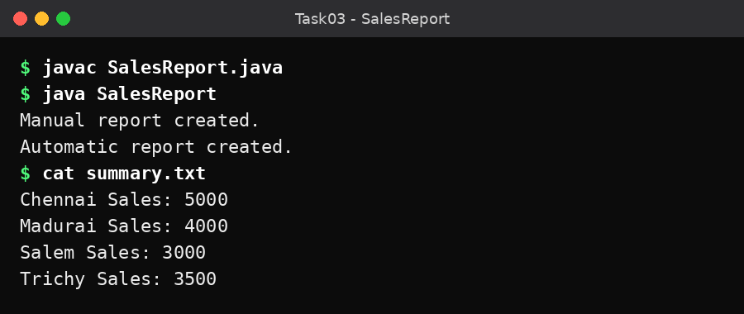
Figure 3.1 – Output of SalesReport.java and content of summary.txt

Explanation
Manual finally | Try-with-resources
Resources are closed manually | Resources are closed automatically
Requires more code | Requires less code
Closing must be handled carefully | Automatically closes resources
Can be harder to maintain | Easier to maintain

Student A – Debugging: Set breakpoints around file opening and reading. Test by removing one input file and observe the error. Record which file caused the failure and how many resources were opened.
Student B – Resource management: Try-with-resources closes resources automatically in reverse order of their creation. If both the main operation and closing produce exceptions, the closing exception can be recorded as a suppressed exception.
Question: When is try-with-resources insufficient? It is insufficient for resources that do not implement AutoCloseable, or for cleanup operations that require special application-specific handling.
Complexity: For f input files and n total lines, the time complexity is O(n) and the resource usage is O(f) open file handles while the files are open.

Conclusion
Both manual resource closing and try-with-resources were implemented. Try-with-resources provides safer and simpler resource management.

Q4 – Thread Creation and Life Cycle (7 Marks)

Aim
To create multiple threads using the Thread class and Runnable interface and demonstrate the thread life cycle.

Introduction / Concepts
A thread is a lightweight unit of execution within a program. A thread may also enter waiting, timed-waiting or blocked states.
Thread life-cycle states
NEW
|
START
|
RUNNABLE
|
RUNNING
|
TERMINATED

Algorithm
Step 1: Create ScannerStation by extending Thread and RunnableStation by implementing Runnable.
Step 2: In each run() method, print three scanning messages with a 500 ms sleep between them.
Step 3: In main(), create two ScannerStation threads and one Thread built from a RunnableStation.
Step 4: Print isAlive() before start() (false).
Step 5: Call start() on all three threads and print isAlive() again (true).
Step 6: Call join() on every thread to wait for completion.
Step 7: Print the completion message and isAlive() of Station 1 (false).
Step 8: Stop.

Java Program
Filename: ScannerStations.java
class ScannerStation extends Thread {

ScannerStation(String name) {
super(name);
}

public void run() {

for (int i = 1; i <= 3; i++) {

System.out.println(
getName() + " scanning document " + i);

try {
Thread.sleep(500);
} catch (InterruptedException e) {
System.out.println("Thread interrupted.");
Thread.currentThread().interrupt();
return;
}
}
}
}

class RunnableStation implements Runnable {

public void run() {

for (int i = 1; i <= 3; i++) {

System.out.println(
"Runnable station scanning document " + i);

try {
Thread.sleep(500);
} catch (InterruptedException e) {
System.out.println("Thread interrupted.");
Thread.currentThread().interrupt();
return;
}
}
}
}

public class ScannerStations {

public static void main(String[] args)
throws InterruptedException {

ScannerStation t1 = new ScannerStation("Station 1");
ScannerStation t2 = new ScannerStation("Station 2");

Thread t3 = new Thread(new RunnableStation());

System.out.println("Before start: " + t1.isAlive());

t1.start();
t2.start();
t3.start();

System.out.println("After start: " + t1.isAlive());

t1.join();
t2.join();
t3.join();

System.out.println("All stations completed.");
System.out.println("Station 1 alive: " + t1.isAlive());
}
}

Input
No keyboard input is required.

Output
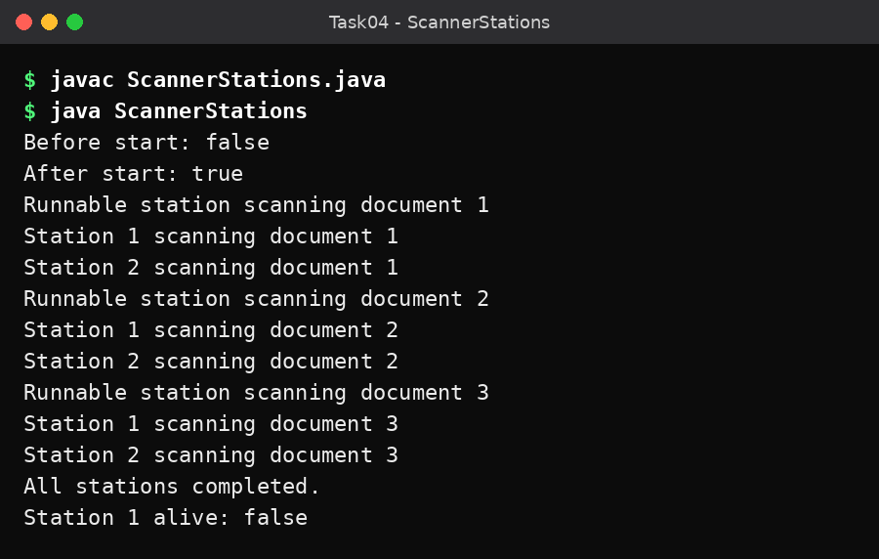
Figure 4.1 – Output of ScannerStations.java
The exact order of thread messages may change every time because the thread scheduler decides their execution order.

Explanation
Thread class | Runnable interface
Extend Thread | Implement Runnable
Cannot extend another class at the same time | Can extend another class
Task and thread are combined | Task and thread are separate
Uses start() on the Thread object | Pass Runnable to a Thread object

Important methods
- start(): Starts a new thread.
- run(): Contains the thread's task.
- sleep(): Pauses a thread for a specified time.
- join(): Waits for another thread to finish.
- isAlive(): Checks whether a thread is still running.
- setPriority(): Sets the thread priority.
Question: Why should correctness not depend on thread order? Thread scheduling is not predictable. A program should use proper synchronization when threads share data rather than depending on which thread runs first.
Question: What is a daemon thread? A daemon thread is a background thread that supports other application threads. The JVM can exit when only daemon threads remain.
Alternative – ExecutorService: Instead of creating a separate thread for every task, a fixed thread pool can reuse a limited number of threads. For n tasks and p worker threads, the work is distributed among at most p threads.

Conclusion
Threads were created using both the Thread class and Runnable interface. The program demonstrates start, sleep, join and isAlive methods.

Q5 – Race Condition in Cinema Seat Booking (6 Marks)

Aim
To demonstrate race conditions and prevent double booking using synchronization.

Introduction / Concepts
A race condition occurs when multiple threads access shared data at the same time and the final result depends on their execution order. In a cinema booking system, two users may try to book the same seat simultaneously.

Algorithm
Step 1: Create a boolean array to store the booking status of every seat.
Step 2: Define bookMethod() (synchronized method), bookBlock() (synchronized block) and bookUnsafe() (no synchronization, for comparison).
Step 3: Inside each method, check whether the seat is free; if so, mark it booked and increase the counter.
Step 4: In main(), start 100 threads, each trying to book seat (i % 10).
Step 5: Use join() to wait for all the threads.
Step 6: Display the total number of seats sold (10).
Step 7: Stop.

Java Program
Filename: SeatBooking.java
public class SeatBooking {

private final boolean[] booked;
private int bookingsMade = 0;

SeatBooking(int seats) {
booked = new boolean[seats];
}

// Synchronized method
public synchronized void bookMethod(int seat) {

if (!booked[seat]) {
booked[seat] = true;
bookingsMade++;
System.out.println("Seat " + seat + " booked.");
}
}

// Synchronized block
public void bookBlock(int seat) {

synchronized (this) {
if (!booked[seat]) {
booked[seat] = true;
bookingsMade++;
System.out.println("Seat " + seat + " booked.");
}
}
}

// Unsynchronized version for comparison
public void bookUnsafe(int seat) {

if (!booked[seat]) {
booked[seat] = true;
bookingsMade++;
System.out.println("Seat " + seat + " booked.");
}
}

public static void main(String[] args)
throws InterruptedException {

SeatBooking screen = new SeatBooking(10);

Thread[] users = new Thread[100];

for (int i = 0; i < users.length; i++) {

final int seat = i % 10;

users[i] = new Thread(
() -> screen.bookMethod(seat));

users[i].start();
}

for (Thread t : users) {
t.join();
}

System.out.println("Seats sold: " + screen.bookingsMade);
}
}

Input
No keyboard input. 100 user threads compete for 10 seats.

Output
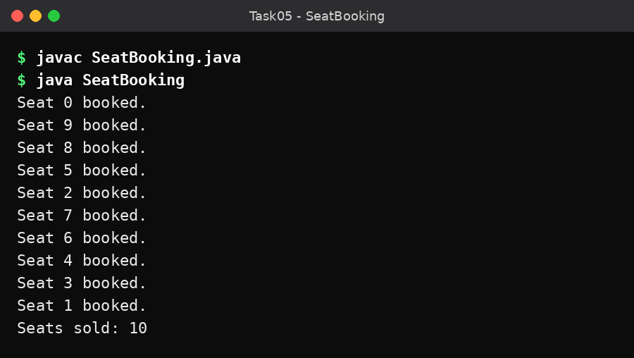
Figure 5.1 – Output of SeatBooking.java
Only 10 seats are sold even though 100 threads tried to book them. The order of the seat numbers may differ in every run.

Explanation
- The unsynchronized version can allow two threads to check the same seat as available before either marks it booked.
- A synchronized method locks the entire method.
- A synchronized block locks only the critical section.
- Both synchronized versions prevent multiple threads from booking the same seat through the same booking object.
Question: What is a critical section? A critical section is the part of the program that accesses shared data and must be protected from simultaneous modification.
Question: What is static synchronization? A static synchronized method locks the class-level Class object rather than an individual object.
Question: How can the system support 20 screens? Each screen can have its own booking object and lock. This avoids unnecessarily blocking bookings on other screens.
Alternative approaches: AtomicBoolean.compareAndSet() for individual seat booking, ReentrantLock for explicit lock management, and ConcurrentHashMap.putIfAbsent() for unique seat allocation.
Complexity: For s seats, storing booking status requires O(s) space. Checking and booking a seat takes O(1) time when protected by a suitable lock.

Conclusion
The program demonstrates race conditions and uses synchronization to prevent double booking.

Q6 – Deadlock and Inter-Thread Communication (7 Marks)

Aim
To demonstrate deadlock prevention and inter-thread communication using wait(), notify() and notifyAll().

Introduction / Concepts
Deadlock: A situation in which two or more threads wait indefinitely for resources held by each other.
Inter-thread communication: Allows threads to communicate with each other using methods such as wait(), notify() and notifyAll().
Four necessary conditions for deadlock
- Mutual exclusion – Only one thread can use a locked resource at a time.
- Hold and wait – A thread holds one resource while waiting for another.
- No preemption – Resources cannot be forcibly taken away.
- Circular wait – Threads wait for resources in a circular chain.
Deadlock can be prevented by maintaining a consistent lock order.

Part A – Wallet Transfer and Deadlock Prevention
Two threads transfer money in opposite directions (A to B and B to A). If the threads lock the accounts in different orders, deadlock may occur.
Algorithm
Step 1: Create two Wallet objects with a balance of 1000 each.
Step 2: In transfer(), decide the lock order using System.identityHashCode() so that both threads always lock in the same order.
Step 3: Lock the first wallet, then the second wallet.
Step 4: If the sender has enough balance, deduct and add the amount; otherwise print an error.
Step 5: Start both transfer threads, join them and print the final balances.
Filename: WalletTransfer.java
class Wallet {

private int balance;

Wallet(int balance) {
this.balance = balance;
}

public int getBalance() {
return balance;
}

public void deduct(int amount) {
balance -= amount;
}

public void add(int amount) {
balance += amount;
}
}

public class WalletTransfer {

static void transfer(Wallet a, Wallet b, int amount) {

Wallet first = a;
Wallet second = b;

// Always lock accounts in the same order
if (System.identityHashCode(first) >
System.identityHashCode(second)) {

first = b;
second = a;
}

synchronized (first) {
synchronized (second) {

if (a.getBalance() >= amount) {
a.deduct(amount);
b.add(amount);

System.out.println(
"Transferred: " + amount);
} else {
System.out.println(
"Insufficient wallet balance.");
}
}
}
}

public static void main(String[] args)
throws InterruptedException {

Wallet a = new Wallet(1000);
Wallet b = new Wallet(1000);

Thread t1 = new Thread(
() -> transfer(a, b, 200));

Thread t2 = new Thread(
() -> transfer(b, a, 300));

t1.start();
t2.start();

t1.join();
t2.join();

System.out.println(
"Account A Balance: " + a.getBalance());

System.out.println(
"Account B Balance: " + b.getBalance());
}
}
Input:
No keyboard input. Account A = 1000, Account B = 1000. Transfers: A → B 200 and B → A 300.
Output
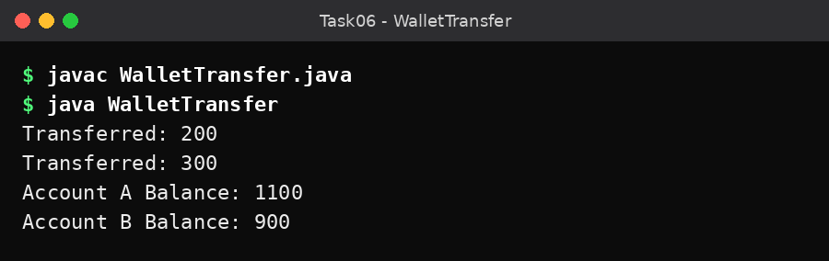
Figure 6.1 – Output of WalletTransfer.java
The transfer order may change, but the total balance remains 2000.
Note: System.identityHashCode() can theoretically produce equal values for different objects. For a production application, assign each account a unique ID and use that ID to determine a consistent lock order.

Part B – Producer-Consumer Using wait() and notifyAll()
Algorithm
Step 1: Create a circular buffer of capacity 5 with count, in and out indices.
Step 2: put(): while the buffer is full, call wait(); otherwise store the value, update the index and call notifyAll().
Step 3: take(): while the buffer is empty, call wait(); otherwise remove the value, update the index and call notifyAll().
Step 4: The producer puts the numbers 1 to 20; the consumer takes 20 numbers and adds them.
Step 5: Join both threads and print the sum (expected value 210).
Filename: TokenCounter.java
class TokenBuffer {

private final int[] buffer = new int[5];

private int count = 0;
private int in = 0;
private int out = 0;

public synchronized void put(int value)
throws InterruptedException {

while (count == buffer.length) {
wait();
}

buffer[in] = value;
in = (in + 1) % buffer.length;
count++;

notifyAll();
}

public synchronized int take()
throws InterruptedException {

while (count == 0) {
wait();
}

int value = buffer[out];

out = (out + 1) % buffer.length;
count--;

notifyAll();

return value;
}
}

public class TokenCounter {

public static void main(String[] args)
throws InterruptedException {

TokenBuffer buffer = new TokenBuffer();

final int total = 20;
final int[] sum = {0};

Thread producer = new Thread(() -> {

try {
for (int i = 1; i <= total; i++) {
buffer.put(i);
}
} catch (InterruptedException e) {
Thread.currentThread().interrupt();
}
});

Thread consumer = new Thread(() -> {

try {
for (int i = 1; i <= total; i++) {
sum[0] += buffer.take();
}
} catch (InterruptedException e) {
Thread.currentThread().interrupt();
}
});

producer.start();
consumer.start();

producer.join();
consumer.join();

System.out.println(
"Sum of tokens collected: " + sum[0]);

System.out.println("Expected: 210");
}
}
Input:
No keyboard input. The producer generates tokens 1 to 20.
Output
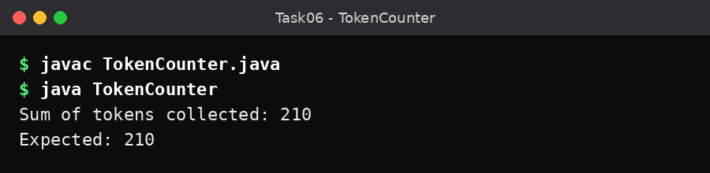
Figure 6.2 – Output of TokenCounter.java

Explanation
- The buffer has a capacity of five elements.
- The producer adds elements to the buffer.
- The consumer removes elements from the buffer.
- wait() makes a thread wait until another thread changes the buffer state.
- notifyAll() wakes up waiting threads.
- The while condition checks the buffer state again after a thread wakes up.
Question: Why should we use while instead of if? A thread may wake up without the condition becoming true, or another thread may change the buffer before it continues. The while loop checks the condition again and prevents incorrect operations.
Difference between sleep() and wait()
sleep() | wait()
Pauses a thread for a specified time | Waits for notification or interruption
Does not release an owned monitor lock | Releases the monitor lock
Static method of Thread | Method of Object
Used for timed pauses | Used for inter-thread communication

Alternative approach: ArrayBlockingQueue<Integer>(5) can be used instead of manually implementing the producer-consumer buffer. It provides thread-safe operations and a fixed capacity.

Conclusion
Deadlock prevention and producer-consumer communication were demonstrated using Java synchronization, wait and notifyAll methods.

Q7 – Concurrent Fault-Tolerant Result Processor (10 Marks)

Aim
To develop a concurrent Java program that processes multiple student result files using ExecutorService, Callable, Future and concurrent collections.

Introduction / Concepts
A concurrent fault-tolerant processor handles many files using multiple threads. If one file is missing or corrupted, the program should continue processing the remaining files. Java provides:
- ExecutorService: Manages a pool of threads.
- Callable: Performs a task and returns a result.
- Future: Retrieves the result of a task.
- ConcurrentLinkedQueue: Stores results safely when accessed by multiple threads.
System workflow
Start
|
Read result files
|
Create thread pool
|
Submit file tasks
|
Validate each file
|
-----------------
| |
Valid file Invalid file
| |
Process Record error
| |
-----------------
|
Generate summary
|
End

Algorithm
Step 1: Create a fixed thread pool with four worker threads.
Step 2: Open the scores folder and submit one ResultTask (Callable) for every .txt file.
Step 3: In each task, read the file, convert the text to an integer and validate that it lies between 0 and 100.
Step 4: Return "SUCCESS" with the score for a valid file; catch any exception and return "FAILED" with the reason.
Step 5: Collect each Future result with get(), print it and count successes and failures.
Step 6: Shut down the executor in the finally block.
Step 7: Print the processing summary.
Step 8: Stop.

Java Program
Filename: ResultProcessor.java
import java.io.*;
import java.nio.file.*;
import java.util.*;
import java.util.concurrent.*;

class ResultTask implements Callable<String> {

private final Path file;

ResultTask(Path file) {
this.file = file;
}

public String call() {

try {
String content = Files.readString(file).trim();

int score = Integer.parseInt(content);

if (score < 0 || score > 100) {
throw new IllegalArgumentException(
"Score must be between 0 and 100");
}

return "SUCCESS: " + file.getFileName()
+ " Score = " + score;

} catch (Exception e) {

return "FAILED: " + file.getFileName()
+ " - " + e.getMessage();
}
}
}

public class ResultProcessor {

public static void main(String[] args) {

ExecutorService executor =
Executors.newFixedThreadPool(4);

List<Future<String>> futures =
new ArrayList<>();

int success = 0;
int failure = 0;

try {
Path folder = Paths.get("scores");

try (DirectoryStream<Path> files =
Files.newDirectoryStream(folder, "*.txt")) {

for (Path file : files) {
futures.add(
executor.submit(new ResultTask(file)));
}
}

for (Future<String> future : futures) {

try {
String result = future.get();

System.out.println(result);

if (result.startsWith("SUCCESS")) {
success++;
} else {
failure++;
}

} catch (ExecutionException e) {
failure++;
System.out.println(
"Task error: " + e.getCause());
} catch (InterruptedException e) {
Thread.currentThread().interrupt();
}
}

} catch (IOException e) {
System.out.println(
"Folder error: " + e.getMessage());

} finally {
executor.shutdown();
}

System.out.println("\nProcessing Summary");
System.out.println("Successful files: " + success);
System.out.println("Failed files: " + failure);
}
}
Java version note: Files.readString() requires Java 11 or later.

Input
Create a folder named scores and place text files inside it. Each file contains one integer score between 0 and 100.
File | Content
student1.txt | 85
student2.txt | 90
student3.txt | 75
student4.txt (invalid file for failure test) | ABC

Output
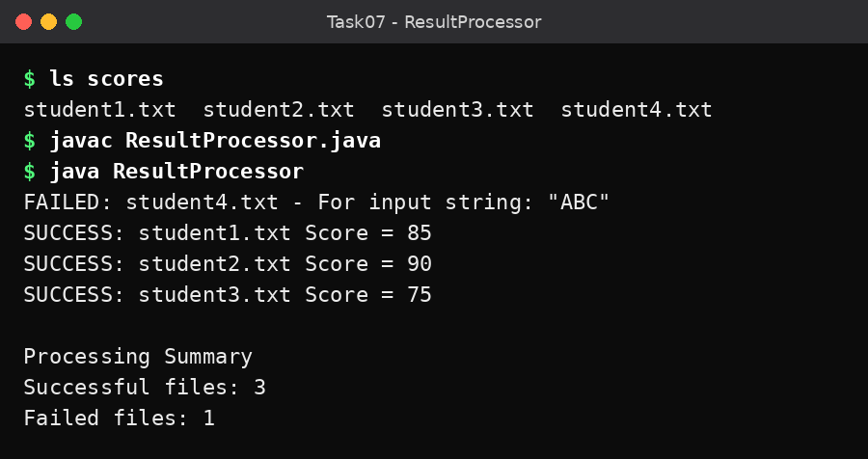
Figure 7.1 – Output of ResultProcessor.java
The order of the output may change because the files are processed concurrently.

Explanation
- The program creates a thread pool with four worker threads.
- Each file is submitted as a separate Callable task.
- Each task reads and validates its score.
- Valid files are marked successful.
- Invalid files are marked failed.
- The Future object retrieves the result of each task.
- The final summary displays the number of successful and failed files.
Question: How does the program handle failures? Each task catches file-reading and validation exceptions. Therefore, one failed file does not stop the remaining tasks.
Question: Why should we not create one thread for every file? Creating thousands of threads requires additional memory and scheduling overhead. A fixed thread pool limits the number of active worker threads and reuses them.

Performance Testing
Run the program with different thread pool sizes and record the actual time measured on your computer (System.nanoTime() or a stopwatch).
Thread pool size | Processing time (record actual time)
1
2
4
8

Question: Why are more threads not always better? Too many threads can increase memory usage, context switching and competition for disk access. The best thread-pool size depends on the computer and workload.
Alternative approaches: Parallel streams can process collections concurrently. ExecutorService provides better control over thread-pool size and task submission. One thread per file is possible but may use excessive resources for large numbers of files.
Complexity: For n files, the program stores O(n) Future references. The thread pool uses a maximum of p worker threads.

Conclusion
The concurrent result processor was implemented using ExecutorService, Callable and Future. It processes multiple files concurrently and handles invalid files without stopping the entire application.

Submission Details

Java Files
Task | Java filename
Q1 | ATM.java
Q2 | StorageDemo.java
Q3 | SalesReport.java
Q4 | ScannerStations.java
Q5 | SeatBooking.java
Q6 – Wallet | WalletTransfer.java
Q6 – Producer-consumer | TokenCounter.java
Q7 | ResultProcessor.java

GitHub Folder Structure
Repository name: CSA09-192524140-Assignment3
CSA09-192524140-Assignment3/
|
+-- README.md
|
+-- Task01/
| +-- ATM.java
+-- Task02/
| +-- StorageDemo.java
+-- Task03/
| +-- SalesReport.java
| +-- store1.txt
| +-- store2.txt
+-- Task04/
| +-- ScannerStations.java
+-- Task05/
| +-- SeatBooking.java
+-- Task06/
| +-- WalletTransfer.java
| +-- TokenCounter.java
+-- Task07/
| +-- ResultProcessor.java
| +-- scores/
| +-- student1.txt
| +-- student2.txt
| +-- student3.txt
+-- Screenshots/

