PROGRAMMING IN JAVA
ASSIGNMENT 4 – CO4
Topic: Event-Driven GUI Design
Student Name | J. Roopa Sai Divya
Register Number | 192524140
Course | Programming in Java (CSA09)
GitHub Repository | https://github.com/roopajallu814-arch/CSA09-192524140_Roopa-JAVA

Contents of this record:
Task | Title | Marks
Task 1 | GUI Design Review | 6 (K4)
Task 2 | From Requirement to Event-Driven Design | 8 (K4)
Task 3 | From Sketch to Layout | 9 (K4)
Task 4 | Event-Handling Forensics | 7 (K4)
Task 5 | Same Screen, Different Event-Handling Styles | 7 (K5)
Task 6 | Design Challenge | 13 (K5)

TASK 1 – GUI DESIGN REVIEW
6 Marks | K4 – Analyse

1.1 Diagnose the Design
The given fee-payment program has several design problems.
S.No. | Design deficiency | Explanation
1 | Poor separation of logic | Database operations and payment logic are written directly inside the event handler.
2 | Incorrect String comparison | == compares object references. The equals() method should compare text values.
3 | No input validation | Empty or invalid registration numbers and amounts may cause errors.
4 | Database operation on event thread | Database work blocks the GUI and makes the window unresponsive.
5 | Use of Thread.sleep() | The window freezes for 3 seconds while waiting for confirmation.
6 | No proper user feedback | The program only prints "Paid" in the console instead of showing a message in the window.
7 | Receipt button not implemented | The Receipt button does not generate or display a receipt.
8 | SQL injection risk | Directly joining user input into SQL statements makes the program vulnerable to SQL injection.
9 | Database connection not closed | The connection may remain open and waste resources.
10 | No window-closing handling | The program does not properly handle closing the window.
11 | Exceptions not handled | Database and interruption exceptions are not handled properly.

1.2 Repair the Design
Aim: To redesign the fee-payment application by separating the GUI and payment logic using a separate FeeService class.
Class Structure:
- FeeWindow – collects user input and displays results.
- FeeService – validates payment details and performs the payment.
- Database connection (JDBC) – connects the application to the database; it plugs into FeeService where the comment in the code marks the payment step.
Java Program – FeeWindow.java
import java.awt.*;
import java.awt.event.*;

class FeeService {

public String payFee(String regNo, String amountText) {

if (regNo.isEmpty() || amountText.isEmpty()) {
return "Please fill all fields";
}

try {
double amount = Double.parseDouble(amountText);

if (amount <= 0) {
return "Enter a valid amount";
}

// Payment processing can be connected to JDBC here.
return "Payment successful";

} catch (NumberFormatException e) {
return "Invalid amount";
}
}
}

public class FeeWindow extends Frame {

TextField regNo = new TextField(15);
TextField amount = new TextField(15);

Button pay = new Button("Pay");
Button clear = new Button("Clear");
Button receipt = new Button("Receipt");

Label status = new Label("Enter payment details");

FeeService service = new FeeService();

public FeeWindow() {

setTitle("Student Fee Payment");
setLayout(new GridLayout(4, 2, 10, 10));

add(new Label("Register Number:"));
add(regNo);

add(new Label("Amount:"));
add(amount);

add(pay);
add(clear);

add(receipt);
add(status);

pay.addActionListener(e -> {
String result = service.payFee(
regNo.getText(),
amount.getText()
);

status.setText(result);
});

clear.addActionListener(e -> {
regNo.setText("");
amount.setText("");
status.setText("Fields cleared");
});

receipt.addActionListener(e -> {
status.setText("Receipt feature selected");
});

addWindowListener(new WindowAdapter() {
public void windowClosing(WindowEvent e) {
dispose();
}
});

setSize(400, 250);
setVisible(true);
}

public static void main(String[] args) {
new FeeWindow();
}
}

Output:
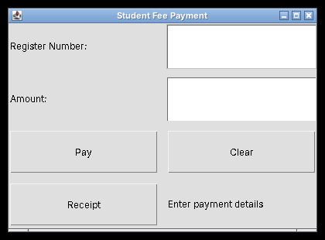
Figure 1.1 – Fee payment window on start-up
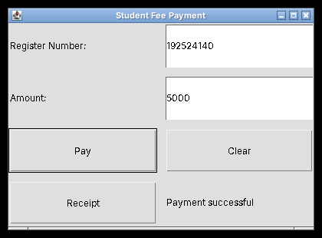
Figure 1.2 – Valid register number and amount: "Payment successful"
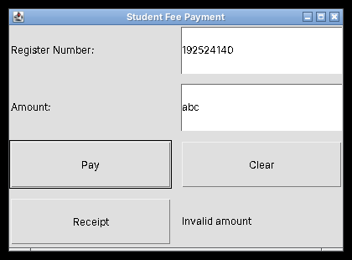
Figure 1.3 – Non-numeric amount: "Invalid amount"
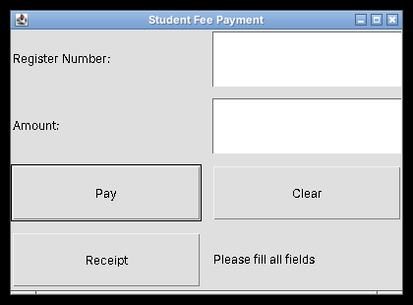
Figure 1.4 – Empty fields: "Please fill all fields"
Note: This is a basic GUI design demonstrating separation of responsibilities. Actual JDBC payment processing and receipt generation must be implemented to satisfy those full requirements.

1.3 Design Defence
The redesigned program is easier to test and maintain because the GUI and payment logic are separated. The FeeWindow class handles user interaction, while the FeeService class handles validation and payment processing. Changes to the payment logic do not require major changes to the GUI. Each class can be tested independently, making debugging easier and improving code reusability.

Alternative Concept and Complexity Analysis
If every button has its own listener object, the program does not need to check every button using a long if-else chain.
Approach | Event dispatch time | Extra space
Single listener with if-else | O(k) worst case | O(1) listener
Separate listener objects | O(1) dispatch after event registration | O(k) listeners

Conclusion: Separate listeners or Swing Action objects make the program easier to maintain when many buttons are present. A single listener may use less memory, but it becomes harder to manage as the number of buttons increases.

TASK 2 – FROM REQUIREMENT TO EVENT-DRIVEN DESIGN
8 Marks | K4 – Analyse
Title: Hospital Outpatient Appointment Desk

2.1 Model the Events
Event source | Event object | Listener interface | Action performed
Patient ID text field | ActionEvent | ActionListener | Accepts patient ID
Department choice | ItemEvent | ItemListener | Refreshes doctor list
Doctor list | ItemEvent | ItemListener | Selects a doctor
Time slot choice | ItemEvent | ItemListener | Selects appointment time
Book button | ActionEvent | ActionListener | Validates and books appointment
Window close button | WindowEvent | WindowListener | Asks for confirmation before closing

2.2 Component Hierarchy
The appointment window can be designed using the following hierarchy:
JFrame – Appointment Desk
|
|-- JPanel – Patient Details
| |-- JLabel – Patient ID
| |-- JTextField – Patient ID
|
|-- JPanel – Appointment Details
| |-- JLabel – Department
| |-- JComboBox – Department
| |-- JLabel – Doctor
| |-- JComboBox – Doctor
| |-- JLabel – Time Slot
| |-- JComboBox – Time Slot
|
|-- JPanel – Actions
| |-- JButton – Book Appointment
| |-- JButton – Clear
|
|-- JLabel – Status Message

Components used:
- JFrame – main application window.
- JPanel – groups related components.
- JLabel – displays text.
- JTextField – accepts patient ID.
- JComboBox – displays departments, doctors and time slots.
- JButton – performs booking and clearing actions.

2.3 Design the Handler Logic
(a) Refreshing the doctor list when the department changes
BEGIN
Read selected department
Clear the doctor list

IF department is selected THEN
Get doctors for the selected department
Add doctors to the doctor list
END IF

Update the doctor list
END

(b) Validating and booking the appointment
BEGIN
Read patient ID
Read selected department
Read selected doctor
Read selected time slot

IF patient ID is empty THEN
Display "Enter Patient ID"
ELSE IF department is not selected THEN
Display "Select Department"
ELSE IF doctor is not selected THEN
Display "Select Doctor"
ELSE IF time slot is not selected THEN
Display "Select Time Slot"
ELSE
Book the appointment
Display booking confirmation
END IF
END

2.4 Trace the Event Sequence
Order of method calls:
- main() starts the application.
- The JFrame object is created.
- The constructor initializes the components.
- Listeners are registered.
- setVisible(true) displays the window.
- The receptionist enters the patient ID.
- The department selection event occurs.
- The doctor list is refreshed.
- The receptionist selects the doctor and time slot.
- The Book button generates an ActionEvent.
- The booking handler validates the details.
- The application displays confirmation or an error.
- The window close event occurs.
- The application asks for confirmation if a booking is in progress.
- The window closes if the user confirms.
Comparison with applet life cycle:
Applet method | Purpose
init() | Initializes the applet
start() | Starts or resumes execution
paint() | Displays graphics
stop() | Pauses execution
destroy() | Releases resources

Difference: An applet uses predefined life-cycle methods controlled by its environment. A GUI application mainly responds to user-generated events through listeners and event handlers.

Alternative Concept and Complexity Analysis
The doctor list can either be fetched from the database every time the department changes or loaded once into a Map<String, List<Doctor>>.
Approach | Time per department change | Extra memory
Fetch from database every time | Database query time, approximately O(m) to process m doctors | O(m) for the current list
Load once into a Map | O(1) average lookup plus O(m) to display the selected doctors | O(d × m) for d departments with up to m doctors each

Conclusion: Loading the doctor lists into a Map reduces repeated database access and improves response time. It uses more memory because the doctor information is stored in advance.

TASK 3 – FROM SKETCH TO LAYOUT
9 Marks | K4 – Analyse
Title: Campus Library Search Screen

3.1 Choose the Layout Managers
Container | Layout manager | Reason
Main frame | BorderLayout | Divides the window into top, centre and bottom regions
Search panel | FlowLayout | Arranges search components in a row
Results panel | BorderLayout | Allows the results area to expand
Bottom panel | FlowLayout | Keeps Prev, Next and Reserve buttons in a row

Explanation:
- BorderLayout allows the centre region to use the available extra space.
- FlowLayout keeps components arranged in a row.
- GridLayout is useful when equal-sized rows and columns are needed.
- CardLayout is useful for switching between different screens.

3.2 Design the Nested Containers
JFrame – Library Search
|
|-- JPanel – North (FlowLayout)
| |-- JLabel – Library Search
| |-- JTextField – Search
| |-- JComboBox – Category
| |-- JButton – Search
|
|-- JPanel – Center (BorderLayout)
| |-- JTable – Search Results
|
|-- JPanel – South (BorderLayout)
|-- JLabel – Status Message
|-- JPanel – FlowLayout
|-- JButton – Prev
|-- JButton – Next
|-- JButton – Reserve

3.3 Implement the Screen
Java Program – LibrarySearch.java
import java.awt.*;
import javax.swing.*;

public class LibrarySearch extends JFrame {

JTextField searchField = new JTextField(15);

JComboBox<String> category =
new JComboBox<>(new String[]{
"All", "Books", "Journals", "Magazines"
});

JButton search = new JButton("Search");
JButton prev = new JButton("Prev");
JButton next = new JButton("Next");
JButton reserve = new JButton("Reserve");

JLabel status = new JLabel("Ready");

public LibrarySearch() {

setTitle("Campus Library Search");
setLayout(new BorderLayout(10, 10));

JPanel top = new JPanel(new FlowLayout());

top.add(new JLabel("Library Search"));
top.add(searchField);
top.add(category);
top.add(search);

String[] columns = {
"Book ID", "Title", "Author"
};

String[][] data = {
{"101", "Java Programming", "James"},
{"102", "Data Structures", "Mark"},
{"103", "Database Systems", "John"}
};

JTable table = new JTable(data, columns);

JPanel bottom = new JPanel(new BorderLayout());

JPanel buttons = new JPanel(new FlowLayout());

buttons.add(prev);
buttons.add(next);
buttons.add(reserve);

bottom.add(status, BorderLayout.WEST);
bottom.add(buttons, BorderLayout.EAST);

add(top, BorderLayout.NORTH);
add(new JScrollPane(table), BorderLayout.CENTER);
add(bottom, BorderLayout.SOUTH);

search.addActionListener(e ->
status.setText("Searching..."));

reserve.addActionListener(e ->
status.setText("Reservation selected"));

setDefaultCloseOperation(JFrame.EXIT_ON_CLOSE);
setSize(600, 400);
setLocationRelativeTo(null);
setVisible(true);
}

public static void main(String[] args) {
SwingUtilities.invokeLater(LibrarySearch::new);
}
}

3.4 Test the Resizing Behaviour
The program was run and screenshots were captured at three different window sizes.
Test | Window size | Observed behaviour
1 | Small (420 × 280) | Results area becomes smaller but remains visible. The FlowLayout search row wraps, so the Search button moves to a second line.
2 | Medium (600 × 400) | Results area expands to use the available space; the whole search row fits on one line.
3 | Large (1000 × 650) | Results area expands further while the top search row and bottom buttons stay in their panels.

Output:
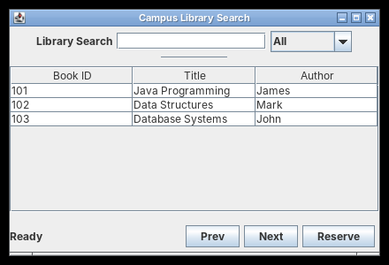
Figure 3.1 – Small window
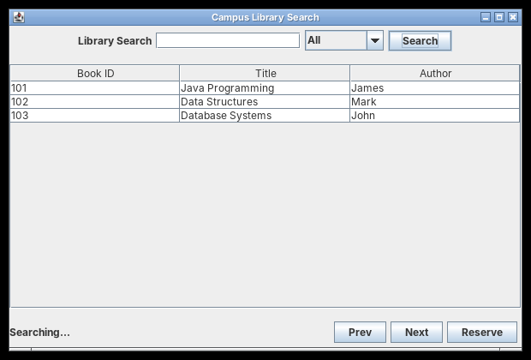
Figure 3.2 – Medium window (after clicking Search: status shows "Searching...")
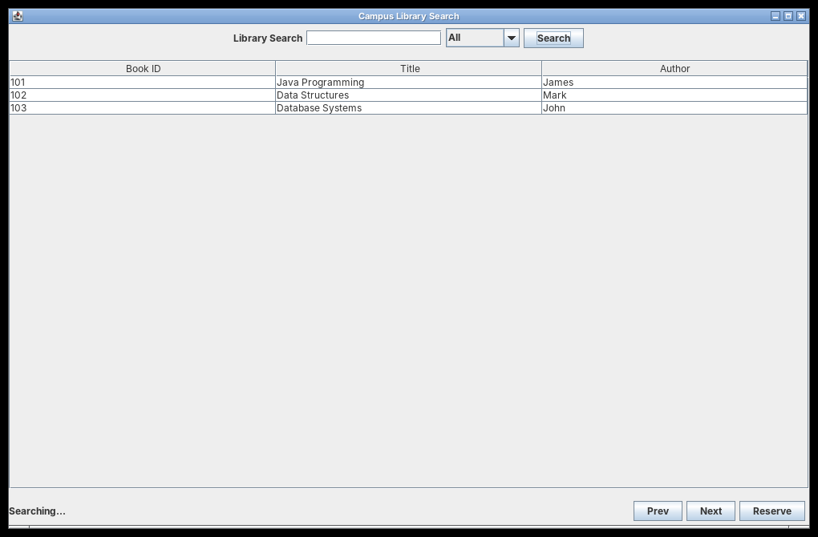
Figure 3.3 – Large window
Result: The BorderLayout and nested FlowLayout panels allow the central results area to expand when the window is resized while keeping the search and button panels in their designated regions.

Alternative Concept and Complexity Analysis
Design | Resizing behaviour | Layout computation | Space
Nested BorderLayout and FlowLayout | Automatically adjusts to available space | Depends on the number of components | Uses multiple containers
GridBagLayout | Flexible positioning and resizing | More constraint calculations | Depends on components and constraints
Absolute positioning | Components do not automatically adjust | Simple positioning calculations | Fewer nested containers may be needed

Conclusion: Nested BorderLayout and FlowLayout panels are suitable for this screen because they provide simple and automatic resizing. Absolute positioning is less suitable because components may overlap or become misplaced when the window size changes.

TASK 4 – EVENT-HANDLING FORENSICS
7 Marks | K4 – Analyse

4.1 Locate the Defect
The given drawing-pad program contains the following defects:
- The method is written as mouseclicked() instead of mouseClicked(). Java is case-sensitive, so the listener method is not overridden.
- The label is never updated after a click.
- The program uses getGraphics() to draw directly on the window. These drawings are temporary and may disappear when the window is repainted.
- The program does not store the clicked points for future repainting.

4.2 Construct a Failing Interaction
Steps to reproduce the problem:
- Open the drawing-pad window.
- Click several places inside the window.
- Observe that the dots are not drawn and the click count remains zero.
- Correct the method name and run the program again.
- Click several places to draw dots.
- Minimise the window and restore it.
Reason: Direct drawing using getGraphics() is not permanent. When the window is minimised, restored or repainted, the drawing may disappear because the program has not stored the points.
The faulty version below was reconstructed from the four defects listed above, and then run with six clicks:
Java Program – BuggyDrawPad.java (faulty version)
import java.awt.*;
import java.awt.event.*;

public class BuggyDrawPad extends Frame {

Label status = new Label("Clicks: 0");

public BuggyDrawPad() {

super("Draw Pad (Faulty Version)");

add(status, BorderLayout.SOUTH);

addMouseListener(new MouseAdapter() {

// Defect 1: wrong method name (mouseclicked) - never called
public void mouseclicked(MouseEvent e) {

// Defect 3: temporary drawing with getGraphics()
Graphics g = getGraphics();
g.fillOval(e.getX() - 3, e.getY() - 3, 6, 6);

// Defect 2: label never updated, Defect 4: points not stored
}
});

addWindowListener(new WindowAdapter() {
public void windowClosing(WindowEvent e) {
dispose();
}
});

setSize(400, 300);
}

public static void main(String[] args) {
new BuggyDrawPad().setVisible(true);
}
}

Output:
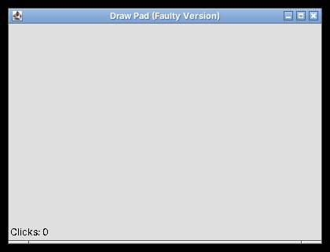
Figure 4.1 – Faulty version after six clicks: no dots and "Clicks: 0"

4.3 Repair the Program
Aim: To create a drawing pad that counts mouse clicks, updates the label and preserves the dots during repainting.
Java Program – DrawPad.java
import java.awt.*;
import java.awt.event.*;
import java.util.ArrayList;
import java.util.List;

public class DrawPad extends Frame {

private final List<Point> points = new ArrayList<>();
private final Label status = new Label("Clicks: 0");

public DrawPad() {

super("Draw Pad");

add(status, BorderLayout.SOUTH);

addMouseListener(new MouseAdapter() {

@Override
public void mouseClicked(MouseEvent e) {

points.add(e.getPoint());

status.setText("Clicks: " + points.size());

repaint();
}
});

addWindowListener(new WindowAdapter() {

@Override
public void windowClosing(WindowEvent e) {
dispose();
}
});

setSize(400, 300);
}

@Override
public void paint(Graphics g) {

super.paint(g);

for (Point p : points) {

g.fillOval(
p.x - 3,
p.y - 3,
6,
6
);
}
}

public static void main(String[] args) {
new DrawPad().setVisible(true);
}
}

Explanation:
- MouseAdapter handles mouse-click events.
- mouseClicked() is used to detect a click.
- points.add() stores the clicked location.
- status.setText() updates the click count.
- repaint() requests the window to redraw.
- paint() draws all stored points as 6 × 6 circles.
- WindowAdapter handles the closing event.
Output:
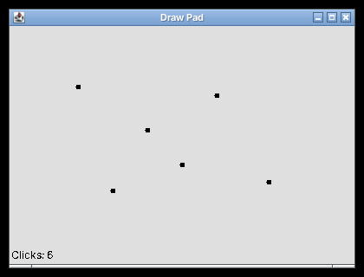
Figure 4.2 – Before minimising: six dots and "Clicks: 6"
Figure 4.3 – After minimising and restoring: the dots are still visible

4.4 Prevent Recurrence
The @Override annotation checks whether a method correctly overrides a method from its parent class or interface. If mouseclicked() is written instead of mouseClicked(), the compiler reports an error because the method does not override the correct method.

Complete the Code – TODO 1 and TODO 2
TODO 1:
@Override
public void mouseClicked(MouseEvent e) {

points.add(e.getPoint());

status.setText("Clicks: " + points.size());

repaint();
}

TODO 2:
@Override
public void paint(Graphics g) {

super.paint(g);

for (Point p : points) {

g.fillOval(
p.x - 3,
p.y - 3,
6,
6
);
}
}

Compiler error when the method is misspelled:
If mouseClicked() is changed to mouseclicked() while @Override is retained, the compiler reports an error. The output below is the actual javac output:
DrawPad.java:19: error: method does not override or implement a method from a supertype
@Override
^
1 error

Alternative Concept and Complexity Analysis
An alternative is to draw the dots on an off-screen BufferedImage and copy that image to the screen inside paint().
Approach | Repaint time | Space
Store points and redraw them | O(n), where n is the number of clicks | O(n) points
Store drawing in BufferedImage | O(width × height) to copy the image | O(width × height) pixels

Conclusion: Storing points is simple and memory-efficient for a small number of dots. A BufferedImage is useful for more complex drawings because the drawing can be preserved as an image.

TASK 5 – SAME SCREEN, DIFFERENT EVENT-HANDLING STYLES
7 Marks | K5 – Evaluate
Title: Currency Converter

5.1 Four Implementations
The Convert action can be implemented in four different ways.

(a) Frame Implements ActionListener
import java.awt.*;
import java.awt.event.*;

public class ConverterA extends Frame
implements ActionListener {

TextField amount = new TextField(10);
Button convert = new Button("Convert");
Label result = new Label(" ");

ConverterA() {

setLayout(new FlowLayout());

add(new Label("INR"));
add(amount);
add(convert);
add(result);

convert.addActionListener(this);

addWindowListener(new WindowAdapter() {
public void windowClosing(WindowEvent e) {
dispose();
}
});

setSize(300, 150);
setVisible(true);
}

public void actionPerformed(ActionEvent e) {
convertAmount();
}

void convertAmount() {

try {
double value =
Double.parseDouble(amount.getText());

double converted = value * 0.012;

result.setText("USD: " +
String.format("%.2f", converted));

} catch (NumberFormatException e) {
result.setText("Invalid amount");
}
}

public static void main(String[] args) {
new ConverterA();
}
}

Output:
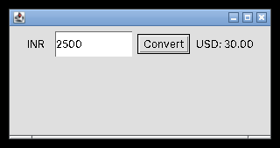
Figure 5.1 – ConverterA: 2500 INR converted to "USD: 30.00"

(b) Named Inner Class
import java.awt.*;
import java.awt.event.*;

public class ConverterB extends Frame {

TextField amount = new TextField(10);
Button convert = new Button("Convert");
Label result = new Label(" ");

class ConvertHandler implements ActionListener {

public void actionPerformed(ActionEvent e) {

try {
double value =
Double.parseDouble(amount.getText());

result.setText("USD: " +
String.format("%.2f", value * 0.012));

} catch (NumberFormatException ex) {
result.setText("Invalid amount");
}
}
}

ConverterB() {

setLayout(new FlowLayout());

add(amount);
add(convert);
add(result);

convert.addActionListener(new ConvertHandler());

addWindowListener(new WindowAdapter() {
public void windowClosing(WindowEvent e) {
dispose();
}
});

setSize(300, 150);
setVisible(true);
}

public static void main(String[] args) {
new ConverterB();
}
}

Output:
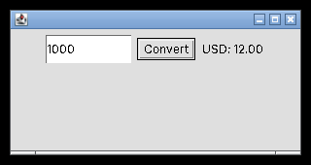
Figure 5.2 – ConverterB: 1000 INR converted to "USD: 12.00"

(c) Anonymous Inner Class
import java.awt.*;
import java.awt.event.*;

public class ConverterC extends Frame {

TextField amount = new TextField(10);
Button convert = new Button("Convert");
Label result = new Label(" ");

ConverterC() {

setLayout(new FlowLayout());

add(amount);
add(convert);
add(result);

convert.addActionListener(new ActionListener() {

public void actionPerformed(ActionEvent e) {

try {
double value =
Double.parseDouble(amount.getText());

result.setText("USD: " +
String.format("%.2f", value * 0.012));

} catch (NumberFormatException ex) {
result.setText("Invalid amount");
}
}
});

addWindowListener(new WindowAdapter() {
public void windowClosing(WindowEvent e) {
dispose();
}
});

setSize(300, 150);
setVisible(true);
}

public static void main(String[] args) {
new ConverterC();
}
}

Output:
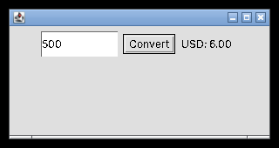
Figure 5.3 – ConverterC: 500 INR converted to "USD: 6.00"

(d) Lambda Expression
The lambda version is the complete Swing program below, which also adds the currency choice, the Enter-key trigger and the dialog box.
Java Program – Converter.java
import java.awt.FlowLayout;
import java.awt.event.ActionListener;
import javax.swing.JButton;
import javax.swing.JComboBox;
import javax.swing.JFrame;
import javax.swing.JLabel;
import javax.swing.JTextField;
import javax.swing.JOptionPane;
import javax.swing.SwingUtilities;

public class Converter extends JFrame {

private final JTextField amount = new JTextField(10);

private final JComboBox<String> target =
new JComboBox<>(new String[]{"USD", "EUR"});

private final JLabel result = new JLabel(" ");

private static double rate(String currency) {
return currency.equals("USD") ? 0.012 : 0.011;
}

public Converter() {

super("Currency Converter");

setLayout(new FlowLayout());

JButton convertButton = new JButton("Convert");

add(new JLabel("INR"));
add(amount);
add(target);
add(convertButton);
add(result);

ActionListener listener = e -> convert();

convertButton.addActionListener(listener);
amount.addActionListener(listener);

setDefaultCloseOperation(EXIT_ON_CLOSE);

pack();
setLocationRelativeTo(null);
}

private void convert() {

try {
double value =
Double.parseDouble(amount.getText());

if (value < 0) {
throw new NumberFormatException();
}

String currency =
(String) target.getSelectedItem();

double converted = value * rate(currency);

String output = String.format(
"%.2f %s", converted, currency
);

result.setText(output);

JOptionPane.showMessageDialog(
this, output, "Conversion Result",
JOptionPane.INFORMATION_MESSAGE
);

} catch (NumberFormatException e) {

result.setText("Invalid amount");

JOptionPane.showMessageDialog(
this, "Invalid amount",
"Error", JOptionPane.ERROR_MESSAGE
);
}
}

public static void main(String[] args) {

SwingUtilities.invokeLater(() ->
new Converter().setVisible(true)
);
}
}

Output:
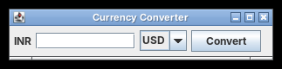
Figure 5.4 – Converter window on start-up
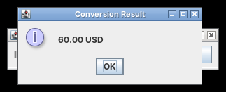
Figure 5.5 – Enter pressed in the amount field (5000): result dialog "60.00 USD"
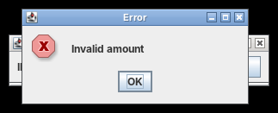
Figure 5.6 – Invalid input: error dialog "Invalid amount"
The conversion rates above are the fixed rates supplied in the assignment. They are for demonstrating the GUI, not live exchange rates.

5.2 Change the Requirement
The converter must also convert when Enter is pressed in the amount field and display the result in a dialog box.
Implementation | Required change
Frame implements ActionListener | Register the frame as listener for the text field and show a dialog in actionPerformed()
Named inner class | Register the same handler with the text field and add dialog display
Anonymous inner class | Add another listener or share the handler with the text field
Lambda expression | Register the same lambda listener with both the button and text field

In the supplied lambda program, these two lines register one shared listener:
convertButton.addActionListener(listener);
amount.addActionListener(listener);

The dialog is displayed using:
JOptionPane.showMessageDialog(this, output);

5.3 Compare the Styles
Style | Readability | Access to frame fields | Reuse | Ease of change
Frame implements ActionListener | Simple for small programs | Direct | Limited | Moderate
Named inner class | Clear and organised | Direct | Good | Good
Anonymous inner class | More code inside constructor | Direct | Limited | Moderate
Lambda expression | Short and clear | Direct | Good when shared | Easy

My preferred approach: For a large application, I would use named handler classes or reusable Swing Action objects. They separate responsibilities, support reuse and make maintenance easier.

Alternative Concept and Complexity Analysis
A method reference can replace the lambda when the handler method has the same parameter list as ActionListener.actionPerformed(ActionEvent). The convert() method in the program takes no parameters, so it is called through a lambda:
convertButton.addActionListener(e -> convert());

If the handler is declared as private void convert(ActionEvent e), a true method reference can be used:
convertButton.addActionListener(this::convert);

A shared Swing Action can be registered with a button, menu item and keyboard shortcut.
Approach | Listener objects | Adding another trigger
Separate listeners | May create multiple objects | Register another listener
Shared handler | One shared handler can serve multiple triggers | Reuse the same handler
Shared Swing Action | One shared Action object | Attach the Action to another component

Conclusion: A shared handler or Swing Action is useful when multiple components must perform the same operation. It avoids duplicating conversion logic.

TASK 6 – DESIGN CHALLENGE
13 Marks | K5 – Evaluate
Title: Campus Event Registration Desktop Application

Stage 1 – Interpret the Problem
Aim: To design a desktop application for managing student registrations for campus events using Java Swing and MySQL.

1. Users
- Student: Registers for campus events.
- Committee Member: Views registrations, filters registrations and exports registration details.

2. Screens
Screen | Purpose
Registration Screen | Enter student details and register for an event
Registration List Screen | Display all registrations in a table
Filter Screen | Filter registrations by event
Export Screen | Export registration details

3. Data Required
- Student ID
- Student Name
- Department
- Event ID
- Event Name
- Registration Date

4. Application Rules
- Student ID must not be empty.
- Student name must not be empty.
- An event must be selected.
- A student cannot register twice for the same event.
- Registration details must be stored in MySQL.
- Invalid inputs must display clear error messages.
- Database operations must not freeze the GUI.
- Registration details must be displayed in a table.

5. Testable Requirements
S.No. | Requirement | Expected result
1 | Enter valid student details | Registration successful
2 | Leave student ID empty | Error message displayed
3 | Leave student name empty | Error message displayed
4 | Register for an event twice | Duplicate registration rejected
5 | Select an event filter | Matching registrations displayed
6 | Export registrations | File created successfully

Stage 2 – Propose the Screen and Event Flow

Screen Design
CAMPUS EVENT REGISTRATION
-----------------------------------

Student ID: [______________]

Student Name: [______________]

Department: [______________]

Select Event: [______________]

[ REGISTER ] [ CLEAR ]

-----------------------------------
Status: Ready
-----------------------------------

REGISTRATION LIST

Event Filter: [ All Events v ]

-----------------------------------
| Student ID | Name | Event |
-----------------------------------
| 101 | Ravi | Tech Fest |
| 102 | Priya| Cultural |
-----------------------------------

[ EXPORT ] [ REFRESH ]

Menu Bar
JMenuBar
|
|-- File
| |-- Export
| |-- Exit
|
|-- Registration
| |-- Register
| |-- View Registrations
|
|-- Help
|-- About

Event Flow
Start Application
|
v
Display Registration Window
|
v
Enter Student Details
|
v
Select Event
|
v
Click Register
|
v
Validate Input
|
v
Check Duplicate Registration
|
v
Save Details in Database
|
v
Display Confirmation
|
v
Refresh Registration Table
|
v
End

Stage 3 – Identify the Critical Design Decisions

1. Input Validation
Input validation is performed in the service layer before inserting registration details into the database.

2. Duplicate Checking
The application checks whether the same student has already registered for the selected event. A database unique constraint is also used to prevent duplicate registrations.

3. Database Access
JDBC is used to connect Java to MySQL.

4. Responsiveness
SwingWorker is used for long-running database operations. It performs background work without blocking the Event Dispatch Thread.

5. Error Handling
The application displays suitable error messages using JOptionPane.

Stage 4 – Design the Classes and Handlers

Class Diagram
EventRegistrationApp
|
v
RegistrationFrame
|
v
RegistrationService
|
v
RegistrationDAO
|
v
MySQL DB

Class descriptions:
Class | Responsibility
EventRegistrationApp | Starts the application
RegistrationFrame | Displays the GUI and handles events
RegistrationService | Validates details and applies business rules
RegistrationDAO | Performs JDBC database operations

In the implementation in Stage 5, the frame, the application entry point and the DAO-style database calls are combined in EventRegistrationApp, RegistrationService and DBConnection to keep the program small.

Pseudocode – Register Action
BEGIN
Read student ID
Read student name
Read department
Read selected event

IF any required field is empty THEN
Display error message
ELSE
Check duplicate registration

IF registration already exists THEN
Display duplicate registration error
ELSE
Insert registration into database
Display success message
Refresh registration table
END IF
END IF
END

Pseudocode – Filter Action
BEGIN
Read selected event

IF selected event is "All Events" THEN
Fetch all registrations
ELSE
Fetch registrations for selected event
END IF

Display matching registrations in JTable
END

Stage 5 – Implement and Demonstrate

Step 1: Create the MySQL Database
Open MySQL Workbench and execute this SQL script:
SQL Script – database.sql
CREATE DATABASE campus_events;

USE campus_events;

CREATE TABLE registrations (
id INT AUTO_INCREMENT PRIMARY KEY,
student_id VARCHAR(20) NOT NULL,
student_name VARCHAR(100) NOT NULL,
department VARCHAR(50),
event_name VARCHAR(100) NOT NULL,
registration_date TIMESTAMP DEFAULT CURRENT_TIMESTAMP,
UNIQUE(student_id, event_name)
);

Step 2: JDBC Connection
Java Program – DBConnection.java
import java.sql.*;

public class DBConnection {

public static Connection getConnection()
throws SQLException {

String url =
"jdbc:mysql://localhost:3306/campus_events";

String user = "root";
String password = "your_password";

return DriverManager.getConnection(
url, user, password
);
}
}

Replace your_password with your actual MySQL password. Add the MySQL Connector/J library to your Java project.

Step 3: Registration Service
Java Program – RegistrationService.java
import java.sql.*;

public class RegistrationService {

public void register(
String id,
String name,
String department,
String event) throws Exception {

if (id.trim().isEmpty()
|| name.trim().isEmpty()
|| event == null
|| event.trim().isEmpty()) {

throw new Exception("Please fill all required fields");
}

String sql =
"INSERT INTO registrations " +
"(student_id, student_name, department, event_name) " +
"VALUES (?, ?, ?, ?)";

try (Connection con = DBConnection.getConnection();
PreparedStatement ps = con.prepareStatement(sql)) {

ps.setString(1, id);
ps.setString(2, name);
ps.setString(3, department);
ps.setString(4, event);

ps.executeUpdate();

} catch (SQLIntegrityConstraintViolationException e) {
throw new Exception(
"Student already registered for this event"
);
}
}
}

Step 4: Main Swing Application
Java Program – EventRegistrationApp.java
import java.awt.*;
import java.awt.event.*;
import java.io.*;
import java.sql.*;
import javax.swing.*;
import javax.swing.table.DefaultTableModel;

public class EventRegistrationApp extends JFrame {

JTextField id = new JTextField(12);
JTextField name = new JTextField(12);

JComboBox<String> department =
new JComboBox<>(new String[]{
"AIDS", "CSE", "ECE", "IT"
});

JComboBox<String> event =
new JComboBox<>(new String[]{
"Tech Fest", "Cultural Fest", "Sports"
});

JComboBox<String> filter =
new JComboBox<>(new String[]{
"All Events", "Tech Fest",
"Cultural Fest", "Sports"
});

JLabel status = new JLabel("Ready");

DefaultTableModel model =
new DefaultTableModel(
new String[]{
"Student ID", "Student Name",
"Department", "Event"
}, 0
);

JTable table = new JTable(model);

RegistrationService service =
new RegistrationService();

public EventRegistrationApp() {

setTitle("Campus Event Registration");
setLayout(new BorderLayout(10, 10));

JMenuBar menuBar = new JMenuBar();

JMenu fileMenu = new JMenu("File");

JMenuItem exportItem = new JMenuItem("Export");
JMenuItem exitItem = new JMenuItem("Exit");

fileMenu.add(exportItem);
fileMenu.add(exitItem);

menuBar.add(fileMenu);
setJMenuBar(menuBar);

JPanel form = new JPanel(new GridLayout(5, 2, 5, 5));

JButton register = new JButton("Register");
JButton clear = new JButton("Clear");
JButton refresh = new JButton("Refresh");
JButton export = new JButton("Export");

form.add(new JLabel("Student ID"));
form.add(id);

form.add(new JLabel("Student Name"));
form.add(name);

form.add(new JLabel("Department"));
form.add(department);

form.add(new JLabel("Event"));
form.add(event);

form.add(register);
form.add(clear);

JPanel top = new JPanel(new BorderLayout());

top.add(form, BorderLayout.CENTER);

JPanel filterPanel = new JPanel();

filterPanel.add(new JLabel("Filter Event"));
filterPanel.add(filter);
filterPanel.add(refresh);
filterPanel.add(export);

top.add(filterPanel, BorderLayout.SOUTH);

add(top, BorderLayout.NORTH);
add(new JScrollPane(table), BorderLayout.CENTER);
add(status, BorderLayout.SOUTH);

register.addActionListener(e -> registerStudent());

clear.addActionListener(e -> {
id.setText("");
name.setText("");
status.setText("Fields cleared");
});

refresh.addActionListener(e -> loadData());

filter.addActionListener(e -> loadData());

export.addActionListener(e -> exportData());

exportItem.addActionListener(e -> exportData());

exitItem.addActionListener(e -> dispose());

addWindowListener(new WindowAdapter() {
public void windowClosing(WindowEvent e) {
dispose();
}
});

setSize(750, 500);
setLocationRelativeTo(null);

loadData();
setVisible(true);
}

private void registerStudent() {

String studentId = id.getText();
String studentName = name.getText();
String dept = (String) department.getSelectedItem();
String selectedEvent = (String) event.getSelectedItem();

status.setText("Registering...");

new SwingWorker<Void, Void>() {

protected Void doInBackground() throws Exception {

service.register(
studentId,
studentName,
dept,
selectedEvent
);

return null;
}

protected void done() {

try {
get();

JOptionPane.showMessageDialog(
EventRegistrationApp.this,
"Registration successful"
);

status.setText("Registration successful");

loadData();

} catch (Exception ex) {

JOptionPane.showMessageDialog(
EventRegistrationApp.this,
ex.getCause() == null
? ex.getMessage()
: ex.getCause().getMessage(),
"Registration Error",
JOptionPane.ERROR_MESSAGE
);

status.setText("Registration failed");
}
}

}.execute();
}

private void loadData() {

String selected =
(String) filter.getSelectedItem();

String sql =
"SELECT student_id, student_name, department, event_name " +
"FROM registrations";

if (selected != null &&
!selected.equals("All Events")) {
sql += " WHERE event_name = ?";
}

sql += " ORDER BY id DESC";

final String query = sql;

new SwingWorker<Void, Void>() {

protected Void doInBackground() throws Exception {

model.setRowCount(0);

try (Connection con = DBConnection.getConnection();
PreparedStatement ps =
con.prepareStatement(query)) {

if (selected != null &&
!selected.equals("All Events")) {
ps.setString(1, selected);
}

try (ResultSet rs = ps.executeQuery()) {

while (rs.next()) {

model.addRow(new Object[]{
rs.getString("student_id"),
rs.getString("student_name"),
rs.getString("department"),
rs.getString("event_name")
});
}
}
}

return null;
}

protected void done() {

try {
get();
status.setText("Records loaded");

} catch (Exception e) {
status.setText("Unable to load records");
}
}

}.execute();
}

private void exportData() {

JFileChooser chooser = new JFileChooser();

chooser.setSelectedFile(
new File("registrations.csv")
);

if (chooser.showSaveDialog(this) ==
JFileChooser.APPROVE_OPTION) {

try (PrintWriter writer = new PrintWriter(
chooser.getSelectedFile())) {

writer.println(
"Student ID,Student Name,Department,Event"
);

for (int i = 0; i < model.getRowCount(); i++) {

for (int j = 0; j < model.getColumnCount(); j++) {

if (j > 0) {
writer.print(",");
}

String value =
model.getValueAt(i, j).toString();

writer.print("\"" +
value.replace("\"", "\"\"") + "\"");
}

writer.println();
}

JOptionPane.showMessageDialog(
this, "Export successful"
);

} catch (Exception e) {

JOptionPane.showMessageDialog(
this, "Export failed: " + e.getMessage()
);
}
}
}

public static void main(String[] args) {

SwingUtilities.invokeLater(() ->
new EventRegistrationApp().setVisible(true)
);
}
}

Correction made while testing: In loadData(), the variable sql is changed with += before it is used inside the SwingWorker. Java requires variables used inside an inner class to be final or effectively final, so the original code does not compile. The fix is the line final String query = sql; and using query in prepareStatement(query).
Implementation note: This is a basic working design with database insertion, duplicate protection, filtering and CSV export. For a production application, database loading should use pagination, and the table model should be updated on the Event Dispatch Thread after background loading. The current code is a starting implementation, not a demonstration of 100,000-record pagination.

Demonstration and Test Cases
Test case | Input | Expected output
Normal registration | Valid student details and event | Registration successful
Invalid registration | Empty student ID | Please fill all required fields
Duplicate registration | Same student and event twice | Student already registered for this event
Event filtering | Select Tech Fest | Only Tech Fest records displayed
Export | Click Export | CSV file saved successfully

Output:
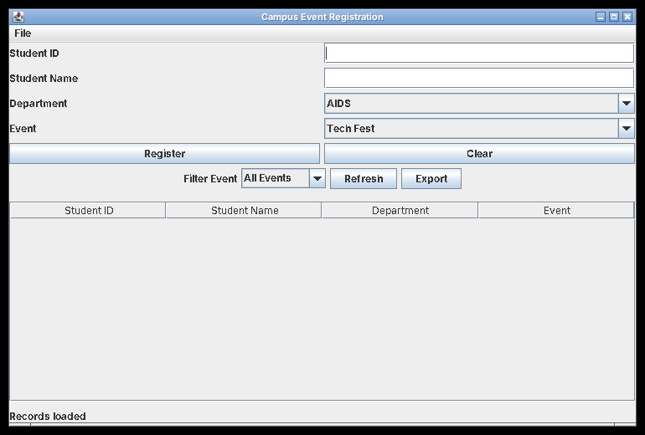
Figure 6.1 – Registration window on start-up (empty table)
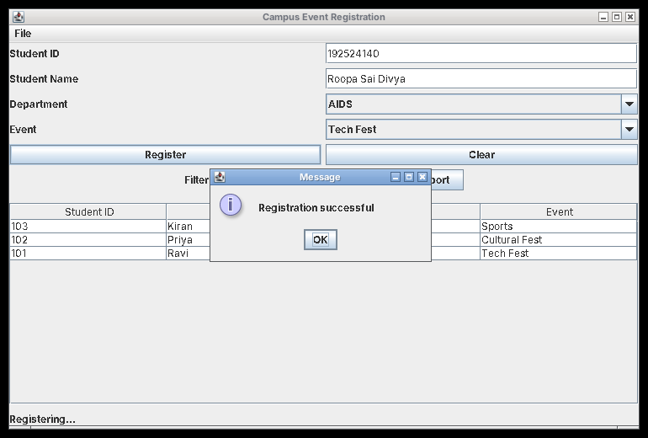
Figure 6.2 – Successful registration (192524140, Tech Fest)
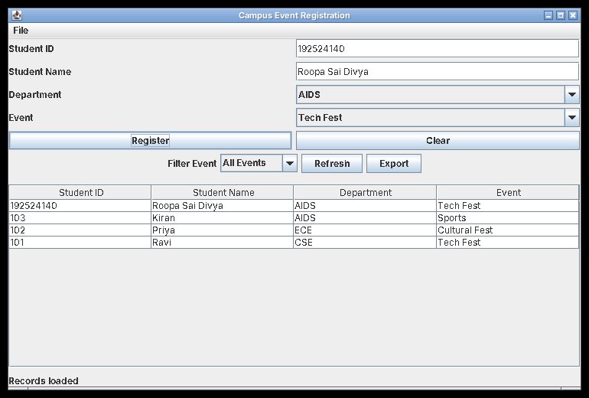
Figure 6.3 – Registration table refreshed with the new record
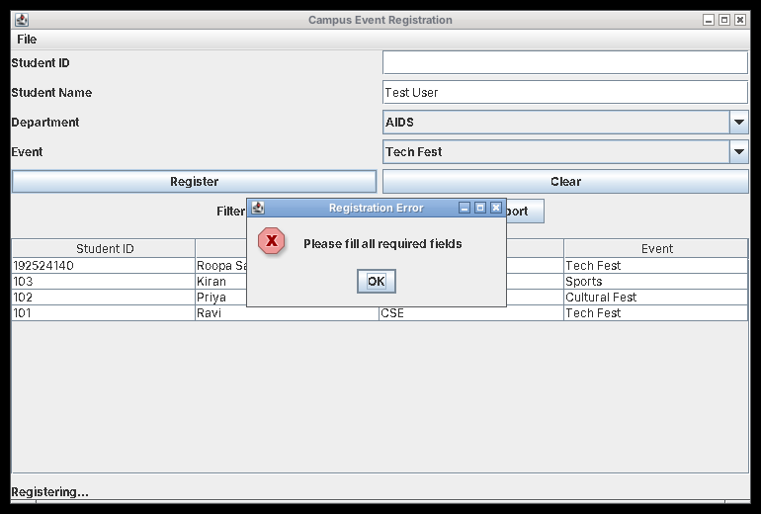
Figure 6.4 – Invalid registration: empty Student ID
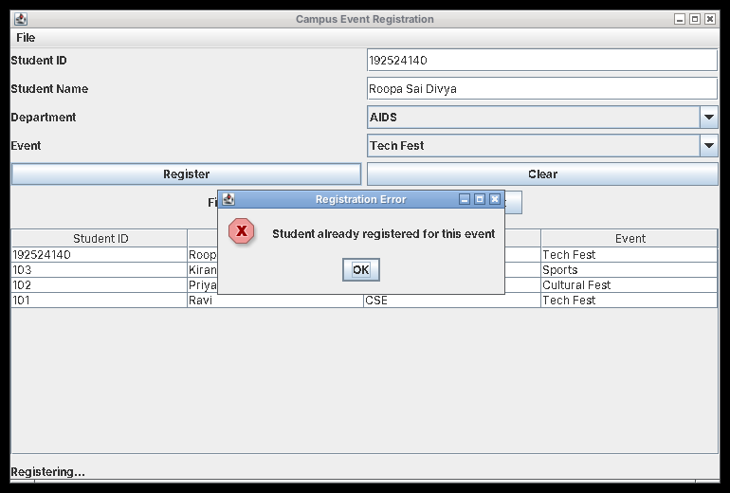
Figure 6.5 – Duplicate registration rejected
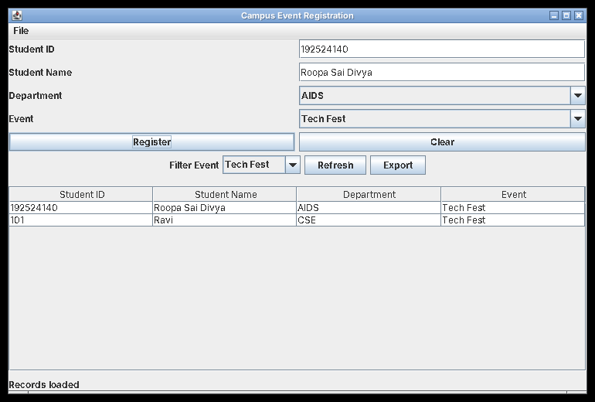
Figure 6.6 – Event filter set to Tech Fest: only matching records shown
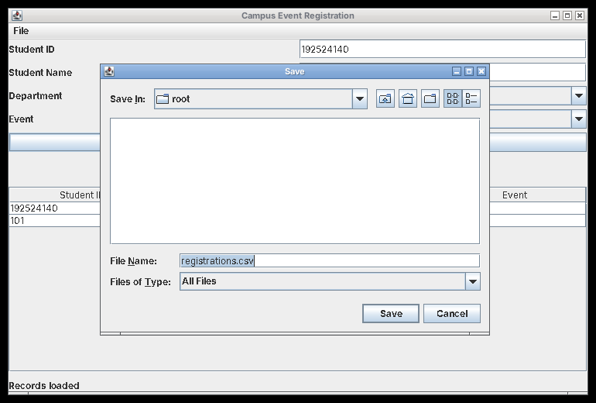
Figure 6.7 – Export: file chooser with registrations.csv
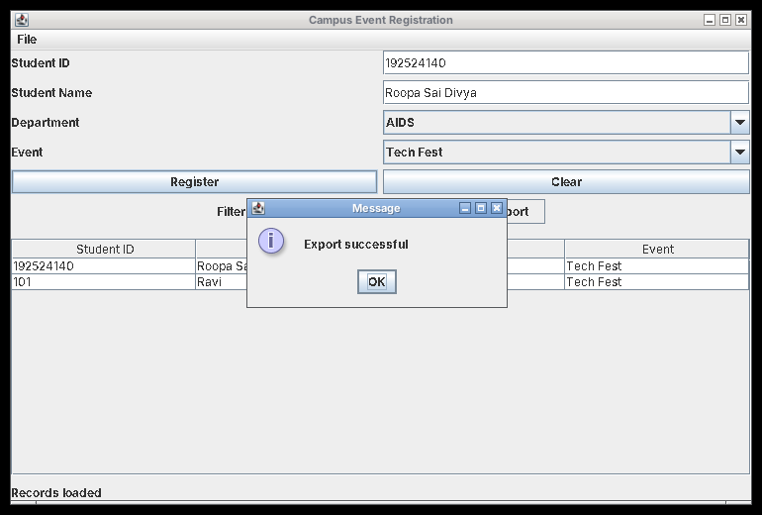
Figure 6.8 – "Export successful" confirmation
Database output (MySQL table after the test run):
+----+------------+-----------------+------------+---------------+
| id | student_id | student_name | department | event_name |
+----+------------+-----------------+------------+---------------+
| 1 | 101 | Ravi | CSE | Tech Fest |
| 2 | 102 | Priya | ECE | Cultural Fest |
| 3 | 103 | Kiran | AIDS | Sports |
| 4 | 192524140 | Roopa Sai Divya | AIDS | Tech Fest |
+----+------------+-----------------+------------+---------------+

Exported file – registrations.csv (the rows exported were those shown by the Tech Fest filter):
Student ID,Student Name,Department,Event
"192524140","Roopa Sai Divya","AIDS","Tech Fest"
"101","Ravi","CSE","Tech Fest"

Alternative Concept and Complexity Analysis
The assignment asks us to compare loading all registrations into a JTable with loading one page at a time using SQL LIMIT and OFFSET in a SwingWorker.
Feature | Load all registrations | Pagination with LIMIT and OFFSET
Data loading | Loads all records at once | Loads a limited number of records
Time | O(N) to retrieve and process N records | O(P) to process a page of P records, plus database query overhead
Memory | O(N) for loaded records | O(P) for the current page
GUI responsiveness | May become slow or freeze if performed on the GUI thread | Better when background loading is used
Suitable for | Small datasets | Large datasets

Example for 100,000 registrations:
- Loading all 100,000 records requires memory for all 100,000 displayed rows and their data.
- Loading 100 records per page requires memory for only the current 100 records, apart from the database and table-model overhead.
- A SwingWorker performs database work in the background, helping keep the window responsive.
Conclusion: Pagination with SQL LIMIT and OFFSET, combined with SwingWorker, is more suitable for large datasets because it reduces the amount of data loaded at one time and improves GUI responsiveness.

OVERALL RESULT
The six tasks demonstrate the design and implementation of event-driven GUI applications using Java AWT and Swing. The assignment covers listener interfaces, adapter classes, inner classes, anonymous classes, lambda expressions, layout managers, event handling, JDBC connectivity and background processing.
The programs and designs demonstrate how to separate GUI components from application logic, handle user events, validate input, manage database operations and create responsive desktop applications.

