PROGRAMMING IN JAVA
ASSIGNMENT 2 – CO2

Student Details
Name | J. Roopa Sai Divya
Register Number | 192524140
Course | Programming in Java
Assignment | Assignment 2 – CO2
GitHub Link | https://github.com/roopajallu814-arch/CSA09-192524140_Roopa-JAVA

Q1. Building Text Under Load: String, StringBuilder or StringBuffer? (6 Marks)

1. Introduction
A railway reservation system generates an e-ticket by combining passenger details, PNR number, coach, berth, fare and journey details.
Java provides three ways to create and modify strings:
- String: String objects are immutable. Once created, their values cannot be changed.
- StringBuilder: It is mutable and allows modification without creating many new objects.
- StringBuffer: It is mutable and thread-safe because its methods are synchronized.

2. Prediction
Class | Expected behaviour
String | Slower when many strings are joined repeatedly
StringBuilder | Faster for repeated string operations
StringBuffer | Thread-safe but may be slightly slower than StringBuilder

String creates new objects when its value is changed. StringBuilder and StringBuffer modify their existing contents.

3. Java Program
File name: StringComparison.java
public class StringComparison {

static String usingString(int fields) {
String result = "";

for (int i = 1; i <= fields; i++) {
result = result + "Field" + i + " ";
}

return result;
}

static String usingStringBuilder(int fields) {
StringBuilder result = new StringBuilder();

for (int i = 1; i <= fields; i++) {
result.append("Field").append(i).append(" ");
}

return result.toString();
}

static String usingStringBuffer(int fields) {
StringBuffer result = new StringBuffer();

for (int i = 1; i <= fields; i++) {
result.append("Field").append(i).append(" ");
}

return result.toString();
}

public static void main(String[] args) {

int fields = 50;

long start = System.nanoTime();
usingString(fields);
long stringTime = System.nanoTime() - start;

start = System.nanoTime();
usingStringBuilder(fields);
long builderTime = System.nanoTime() - start;

start = System.nanoTime();
usingStringBuffer(fields);
long bufferTime = System.nanoTime() - start;

System.out.println("String Time: " + stringTime + " ns");
System.out.println("StringBuilder Time: " + builderTime + " ns");
System.out.println("StringBuffer Time: " + bufferTime + " ns");
}
}

Output:
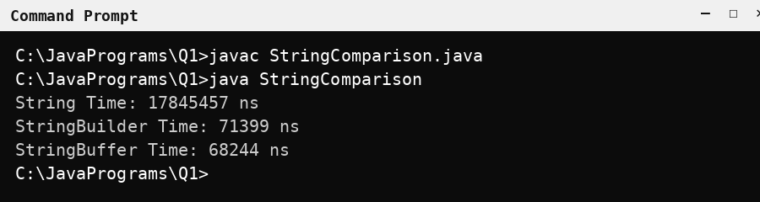
Figure 1: Output of StringComparison.java
Note: this is a single, cold run that includes JVM start-up and JIT warm-up time, so the exact values change from run to run. A reliable comparison is given in the Experimental Record (Section 7).

4. Complexity Analysis
- Repeated String concatenation can require O(n²) character copying for n fields of similar size.
- StringBuilder generally requires O(n) total character work for appending n fields, excluding occasional buffer resizing.
- StringBuffer has similar complexity to StringBuilder but adds synchronization overhead.

5. Design Decision
I recommend StringBuilder for creating individual e-tickets because it is fast and efficient.
For a shared booking log accessed by multiple threads, StringBuffer can be used because it provides synchronized methods. In a real application, a separate thread-safe logging mechanism is often a better choice.

6. Alternative Concept
StringJoiner can also be used to combine multiple fields.
File name: TicketJoiner.java
import java.util.StringJoiner;

public class TicketJoiner {
public static void main(String[] args) {

StringJoiner ticket = new StringJoiner(" | ");

ticket.add("PNR: 12345");
ticket.add("Name: Roopa");
ticket.add("Coach: A1");
ticket.add("Berth: 25");
ticket.add("Fare: 500");

System.out.println(ticket);
}
}

Output:
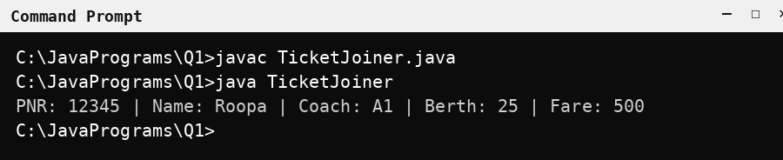
Figure 2: Output of TicketJoiner.java
Conclusion: StringBuilder is suitable for repeated text construction. StringBuffer is useful when synchronized string modification is required.

7. Experimental Record
The benchmark program (Appendix A) builds the tickets using each class. Each value is the median of 21 runs after a warm-up period, measured in microseconds (µs) on Java 21 (OpenJDK).
Workload | String time (µs) | StringBuilder time (µs) | StringBuffer time (µs)
1 ticket, 5 fields | 0.07 | 0.09 | 0.10
1,000 tickets, 50 fields | 1,005.11 | 339.90 | 425.72
10,000 tickets, 50 fields | 7,472.23 | 3,147.00 | 4,161.97

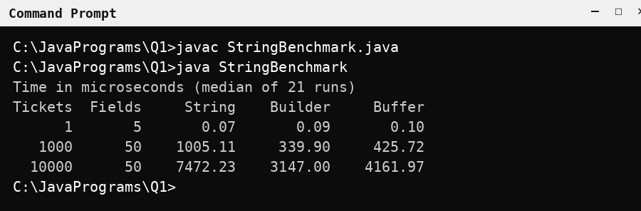
Figure 3: Output of StringBenchmark.java (timing experiment)
Observation: For 1 ticket with 5 fields, all three classes took about 0.07–0.10 µs, which is too small to compare reliably. For 10,000 tickets with 50 fields, String took 7,472.23 µs, StringBuffer took 4,161.97 µs and StringBuilder took 3,147.00 µs. This matches the prediction: String is the slowest, and StringBuilder is faster than StringBuffer because it has no synchronization overhead.

Q2. When Is ArrayList an Appropriate Engineering Choice? (4 Marks)

1. Introduction
ArrayList and LinkedList are two commonly used classes in Java Collections.
- ArrayList: Stores elements in a dynamic array.
- LinkedList: Stores elements as linked nodes.
- ArrayDeque: Supports efficient insertion and deletion at both ends.

2. Comparison
Operation | ArrayList | LinkedList | ArrayDeque
Add at end | O(1) amortized | O(1) | O(1) amortized
Insert at front | O(n) | O(1) | O(1) amortized
Insert in middle | O(n) | O(n) to find position | Not suitable for indexed insertion
Access by index | O(1) | O(n) | Not supported
Remove front | O(n) | O(1) | O(1) amortized
Iteration | O(n) | O(n) | O(n)

3. Java Program
File name: ListComparison.java
import java.util.ArrayList;
import java.util.LinkedList;
import java.util.ArrayDeque;

public class ListComparison {

public static void main(String[] args) {

ArrayList<String> arrayList = new ArrayList<>();
LinkedList<String> linkedList = new LinkedList<>();
ArrayDeque<String> deque = new ArrayDeque<>();

arrayList.add("Song 1");
arrayList.add("Song 2");
arrayList.add("Song 3");

linkedList.add("Song 1");
linkedList.add("Song 2");
linkedList.add("Song 3");

deque.addLast("Song 1");
deque.addLast("Song 2");
deque.addLast("Song 3");

System.out.println("ArrayList: " + arrayList);
System.out.println("LinkedList: " + linkedList);
System.out.println("ArrayDeque: " + deque);

System.out.println("Third song: " + arrayList.get(2));

arrayList.add(1, "New Song");
linkedList.add(1, "New Song");

System.out.println("Updated ArrayList: " + arrayList);
System.out.println("Updated LinkedList: " + linkedList);

deque.addFirst("Up Next");
deque.removeFirst();

System.out.println("Updated ArrayDeque: " + deque);
}
}

Output:
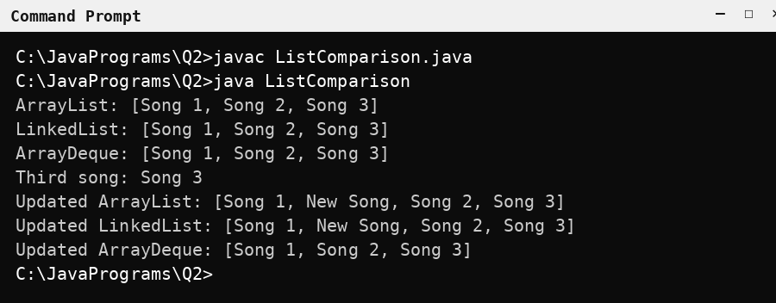
Figure 4: Output of ListComparison.java

4. Analysis
ArrayList is suitable when the application frequently accesses songs using an index and adds songs at the end.
LinkedList is useful when insertions and deletions occur frequently at known positions, although finding a middle position still takes linear time.
ArrayDeque is suitable for an Up Next queue because it efficiently adds and removes songs at both ends.

5. Alternative Concept
A plain array can store playlist songs. However, its size is fixed, and inserting or deleting elements requires shifting other elements.
Conclusion: ArrayList is the best choice for normal playlists with frequent random access. ArrayDeque is better for an Up Next queue.

6. Experimental Record
The benchmark program (Appendix B) was tested with playlist sizes of 100, 1,000 and 10,000 songs. Each value is the median of 21 runs after warm-up, in microseconds (µs), for performing the operation n times.
Size | Operation | ArrayList (µs) | LinkedList (µs) | ArrayDeque (µs)
100 | Add at end | 0.49 | 0.48 | 0.32
100 | Access by index | 0.10 | 0.97 | N/A
100 | Remove front | 0.96 | 0.18 | 0.11
100 | Insert at front | 1.27 | 0.49 | 0.32
1,000 | Add at end | 7.15 | 8.08 | 6.25
1,000 | Access by index | 0.72 | 275.37 | N/A
1,000 | Remove front | 20.58 | 2.16 | 0.73
1,000 | Insert at front | 27.31 | 8.43 | 6.33
10,000 | Add at end | 61.83 | 62.03 | 54.30
10,000 | Access by index | 15.27 | 32,732.59 | N/A
10,000 | Remove front | 1,251.07 | 25.01 | 10.03
10,000 | Insert at front | 1,319.39 | 79.76 | 54.36

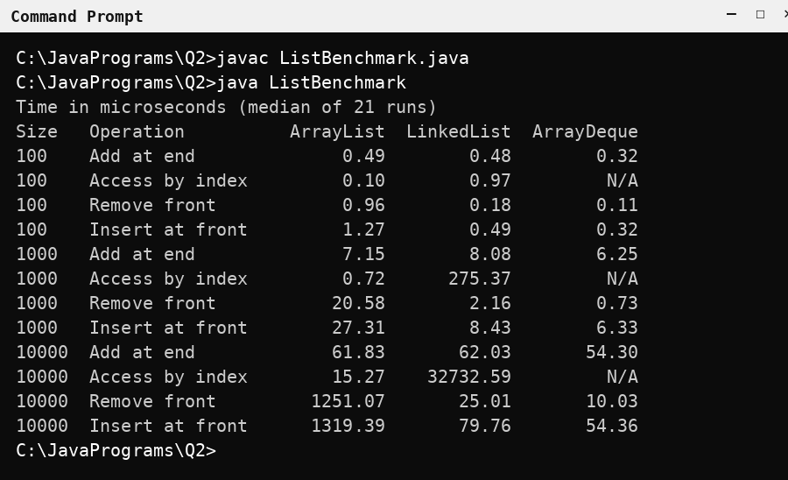
Figure 5: Output of ListBenchmark.java (timing experiment)
Observation: For 10,000 songs, access by index took 15.27 µs in ArrayList but 32,732.59 µs in LinkedList. Removing from the front took 1,251.07 µs in ArrayList, 25.01 µs in LinkedList and 10.03 µs in ArrayDeque. Adding at the end was similar for all three. Therefore ArrayList is best for index access, and ArrayDeque is best for front/back queue operations.

Q3. Engineer the hashCode–equals Contract (6 Marks)

1. Introduction
HashSet is a Java collection that stores only unique elements.
The equals() method checks whether two objects are logically equal. The hashCode() method generates an integer hash value for an object.
If two objects are equal according to equals(), they must have the same hash code.

2. Problem
If hashCode() is not overridden, HashSet may store duplicate Student objects even when their registration numbers are the same. The following program overrides only equals():
File name: AttendanceProblem.java
import java.util.HashSet;
import java.util.Set;

class BrokenStudent {

private final String regNo;
private final String name;

BrokenStudent(String regNo, String name) {
this.regNo = regNo;
this.name = name;
}

// Only equals() is overridden. hashCode() is NOT overridden.
@Override
public boolean equals(Object o) {
if (this == o)
return true;
if (!(o instanceof BrokenStudent))
return false;
BrokenStudent s = (BrokenStudent) o;
return regNo.equals(s.regNo);
}
}

public class AttendanceProblem {

public static void main(String[] args) {

Set<BrokenStudent> present = new HashSet<>();

present.add(new BrokenStudent("192311001", "Arun"));
present.add(new BrokenStudent("192311002", "Divya"));
present.add(new BrokenStudent("192311001", "Arun"));

System.out.println("Unique students (without hashCode): "
+ present.size());
}
}

Output:
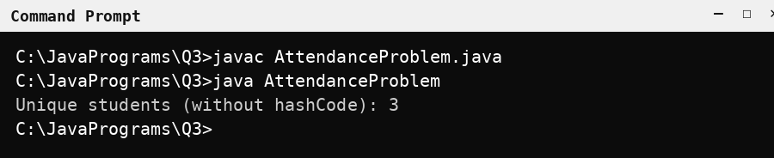
Figure 6: Output of AttendanceProblem.java (duplicate stored)
The same student (192311001) is stored twice, so the set size is 3 instead of 2.

3. Correct Java Program
File name: Attendance.java
import java.util.HashSet;
import java.util.Set;
import java.util.Objects;

class Student {

private final String regNo;
private final String name;

Student(String regNo, String name) {
this.regNo = regNo;
this.name = name;
}

@Override
public boolean equals(Object o) {

if (this == o)
return true;

if (!(o instanceof Student))
return false;

Student s = (Student) o;

return regNo.equals(s.regNo);
}

@Override
public int hashCode() {
return Objects.hash(regNo);
}

@Override
public String toString() {
return regNo + " " + name;
}
}

public class Attendance {

public static void main(String[] args) {

Set<Student> present = new HashSet<>();

present.add(new Student("192311001", "Arun"));
present.add(new Student("192311002", "Divya"));
present.add(new Student("192311001", "Arun"));

System.out.println("Unique students: " + present.size());
}
}

4. Output
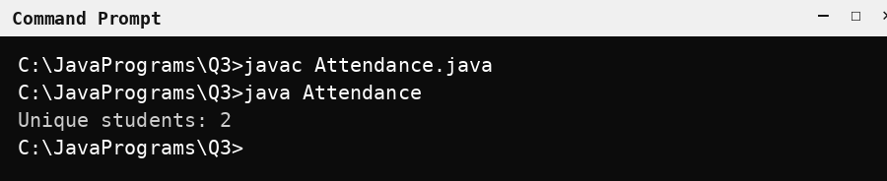
Figure 7: Output of Attendance.java

5. Explanation
The first and third students have the same registration number. Therefore, they are considered equal.
HashSet uses hashCode() to find the appropriate location and equals() to check whether an existing element is equal to the new element.
When both methods are correctly implemented, duplicate students are not added.

6. Alternative Concept
A TreeSet can store students in sorted order using a Comparator based on registration number.
A HashMap can also store students using registration numbers as keys.
Collection | Average time per scan | Space
HashSet | O(1) | O(n)
TreeSet | O(log n) | O(n)
HashMap | O(1) | O(n)

Conclusion: The hashCode() and equals() methods must follow their contract to maintain unique records in HashSet.

Q4. Choosing a Map for a Pharmacy Inventory (6 Marks)

1. Introduction
A Map stores data in key-value pairs. In a pharmacy inventory, the medicine code is the key and the medicine name or stock quantity is the value.
Java provides three commonly used Map implementations:
- HashMap: Stores key-value pairs without guaranteeing order.
- TreeMap: Stores keys in sorted order.
- LinkedHashMap: Maintains insertion order.

2. Comparison
Operation | HashMap | TreeMap | LinkedHashMap
put() | O(1) average | O(log n) | O(1) average
get() | O(1) average | O(log n) | O(1) average
Iteration | O(n) | O(n) | O(n)
Order | No guaranteed order | Sorted order | Insertion order

3. Java Program
File name: PharmacyInventory.java
import java.util.HashMap;
import java.util.TreeMap;
import java.util.LinkedHashMap;
import java.util.Map;

public class PharmacyInventory {

public static void main(String[] args) {

Map<String, Integer> hashMap = new HashMap<>();
Map<String, Integer> treeMap = new TreeMap<>();
Map<String, Integer> linkedMap = new LinkedHashMap<>();

hashMap.put("M103", 50);
hashMap.put("M101", 30);
hashMap.put("M102", 40);

treeMap.putAll(hashMap);
linkedMap.put("M103", 50);
linkedMap.put("M101", 30);
linkedMap.put("M102", 40);

System.out.println("HashMap: " + hashMap);
System.out.println("TreeMap: " + treeMap);
System.out.println("LinkedHashMap: " + linkedMap);

System.out.println("Stock of M101: " + hashMap.get("M101"));

System.out.println("Medicine codes in sorted order:");

for (String code : treeMap.keySet()) {
System.out.println(code + " : " + treeMap.get(code));
}

System.out.println("Medicines in insertion order:");

for (String code : linkedMap.keySet()) {
System.out.println(code + " : " + linkedMap.get(code));
}
}
}

4. Output
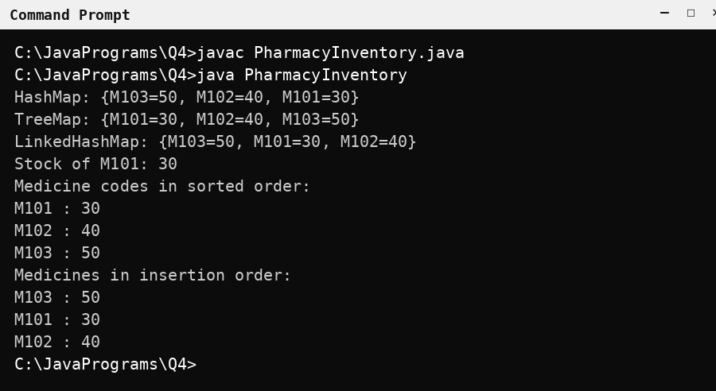
Figure 8: Output of PharmacyInventory.java
Note: The order of HashMap output is not guaranteed. It may appear differently on another execution or Java version.

5. Analysis
HashMap is suitable for fast medicine stock lookups. TreeMap is suitable for generating reports in sorted medicine-code order. LinkedHashMap is suitable for displaying medicines in the order they were added.
Hashtable is not preferred in new applications because it is a legacy synchronized class. Modern alternatives include HashMap and ConcurrentHashMap.

6. Alternative Concept
A sorted array can store medicine codes in ascending order. Arrays.binarySearch() can search for a medicine in O(log n) time.
Operation | Sorted Array | HashMap | TreeMap
Lookup | O(log n) | O(1) average | O(log n)
Insertion | O(n) | O(1) average | O(log n)
Sorted report | O(n) | O(n log n) if sorted first | O(n)
Space | O(n) | O(n) | O(n)

Conclusion: HashMap is suitable for fast stock lookup, TreeMap is suitable for sorted reports, and LinkedHashMap is suitable for insertion-order reports.

7. Experimental Record
The benchmark program (Appendix C) was tested with 100, 1,000 and 10,000 medicines. It records the time for 100,000 lookups and the time taken to produce both reports. Each value is the median of 21 runs after warm-up, in microseconds (µs).
Size | Test | HashMap (µs) | TreeMap (µs) | LinkedHashMap (µs)
100 | 100,000 lookups | 1,211.35 | 5,801.03 | 746.95
100 | Sorted-order report | 29.66 | 4.62 | 16.44
100 | Insertion-order report | N/A | N/A | 3.37
1,000 | 100,000 lookups | 2,061.44 | 10,278.03 | 1,664.06
1,000 | Sorted-order report | 158.57 | 39.08 | 189.02
1,000 | Insertion-order report | N/A | N/A | 21.46
10,000 | 100,000 lookups | 2,694.26 | 17,236.88 | 2,314.52
10,000 | Sorted-order report | 1,317.67 | 366.35 | 2,793.92
10,000 | Insertion-order report | N/A | N/A | 266.24

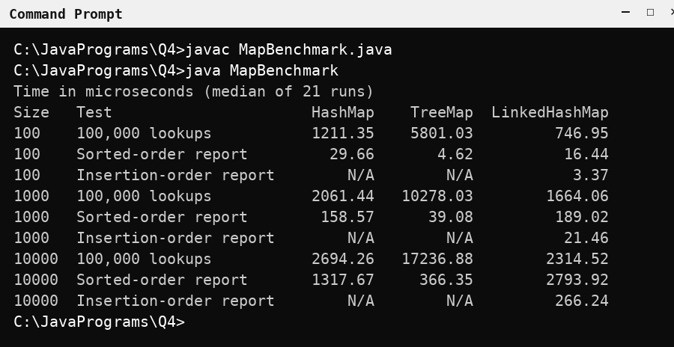
Figure 9: Output of MapBenchmark.java (timing experiment)
Observation: For 10,000 medicines, 100,000 lookups took 2,694.26 µs in HashMap, 2,314.52 µs in LinkedHashMap and 17,236.88 µs in TreeMap, so hash-based maps are faster for lookup. The sorted report was fastest with TreeMap (366.35 µs) because its keys are already sorted, whereas HashMap (1,317.67 µs) and LinkedHashMap (2,793.92 µs) had to sort the keys first. Only LinkedHashMap can produce the insertion-order report directly.

Q5. Derive a Generic Ranking Component from a Principle (7 Marks)

1. Introduction
A leaderboard is used to rank teams based on their performance.
The ranking rules are:
- Higher points should receive a higher rank.
- If points are equal, higher goal difference should receive a higher rank.
- If both are equal, team names should be arranged alphabetically.
Java provides Comparable and Comparator to compare objects.
- Comparable: Defines the natural ordering inside a class.
- Comparator: Defines a separate comparison rule.
- Generics: Allow a class or method to work with different data types.

2. Java Program
File name: LeaderboardDemo.java
import java.util.ArrayList;
import java.util.Comparator;
import java.util.List;

class Team {

final String name;
final int points;
final int goalDiff;

Team(String name, int points, int goalDiff) {
this.name = name;
this.points = points;
this.goalDiff = goalDiff;
}

@Override
public String toString() {
return name + "(" + points + "," + goalDiff + ")";
}
}

class Leaderboard<T> {

private final List<T> items = new ArrayList<>();
private final Comparator<? super T> order;

Leaderboard(Comparator<? super T> order) {
this.order = order;
}

void add(T item) {
items.add(item);
}

List<T> ranking() {
List<T> result = new ArrayList<>(items);
result.sort(order);
return result;
}
}

public class LeaderboardDemo {

public static void main(String[] args) {

Comparator<Team> byRank =
Comparator.comparingInt((Team t) -> t.points).reversed()
.thenComparing(
Comparator.comparingInt((Team t) -> t.goalDiff).reversed()
)
.thenComparing(t -> t.name);

Leaderboard<Team> board = new Leaderboard<>(byRank);

board.add(new Team("Panthers", 9, 4));
board.add(new Team("Eagles", 9, 6));
board.add(new Team("Cobras", 6, 1));
board.add(new Team("Bisons", 9, 4));

System.out.println(board.ranking());
}
}

3. Output
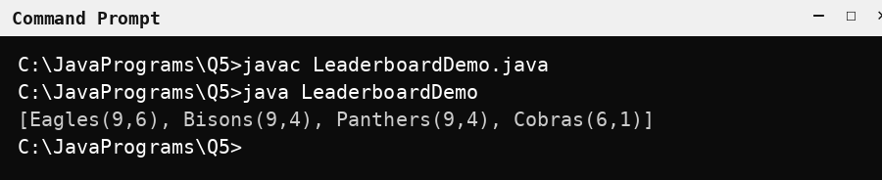
Figure 10: Output of LeaderboardDemo.java

4. Explanation
Eagles is ranked first because it has the highest goal difference among teams with 9 points.
Bisons is ranked above Panthers because both teams have equal points and goal difference, but Bisons comes before Panthers alphabetically.
Cobras is ranked last because it has fewer points.
The ranking() method creates a new list and sorts it. Therefore, the original list is not modified.

5. Complexity Analysis
- Adding an element: O(1) amortized.
- Sorting the leaderboard: O(n log n).
- Creating the sorted copy: O(n) extra space.
- Comparator chain: Uses the specified ranking rules.

6. Alternative Concept
If Team implements Comparable, the ranking rules are written inside the class as its natural ordering. A generic method can then rank any list whose elements are Comparable.
File name: ComparableLeaderboard.java
import java.util.ArrayList;
import java.util.Collections;
import java.util.List;

class RankedTeam implements Comparable<RankedTeam> {

final String name;
final int points;
final int goalDiff;

RankedTeam(String name, int points, int goalDiff) {
this.name = name;
this.points = points;
this.goalDiff = goalDiff;
}

// Natural ordering: best team comes first
@Override
public int compareTo(RankedTeam other) {

if (this.points != other.points)
return Integer.compare(other.points, this.points);

if (this.goalDiff != other.goalDiff)
return Integer.compare(other.goalDiff, this.goalDiff);

return this.name.compareTo(other.name);
}

@Override
public String toString() {
return name + "(" + points + "," + goalDiff + ")";
}
}

public class ComparableLeaderboard {

// Generic ranking method: works for any type that is Comparable
static <T extends Comparable<? super T>>
List<T> rank(List<T> items) {
List<T> result = new ArrayList<>(items);
Collections.sort(result);
return result;
}

public static void main(String[] args) {

List<RankedTeam> teams = new ArrayList<>();

teams.add(new RankedTeam("Panthers", 9, 4));
teams.add(new RankedTeam("Eagles", 9, 6));
teams.add(new RankedTeam("Cobras", 6, 1));
teams.add(new RankedTeam("Bisons", 9, 4));

System.out.println(rank(teams));
}
}

Output:
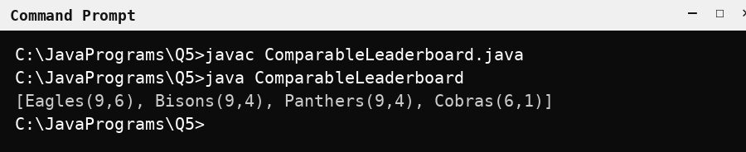
Figure 11: Output of ComparableLeaderboard.java
The output is the same as the Comparator version.
Feature | Comparable | Comparator
Where the rule is written | Inside the class | Separate from the class
Number of orderings | Only one natural ordering | Many orderings can be created
Method used | compareTo() | compare()
Class can be changed? | Required | Not required

Conclusion: The generic Leaderboard<T> with a Comparator keeps the ranking rule separate from the data, so the same component can rank any type of object. Comparable is simpler when a class has one fixed natural ordering.

Appendix – Benchmark Programs Used for the Experimental Records

A. StringBenchmark.java (Q1)
import java.util.Arrays;

public class StringBenchmark {

static int usingString(int fields) {
String result = "";
for (int i = 1; i <= fields; i++) {
result = result + "Field" + i + " ";
}
return result.length();
}

static int usingStringBuilder(int fields) {
StringBuilder result = new StringBuilder();
for (int i = 1; i <= fields; i++) {
result.append("Field").append(i).append(" ");
}
return result.toString().length();
}

static int usingStringBuffer(int fields) {
StringBuffer result = new StringBuffer();
for (int i = 1; i <= fields; i++) {
result.append("Field").append(i).append(" ");
}
return result.toString().length();
}

// Builds many tickets and returns the total time in microseconds
static double run(int type, int tickets, int fields) {
long sink = 0;
long start = System.nanoTime();
for (int t = 0; t < tickets; t++) {
if (type == 0) {
sink += usingString(fields);
} else if (type == 1) {
sink += usingStringBuilder(fields);
} else {
sink += usingStringBuffer(fields);
}
}
long time = System.nanoTime() - start;
// using sink stops the JIT compiler from removing the loop
if (sink == 42) System.out.println();
return time / 1000.0;
}

static double median(double[] v) {
double[] c = v.clone();
Arrays.sort(c);
return c[c.length / 2];
}

public static void main(String[] args) {
int[][] workloads = { {1, 5}, {1000, 50}, {10000, 50} };
int warmUp = 30, runs = 21;

// warm-up: lets the JIT compiler optimise the code before timing
for (int i = 0; i < warmUp; i++) {
for (int[] w : workloads) {
for (int type = 0; type < 3; type++) {
run(type, w[0], w[1]);
}
}
}

System.out.println("Time in microseconds (median of 21 runs)");
System.out.printf("%7s %6s %9s %9s %9s%n",
"Tickets", "Fields", "String", "Builder", "Buffer");

for (int[] w : workloads) {
double[] res = new double[3];
for (int type = 0; type < 3; type++) {
double[] t = new double[runs];
for (int i = 0; i < runs; i++) {
t[i] = run(type, w[0], w[1]);
}
res[type] = median(t);
}
System.out.printf("%7d %6d %9.2f %9.2f %9.2f%n",
w[0], w[1], res[0], res[1], res[2]);
}
}
}

B. ListBenchmark.java (Q2)
import java.util.ArrayDeque;
import java.util.ArrayList;
import java.util.Arrays;
import java.util.LinkedList;

public class ListBenchmark {

static long sink = 0;

static double time(Runnable r) {
long s = System.nanoTime();
r.run();
return (System.nanoTime() - s) / 1000.0;
}

// returns 12 timings (microseconds): 4 operations x 3 structures
static double[] measure(int n) {
ArrayList<Integer> a = new ArrayList<>();
LinkedList<Integer> l = new LinkedList<>();
ArrayDeque<Integer> d = new ArrayDeque<>();
double[] r = new double[12];

// 1. add at end
r[0] = time(() -> { for (int i = 0; i < n; i++) a.add(i); });
r[1] = time(() -> { for (int i = 0; i < n; i++) l.add(i); });
r[2] = time(() ->
{ for (int i = 0; i < n; i++) d.addLast(i); });

// 2. access by index (ArrayDeque has no index access)
r[3] = time(() ->
{ for (int i = 0; i < n; i++) sink += a.get(i); });
r[4] = time(() ->
{ for (int i = 0; i < n; i++) sink += l.get(i); });
r[5] = Double.NaN;

// 3. remove from front
r[6] = time(() -> { for (int i = 0; i < n; i++) a.remove(0); });
r[7] = time(() ->
{ for (int i = 0; i < n; i++) l.removeFirst(); });
r[8] = time(() ->
{ for (int i = 0; i < n; i++) d.removeFirst(); });

// 4. insert at front (fresh, empty structures)
ArrayList<Integer> a2 = new ArrayList<>();
LinkedList<Integer> l2 = new LinkedList<>();
ArrayDeque<Integer> d2 = new ArrayDeque<>();
r[9] = time(() ->
{ for (int i = 0; i < n; i++) a2.add(0, i); });
r[10] = time(() ->
{ for (int i = 0; i < n; i++) l2.addFirst(i); });
r[11] = time(() ->
{ for (int i = 0; i < n; i++) d2.addFirst(i); });
return r;
}

static double median(double[] v) {
double[] c = v.clone();
Arrays.sort(c);
return c[c.length / 2];
}

static String f(double v) {
return Double.isNaN(v) ? "N/A" : String.format("%.2f", v);
}

public static void main(String[] args) {
int[] sizes = { 100, 1000, 10000 };
String[] ops = { "Add at end", "Access by index",
"Remove front", "Insert at front" };
int warmUp = 30, runs = 21;

for (int i = 0; i < warmUp; i++) {
for (int n : sizes) measure(n);
}

System.out.println("Time in microseconds (median of 21 runs)");
System.out.printf("%-6s %-16s %11s %11s %11s%n", "Size",
"Operation", "ArrayList", "LinkedList", "ArrayDeque");

for (int n : sizes) {
double[][] all = new double[12][runs];
for (int i = 0; i < runs; i++) {
double[] r = measure(n);
for (int k = 0; k < 12; k++) all[k][i] = r[k];
}
for (int o = 0; o < 4; o++) {
System.out.printf("%-6d %-16s %11s %11s %11s%n", n,
ops[o], f(median(all[o * 3])),
f(median(all[o * 3 + 1])),
f(median(all[o * 3 + 2])));
}
}
if (sink == 42) System.out.println();
}
}

C. MapBenchmark.java (Q4)
import java.util.ArrayList;
import java.util.Arrays;
import java.util.Collections;
import java.util.HashMap;
import java.util.LinkedHashMap;
import java.util.List;
import java.util.Map;
import java.util.Random;
import java.util.TreeMap;

public class MapBenchmark {

static long sink = 0;

static double time(Runnable r) {
long s = System.nanoTime();
r.run();
return (System.nanoTime() - s) / 1000.0;
}

static String code(int id) {
return "M" + String.format("%05d", id);
}

// codes are inserted in shuffled order, so the insertion order
// is different from the sorted order
static void fill(Map<String, Integer> map, int n) {
List<Integer> ids = new ArrayList<>();
for (int i = 0; i < n; i++) ids.add(i);
Collections.shuffle(ids, new Random(7));
for (int id : ids) map.put(code(id), id);
}

static String report(Map<String, Integer> map, boolean sorted) {
StringBuilder sb = new StringBuilder();
if (sorted && !(map instanceof TreeMap)) {
// HashMap and LinkedHashMap must sort the keys first
List<String> keys = new ArrayList<>(map.keySet());
Collections.sort(keys);
for (String k : keys) {
sb.append(k).append(" : ")
.append(map.get(k)).append('\n');
}
} else {
for (Map.Entry<String, Integer> e : map.entrySet()) {
sb.append(e.getKey()).append(" : ")
.append(e.getValue()).append('\n');
}
}
return sb.toString();
}

static double lookups(Map<String, Integer> map, String[] keys) {
return time(() -> {
long sum = 0;
for (String k : keys) sum += map.get(k);
sink += sum;
});
}

static double reportTime(Map<String, Integer> map, boolean sorted) {
return time(() -> sink += report(map, sorted).length());
}

static double[] measure(int n) {
Map<String, Integer> h = new HashMap<>();
Map<String, Integer> t = new TreeMap<>();
Map<String, Integer> l = new LinkedHashMap<>();
fill(h, n);
fill(t, n);
fill(l, n);

Random rnd = new Random(1);
String[] keys = new String[100_000];
for (int i = 0; i < keys.length; i++) {
keys[i] = code(rnd.nextInt(n));
}

return new double[] {
lookups(h, keys), lookups(t, keys), lookups(l, keys),
reportTime(h, true), reportTime(t, true),
reportTime(l, true), reportTime(l, false)
};
}

static double median(double[] v) {
double[] c = v.clone();
Arrays.sort(c);
return c[c.length / 2];
}

static void row(int n, String test, String a, String b, String c) {
System.out.printf("%-6d %-22s %10s %10s %14s%n",
n, test, a, b, c);
}

static String f(double v) {
return String.format("%.2f", v);
}

public static void main(String[] args) {
int[] sizes = { 100, 1000, 10000 };
int warmUp = 20, runs = 21;

for (int i = 0; i < warmUp; i++) {
for (int n : sizes) measure(n);
}

System.out.println("Time in microseconds (median of 21 runs)");
System.out.printf("%-6s %-22s %10s %10s %14s%n", "Size", "Test",
"HashMap", "TreeMap", "LinkedHashMap");

for (int n : sizes) {
double[][] all = new double[7][runs];
for (int i = 0; i < runs; i++) {
double[] r = measure(n);
for (int k = 0; k < 7; k++) all[k][i] = r[k];
}
double[] m = new double[7];
for (int k = 0; k < 7; k++) m[k] = median(all[k]);

row(n, "100,000 lookups", f(m[0]), f(m[1]), f(m[2]));
row(n, "Sorted-order report", f(m[3]), f(m[4]), f(m[5]));
row(n, "Insertion-order report", "N/A", "N/A", f(m[6]));
}
if (sink == 42) System.out.println();
}
}

