**Atmel Coding Assignment HOW-TO:**

**Setup:**

* Clone git repo from https://github.com/roopakingole/AtmelCodingAssignment.git
* Open the “AtmelCodingAssignment.atsln” in Atmel Studio 6.2
* This tutorial assumes that OLED1 Module is connected to EXT3.
* Select Debugger/Programmer in Project🡪AtmelCodingAssignment Properties🡪Tools, in case if it is not already selected.
* Open Terminal Window from View🡪Terminal Window and select appropriate COM port with 115200 baud.
* Build the project with F7.
* Online Wiki @ <https://github.com/roopakingole/AtmelCodingAssignment/wiki/1.-Home>
* Additional Program Documentation can be obtained from Doxygen Report at

<clone base dir>\AtmelCodingAssignment\AtmelCodingAssignment\doxygen\html\index.html

**Execution:**

* Flash & Run the project with F5.

1. Upon PowerUp
   1. On OLED “Roopak Ingole” & “Atmel Corp.” will be displayed.

|  |  |
| --- | --- |
| IMG_1699.JPG | IMG_1702.JPG |

* 1. On Terminal Window, “Roopak Ingole” & “Atmel Corp.” will be printed.

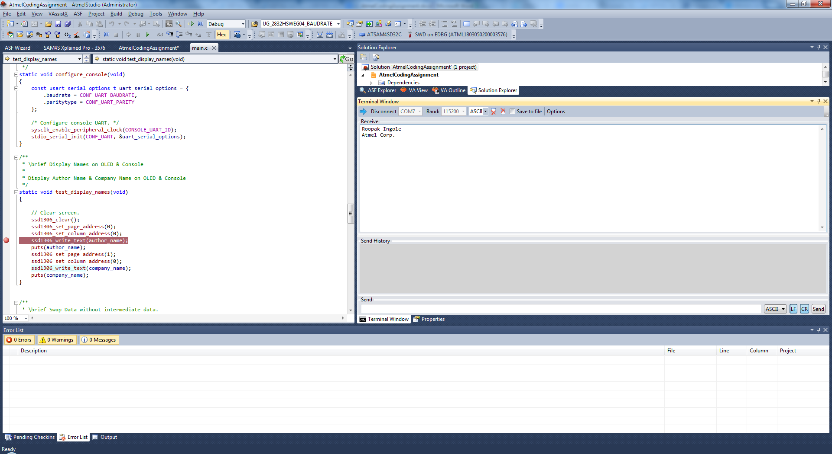

1. Debug Mode Screenshot of break the debugging application
   1. Firmware under debug mode with a breakpoint set at the line of code where Author Name is outputted
   2. Watch window showing the C variables containing Author name and Company Name.

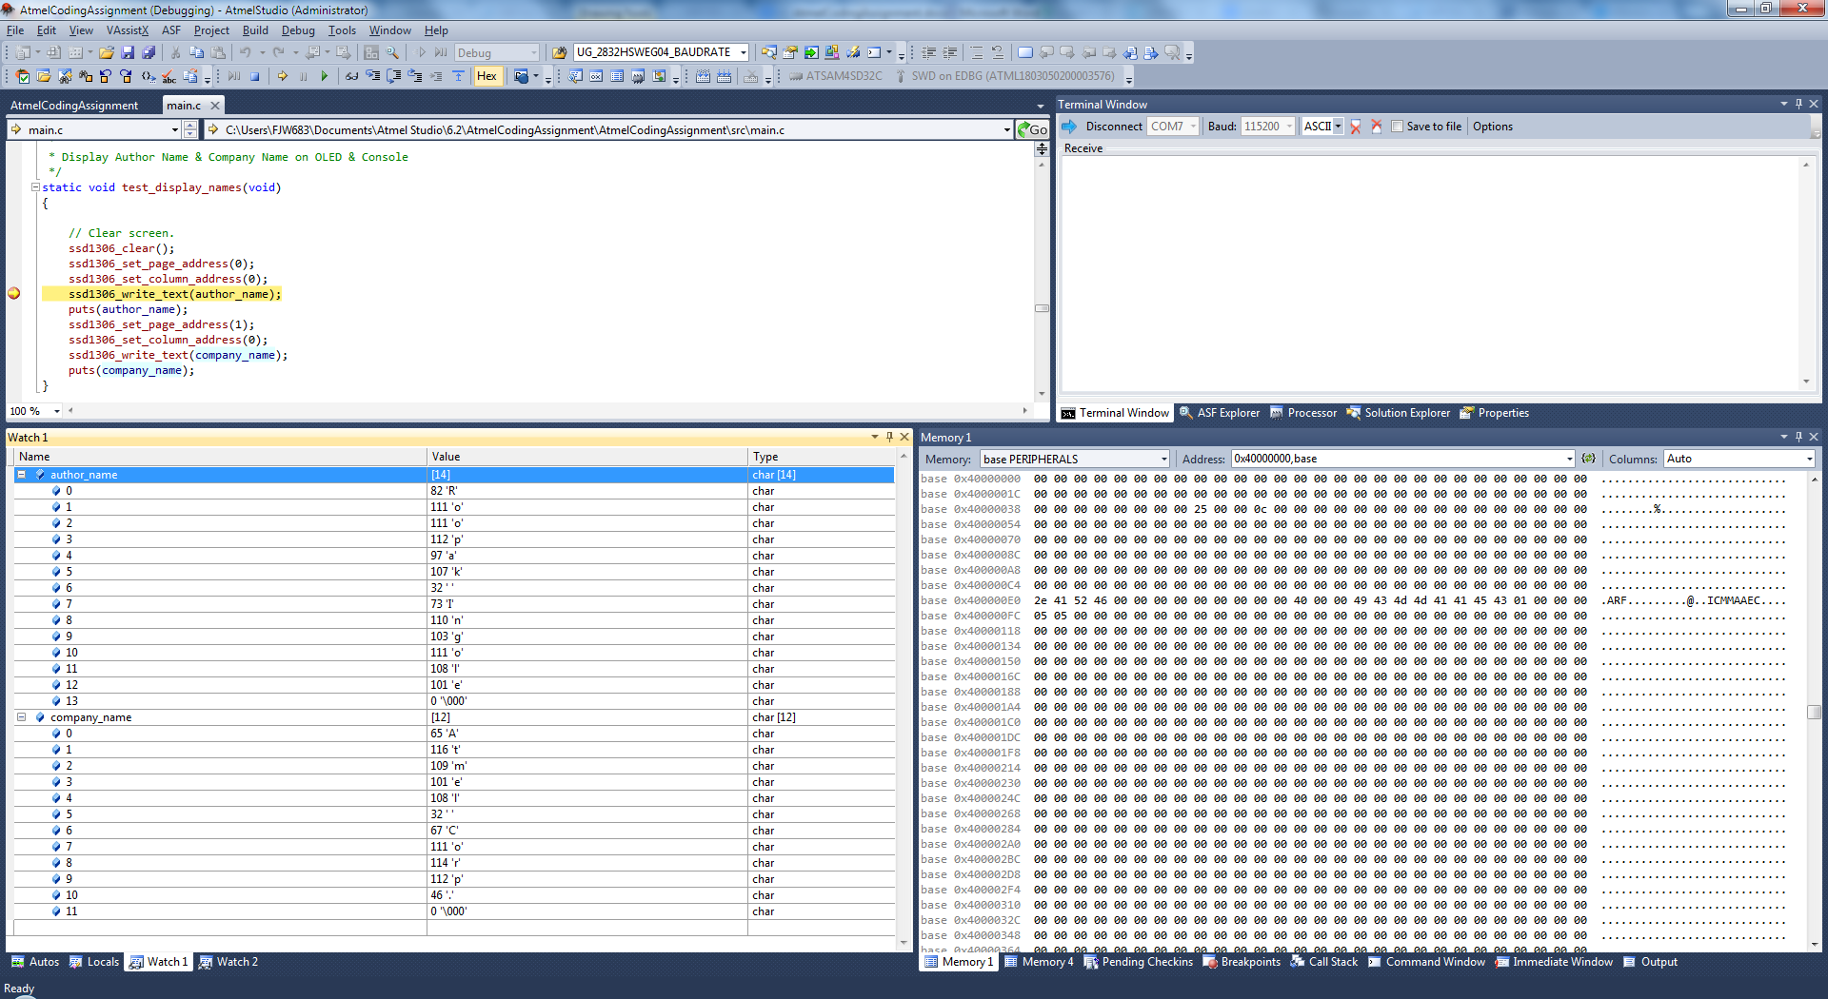

1. Press Button1 on OLED module
   1. Test result of “Swap Data” will be printed on Terminal Window like below:

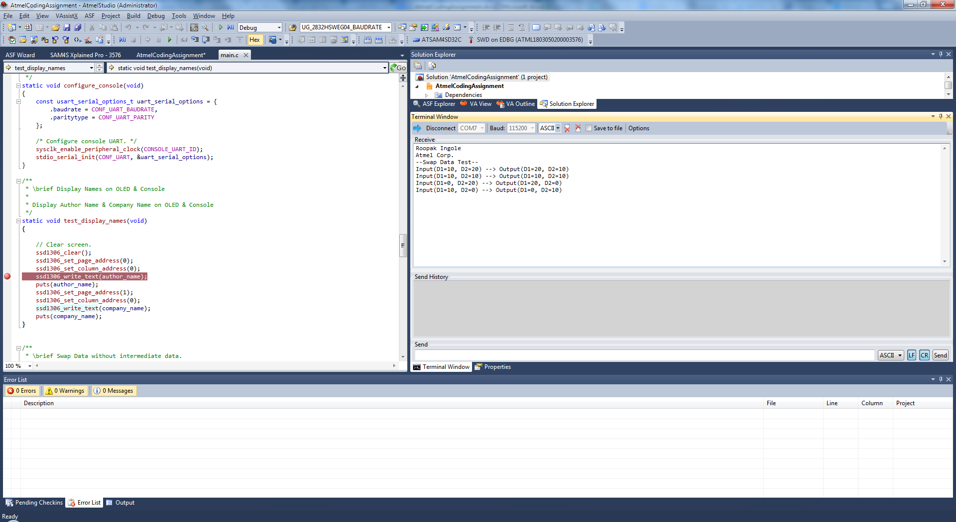

1. Pres Button1 on OLED module.
   1. Test result of “Set Bit Count” will be printed on Terminal Window like below:

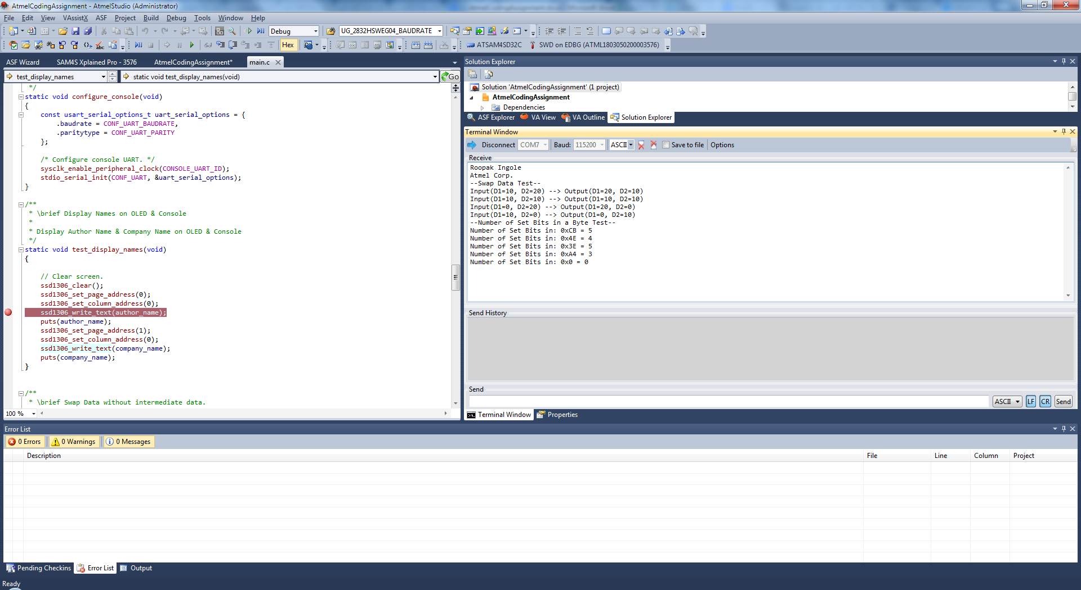

1. Press Button1 on OLED module.
   1. Test result of “Set Bit” will be printed on Terminal Window like below:

