

Programme | : | M.Tech Int Software Engineering | Semester | : | Fall 2026-2027
Course | : | Database Systems Lab | Code | : | IASWE206
Faculty | : | Dr. M. Premalatha | Slot | : | L31+L32

Date: 12-10-2026
Ex No: 8
PL/SQL Basics

Regno:25MIS1113
Name:Nathan Anthony A

Ex:
SQL> create table student_mp(regno varchar(4), sname char(10), mobno number(10), dob date);
Table created.

SQL> desc student_mp
Name Null? Type
----------------------------------------- -------- ----------
REGNO VARCHAR2(4)
SNAME CHAR(10)
MOBNO NUMBER(10)
DOB DATE
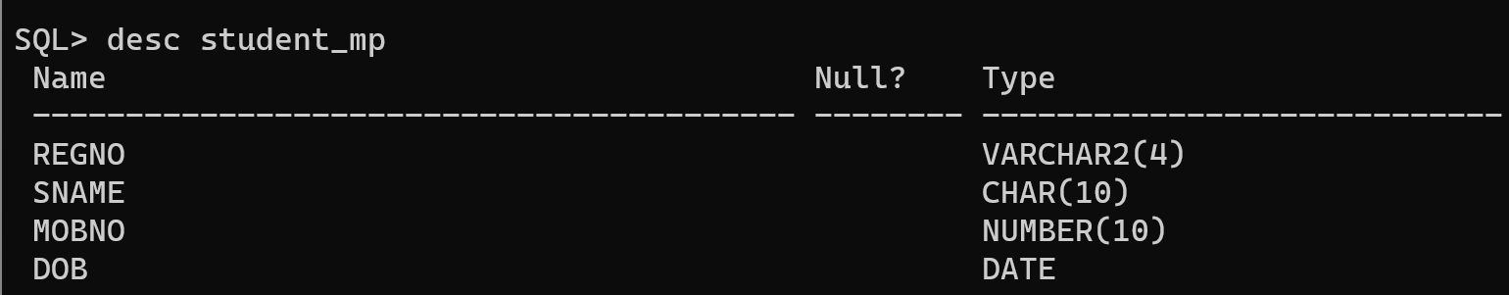

PL/SQL – Basics

- Write a PL/SQL structure to find a given number is Armstrong number or not, using loops.

[Individual digits cube is summed – result will be the original number]

Example 1:

a=153
b= 1³+5³+3³= 1+125+27=153
a=153 is equal to b=153, so 153 is an Armstrong number.

Example 2:

a=121
b= 1³+2³+1³= 1+8+1=10
a=121 is not equal to b=10, so 121 is not an Armstrong number.

SQL Query:

SQL> set serveroutput on;
SQL> declare
2 n number:=153;
3 temp number;
4 digit number;
5 total number:=0;
6 digits_count number:=0;
7 begin
8 temp:=n;
9 while temp>0 loop digits_count:=digits_count+1;
10 temp:=trunc(temp/10);
11 end loop;
12 temp:=n;
13 while temp>0 loop digit:=mod(temp,10);
14 total:=total+power(digit,digits_count);
15 temp:=trunc(temp/10);
16 end loop;
17 if total=n then dbms_output.put_line(n||'is an Armstrong number');
18 else dbms_output.put_line(n||'is not an Armstrong number');
19 end if;
20 end;
21 /
153 is an Armstrong number

PL/SQL procedure successfully completed.

Screenshot:
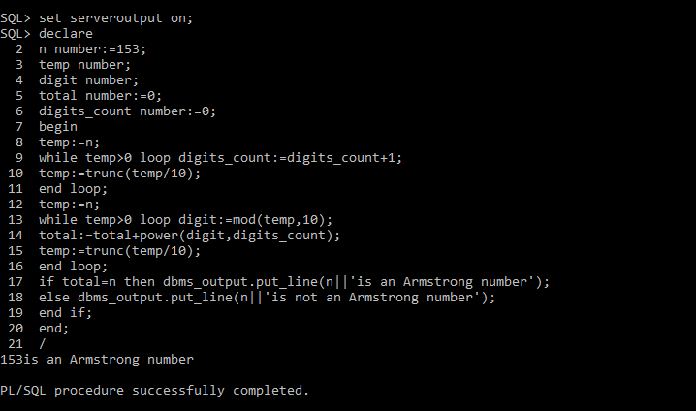

- Write a PL/SQL structure to find addition, subtraction, multiplication and division of two numbers using ‘case’. Use the following strings to do the operations

Add = addition
Sub – subtraction
Mul – multiplication
Div – division
Mod – Modulus

SQL Query:

SQL> set serveroutput on;
SQL> declare
2 a number:=20;
3 b number:=10;
4 operation varchar2(20):='add';
5 begin
6 case operation
7 when'add'then dbms_output.put_line('Addition='||(a+b));
8 when'sub'then dbms_output.put_line('Subtraction='||(a-b));
9 when'mul'then dbms_output.put_line('Multiplication='||(a*b));
10 when'div'then if b!=0 then dbms_output.put_line('Division='||(a/b));
11 else dbms_output.put_line('Division by zero is not allowed');
12 end if;
13 when'mod'then dbms_output.put_line('Modulus='||MOD(a,b));
14 else dbms_output.put_line('Invalid operation');
15 end case;
16 end;
17 /
Addition=30

PL/SQL procedure successfully completed.

Screenshot:
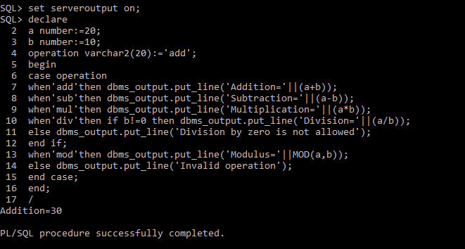

- Get an input of a 4 digit number. Form a 3 digit pin number from the 4 digit input number. Pin number should be generated as follows:

Input: 7793, Output: 147

- First digit of the pin number should be the integer squareroot of the 4th digit of the input number. [Fourth digit of input is 3. Int(SQRT(3)) = 1]. So first digit of the pin is 1.
- Second digit of the pin number should be the 1st digit of the square of the 1st digit of the input number [First digit of input is 7. First digit of square(7) = 49 i.e 4]. So second digit of the pin is 4.
- Third digit of the pin number is the least addition of the second and the third number of the input number. [second number is 9, third number is 9. Least addition = 7+9 = 16 = 1+6= 7]. So third digit is 7.

SQL Query:

SQL> set serveroutput on;
SQL> declare
2 n NUMBER := 7793;
3 d1 NUMBER;
4 d2 NUMBER;
5 d3 NUMBER;
6 pin1 NUMBER;
7 pin2 NUMBER;
8 pin3 NUMBER;
9 sq NUMBER;
10 sum1 NUMBER;
11 BEGIN
12 d1 := TRUNC(n / 1000);
13 d2 := MOD(TRUNC(n / 100), 10);
14 d3 := MOD(TRUNC(n / 10), 10);
15 pin1 := TRUNC(SQRT(MOD(n, 10)));
16
17 sq := d1 * d1;
18 pin2 := TRUNC(sq / 10);
19
20 sum1 := d2 + d3;
21
22 WHILE sum1 >= 10 LOOP
23 sum1 := TRUNC(sum1 / 10) + MOD(sum1, 10);
24 END LOOP;
25
26 pin3 := sum1;
27
28 DBMS_OUTPUT.PUT_LINE('Input Number = ' || n);
29 DBMS_OUTPUT.PUT_LINE('PIN Number = ' || pin1 || pin2 || pin3);
30 END;
31 /
Input Number = 7793
PIN Number = 147

PL/SQL procedure successfully completed.

Screenshot:
