Simple Add – Addition of 2 Numbers

A.Nathan Anthony
25MIS1113
SQL> set serveroutput on;
SQL> declare
2 a integer:=2;
3 b integer:=5;
4 c integer;
5 begin
6 c:=a+b;
7 dbms_output.put_line('sum='||c);
8 end;
9 /
sum=7
PL/SQL procedure successfully completed.
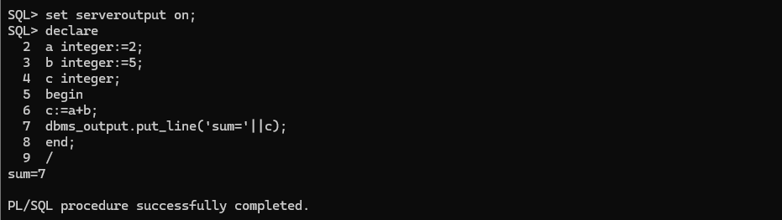
Getting input from user
SQL> set serveroutput on
SQL> declare
2 a number;
3 b number;
4 begin
5 b := &a;
6 dbms_output.put_line('The value of a is '||b);
7 end;
8 /
Enter value for a: 8
old 5: b := &a;
new 5: b := 8;
The value of a is 8
PL/SQL procedure successfully completed.
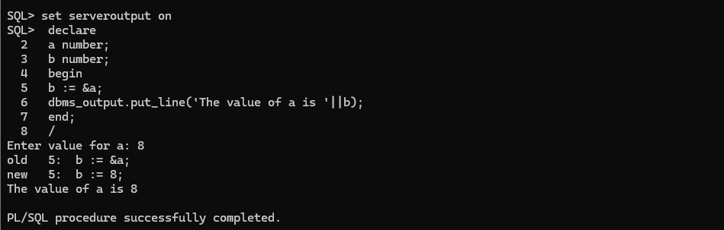
ADD
SQL> set serveroutput on
SQL> declare
2 a number;
3 b number;
4 c number;
5 begin
6 a := &a;
7 b := &b;
8 c := a+b;
9 dbms_output.put_line('The Sum is '||c);
10 end;
11 /
Enter value for a: 4
old 6: a := &a;
new 6: a := 4;
Enter value for b: 5
old 7: b := &b;
new 7: b := 5;
The Sum is 9
PL/SQL procedure successfully completed.
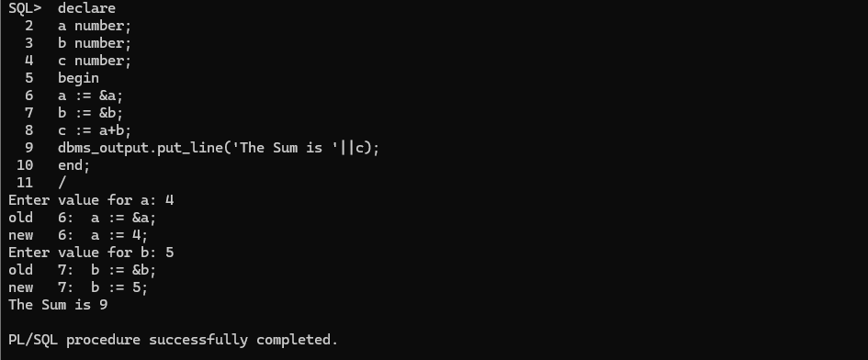
PL/SQL Variables – Print an integer and float values
SQL> declare
2 a integer := 30;
3 b integer := 20;
4 c integer;
5 f real;
6 begin
7 c:=a+b;
8 f:=100.0/3.0;
9 dbms_output.put_line('c : '||c);
10 dbms_output.put_line('f : '||f);
11 end;
12 /
c : 50
f : 33.33333333333333333333333333333333333333
PL/SQL procedure successfully completed.
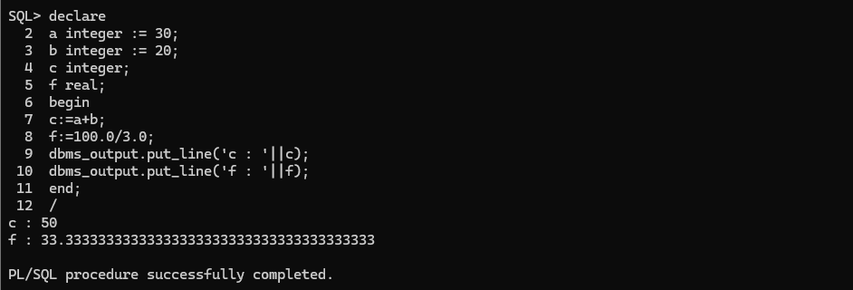
PL/SQL – Constants – Find diameter, circumference, area
SQL> declare
2 area number(15,11);
3 pi constant number := 3.141592654;
4 radius number(5,2) := 9.5;
5 diameter number(5,2);
6 circumference number(7,2);
7 begin
8 diameter:=radius*2;
9 circumference:=2*pi*radius;
10 area := pi*radius*radius;
11 dbms_output.put_line('radius: '||radius);
12 dbms_output.put_line('diameter: '||diameter);
13 dbms_output.put_line('circumference: '||circumference);
14 dbms_output.put_line('area: '||area);
15 end;
16 /
radius: 9.5
diameter: 19
circumference: 59.69
area: 283.5287370235
PL/SQL procedure successfully completed.
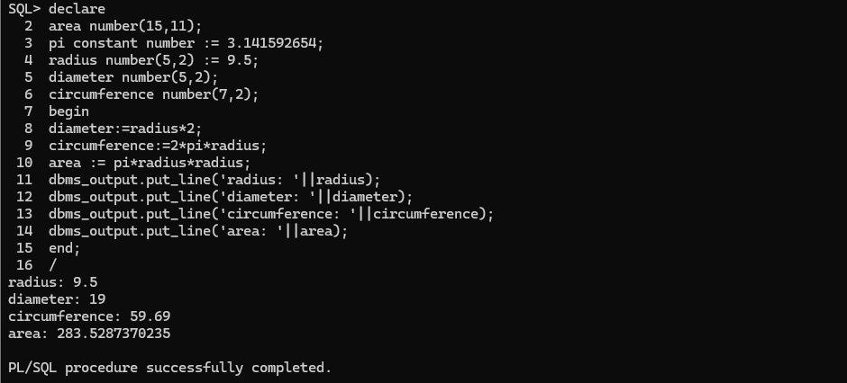
Input from the user
SQL> declare
2 t int;
3 begin
4 t := &t;
5 dbms_output.put_line('Value of t is: '||t);
6 end;
7 /
Enter value for t: 7
old 4: t := &t;
new 4: t := 7;
Value of t is: 7
PL/SQL procedure successfully completed.
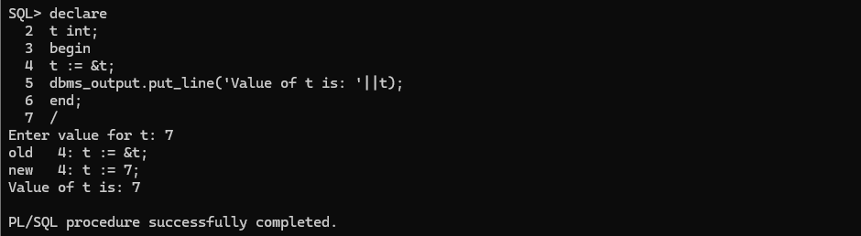
SQL> declare
2 t int;
3 s int;
4 begin
5 t := &t;
6 s := &s;
7 dbms_output.put_line('Sum is: '||(s+t));
8 end;
9 /
Enter value for t: 7
old 5: t := &t;
new 5: t := 7;
Enter value for s: 7
old 6: s := &s;
new 6: s := 7;
Sum is: 14
PL/SQL procedure successfully completed.
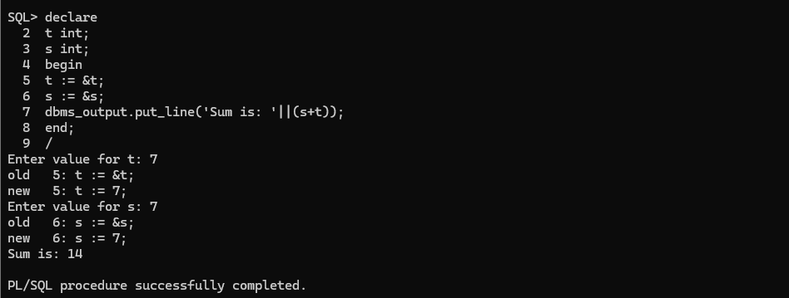
PL/SQL Basics – If – Example – Given number is Greater or lesser
SQL> DECLARE
2 a NUMBER(3) := 500;
3 BEGIN
4 IF (a < 20) THEN
5 DBMS_OUTPUT.PUT_LINE('a is less than 20');
6 ELSE
7 DBMS_OUTPUT.PUT_LINE('a is not less than 20');
8 END IF;
9
10 DBMS_OUTPUT.PUT_LINE('value of a is : ' || a);
11 END;
12 /
a is not less than 20
value of a is : 500
PL/SQL procedure successfully completed.
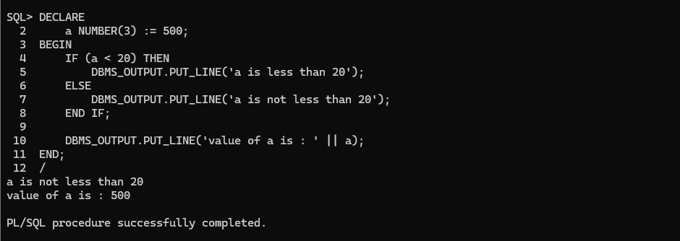
Greatest of 3 numbers
SQL> declare
2 a int:=2;
3 b int:=3;
4 c int:=4;
5 begin
6 if ( a > b and a > c) then
7 dbms_output.put_line('a is greater');
8 else if( b > c) then
9 dbms_output.put_line('b is greater');
10 else
11 dbms_output.put_line('c is greater');
12 end if;
13 end if;
14 end;
15 /
c is greater
PL/SQL procedure successfully completed.
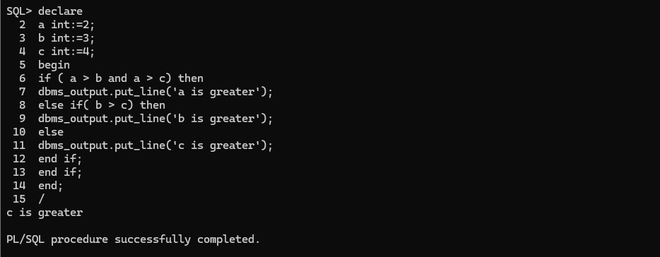
PL/SQL Basics – Case – Example
SQL> DECLARE
2 grade CHAR(1) := 'a';
3 BEGIN
4 CASE grade
5 WHEN 'a' THEN DBMS_OUTPUT.PUT_LINE('excellent');
6 WHEN 'b' THEN DBMS_OUTPUT.PUT_LINE('very good');
7 WHEN 'c' THEN DBMS_OUTPUT.PUT_LINE('good');
8 WHEN 'd' THEN DBMS_OUTPUT.PUT_LINE('average');
9 WHEN 'f' THEN DBMS_OUTPUT.PUT_LINE('passed with grace');
10 ELSE DBMS_OUTPUT.PUT_LINE('failed');
11 END CASE;
12 END;
13 /
excellent
PL/SQL procedure successfully completed.
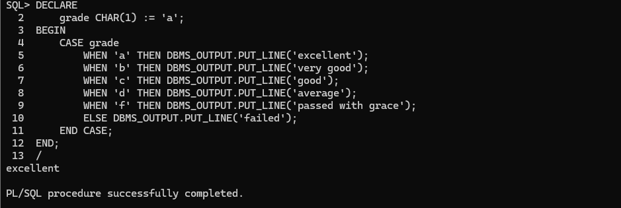
PL/SQL Basics – Basic Loop – Example – Print 1 to 10
SQL> DECLARE
2 i NUMBER := 1;
3 BEGIN
4 LOOP
5 EXIT WHEN i >= 10;
6 DBMS_OUTPUT.PUT_LINE(i);
7 i := i + 1;
8 END LOOP;
9 END;
10 /
1
2
3
4
5
6
7
8
9
PL/SQL procedure successfully completed.
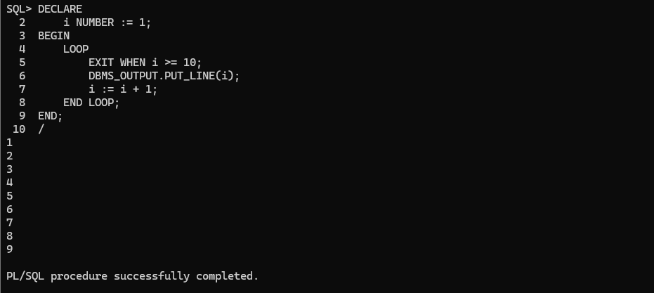
PL/SQL Basics – While Loop – Example
SQL> DECLARE
2 i INTEGER := 1;
3 BEGIN
4 WHILE i <= 10
5 LOOP
6 DBMS_OUTPUT.PUT_LINE(i);
7 i := i + 1;
8 END LOOP;
9 END;
10 /
1
2
3
4
5
6
7
8
9
10
PL/SQL procedure successfully completed.
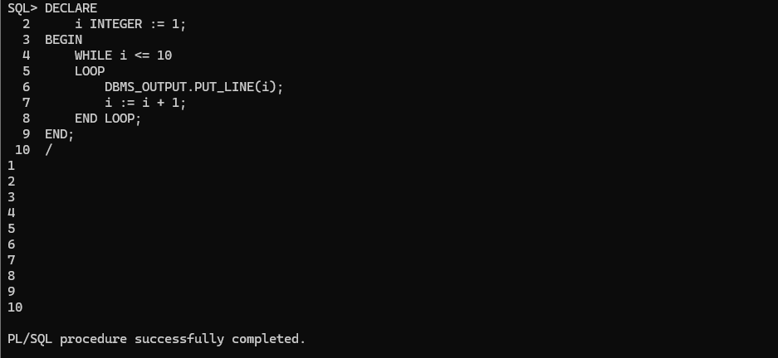
Multiples of 7
SQL> DECLARE
2 i INTEGER := 1;
3 BEGIN
4 WHILE i <= 70
5 LOOP
6 IF MOD(i, 7) = 0 THEN
7 DBMS_OUTPUT.PUT_LINE(i);
8 END IF;
9
10 i := i + 1;
11 END LOOP;
12 END;
13 /
7
14
21
28
35
42
49
56
63
70
PL/SQL procedure successfully completed.
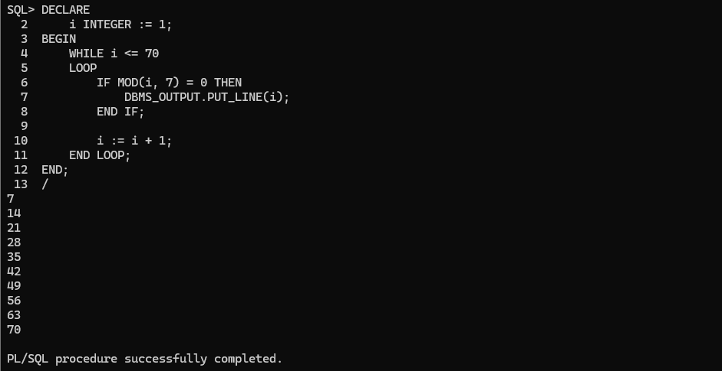
PL/SQL Basics – For Loop – Example – Print 1 to 10
SQL> BEGIN
2 FOR i IN 1..10
3 LOOP
4 DBMS_OUTPUT.PUT_LINE(i);
5 END LOOP;
6 END;
7 /
1
2
3
4
5
6
7
8
9
10
PL/SQL procedure successfully completed.
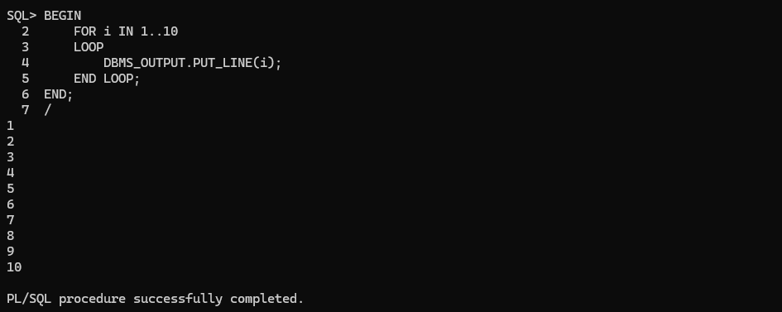
Incrementing the for loop >2
SQL> DECLARE
2 a INTEGER := 0;
3 BEGIN
4 FOR i IN 1..10
5 LOOP
6 DBMS_OUTPUT.PUT_LINE(a);
7 a := a + 2;
8 END LOOP;
9 END;
10 /
0
2
4
6
8
10
12
14
16
18
PL/SQL procedure successfully completed.
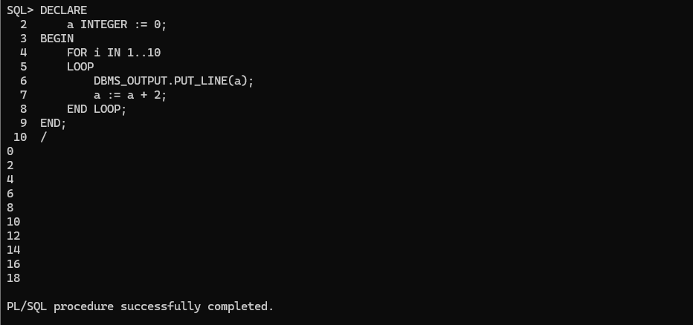
PL/SQL Basics – Continue – Example
SQL> DECLARE
2 x NUMBER := 0;
3 BEGIN
4 LOOP
5 DBMS_OUTPUT.PUT_LINE('inside loop: x = ' || TO_CHAR(x));
6
7 x := x + 1;
8
9 IF x < 3 THEN
10 CONTINUE;
11 END IF;
12
13 DBMS_OUTPUT.PUT_LINE(
14 'inside loop, after continue: x = ' || TO_CHAR(x)
15 );
16
17 EXIT WHEN x = 5;
18 END LOOP;
19
20 DBMS_OUTPUT.PUT_LINE('after loop: x = ' || TO_CHAR(x));
21 END;
22 /
inside loop: x = 0
inside loop: x = 1
inside loop: x = 2
inside loop, after continue: x = 3
inside loop: x = 3
inside loop, after continue: x = 4
inside loop: x = 4
inside loop, after continue: x = 5
after loop: x = 5
PL/SQL procedure successfully completed.
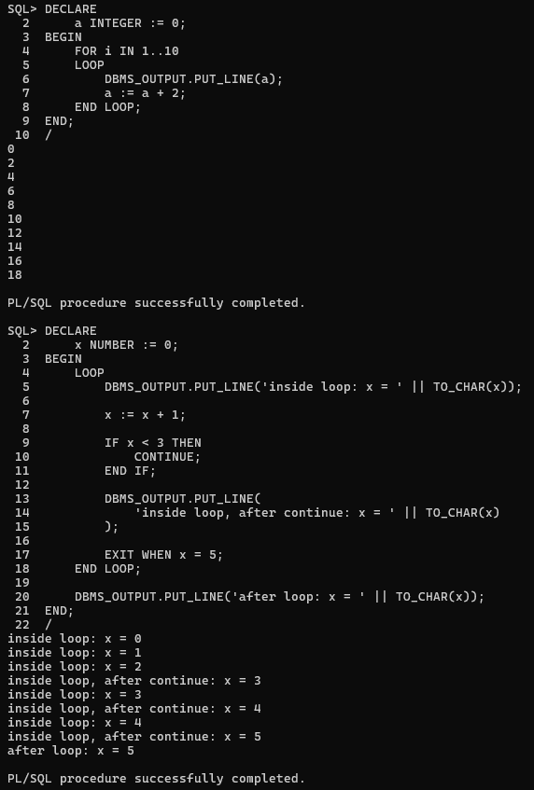
OWN QUESTIONS
1)Calculate remaining money:

SQL> set serveroutput on;
SQL> declare
2 total_money number;
3 spent_money number;
4 remaining number;
5 begin
6 total_money:=&total_money;
7 spent_money:=&spent_money;
8 remaining:=total_money-spent_money;
9 dbms_output.put_line('Remaining money= '||remaining);
10 end;
11 /
Enter value for total_money: 57899
old 6: total_money:=&total_money;
new 6: total_money:=57899;
Enter value for spent_money: 3244
old 7: spent_money:=&spent_money;
new 7: spent_money:=3244;
Remaining money= 54655

PL/SQL procedure successfully completed.

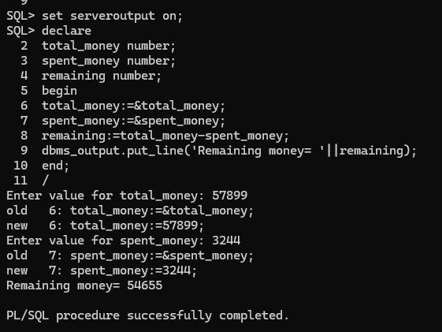

2)AGE

SQL> set serveroutput on;
SQL> declare
2 current_age number;
3 future_age number;
4 begin
5 current_age := &current_age;
6 future_age := current_age + 5;
7 dbms_output.put_line('Age after 5 years = ' || future_age);
8 end;
9 /
Enter value for current_age: 23
old 5: current_age := &current_age;
new 5: current_age := 23;
Age after 5 years = 28

PL/SQL procedure successfully completed.

