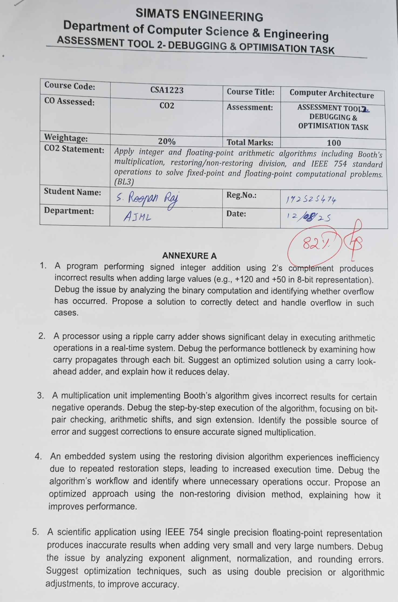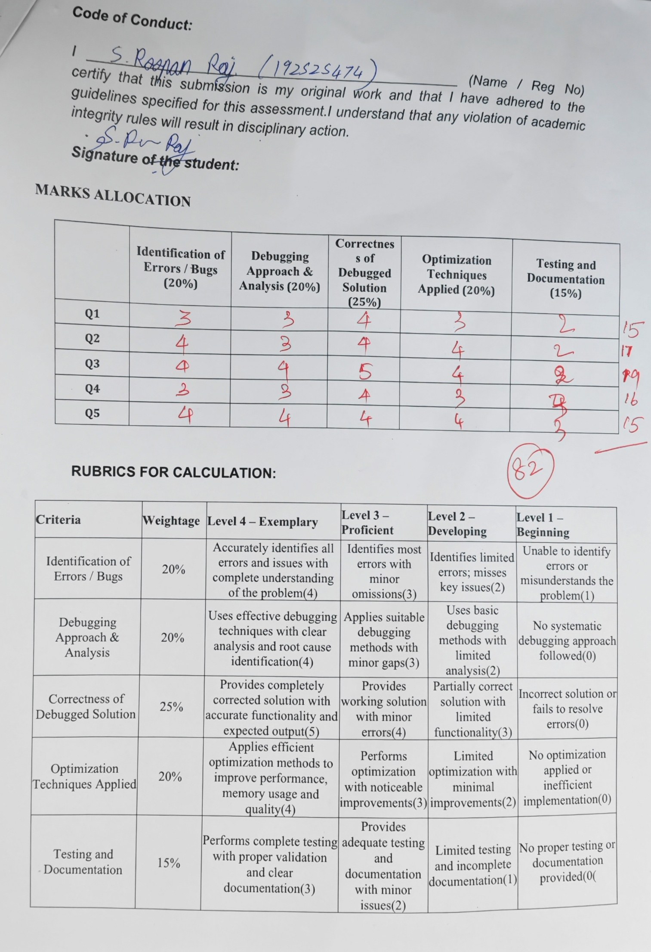SIMATS ENGINEERING
Department of Computer Science & Engineering
ASSESSMENT TOOL 2- DEBUGGING & OPTIMISATION TASK
Course Code: | CSA1223 | Course Title: | Computer Architecture
CO Assessed: | CO2 | Assessment: | ASSESSMENT TOOL2- DEBUGGING & OPTIMISATION TASK
Weightage: | 45% | Total Marks: | 100
CO2 Statement: | Apply integer and floating-point arithmetic algorithms including Booth's multiplication, restoring/non-restoring division, and IEEE 754 standard operations to solve fixed-point and floating-point computational problems. (BL3)
Student Name: |  | Reg.No.:
Department: |  | Date:

ANNEXURE A
- A program performing signed integer addition using 2’s complement produces incorrect results when adding large values (e.g., +120 and +50 in 8-bit representation). Debug the issue by analyzing the binary computation and identifying whether overflow has occurred. Propose a solution to correctly detect and handle overflow in such cases.
Answer to Question 1: 2's Complement Overflow Debugging
In signed 8-bit 2's complement, the range is -128 to +127. The inputs are +120 = 01111000 and +50 = 00110010.
01111000 (+120)
+ 00110010 (+50)
-------------
10101010

The result bit pattern has sign bit 1. Its magnitude is found by taking the 2's complement: 10101010 -> 01010101 -> 01010110 = 86. Hence the 8-bit circuit displays -86. The mathematical result, however, is +120 + +50 = +170. Since +170 exceeds +127, it cannot be represented in an 8-bit signed register. Therefore signed overflow has occurred: two positive inputs have produced a negative sign bit.

Overflow detection
The processor can detect overflow in either of two equivalent ways:
1. Sign test: A7 = 0, B7 = 0, but S7 = 1 -> overflow
2. Carry test: overflow = carry into bit 7 XOR carry out of bit 7
For this addition, the sign test is satisfied. The bit pattern 10101010 must not be accepted as the valid signed answer; it is only the modulo-256 bit result.

Correct handling / optimisation
Method | How it handles this case
Overflow flag / exception | Sets a status flag so software can branch to an error-handling routine.
Wider arithmetic | Use 16 bits: +170 = 00000000 10101010, which is valid.
Saturating arithmetic | For applications such as audio/DSP, clamp the result to +127 rather than wrap to -86.

Thus the bug is not an incorrect binary addition circuit; it is the failure to detect and handle a result outside the signed 8-bit range.
- A processor using a ripple carry adder shows significant delay in executing arithmetic operations in a real-time system. Debug the performance bottleneck by examining how carry propagates through each bit. Suggest an optimized solution using a carry look-ahead adder, and explain how it reduces delay.
Answer to Question 2: Ripple Carry Delay and CLA Optimisation
A ripple carry adder has a serial critical path. At bit 0, the full adder produces C1; bit 1 cannot complete its final sum until C1 arrives, and so on. The worst-case path is C0 -> C1 -> C2 -> ... -> Cn. In a real-time system this makes adder delay approximately proportional to the number of bits, especially when every input bit propagates a carry.

Generate and propagate analysis

For bit i, define Pi = Ai XOR Bi (the bit propagates an incoming carry) and Gi = Ai AND Bi (the bit generates a carry itself). The basic carry relation is Ci+1 = Gi + PiCi. A CLA expands this relation so all carries can be generated without waiting for the preceding full adder.

C1 = G0 + P0C0
C2 = G1 + P1G0 + P1P0C0
C3 = G2 + P2G1 + P2P1G0 + P2P1P0C0
C4 = G3 + P3G2 + P3P2G1 + P3P2P1G0 + P3P2P1P0C0
Aspect | Ripple carry adder | Carry look-ahead adder
Carry computation | Sequential; waits stage by stage. | Parallel Boolean carry generation.
Delay | Approximately proportional to n. | Lower for grouped CLA blocks.
Cost | Simple hardware. | Extra P/G logic and wiring.

The CLA uses more gates and longer Boolean expressions, but the carry path is much shorter. A practical high-speed processor groups bits into 4-bit CLA blocks and then uses group generate/propagate signals between blocks. This avoids one long n-stage ripple and improves the response time of the arithmetic unit.

- A multiplication unit implementing Booth’s algorithm gives incorrect results for certain negative operands. Debug the step-by-step execution of the algorithm, focusing on bit-pair checking, arithmetic shifts, and sign extension. Identify the possible source of error and suggest corrections to ensure accurate signed multiplication.
Answer to Question 3: Debugging Booth's Algorithm
Booth multiplication uses M (multiplicand), A (accumulator), Q (multiplier) and Q-1 (Booth bit). It works correctly for signed 2's complement operands only when the bit-pair decision, subtraction, sign extension and right shift are all performed correctly.
Required Booth rules
Q0 Q-1 | Required operation
00 | No operation
01 | A = A + M
10 | A = A - M
11 | No operation

After the selected operation, the combined A, Q, Q-1 register must be arithmetic-right-shifted once. The old A0 enters Q's most significant bit, the old Q0 enters Q-1, and A's old sign bit is copied into the new A most significant bit.
Likely fault | Effect | Correction
Checking Q-1Q0 instead of Q0Q-1 | Reverses the add/subtract decision. | Always evaluate Q0Q-1 in that order.
Logical right shift | Inserts 0 and loses the negative sign. | Use arithmetic right shift: copy A sign bit.
Missing sign extension | Negative M or A becomes an unsigned value. | Sign-extend all signed registers.
Incorrect subtraction | A - M is computed incorrectly. | Implement as A + 2's complement(M).
Example debugging trace: (-6) x (+5)
M = 1010 (-6), Q = 0101 (+5), A = 0000, Q-1 = 0
Iteration 1: Q0Q-1 = 10; A = A - M = 0110; shift -> A=0011, Q=0010, Q-1=1
Iteration 2: Q0Q-1 = 01; A = A + M = 1101; shift -> A=1110, Q=1001, Q-1=0
Iteration 3: Q0Q-1 = 10; A = A - M = 0100; shift -> A=0010, Q=0100, Q-1=1
Iteration 4: Q0Q-1 = 01; A = A + M = 1100; shift -> A=1110, Q=0010, Q-1=0
AQ = 11100010 = -30
A debugging trace must record A, Q, Q-1, Q0Q-1, the selected operation and the state after each shift. Comparing this trace with the expected values identifies the first iteration where an incorrect sign or action appears. The correction is to use the exact rules above, arithmetic shifting, and consistent sign extension for every register.

- An embedded system using the restoring division algorithm experiences inefficiency due to repeated restoration steps, leading to increased execution time. Debug the algorithm’s workflow and identify where unnecessary operations occur. Propose an optimized approach using the non-restoring division method, explaining how it improves performance.
Answer to Question 4: Optimising Restoring Division
Restoring division shifts the partial remainder A and quotient Q left by one bit, subtracts the divisor M from A, and tests the sign. If the subtraction is negative, the algorithm immediately restores the old remainder by adding M back and writes Q0 = 0. The restore addition is the repeated overhead.

Where the unnecessary work occurs: example 13 / 3
Initial: A = 0000, Q = 1101, M = 0011
Iteration 1: shift -> A,Q = 0001,1010; A-M = 1110 (negative); restore A=0001; Q0=0
Iteration 2: shift -> A,Q = 0011,0100; A-M = 0000 (non-negative); Q0=1 -> Q=0101
Iteration 3: shift -> A,Q = 0000,1010; A-M = 1101 (negative); restore A=0000; Q0=0
Iteration 4: shift -> A,Q = 0001,0100; A-M = 1110 (negative); restore A=0001; Q0=0
Result: Q = 0100 = 4, A = 0001 = 1
In iterations 1, 3 and 4, a subtract is followed by a restoration addition. Those restoration additions do not change the final quotient decision; they only reset A for the next iteration.
Non-restoring division
Non-restoring division keeps the negative partial remainder. If the previous A is non-negative, shift then subtract M; if it is negative, shift then add M. Set Q0 = 1 when the new A is non-negative, otherwise set Q0 = 0. A final correction A = A + M is made only when the last A is negative.

Feature | Restoring | Non-restoring
Negative remainder | Immediately restored. | Retained until the next iteration.
Arithmetic work | May do subtract plus restore addition. | One add/subtract per iteration; possible final correction.
Performance | More operations. | Usually faster and more efficient.

The optimized non-restoring approach produces the same valid quotient and remainder while avoiding unnecessary intermediate restorations. It is therefore preferred in faster arithmetic hardware, although it requires careful sign-based control and the final-correction check.
- A scientific application using IEEE 754 single precision floating-point representation produces inaccurate results when adding very small and very large numbers. Debug the issue by analyzing exponent alignment, normalization, and rounding errors. Suggest optimization techniques, such as using double precision or algorithmic adjustments, to improve accuracy.
Answer to Question 5: IEEE 754 Accuracy Debugging
IEEE 754 single precision stores 1 sign bit, 8 exponent bits and 23 fraction bits. When adding a very small value to a very large one, the exponents must first be made equal. The smaller significand is shifted right by the exponent difference, and significant bits may be lost before the arithmetic addition even begins.
Large: 1.xxxxxxxxxxxxxxxxxxxxxxx x 2^E
Small: 1.yyyyyyyyyyyyyyyyyyyyyyy x 2^(E-k)
Aligned: 0.000...0001.yyyyy... x 2^E

Why the result becomes inaccurate
If the shift is large, the small addend falls below one unit in the last place (ULP) of the large value. The aligned low-order bits are represented only by guard, round and sticky information, and rounding may leave the stored result unchanged. A second issue is catastrophic cancellation: subtracting nearly equal values removes leading significant bits, so the remaining result has much lower relative precision and must be renormalized.

Optimisation techniques

Optimisation | Benefit
Use double precision | 52 fraction bits retain substantially more significant information.
Compensated summation (Kahan) | Tracks and reapplies rounding error.
Sum small values first | Reduces loss during exponent alignment.
Keep intermediates at higher precision | Avoids repeated rounding.

Correct implementation uses guard, round and sticky bits with IEEE 754 round-to-nearest, ties-to-even. For scientific work, double precision together with a numerically stable algorithm is normally the best solution. The program should also avoid testing floating-point results for exact equality and should use an appropriate tolerance when comparing calculated values.

Code of Conduct:

I ____________________________________ (Name / Reg No) certify that this submission is my original work and that I have adhered to the guidelines specified for this assessment.I understand that any violation of academic integrity rules will result in disciplinary action.

Signature of the student:

MARKS ALLOCATION
 | Problem Understanding (20%) | Method Selection (20%) | Solution Process (25%) | Accuracy of Calculation (20%) | Interpretation of Results (15%)
Q1
Q2
Q3
Q4
Q5

RUBRICS FOR CALCULATION:

Criteria | Weightage | Level 4 – Exemplary | Level 3 – Proficient | Level 2 – Developing | Level 1 – Beginning
Problem Understanding | 20% | Clearly interprets problem, identifies all parameters and requirements accurately(4) | Understands problem with minor gaps(3) | Partial understanding; misses key elements(2) | Misinterprets or unable to understand problem(1)
Method Selection | 20% | Selects most appropriate method/formula with strong justification(4) | Selects correct method with minor errors(3) | Inappropriate or partially correct method(2) | Unable to select method(1)
Solution Process | 25% | Logical, systematic steps with correct approach throughout(5) | Mostly correct steps with minor mistakes(4) | Disorganized steps; multiple errors(3) | No clear process(0)
Accuracy of Calculation | 20% | All calculations accurate; correct final answer(4) | Minor calculation errors(3) | Frequent errors; incorrect final answer(2) | No valid calculations(0)
Interpretation of Results | 15% | Clearly interprets results with units and engineering relevance(3) | Basic interpretation with minor omissions(2) | Limited or unclear interpretation(1) | No interpretation(0)

