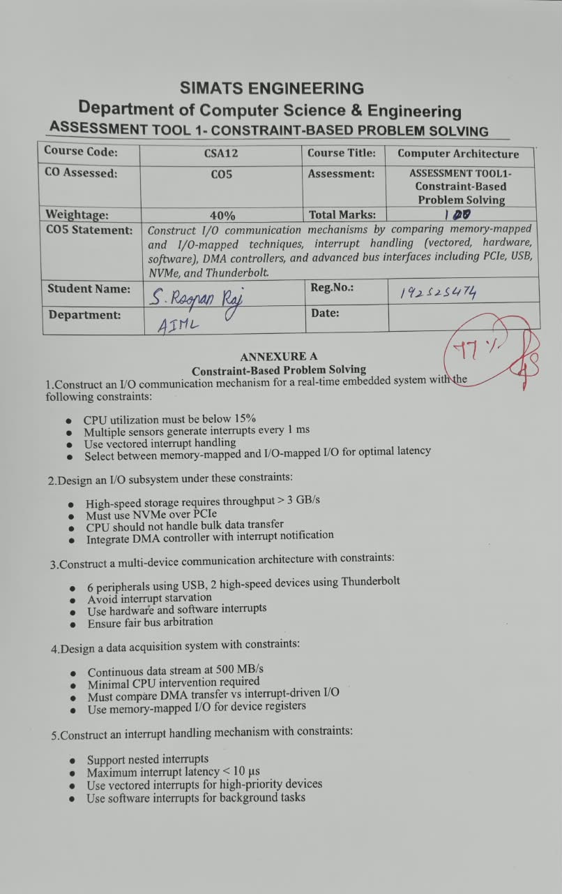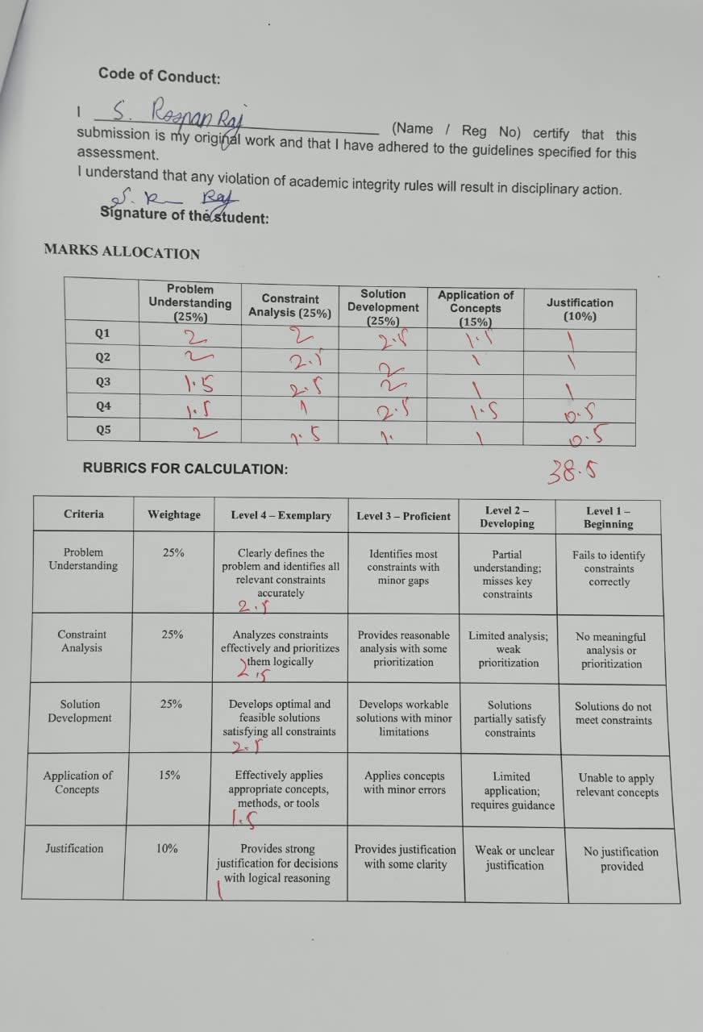

SIMATS ENGINEERING
Department of Computer Science & Engineering
ASSESSMENT TOOL 1- CONSTRAINT-BASED PROBLEM SOLVING
Course Code: | CSA12 | Course Title: | Computer Architecture
CO Assessed: | CO5 | Assessment: | ASSESSMENT TOOL1- Constraint-Based Problem Solving
Weightage: | 40% | Total Marks: | 25
CO5 Statement: | Construct I/O communication mechanisms by comparing memory-mapped and I/O-mapped techniques, interrupt handling (vectored, hardware, software), DMA controllers, and advanced bus interfaces including PCIe, USB, NVMe, and Thunderbolt.
Student Name: |  | Reg.No.:
Department: |  | Date:

ANNEXURE A
Constraint-Based Problem Solving

1.Construct an I/O communication mechanism for a real-time embedded system with the following constraints:
- CPU utilization must be below 15%
- Multiple sensors generate interrupts every 1 ms
- Use vectored interrupt handling
- Select between memory-mapped and I/O-mapped I/O for optimal latency
Answer:
Problem Understanding:
• The system must service interrupts from multiple sensors arriving every 1 ms while keeping CPU utilization strictly below 15%, requiring a fast, low-overhead I/O mechanism.
• Vectored interrupt handling is mandated, so each sensor must be uniquely identifiable to jump directly to its own Interrupt Service Routine (ISR) without polling overhead.
• A choice must be made between memory-mapped I/O and I/O-mapped (port-mapped) I/O based on which gives lower latency for this real-time context.
Constraint Analysis & Prioritization:
• Highest priority: CPU utilization ceiling (15%) - this rules out any polling-based approach, since polling every sensor at sub-millisecond granularity would consume excessive CPU cycles.
• Second priority: 1 ms interrupt interval per sensor - the ISR and interrupt-response path must complete well within this window, including for multiple simultaneous sensors.
• Third priority: vectored interrupt requirement - this is a design mandate rather than a trade-off, so it constrains the implementation, not the choice of memory access technique.
• Fourth priority: I/O access technique choice - directly affects the latency of the register read within each ISR, which matters most under tight 1 ms windows.
Proposed Solution / Design:
• Use a vectored interrupt controller (e.g., an Advanced Programmable Interrupt Controller-style design) where each sensor line has a unique vector number, allowing the CPU to jump straight to the correct ISR with no software polling loop.
• Choose memory-mapped I/O over I/O-mapped I/O: memory-mapped I/O lets sensor registers be accessed with regular load/store instructions (often via cached or pipelined memory bus paths), avoiding the separate, typically slower IN/OUT instruction cycle that port-mapped I/O requires.
• Keep each ISR minimal ('bottom-half' design): the ISR only reads the sensor's data register and acknowledges the interrupt; heavier processing is deferred to a lower-priority task/thread outside the interrupt context.
• Use interrupt coalescing/priority grouping if multiple sensors trigger near-simultaneously, so the vectored controller queues them by priority instead of causing repeated context switches.
Aspect | Memory-Mapped I/O | I/O-Mapped I/O
Access Method | Standard load/store instructions | Dedicated IN/OUT instructions
Address Space | Shares main memory address space | Separate, smaller address space
Latency | Lower - uses regular memory bus/cache paths | Higher - dedicated but less pipelined I/O bus cycle
Suitability Here | Better fit for sub-ms, low-CPU-overhead access | Less efficient for frequent, fast sensor polling

Application of Concepts:
• Vectored interrupt handling (unique ISR entry points, interrupt vector table).
• Memory-mapped I/O addressing for peripheral registers.
• Interrupt latency and CPU-utilization analysis for real-time embedded constraints.
• ISR design principles (top-half/bottom-half split) to minimize time spent in interrupt context.
Justification:
Memory-mapped I/O combined with vectored interrupts satisfies all constraints together: vectoring eliminates the CPU cost of polling/scanning (keeping utilization under 15%), while memory-mapped access reduces the per-interrupt register-read latency compared to I/O-mapped access, ensuring each 1 ms sensor deadline is met with margin to spare.

2.Design an I/O subsystem under these constraints:
- High-speed storage requires throughput > 3 GB/s
- Must use NVMe over PCIe
- CPU should not handle bulk data transfer
- Integrate DMA controller with interrupt notification
Answer:
Problem Understanding:
• The storage subsystem must sustain throughput greater than 3 GB/s, which rules out CPU-mediated (Programmed I/O) data transfer since it cannot sustain such rates without saturating the CPU.
• NVMe over PCIe is mandated as the interface/protocol standard.
• The CPU must be kept out of the bulk data path entirely, and DMA completion must still be reported back to the CPU via interrupt notification.
Constraint Analysis & Prioritization:
• Highest priority: CPU must not handle bulk transfer - this is a hard functional constraint that determines the overall architecture (DMA-based, not PIO-based).
• Second priority: throughput > 3 GB/s - this determines the choice of PCIe generation/lane count, since bandwidth must exceed this target with headroom.
• Third priority: DMA-interrupt integration - notification must be efficient (not per-block) to avoid reintroducing CPU overhead through excessive interrupts.
• Fourth priority: protocol conformance to NVMe over PCIe, which shapes queue/command structure (submission/completion queues).
Proposed Solution / Design:
• Use an NVMe SSD controller connected via PCIe Gen4 x4 (theoretical ~7.9 GB/s) or PCIe Gen3 x4 (~3.94 GB/s) to comfortably exceed the 3 GB/s throughput requirement.
• Implement NVMe's native multiple submission/completion queue model: the CPU only writes a command descriptor (source, destination, length) to the submission queue; the NVMe controller's DMA engine then transfers data directly to/from system RAM.
• Use scatter-gather DMA so a single DMA descriptor list can handle large, non-contiguous transfers in one operation, minimizing the number of CPU-DMA handoffs needed for a large file transfer.
• Configure interrupt coalescing (MSI-X interrupts) so the DMA controller raises one completion interrupt per batch of finished commands rather than one interrupt per block, keeping CPU overhead low even at high throughput.
Application of Concepts:
• DMA controller operation (descriptor-based, scatter-gather transfer).
• NVMe command queue architecture (submission/completion queue pairs).
• PCIe bandwidth/lane calculations to validate throughput constraints.
• MSI-X interrupt notification and coalescing for efficient completion signaling.
Justification:
Routing all bulk data through a DMA engine keeps the CPU free of the transfer path entirely, while PCIe Gen3/Gen4 x4 lanes provide the raw bandwidth headroom above 3 GB/s; interrupt coalescing on DMA completion preserves low CPU overhead even though bulk transfer completion must still be reported to the CPU, satisfying every stated constraint simultaneously.

3.Construct a multi-device communication architecture with constraints:
- 6 peripherals using USB, 2 high-speed devices using Thunderbolt
- Avoid interrupt starvation
- Use hardware and software interrupts
- Ensure fair bus arbitration
Answer:
Problem Understanding:
• Six USB peripherals and two Thunderbolt high-speed devices must share the system's I/O resources without any device being starved of interrupt servicing.
• The design must use a mix of hardware and software interrupts, and bus arbitration must be fair across all eight devices.

Constraint Analysis & Prioritization:
• Highest priority: avoid interrupt starvation - with 8 devices contending for CPU attention, a fixed-priority scheme could starve low-priority USB peripherals if Thunderbolt devices interrupt too frequently.
• Second priority: fair bus arbitration - Thunderbolt (PCIe-tunneled, very high bandwidth) and USB (lower bandwidth, hub-based) have very different bus characteristics, so arbitration must account for this asymmetry rather than treating all devices identically.
• Third priority: correct use of hardware vs software interrupts - hardware interrupts for genuine device events, software interrupts for scheduling background/deferred work.
Proposed Solution / Design:
• Use a hardware interrupt per device controller (one for the USB host controller, one for the Thunderbolt controller) rather than one line per peripheral; the USB host controller then internally identifies which of its 6 attached peripherals raised the request via its own frame-based polling/interrupt-transfer scheduling.
• Apply round-robin or weighted fair-queuing arbitration at the USB host-controller level across its 6 peripherals, and separately allocate dedicated PCIe bandwidth slices to the 2 Thunderbolt devices so high-speed traffic cannot monopolize the shared bus indefinitely.
• Use a rotating/aging priority scheme: any device whose request has been pending beyond a threshold time has its priority temporarily boosted, which mathematically bounds the worst-case wait and prevents starvation of the 6 lower-speed USB devices.
• Use software interrupts for deferred, non-time-critical work (e.g., a USB peripheral's data-processing task queued after the hardware interrupt merely acknowledges receipt), keeping hardware ISRs short.
Interrupt Type | Trigger Source | Role in This Design
Hardware Interrupt | USB host controller / Thunderbolt controller signal | Immediate, short ISR to acknowledge and queue the event
Software Interrupt | Triggered by the OS/driver after hardware ISR | Deferred processing of peripheral data without blocking new hardware interrupts

Application of Concepts:
• Interrupt starvation and aging-based priority scheduling.
• Bus arbitration schemes (round-robin, weighted fair queuing) for heterogeneous buses (USB vs PCIe/Thunderbolt).
• Distinction and coordinated use of hardware interrupts vs software interrupts.
• USB hub/host-controller interrupt-transfer polling mechanism.
Justification:
Separating hardware interrupts (one per controller, kept minimal) from software interrupts (deferred per-peripheral work) keeps ISR time short for all 8 devices, while aging-based arbitration guarantees that no USB peripheral waits indefinitely behind higher-bandwidth Thunderbolt traffic, jointly satisfying the starvation-avoidance and fairness constraints.

4.Design a data acquisition system with constraints:
- Continuous data stream at 500 MB/s
- Minimal CPU intervention required
- Must compare DMA transfer vs interrupt-driven I/O
- Use memory-mapped I/O for device registers
Answer:
Problem Understanding:
• The system must sustain a continuous 500 MB/s data stream while requiring minimal CPU intervention, and must justify DMA over interrupt-driven I/O through explicit comparison.
• Device registers must be accessed using memory-mapped I/O.
Constraint Analysis & Prioritization:
• Highest priority: minimal CPU intervention at 500 MB/s - at this sustained rate, a purely interrupt-driven, per-sample approach would generate an infeasible interrupt rate, so this constraint effectively mandates DMA as the primary transfer mechanism.
• Second priority: continuous streaming nature of the data - favors a circular/ring-buffer DMA scheme over one-shot transfers.
• Third priority: memory-mapped I/O requirement for device registers - determines how the CPU configures and monitors the acquisition hardware (not the bulk data path itself).
Proposed Solution / Design:
• Configure the data-acquisition hardware's control/status registers as memory-mapped I/O so the CPU can set sampling rate, start/stop the stream, and read status flags using ordinary load/store instructions.
• Use a DMA controller operating in circular (ring) buffer mode: the ADC/sensor interface streams samples directly into a pre-allocated RAM buffer without CPU involvement per sample.
• Use double-buffering (ping-pong buffers): while DMA fills buffer A, the CPU processes buffer B, then the roles swap, ensuring continuous 500 MB/s throughput without data loss or CPU stalls.
• Raise a single interrupt only when each buffer is full (batch-level notification), not per sample, so CPU intervention is limited to periodic buffer-swap handling rather than constant servicing.
Aspect | DMA Transfer | Interrupt-Driven I/O
CPU Involvement | Minimal - only for setup and buffer-full notification | High - CPU services every data-ready event
Achievable Throughput | Very high; limited mainly by bus/memory bandwidth | Limited by interrupt-handling overhead and context-switch cost
Suitability at 500 MB/s | Well suited - matches the 'minimal CPU intervention' constraint | Not suitable - interrupt rate at this throughput would overwhelm the CPU

Application of Concepts:
• DMA ring-buffer / double-buffering (ping-pong) technique for continuous streaming.
• Memory-mapped I/O for device configuration and status registers.
• Quantitative comparison of DMA vs interrupt-driven I/O overhead at high data rates.
• Batch-level interrupt notification to reduce CPU load.
Justification:
At 500 MB/s, an interrupt-driven approach would require an interrupt on the order of every few hundred nanoseconds to microseconds per sample, which is far beyond feasible CPU servicing rates; a DMA engine with double-buffering moves data directly to memory and only interrupts the CPU once per full buffer, meeting the minimal-CPU-intervention constraint while memory-mapped control registers keep configuration and monitoring simple and fast.

5.Construct an interrupt handling mechanism with constraints:
- Support nested interrupts
- Maximum interrupt latency < 10 µs
- Use vectored interrupts for high-priority devices
- Use software interrupts for background tasks
Answer:
Problem Understanding:
• The interrupt handling mechanism must support nested interrupts (a higher-priority interrupt can preempt a lower-priority ISR already in progress).
• Maximum interrupt latency must remain below 10 microseconds, and the design must combine vectored interrupts for high-priority devices with software interrupts for background tasks.
Constraint Analysis & Prioritization:
• Highest priority: the 10 microsecond maximum latency bound - this constrains ISR length, interrupt-controller response time, and how nesting is implemented (must not add significant overhead).
• Second priority: correct nested-interrupt support - a naive design that disables all interrupts during an ISR would violate both the nesting requirement and potentially the latency bound for high-priority events arriving during a lower-priority ISR.
• Third priority: appropriate use of vectored interrupts for high-priority devices (fast, direct dispatch) versus software interrupts for background tasks (deferred, non-time-critical).
Proposed Solution / Design:
• Use a priority-based vectored interrupt controller that supports interrupt nesting: each interrupt source is assigned a priority level, and the controller automatically allows a higher-priority interrupt to preempt a currently executing lower-priority ISR.
• Keep every high-priority ISR extremely short (only save minimal context, read/acknowledge the device, and re-enable interrupts above the current priority) to keep worst-case latency for a higher-priority event well under 10 microseconds even while another ISR is running.
• Assign vectored interrupts to genuinely time-critical hardware devices so they dispatch directly to their ISR with no software dispatch/lookup overhead.
• Use software interrupts (e.g., a trap/syscall-like mechanism or a scheduled deferred-procedure call) for background tasks such as logging or non-urgent housekeeping, which run at the lowest priority level and can always be preempted by any hardware interrupt.
Interrupt Type | Priority Level | Example Use in This Design
Vectored Hardware Interrupt | High | Time-critical device requiring <10 us response
Software Interrupt | Low (background) | Logging, deferred non-urgent processing

Application of Concepts:
• Nested interrupt architecture with priority-based preemption.
• Vectored interrupt dispatch for deterministic, low-latency response.
• Software interrupts / deferred procedure calls for background work.
• Worst-case interrupt latency analysis against a hard real-time bound.
Justification:
A priority-based, nestable vectored interrupt controller directly supports preemption of low-priority ISRs by high-priority ones, and keeping ISRs minimal ensures the worst-case response time for any high-priority device stays under 10 microseconds; relegating non-urgent work to software interrupts at the lowest priority ensures background tasks never block or delay a real-time-critical hardware event.

Code of Conduct:

I ____________________________________ (Name / Reg No) certify that this submission is my original work and that I have adhered to the guidelines specified for this assessment.
I understand that any violation of academic integrity rules will result in disciplinary action.

Signature of the student:

MARKS ALLOCATION
 | Problem Understanding (25%) | Constraint Analysis (25%) | Solution Development (25%) | Application of Concepts (15%) | Justification (10%)
Q1
Q2
Q3
Q4
Q5

RUBRICS FOR CALCULATION:

Criteria | Weightage | Level 4 – Exemplary | Level 3 – Proficient | Level 2 – Developing | Level 1 – Beginning
Problem Understanding | 25% | Clearly defines the problem and identifies all relevant constraints accurately | Identifies most constraints with minor gaps | Partial understanding; misses key constraints | Fails to identify constraints correctly
Constraint Analysis | 25% | Analyzes constraints effectively and prioritizes them logically | Provides reasonable analysis with some prioritization | Limited analysis; weak prioritization | No meaningful analysis or prioritization
Solution Development | 25% | Develops optimal and feasible solutions satisfying all constraints | Develops workable solutions with minor limitations | Solutions partially satisfy constraints | Solutions do not meet constraints
Application of Concepts | 15% | Effectively applies appropriate concepts, methods, or tools | Applies concepts with minor errors | Limited application; requires guidance | Unable to apply relevant concepts
Justification | 10% | Provides strong justification for decisions with logical reasoning | Provides justification with some clarity | Weak or unclear justification | No justification provided

