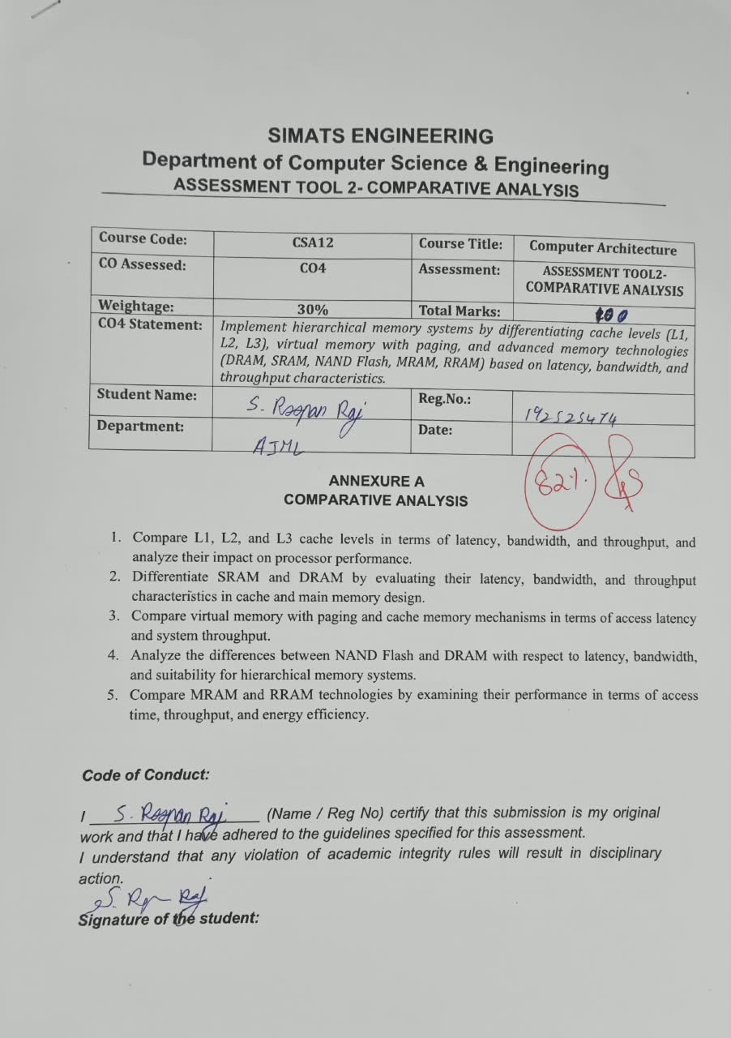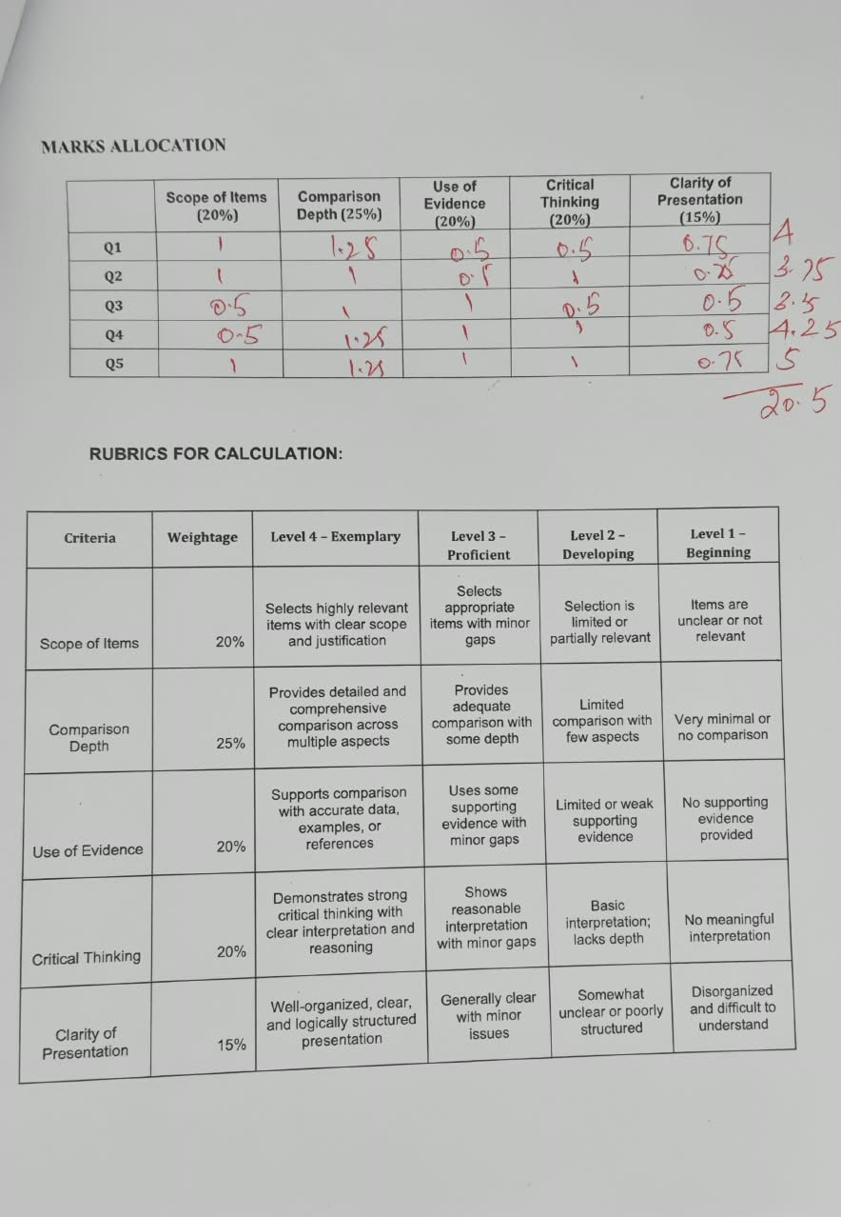 SIMATS ENGINEERING
Department of Computer Science & Engineering
ASSESSMENT TOOL 2- COMPARATIVE ANALYSIS

Course Code: | CSA12 | Course Title: | Computer Architecture
CO Assessed: | CO4 | Assessment: | ASSESSMENT TOOL2- COMPARATIVE ANALYSIS
Weightage: | 30% | Total Marks: | 25
CO4 Statement: | Implement hierarchical memory systems by differentiating cache levels (L1, L2, L3), virtual memory with paging, and advanced memory technologies (DRAM, SRAM, NAND Flash, MRAM, RRAM) based on latency, bandwidth, and throughput characteristics.
Student Name: |  | Reg.No.:
Department: |  | Date:

ANNEXURE A
COMPARATIVE ANALYSIS

- Compare L1, L2, and L3 cache levels in terms of latency, bandwidth, and throughput, and analyze their impact on processor performance.
Answer:
Comparison Table (Evidence-Based):
Parameter | L1 Cache | L2 Cache | L3 Cache
Location | Per-core, on-die | Per-core/cluster, on-die | Shared across all cores
Typical Size | 16-64 KB | 256 KB - 1 MB | 2-32 MB
Access Latency | ~1-2 cycles (~0.5-1 ns) | ~8-12 cycles (~3-5 ns) | ~30-40 cycles (~10-20 ns)
Bandwidth | Very High (100+ GB/s per core) | High | Medium-High (shared, contended)
Miss Penalty | Low (goes to L2) | Moderate (goes to L3) | High (goes to DRAM, 100+ cycles)

Detailed Comparison:
• L1 is split into instruction (I-cache) and data (D-cache) caches and is tightly coupled to the pipeline for single-cycle-class access; its small size keeps latency minimal but capacity is limited.
• L2 is larger and slightly slower than L1; it acts as a mid-level buffer that reduces the frequency of costly L3/DRAM accesses by holding a broader working set.
• L3 is shared among cores, trading higher latency and contention for much greater capacity, which allows it to absorb misses from many cores simultaneously and support inter-core data sharing.
• Bandwidth decreases and latency increases moving from L1 to L3, reflecting the classic speed-capacity-cost trade-off in cache hierarchy design.

Critical Analysis / Impact on Performance:
• A well-tuned L1/L2/L3 hierarchy directly improves IPC (instructions per cycle): more hits in low-latency L1/L2 reduce pipeline stalls, while a larger shared L3 reduces expensive DRAM round-trips for multi-threaded workloads.
• Poor L1 utilization (e.g., due to cache-unfriendly code) increases L2/L3 traffic and DRAM accesses, which can dominate execution time in memory-bound applications far more than any change to core clock speed.
• Shared L3 introduces contention between cores in multi-core systems, so its effectiveness depends heavily on replacement policy (e.g., LRU vs adaptive) and cache-partitioning strategies for co-running workloads.
Conclusion:
L1, L2, and L3 form a latency-capacity trade-off hierarchy: L1 optimizes for speed, L3 optimizes for capacity/sharing, and overall processor performance depends on minimizing misses at each level to avoid the high cost of a DRAM access.

- Differentiate SRAM and DRAM by evaluating their latency, bandwidth, and throughput characteristics in cache and main memory design.
Answer:
Comparison Table (Evidence-Based):
Parameter | SRAM | DRAM
Cell Structure | 6-transistor flip-flop | 1 transistor + 1 capacitor
Access Latency | ~1-2 ns (very fast) | ~10-15 ns (needs charge sensing)
Bandwidth | Very High | High (with wide buses, e.g., DDR/GDDR)
Density/Capacity | Low density, expensive per bit | High density, cheap per bit
Refresh Requirement | None (static) | Requires periodic refresh (dynamic)
Typical Use | L1/L2/L3 cache | Main memory (system RAM)

Detailed Comparison:
• SRAM stores each bit in a bistable latch, so it retains data without refreshing as long as power is applied, giving deterministic, very low access latency.
• DRAM stores each bit as charge on a capacitor, which leaks over time and must be refreshed every few milliseconds; this refresh overhead adds latency and periodically blocks access.
• SRAM's six-transistor cell is far larger than DRAM's one-transistor-one-capacitor cell, so DRAM achieves much higher storage density at a lower cost per gigabyte, making it practical for GB-scale main memory.
• In throughput terms, SRAM sustains very high random-access throughput because there is no row-activate/precharge cycle, whereas DRAM throughput depends on row-buffer locality and burst length.
Critical Analysis / Impact on Performance:
• The choice of SRAM for cache and DRAM for main memory reflects a deliberate hierarchy: SRAM's speed hides latency for frequently reused data, while DRAM's density affordably holds the much larger working set.
• Emerging systems that need both speed and density (e.g., HBM stacking DRAM close to the die) show engineers working around DRAM's latency limitation with wider parallel access rather than replacing it with SRAM, since SRAM at DRAM capacities would be prohibitively expensive and power-hungry.
• DRAM refresh cycles introduce a subtle throughput penalty in bursty or latency-sensitive workloads (e.g., real-time systems), which is why SRAM remains essential wherever deterministic low latency is critical.
Conclusion:
SRAM trades density and cost for speed and determinism, making it ideal for cache; DRAM trades speed for density and cost-efficiency, making it the practical choice for large main memory - together they balance the latency-capacity requirements of a computer system.

- Compare virtual memory with paging and cache memory mechanisms in terms of access latency and system throughput.
Answer:
Comparison Table (Evidence-Based):
Parameter | Cache Memory | Virtual Memory (Paging)
Purpose | Speeds up access to frequently used data | Extends addressable memory beyond physical RAM
Managed By | Hardware (cache controller) | Operating System + MMU/TLB
Access Latency (hit) | ~1-40 cycles (ns range) | ~100+ cycles for RAM-resident page (via TLB)
Access Latency (miss/fault) | Goes to next cache level or DRAM | Page fault: disk/SSD access, microseconds to milliseconds
Granularity | Cache lines (32-128 bytes) | Pages (typically 4KB, or 2MB/1GB huge pages)
Effect on Throughput | High hit rate sustains near-peak throughput | Frequent page faults ('thrashing') sharply reduce throughput

Detailed Comparison:
• Cache memory operates transparently in hardware at nanosecond timescales, exploiting temporal and spatial locality within a running program's immediate working set.
• Virtual memory paging is managed by the OS and MMU, mapping virtual addresses to physical frames via page tables and a Translation Lookaside Buffer (TLB); a TLB hit is fast, but a TLB miss requires a page-table walk, and a page fault requires a slow disk/SSD access.
• Cache misses are resolved within the memory hierarchy in tens to hundreds of cycles, while page faults can cost orders of magnitude more time (microseconds to milliseconds) because they may involve secondary storage.
• Both mechanisms use locality principles, but cache optimizes for speed within available fast memory, while paging optimizes for the illusion of unlimited memory space at the cost of occasional large latency spikes.
Critical Analysis / Impact on Performance:
• System throughput is highly sensitive to page-fault rate: excessive faulting ('thrashing') under memory pressure can degrade throughput far more severely than any cache-miss scenario, since disk/SSD latency is 1,000-100,000x that of DRAM.
• Modern systems mitigate this gap with huge pages (fewer TLB entries needed per GB) and NVMe-based swap, narrowing but not eliminating the latency disparity between cache and paging.
• From a design standpoint, cache misses are a performance concern while page faults (especially major faults to disk) are a correctness-adjacent concern for responsiveness, since an application can stall for milliseconds waiting on a page.
Conclusion:
Cache memory and virtual memory paging both bridge speed and capacity gaps, but at very different scales: cache narrows the CPU-to-DRAM gap in nanoseconds, while paging narrows the DRAM-to-storage gap at a cost of microseconds to milliseconds, making paging efficiency far more critical to sustained system throughput under memory pressure.

- Analyze the differences between NAND Flash and DRAM with respect to latency, bandwidth, and suitability for hierarchical memory systems.
Answer:
Comparison Table (Evidence-Based):
Parameter | NAND Flash | DRAM
Volatility | Non-volatile (retains data without power) | Volatile (loses data without power)
Read Latency | ~25-50 microseconds | ~10-15 nanoseconds
Write Latency | ~200-500 microseconds (plus erase-before-write) | ~10-15 nanoseconds
Bandwidth | ~500 MB/s - 3.5 GB/s (per NVMe lane/controller) | ~20-90+ GB/s (per DIMM/channel)
Endurance | Limited (~1,000-100,000 program/erase cycles) | Effectively unlimited
Cost per GB | Low | High
Role in Hierarchy | Persistent bulk/secondary storage | Active working-set main memory

Detailed Comparison:
• NAND Flash stores charge in floating-gate or charge-trap cells, giving non-volatility but requiring a slow block-erase-before-write process that limits write speed and endurance.
• DRAM stores charge on capacitors accessed at nanosecond speed but is volatile, requiring continuous power and periodic refresh to retain data.
• NAND Flash offers roughly 1,000x lower cost per GB than DRAM, which is why it is the practical choice for large persistent storage (SSDs), while DRAM's speed makes it indispensable for active computation.
• Bandwidth-wise, DRAM channels vastly outperform NAND interfaces, though modern NVMe SSDs with multiple parallel NAND dies narrow the gap for sequential throughput while still lagging badly on latency and random access.
Critical Analysis / Impact on Performance:
• In hierarchical memory systems, NAND Flash and DRAM are complementary rather than competing: DRAM handles the low-latency active tier while NAND Flash handles persistent, high-capacity storage, with the OS/paging system bridging the two.
• NAND's limited write endurance means wear-leveling and write-amplification management are critical design considerations if NAND is used anywhere near the 'hot' data path (e.g., as a swap device), whereas DRAM has no such constraint.
• Emerging technologies (e.g., Intel Optane/3D XPoint-class NVM) attempted to sit between NAND and DRAM in the hierarchy, illustrating that the latency-cost gap between these two technologies is significant enough to justify an intermediate tier in some system designs.

Conclusion:
DRAM is optimized for speed and is unsuitable for persistent storage, while NAND Flash is optimized for non-volatile, low-cost, high-density storage but is far too slow for active computation - hierarchical memory systems place DRAM as main memory and NAND Flash as the persistent storage tier beneath it.

- Compare MRAM and RRAM technologies by examining their performance in terms of access time, throughput, and energy efficiency.
Answer:
Comparison Table (Evidence-Based):
Parameter | MRAM | RRAM
Storage Mechanism | Magnetic tunnel junction (spin orientation) | Resistance change in a metal-oxide layer
Volatility | Non-volatile | Non-volatile
Access Time (Read) | ~3-20 ns (near-SRAM speed) | ~10-50 ns
Access Time (Write) | ~3-20 ns | ~10-50 ns (can vary with forming/set/reset)
Endurance | Very high (~10^15 cycles, effectively unlimited) | Moderate-High (~10^6-10^12 cycles)
Energy Efficiency | Low write energy, no leakage at rest | Very low write energy, supports in-memory compute
Typical Use | Persistent cache/registers, safety-critical state | Fast persistent storage, neuromorphic/in-memory compute

Detailed Comparison:
• MRAM (Magnetoresistive RAM) encodes bits using the relative magnetic orientation of two ferromagnetic layers in a magnetic tunnel junction, switched electrically; this gives near-SRAM speed with non-volatility and very high write endurance.
• RRAM (Resistive RAM) encodes bits as a high- or low-resistance state formed by a conductive filament in a metal-oxide layer; it is slightly slower than MRAM but supports simpler, denser crossbar array structures and analog resistance states useful for compute-in-memory.
• Both are non-volatile, unlike DRAM/SRAM, meaning both retain data without power, which reduces standby energy consumption significantly.
• MRAM generally offers superior endurance and faster, more deterministic switching, whereas RRAM tends to offer higher potential density and lower cost per bit, along with native support for multi-level (analog) storage.
Critical Analysis / Impact on Performance:
• MRAM's very high endurance and speed make it well suited for applications needing frequent, safety-critical writes (e.g., storing last-known-good state in an automotive or industrial system) where RRAM's lower endurance could become a reliability risk over the product lifetime.
• RRAM's ability to perform analog, multi-level resistance storage and in-memory multiply-accumulate operations gives it a distinct advantage for AI/edge-inference accelerators, an area where MRAM (binary magnetic states) is less naturally suited.
• Energy efficiency favors RRAM for very-low-power always-on applications (ultra-low write energy, no refresh), while MRAM's efficiency advantage lies in eliminating the need for error-correction-heavy over-provisioning due to its higher endurance and reliability.
Conclusion:
MRAM and RRAM are both promising non-volatile memory technologies that could bridge cache and storage, but MRAM leans toward high-endurance, high-speed, safety-critical roles, while RRAM leans toward high-density, low-power, compute-in-memory and AI-accelerator roles.

Code of Conduct:

I ____________________ (Name / Reg No) certify that this submission is my original work and that I have adhered to the guidelines specified for this assessment.
I understand that any violation of academic integrity rules will result in disciplinary action.

Signature of the student:

MARKS ALLOCATION
 | Scope of Items (20%) | Comparison Depth (25%) | Use of Evidence (20%) | Critical Thinking (20%) | Clarity of Presentation (15%)
Q1
Q2
Q3
Q4
Q5

RUBRICS FOR CALCULATION:

Criteria | Weightage | Level 4 – Exemplary | Level 3 – Proficient | Level 2 – Developing | Level 1 – Beginning
Scope of Items | 20% | Selects highly relevant items with clear scope and justification | Selects appropriate items with minor gaps | Selection is limited or partially relevant | Items are unclear or not relevant
Comparison Depth | 25% | Provides detailed and comprehensive comparison across multiple aspects | Provides adequate comparison with some depth | Limited comparison with few aspects | Very minimal or no comparison
Use of Evidence | 20% | Supports comparison with accurate data, examples, or references | Uses some supporting evidence with minor gaps | Limited or weak supporting evidence | No supporting evidence provided
Critical Thinking | 20% | Demonstrates strong critical thinking with clear interpretation and reasoning | Shows reasonable interpretation with minor gaps | Basic interpretation; lacks depth | No meaningful interpretation
Clarity of Presentation | 15% | Well-organized, clear, and logically structured presentation | Generally clear with minor issues | Somewhat unclear or poorly structured | Disorganized and difficult to understand

