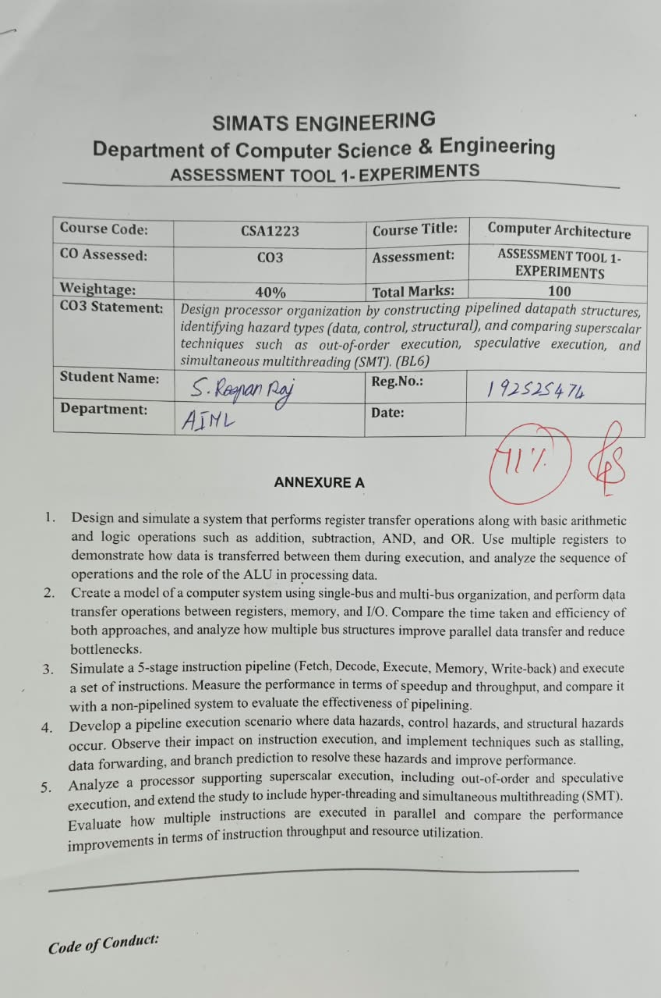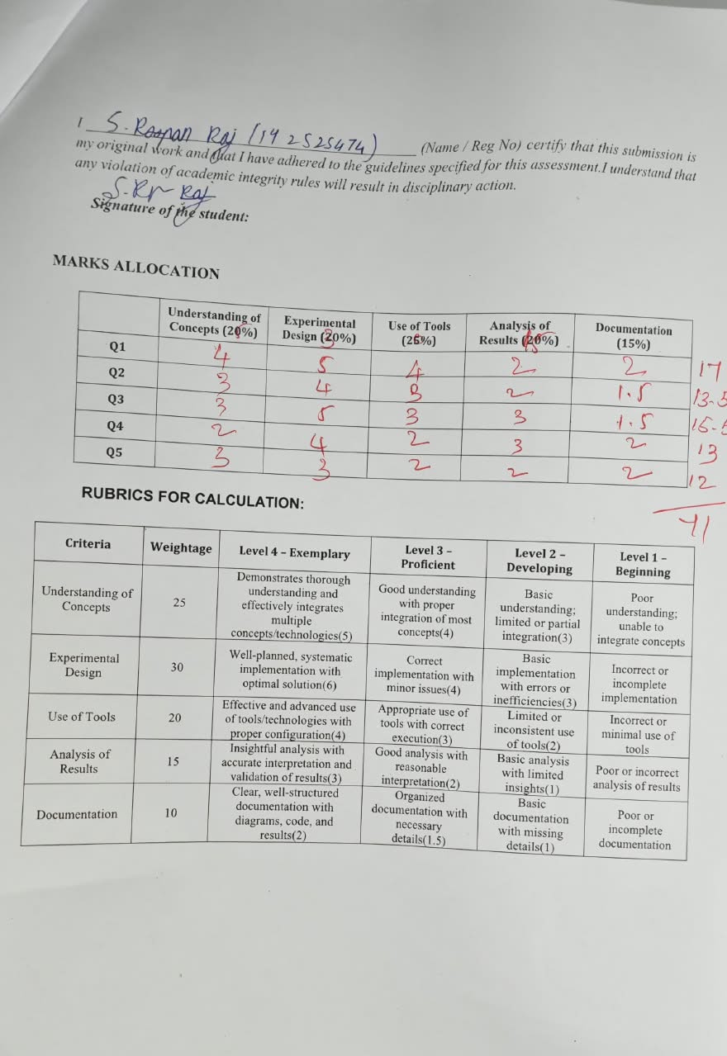SIMATS ENGINEERING
Department of Computer Science & Engineering
ASSESSMENT TOOL 1- EXPERIMENTS

Course Code: | CSA1223 | Course Title: | Computer Architecture
CO Assessed: | CO3 | Assessment: | ASSESSMENT TOOL 1- EXPERIMENTS
Weightage: | 40% | Total Marks: | 100
CO3 Statement: | Design processor organization by constructing pipelined datapath structures, identifying hazard types (data, control, structural), and comparing superscalar techniques such as out-of-order execution, speculative execution, and simultaneous multithreading (SMT). (BL6)
Student Name: |  | Reg.No.:
Department: |  | Date:

ANNEXURE A

- Design and simulate a system that performs register transfer operations along with basic arithmetic and logic operations such as addition, subtraction, AND, and OR. Use multiple registers to demonstrate how data is transferred between them during execution, and analyze the sequence of operations and the role of the ALU in processing data.
- Create a model of a computer system using single-bus and multi-bus organization, and perform data transfer operations between registers, memory, and I/O. Compare the time taken and efficiency of both approaches, and analyze how multiple bus structures improve parallel data transfer and reduce bottlenecks.
- Simulate a 5-stage instruction pipeline (Fetch, Decode, Execute, Memory, Write-back) and execute a set of instructions. Measure the performance in terms of speedup and throughput, and compare it with a non-pipelined system to evaluate the effectiveness of pipelining.
- Develop a pipeline execution scenario where data hazards, control hazards, and structural hazards occur. Observe their impact on instruction execution, and implement techniques such as stalling, data forwarding, and branch prediction to resolve these hazards and improve performance.
- Analyze a processor supporting superscalar execution, including out-of-order and speculative execution, and extend the study to include hyper-threading and simultaneous multithreading (SMT). Evaluate how multiple instructions are executed in parallel and compare the performance improvements in terms of instruction throughput and resource utilization.

QUESTION 1
Design and simulate a system that performs register transfer operations along with basic arithmetic and logic operations such as addition, subtraction, AND, and OR. Use multiple registers to demonstrate how data is transferred between them during execution, and analyze the sequence of operations and the role of the ALU in processing data.

1. Aim
To design and simulate a register-transfer system with multiple registers and an ALU, demonstrating data movement and ADD, SUB, AND and OR operations.

2. Requirements / Tools
- Python 3.x or an HDL simulator.
- Four 8-bit registers: R0, R1, R2 and R3.
- An ALU supporting ADD, SUB, AND and OR.
- Control logic for selecting source registers, destination registers and ALU operation.

3. System Design
The source register supplies an operand to the ALU. The control unit selects the operation and destination register. The ALU result is then written into the selected register.
R0 ──┐
├──> ALU ───> Destination Register
R1 ──┘
↑
Control Unit
Step | Register-transfer operation | Purpose
1 | R0 ← 25 | Load first operand.
2 | R1 ← 10 | Load second operand.
3 | R2 ← R0 + R1 | ALU addition; R2 becomes 35.
4 | R3 ← R0 − R1 | ALU subtraction; R3 becomes 15.
5 | R2 ← R2 AND R0 | Bitwise AND.
6 | R3 ← R3 OR R1 | Bitwise OR.

4. Python Simulation
MASK = 0xFF
R = {"R0":0, "R1":0, "R2":0, "R3":0}
def alu(a, b, op):
if op == "ADD": return (a + b) & MASK
if op == "SUB": return (a - b) & MASK
if op == "AND": return a & b
if op == "OR": return a | b
raise ValueError("Invalid operation")
R["R0"], R["R1"] = 25, 10
R["R2"] = alu(R["R0"], R["R1"], "ADD")
R["R3"] = alu(R["R0"], R["R1"], "SUB")
R["R2"] = alu(R["R2"], R["R0"], "AND")
R["R3"] = alu(R["R3"], R["R1"], "OR")
print(R)

5. Sample Results
Operation | Operands | Result
ADD | 25 + 10 | 35
SUB | 25 − 10 | 15
AND | 35 AND 25 | 1
OR | 15 OR 10 | 15

35 AND 25 = 00000001₂ = 1, while 15 OR 10 = 00001111₂ = 15.

6. Analysis
- Registers store operands and intermediate results.
- The ALU performs the arithmetic and logical computation.
- The control unit determines the transfer and operation sequence.
- The register/ALU separation forms the basic datapath organization of a processor.

7. Conclusion
The simulation demonstrates register transfers and all four required ALU operations. Multiple registers preserve intermediate values while the ALU performs the selected computation.

QUESTION 2
Create a model of a computer system using single-bus and multi-bus organization, and perform data transfer operations between registers, memory, and I/O. Compare the time taken and efficiency of both approaches, and analyze how multiple bus structures improve parallel data transfer and reduce bottlenecks.

1. Aim
To model single-bus and multi-bus organizations and compare their transfer time, parallelism and efficiency.

2. Single-Bus Organization
A single-bus organization uses one shared communication path. Only one source can place data on the bus at a time, so complex transfers require several clock cycles.
R0 ─┐
R1 ─┤
R2 ─┤──> COMMON BUS ───> ALU / Memory / I/O
R3 ─┘

3. Multi-Bus Organization
A multi-bus organization provides two or more independent paths. Two source operands can be transferred simultaneously to an ALU, reducing contention.
Bus A ─────────> ALU input A
Bus B ─────────> ALU input B
│
▼
ALU
│
Bus C <──────────────┘

4. Example: R3 ← R1 + R2
Organization | Transfer sequence | Effect
Single bus | R1 → bus → ALU; R2 → bus → ALU; result → bus → R3 | Sequential transfers; more cycles.
Multi-bus | R1 → Bus A and R2 → Bus B; ALU adds; result → R3 | Parallel operand transfer; fewer cycles.

5. Timing Model
For four independent transfers:
Single bus: 4 transfers ÷ 1 bus = 4 cycles
Two buses: 4 transfers ÷ 2 buses = 2 ideal cycles
Parameter | Single Bus | Two-Bus
Independent buses | 1 | 2
Four ideal transfers | 4 cycles | 2 cycles
Parallelism | Low | Higher
Contention | Higher | Lower
Hardware complexity | Lower | Higher

The cycle comparison is an idealized model. Actual timing also depends on memory latency, arbitration, control logic and resource availability.

6. Analysis
- Single-bus organization is simple and inexpensive but creates a shared bottleneck.
- Multi-bus organization permits parallel transfers when operations are independent.
- Additional buses increase hardware and control complexity.
- High-performance processors use wider or multiple datapaths to reduce transfer bottlenecks.

7. Conclusion
The multi-bus organization provides greater parallel data movement and better potential throughput, while the single-bus design offers simpler hardware.

QUESTION 3
Simulate a 5-stage instruction pipeline (Fetch, Decode, Execute, Memory, Write-back) and execute a set of instructions. Measure the performance in terms of speedup and throughput, and compare it with a non-pipelined system to evaluate the effectiveness of pipelining.

1. Aim
To simulate a five-stage pipeline and calculate its execution time, speedup and throughput relative to a non-pipelined system.

2. Pipeline Stages
Stage | Function
IF – Fetch | Fetch instruction.
ID – Decode | Decode and read registers.
EX – Execute | Perform ALU operation/address calculation.
MEM – Memory | Perform data-memory access.
WB – Write-back | Write result to destination register.

3. Instruction Set
I1: ADD R1, R2, R3
I2: SUB R4, R5, R6
I3: AND R7, R8, R9
I4: OR R10, R11, R12
I5: ADD R13, R14, R15
The ideal comparison assumes independent instructions and no stalls.

4. Pipeline Schedule
Instruction | C1 | C2 | C3 | C4 | C5 | C6 | C7 | C8 | C9
I1 | IF | ID | EX | MEM | WB
I2 |  | IF | ID | EX | MEM | WB
I3 |  |  | IF | ID | EX | MEM | WB
I4 |  |  |  | IF | ID | EX | MEM | WB
I5 |  |  |  |  | IF | ID | EX | MEM | WB

5. Cycle Calculation
Pipelined cycles = K + N − 1
= 5 + 5 − 1
= 9 cycles
Non-pipelined cycles = N × K
= 5 × 5
= 25 cycles

6. Speedup
Speedup = Non-pipelined time / Pipelined time
= 25 / 9
≈ 2.78
Therefore, the ideal five-instruction example gives approximately 2.78× speedup.

7. Throughput
After the pipeline is filled, an ideal five-stage pipeline can complete approximately one instruction per clock cycle, so the steady-state throughput approaches 1 instruction/cycle.

8. Python Simulation
stages = ["IF", "ID", "EX", "MEM", "WB"]
instructions = ["I1","I2","I3","I4","I5"]
for cycle in range(len(instructions) + len(stages) - 1):
active = []
for i, inst in enumerate(instructions):
s = cycle - i
if 0 <= s < len(stages):
active.append(f"{inst}:{stages[s]}")
print("Cycle", cycle + 1, ":", ", ".join(active))
N, K = len(instructions), len(stages)
pipe = K + N - 1
nonpipe = N * K
print("Speedup =", nonpipe / pipe)

9. Analysis
- Pipelining overlaps different stages of multiple instructions.
- The first instruction fills the pipeline; later instructions overlap with it.
- Ideal speedup approaches the number of stages for long instruction streams, but real speedup is reduced by stalls, hazards and pipeline fill time.
- Pipelining mainly improves throughput rather than the latency of one instruction.

10. Conclusion
For five instructions and five stages, the ideal pipeline takes 9 cycles compared with 25 cycles for the non-pipelined model, giving approximately 2.78× speedup.

QUESTION 4
Develop a pipeline execution scenario where data hazards, control hazards, and structural hazards occur. Observe their impact on instruction execution, and implement techniques such as stalling, data forwarding, and branch prediction to resolve these hazards and improve performance.

1. Aim
To identify data, control and structural hazards in a five-stage pipeline and demonstrate appropriate resolution techniques.

2. Hazard Types
Hazard | Cause | Effect | Resolution
Data | Instruction depends on an unfinished result. | Incorrect/late operand; stall. | Forwarding or stalling.
Control | Branch changes the next PC. | Wrong-path instructions. | Branch prediction and flush.
Structural | Two stages need one resource. | Resource conflict. | Duplicate/separate resource or stall.

3. Data Hazard Scenario
I1: ADD R1, R2, R3
I2: SUB R4, R1, R5
I2 depends on R1 produced by I1. Forwarding can send the ALU result directly to the dependent EX stage.
Without forwarding:
I1: IF ID EX MEM WB
I2: IF ID ST ST EX MEM WB
With forwarding:
I1: IF ID EX MEM WB
I2: IF ID EX MEM WB
↑
forwarded result
A typical load-use dependency may still require a stall because the loaded value becomes available later than an ALU result.

4. Control Hazard Scenario
I1: BEQ R1, R2, TARGET
I2: ADD R3, R4, R5
I3: SUB R6, R7, R8
TARGET: OR R9, R10, R11
If the branch is taken, sequentially fetched instructions may be wrong-path instructions. Branch prediction guesses the direction/target so useful instructions can continue without waiting for the branch to resolve.

5. Structural Hazard Scenario
Assume a single shared memory is used for instruction fetch and data access. If one instruction is in MEM while another needs IF in the same cycle, both request the same memory resource.
Cycle X:
Instruction A → MEM → needs memory
Instruction B → IF → needs memory
↓
Resource conflict
The processor can stall one access or use separate instruction and data memories/caches.

6. Resolution Summary
Scenario | Technique | Benefit
ALU result dependency | Data forwarding | Reduces unnecessary stalls.
Load-use dependency | Stall + forwarding | Preserves correctness with small penalty.
Branch | Branch prediction + flush if wrong | Reduces average control penalty.
Shared resource | Separate/duplicate resource or stall | Removes or manages structural conflict.

7. Python Demonstration
print("Data hazard: I2 consumes R1 produced by I1.")
print("Resolution: forward the ALU result to I2.")
print("Control hazard: branch changes the next PC.")
print("Resolution: predict branch; flush if prediction is wrong.")
print("Structural hazard: IF and MEM compete for one memory.")
print("Resolution: stall or separate instruction/data memory.")

8. Analysis
- Forwarding handles many ALU-to-ALU dependencies without waiting for WB.
- Stalling is necessary when the required value is not yet available.
- Branch prediction reduces the average control-hazard penalty but mispredictions cause flushing.
- Structural hazards arise from insufficient resources and can be reduced by adding or separating resources.

9. Conclusion
The experiment demonstrates that pipeline hazards can reduce throughput. Forwarding, controlled stalling and branch prediction maintain correct execution while reducing the performance penalty of data, control and structural conflicts.

QUESTION 5
Analyze a processor supporting superscalar execution, including out-of-order and speculative execution, and extend the study to include hyper-threading and simultaneous multithreading (SMT). Evaluate how multiple instructions are executed in parallel and compare the performance improvements in terms of instruction throughput and resource utilization.

1. Aim
To analyze superscalar execution, out-of-order execution, speculative execution and SMT, and evaluate their effect on instruction throughput and resource utilization.

2. Superscalar Execution
A superscalar processor has multiple execution resources and can issue more than one suitable instruction in a cycle.
Instruction Stream
│
Fetch / Decode
│
Issue / Dispatch
┌──┴──┐
▼ ▼
ALU 1 ALU 2
│ │
└──┬──┘
▼
Retirement

3. Out-of-Order Execution
Out-of-order execution permits ready instructions to execute before older instructions that are waiting for operands or resources. Register renaming removes false dependencies, while structures such as issue queues/reservation stations and a reorder buffer help maintain correct program-order retirement.
Mechanism | Purpose
Register renaming | Reduces WAR and WAW false dependencies.
Issue queue / reservation station | Waits for operands and suitable execution resources.
Reorder buffer | Supports in-order architectural retirement.
Multiple execution units | Allow independent instructions to execute in parallel.

4. Speculative Execution
Speculative execution executes instructions before the processor knows with certainty that they belong to the correct control-flow path. Correct predictions preserve useful work; incorrect predictions require wrong-path results to be discarded.

5. Hyper-Threading / SMT
Simultaneous multithreading allows a physical core to maintain state for multiple hardware threads and issue instructions from more than one thread when resources are available. Intel Hyper-Threading is a commercial implementation of SMT. SMT improves utilization of shared resources; it does not create another physical core.

6. Example of Parallel Issue
I1: ADD R1, R2, R3
I2: MUL R4, R5, R6
I3: AND R7, R8, R9
I4: OR R10, R11, R12
In an ideal 2-issue processor, independent instructions such as I1 and I2 can potentially issue in the same cycle, followed by I3 and I4, provided operands and execution resources are available.

7. Ideal Throughput
Organization | Ideal issue width | Ideal upper-bound throughput
Scalar pipeline | 1 | 1 instruction/cycle
2-issue superscalar | 2 | 2 instructions/cycle
4-issue superscalar | 4 | 4 instructions/cycle
SMT core | Shared by multiple threads | Up to the machine's issue/resource limits

These are ideal upper bounds. Dependencies, cache misses, branch mispredictions and execution-resource conflicts reduce actual throughput.

8. Python Throughput Model
def cycles(n, width):
return (n + width - 1) // width
N = 8
print("Scalar cycles:", cycles(N, 1))
print("2-issue cycles:", cycles(N, 2))
print("4-issue cycles:", cycles(N, 4))

9. Resource Utilization
Technique | Benefit | Limitation
Superscalar | More independent instructions can execute per cycle. | Needs parallel work and multiple resources.
Out-of-order | Keeps execution units busy while some instructions wait. | Complex scheduling and retirement hardware.
Speculative | Reduces average branch delay when prediction is correct. | Mispredictions waste work.
SMT | Uses otherwise idle resources from multiple threads. | Threads compete for shared resources.

10. Analysis
- Superscalar execution increases instruction-level parallelism.
- Out-of-order scheduling exposes ready work and improves resource utilization.
- Speculation reduces the average cost of control dependencies when predictions are accurate.
- SMT can use idle execution capacity by scheduling instructions from multiple threads.
- These techniques increase complexity, power requirements and resource-management demands.

11. Conclusion
Superscalar, out-of-order and speculative execution increase the amount of instruction-level parallelism available to a processor. SMT further improves utilization by allowing multiple threads to share a physical core. Actual performance depends on dependencies, branch behavior, memory latency and available execution resources.

Code of Conduct:

I ____________________________________________ (Name / Reg No) certify that this submission is my original work and that I have adhered to the guidelines specified for this assessment.I understand that any violation of academic integrity rules will result in disciplinary action.

Signature of the student:

MARKS ALLOCATION
 | Understanding of Concepts (20%) | Experimental Design (20%) | Use of Tools (25%) | Analysis of Results (20%) | Documentation (15%)
Q1
Q2
Q3
Q4
Q5

RUBRICS FOR CALCULATION:

Criteria | Weightage | Level 4 – Exemplary | Level 3 – Proficient | Level 2 – Developing | Level 1 – Beginning
Understanding of Concepts | 25 | Demonstrates thorough understanding and effectively integrates multiple concepts/technologies(5) | Good understanding with proper integration of most concepts(4) | Basic understanding; limited or partial integration(3) | Poor understanding; unable to integrate concepts
Experimental Design | 30 | Well-planned, systematic implementation with optimal solution(6) | Correct implementation with minor issues(4) | Basic implementation with errors or inefficiencies(3) | Incorrect or incomplete implementation
Use of Tools | 20 | Effective and advanced use of tools/technologies with proper configuration(4) | Appropriate use of tools with correct execution(3) | Limited or inconsistent use of tools(2) | Incorrect or minimal use of tools
Analysis of Results | 15 | Insightful analysis with accurate interpretation and validation of results(3) | Good analysis with reasonable interpretation(2) | Basic analysis with limited insights(1) | Poor or incorrect analysis of results
Documentation | 10 | Clear, well-structured documentation with diagrams, code, and results(2) | Organized documentation with necessary details(1.5) | Basic documentation with missing details(1) | Poor or incomplete documentation

