Goto control panel - > folder options -> enable show hidden files in View Tab

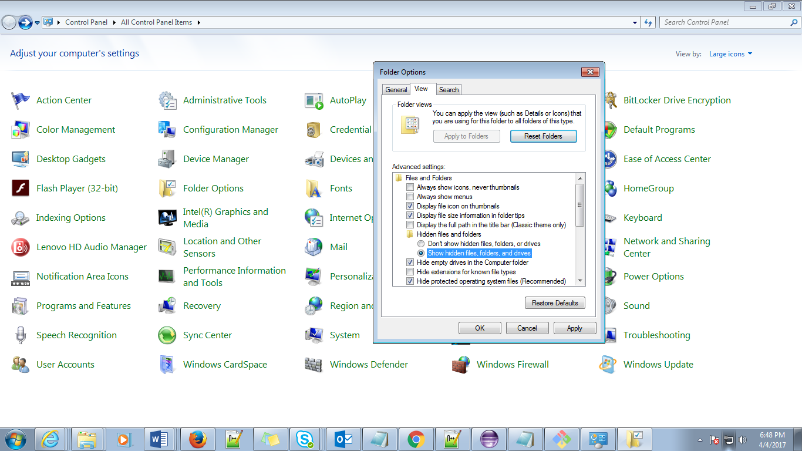

Once we give the command “git init” then that folder will become a git folder and .git folder will get generated automatically

