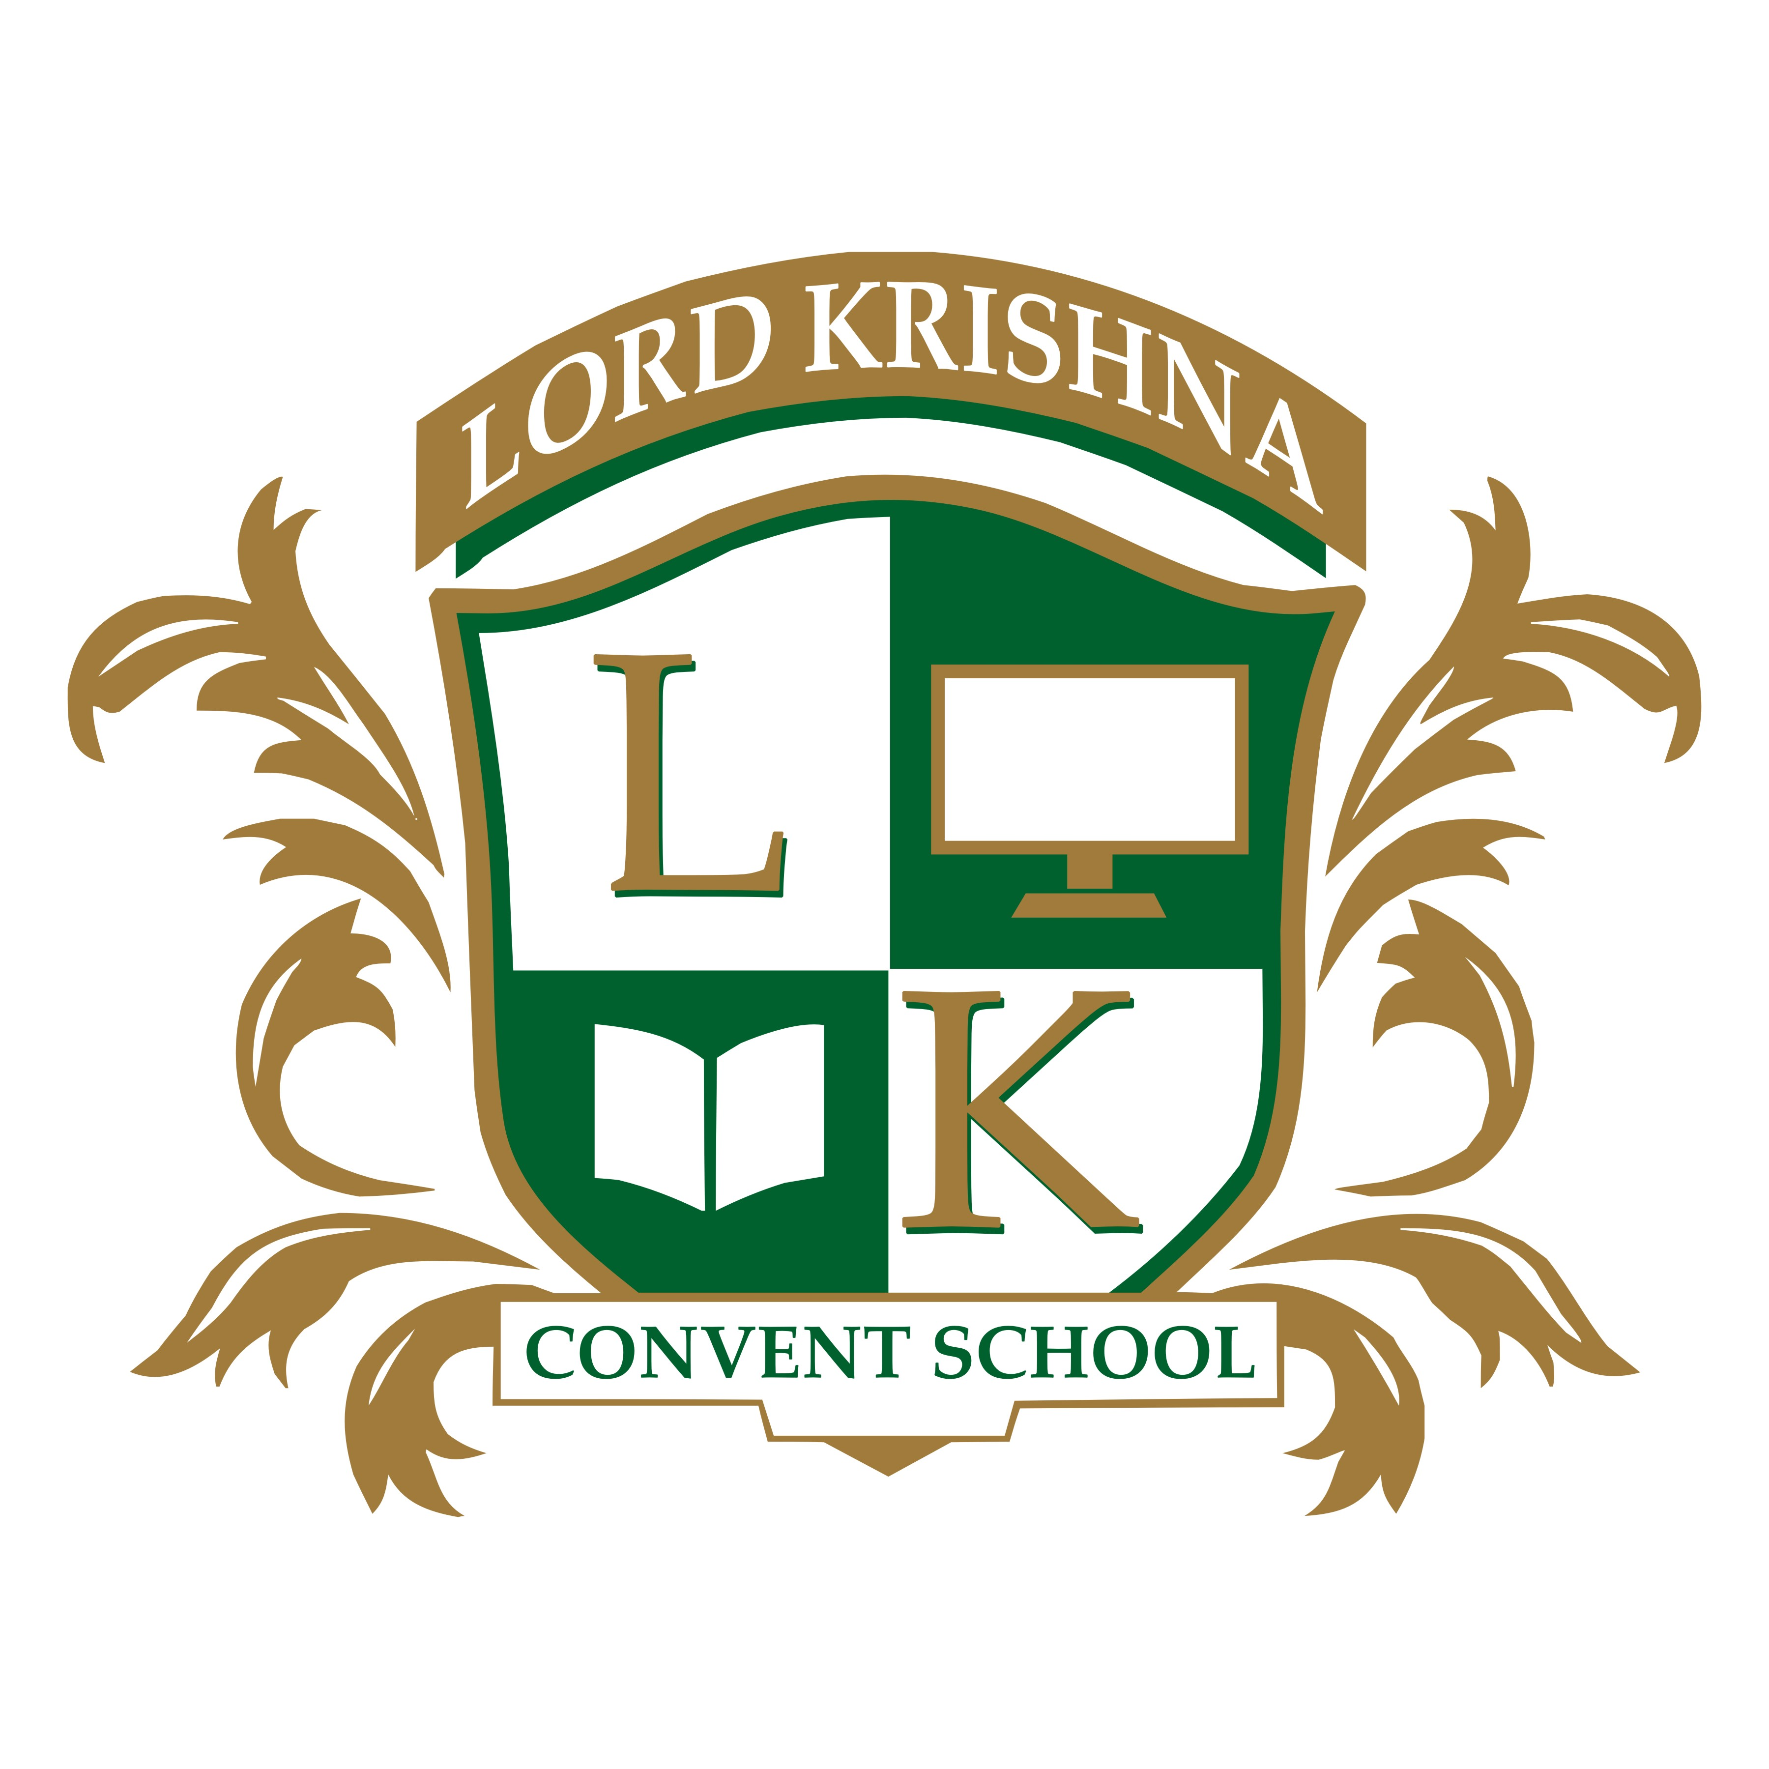 | LORD KRISHNA CONVENT SCHOOL  Affiliated to CBSE, New Delhi  Knowledge Park, New Delhi
TEST MIDTERM EXAM NO SECTION
Class: Class 10 | Subject: Science | Roll No: ________________
Time Allowed: 120 Mins | Maximum Marks: 20.0 | Date: ____________
General Instructions:
All questions compulsory.
――――――――――――――――――――――――――――――――――――――――――――――――――――――――――
*** END OF QUESTION PAPER ***

