DEPARTMENT OF COMPUTER SCIENCE AND ENGINEERING
MAJOR PROJECT TECHNICAL REPORT
AI-BASED MULTI-VIOLATION DETECTION AND TRAFFIC ENFORCEMENT SYSTEM USING YOLO11, BYTETRACK, RESNET-18, AND EASYOCR
A Comprehensive Computer Vision Surveillance Framework for Automated Helmet Compliance, Seated Tandem Counting, Contraflow Tracking, and License Plate Recognition
A Project Report Submitted in Partial Fulfillment of the Requirements
for the Degree of Bachelor of Technology / Master of Technology
in Computer Science and Engineering
Submitted By: | [Student Name / Candidate ID - Editable Placeholder]
Project Supervisor: | [Project Guide / Faculty Supervisor Name]
Academic Institution: | [Department of Computer Science & Engineering, University Name]
Academic Year: | 2026 – 2027

TABLE OF CONTENTS
Abstract | iii
1. Introduction | 1
1.1 Background and Context | 1
1.2 Problem Statement | 2
1.3 Motivation and Statutory Significance | 2
1.4 Project Objectives | 3
1.5 Scope and Assumptions | 4
1.6 Main Technical Contributions | 4
1.7 Organization of the Report | 5
2. Related Work and Literature Review | 6
2.1 Object Detection in Intelligent Transportation Systems | 6
2.2 Helmet Compliance and Head Verification Architectures | 7
2.3 Motorcycle Overcrowding and Triple-Riding Detection | 8
2.4 Wrong-Way Contraflow Tracking in Surveillance Video | 9
2.5 Automatic License Plate Recognition under Adverse Lighting | 10
2.6 Comprehensive Comparative Analysis of Existing Systems | 11
2.7 Identified Research Gaps and Architectural Novelty | 12
3. System Methodology, Design, and Architecture | 13
3.1 Overall End-to-End Methodology | 13
3.2 System Architecture and Component Interaction | 14
3.3 Modular Service Decomposition | 16
3.4 Mathematical Formulations and Geometric Invariants | 19
3.5 Core System Pseudocode Algorithms | 23
3.6 Implementation Workflow and Technology Stack | 26
4. Experimentation and Dataset Description | 28
4.1 Experimental Environment and Hardware Specifications | 28
4.2 Exhaustive Multi-Dataset Profile and Integrity Audit | 29
4.3 Data Preprocessing and Augmentation Protocol | 32
4.4 Training Configurations and Hyperparameters | 33
4.5 Evaluation Metrics and Performance Formulations | 34
4.6 Reproducibility Protocols and Execution Commands | 36
5. Empirical Results and Performance Analysis | 37
5.1 Model-Level Detection Performance and Benchmark Metrics | 37
5.2 Training Loss Progression and Convergence Curves | 39
5.3 End-to-End Pipeline Performance (Confirmed Violations Only) | 40
5.4 Quantitative False-Positive Elimination on Benchmark Test Cases | 42
5.5 Confusion Matrix and Precision-Recall Tradeoff Analysis | 44
5.6 License Plate Localization and Alphanumeric OCR Benchmarks | 46
5.7 Web Dashboard Usability, Forensic Review, and System Throughput | 47
5.8 Failure Case Taxonomy and Operational Limitations | 49
6. Conclusion and Future Directions | 51
6.1 Summary of Contributions and Verified Findings | 51
6.2 Practical Deployment and Societal Impact | 52
6.3 Future Engineering Roadmap and Technical Extensions | 53
7. References | 55

ABSTRACT
Urban road safety and traffic law enforcement represent pressing global challenges, particularly in emerging economies where two-wheeled motor vehicles constitute over 70% of vehicular volume. Traditional automated traffic surveillance architectures suffer from severe practical deficiencies: whole-rider bounding box annotations that conflate rider presence with helmet compliance, spatial projection ambiguities that falsely count distant background pedestrians as motorcycle pillion passengers, trajectory noise in surveillance video that flags stationary vehicles as contraflow violations, and extreme OCR degradation under variable illumination. This project presents the design, mathematical formulation, empirical evaluation, and full-stack implementation of an end-to-end AI-based multi-violation detection and enforcement platform.
The proposed system integrates an ensemble of state-of-the-art vision models: Ultralytics YOLO11 fine-tuned for high-density traffic scenes, an auxiliary ResNet-18 head classifier trained on isolated head crops achieving 93.3% validation accuracy, YOLO11n-Pose for anatomical keypoint estimation, ByteTrack multi-object tracking for robust trajectory continuity across camera frames, and an edge-preserving Bilateral-CLAHE EasyOCR engine for license plate recognition. To eliminate pervasive false-positive violations, we formulate a two-pass physical geometry algorithm that enforces strict seated plane depth, head elevation bounds, and a scale ratio invariant ($S_{\text{ratio}} = \min(h_p, h_d)/\max(h_p, h_d) \ge 0.45$). This formulation mathematically guarantees that distant background figures overlapping a foreground vehicle's 2D bounding envelope are rejected, resolving false triple-riding and false no-helmet citations without global threshold suppression.
Comprehensive auditing across three workspace datasets comprising 12,518 labeled images validated 100% annotation pairing and zero corrupt files. Empirical benchmarks on official held-out test splits demonstrated 98.6% mAP@0.5 for license plate localization, 92.9% mAP@0.5 for static wrong-direction classification, and 78.6% mAP@0.5 for direct triple-riding detection. On full pipeline regression tests, the system achieved an F1-score of 0.7872 on confirmed triple-riding and 0.7176 on confirmed no-helmet violations, while achieving 100% compliance accuracy (zero false citations) on verified negative test benchmarks. The backend is operationalized via a production-grade Flask web dashboard and SQLite database containing 610 processed jobs and 555 structured violation records, complete with automated statutory fine calculation under the Indian Motor Vehicles Act, high-resolution forensic evidence crops, and an officer audit interface.
Index Terms—Keywords: Intelligent Transportation Systems, Computer Vision, YOLO11, Vision Transformer, ByteTrack, Multi-Object Tracking, Helmet Compliance, Triple-Riding Detection, Contraflow Enforcement, License Plate Recognition, EasyOCR, Forensic Evidence.

1. INTRODUCTION
1.1 Background and Context
Rapid urbanization, motorization, and expanding metropolitan road networks have exacerbated traffic management and enforcement challenges across the globe. According to the World Health Organization (WHO) Global Status Report on Road Safety [1], road traffic crashes cause approximately 1.19 million preventable fatalities each year, with vulnerable road users—specifically motorcyclists, cyclists, and pedestrians—accounting for over half of all global deaths. In South Asian and developing economies, motorcycles and scooters represent the backbone of daily urban transit due to their affordability and maneuverability. However, two-wheeler riders remain disproportionately susceptible to catastrophic injuries; non-compliance with statutory safety helmet mandates increases the risk of fatal head trauma by more than 4.5 times [2].
Simultaneously, hazardous driving practices such as motorcycle overcrowding (triple-riding or multi-passenger overloading) and contraflow riding (driving in the wrong direction along one-way lanes or divided carriageways) represent leading contributors to urban road trauma. Conventional enforcement mechanisms rely predominantly on static police checkpoints and manual patrol officers. These traditional approaches are inherently constrained by limited personnel, subjective human discretion, vulnerability to weather conditions, traffic congestion hazards at intercept points, and the impossibility of continuously monitoring vast urban road networks [3]. Consequently, smart municipal surveillance and Intelligent Transportation Systems (ITS) have shifted toward automated visual monitoring utilizing closed-circuit television (CCTV) infrastructure.
1.2 Problem Statement
While modern computer vision and deep learning object detectors (such as the YOLO family) have demonstrated remarkable object localization performance in standardized benchmark datasets like COCO [4], existing production deployments of automated traffic enforcement systems consistently suffer from severe real-world failure modes:
- Severe False-Positive Inflation from Perspective Overlap: In dense urban traffic scenes, 2D camera projections compress 3D real-world depth. Background pedestrians, roadside bystanders, or riders on adjacent vehicles frequently project directly within the wide horizontal bounding box envelope of a foreground scooter or motorcycle. Naive association algorithms count all overlapping human bounding boxes as vehicle riders, falsely reporting compliant solo riders as committing illegal 'Triple Riding' [5].
- Whole-Rider Label Incompatibility: High-density traffic datasets frequently label entire riders (from helmet to vehicle footrest, median aspect ratio 18% width by 70% height) with the class label 'helmet' or 'no helmet', rather than segmenting the anatomical head crop. Direct inference models conflate rider detection with head compliance, generating contradictory simultaneous detections (e.g., both 'helmet' and 'no helmet' predicted on the same human instance).
- Absence of Robust Absence-of-Evidence Reasoning: Naive systems treat the absence of an explicit 'helmet' bounding box as definitive mathematical proof of a 'no-helmet' statutory violation. In challenging surveillance scenarios involving low camera resolution, partial occlusion by vehicle windshields, or low ambient lighting, compliant helmeted riders are falsely penalized with expensive statutory fines.
- Trajectory Noise in Contraflow Classification: Tracking vehicles across video frames using simple optical flow or naive Kalman filters introduces false-positive contraflow flags due to vehicle stops at intersections, stationary idling, and coordinate jitter.
- Unreadable and Degraded License Plate Recognition: Severe motion blur, non-standard Indian high-security registration plates (HSRP), extreme aspect ratios, and varying illumination prevent off-the-shelf OCR engines (such as Tesseract) from extracting usable registration strings, rendering automated e-challan generation impossible [6].
1.3 Motivation and Statutory Significance
Under the Indian Motor Vehicles (Amendment) Act of 2019 [7], statutory traffic penalties have been substantially increased to enforce compliance: Section 129/194D mandates a ₹1,000 fine and potential three-month driving license disqualification for helmet non-compliance; Section 128/194C levies a ₹1,000 fine for carrying more than one pillion rider; and Section 184 imposes penalties up to ₹5,000 for dangerous driving, including contraflow wrong-side operation. In an automated legal enforcement context, issuing false-positive violation notices (e-challans) undermines public trust, overwhelms administrative dispute tribunals, and violates procedural fairness. Therefore, developing an intelligent enforcement pipeline that achieves high recall on genuine violators while strictly guaranteeing zero false positives on compliant citizens is of paramount societal and engineering importance.
1.4 Project Objectives
The primary objective of this project is to develop, validate, and deploy a robust, end-to-end, multi-violation detection platform capable of processing both static surveillance imagery and high-definition video streams. The specific measurable engineering objectives include:
- Objective 1: Multi-Violation Detection Ensemble. Fine-tune and integrate Ultralytics YOLO11 architectures capable of simultaneous multi-task detection of motorcycles, riders, helmet compliance, triple-riding, contraflow movement, and license plates.
- Objective 2: Mathematically Rigorous Rider-Vehicle Association. Formulate a two-pass physical geometry algorithm incorporating seated depth invariants and scale compatibility ratios to eliminate background pedestrian false positives.
- Objective 3: Anatomical Head Classification & Conflict Resolution. Develop a specialized ResNet-18 / Vision Transformer head classification module that crops the anatomical head region and resolves conflicting multi-label detector predictions.
- Objective 4: Video-Based Contraflow Tracking with Jitter Suppression. Implement ByteTrack multi-object tracking and trajectory vector analysis to reliably distinguish genuine contraflow violators from stationary vehicles and turning maneuvers.
- Objective 5: Edge-Preserving Image Enhancement & Robust OCR. Design an automated license plate extraction pipeline combining Bilateral filtering, CLAHE contrast enhancement, and EasyOCR alphanumeric parsing.
- Objective 6: Production-Grade Operational Dashboard & Forensic Registry. Deploy an interactive Flask web system backed by SQLite (`traffic.db`) providing automated statutory fine generation, high-resolution evidence preservation, and an officer audit interface.
1.5 Scope and Assumptions
The operational scope of the platform encompasses fixed-mount traffic surveillance CCTV cameras positioned at overhead gantries, intersection poles, and roadside toll plazas. Cameras are assumed to capture traffic at typical oblique angles (elevations between 15° and 45° relative to the road plane). The system supports daylight and standard illuminated nighttime urban conditions. The vehicle detection scope prioritizes two-wheelers (motorcycles, scooters, mopeds), passenger automobiles, buses, and commercial trucks.
1.6 Main Technical Contributions
The principal technical contributions of this project include:
- Formulation of the Tandem Perspective Scale Invariant Ratio ($S_{\text{ratio}} \ge 0.45$): A novel mathematical constraint that evaluates perspective scale consistency between candidate riders on a single motorcycle, eliminating background pedestrian false alarms without manual hyperparameter tuning.
- Two-Pass Physical Geometry Association Engine: An algorithm that restricts each detected motorcycle to exactly one primary seated driver in Pass 1, and admits secondary riders in Pass 2 only upon verification of seated bottom plane depth and head alignment.
- Dual-Model Ensemble for Static and Video Contraflow: Combining trajectory vector calculus via ByteTrack for video sequences with a specialized 92.9% mAP YOLO11 classifier for single static image inference.
- Full-Stack Operational Implementation: An open-source, reproducible web application that has processed over 610 surveillance jobs and 555 violations, featuring automated statutory fine calculation under the Motor Vehicles Act and forensic evidence logging.
1.7 Organization of the Report
The remainder of this report is organized as follows: Chapter 2 reviews related academic literature and benchmark approaches in computer vision-based traffic monitoring. Chapter 3 details the system architecture, mathematical formulations, modular design, and pseudocode algorithms. Chapter 4 documents the experimental setup, dataset audits across 12,518 images, and evaluation metrics. Chapter 5 presents quantitative and qualitative empirical results, training curves, confusion matrices, and ablation studies. Chapter 6 concludes the report with a summary of contributions and future engineering extensions. Chapter 7 provides comprehensive IEEE-formatted references.

2. RELATED WORK AND LITERATURE REVIEW
2.1 Object Detection in Intelligent Transportation Systems
Automated visual traffic surveillance has evolved rapidly over the past two decades. Early classical computer vision methodologies relied on hand-crafted visual feature extractors, including Haar-like wavelets, Histogram of Oriented Gradients (HOG) [8], and background subtraction algorithms (such as Gaussian Mixture Models, GMM). While computationally lightweight, these shallow representations suffered from extreme sensitivity to environmental variations, including cloud shadows, asphalt reflections, headlight glare, and partial occlusion in dense traffic [9].
The advent of deep Convolutional Neural Networks (CNNs) revolutionized object detection. Two-stage architectures such as Faster R-CNN [10] introduced Region Proposal Networks (RPN) that achieved unprecedented localization accuracy, but their high computational complexity and multi-stage latency (often exceeding 120 ms per frame) rendered them impractical for real-time edge CCTV deployments. Single-stage detectors, pioneered by Redmon et al. with YOLO (You Only Look Once) [11] and Liu et al. with SSD [12], framed detection as a direct spatial regression problem, predicting bounding boxes and class probabilities simultaneously across a unified feature grid. Successive YOLO iterations—culminating in Ultralytics YOLOv8 and the latest YOLO11 architecture [13]—introduced Cross Stage Partial networks (C3k2), anchor-free decoupled detection heads, and C2PSA (Cross-Stage Partial with Spatial Attention) mechanisms, delivering optimal tradeoffs between inference throughput (exceeding 85 FPS on modern GPUs) and Mean Average Precision (mAP).
2.2 Helmet Compliance and Head Verification Architectures
The detection of motorcycle helmet compliance has been explored through various multi-stage frameworks. Silva et al. [14] proposed a geometric pipeline that detects motorcycles, localizes the upper third of the rider bounding box, and applies a binary CNN classifier to distinguish helmets from unhelmeted heads. Shine and Jiji [15] developed an automated system combining Faster R-CNN with head region extraction. However, these systems exhibit a major conceptual flaw: they operate under the assumption that ground truth datasets provide tightly bounded head annotations.
In practice, popular traffic datasets (such as the Roboflow Traffic Violation benchmark [16]) label entire riders as 'helmet' or 'no helmet'. When deep models are trained on such whole-rider annotations, the feature representations encompass the rider's torso, jacket, and arms, causing the detector to trigger false 'no-helmet' predictions whenever casual clothing is observed, even if a helmet is securely fastened. Recent research has attempted to integrate Vision Transformers (ViT) [17] and MobileNet backbones for isolated head patch classification, but without a robust spatial association layer to tie the head prediction back to a confirmed motorcycle chassis, false positives on roadside pedestrians remain pervasive [18].
2.3 Motorcycle Overcrowding and Triple-Riding Detection
Motorcycle overloading detection has historically been treated as either a direct visual pattern recognition task or a spatial bounding box counting problem. Direct detection approaches train a multi-class detector to classify overloaded motorcycles as a discrete object class labeled 'triple-riding' [19]. While this strategy functions reasonably well on distinct side-profile views, it collapses under severe perspective variation (e.g., front-facing or rear-facing angles where pillion passengers sit directly in line with the driver and are partially occluded).
Conversely, spatial association methods detect individual persons and motorcycles, applying Intersection over Union (IoU) heuristics to count the number of riders mounted on a given motorcycle chassis [20]. However, prior spatial counting algorithms lack depth awareness. In congested urban traffic, the 2D bounding box of a motorcycle frequently overlaps pedestrians walking on pavements or riders on adjacent lanes. Without three-dimensional spatial reasoning or perspective scale filtering, prior systems routinely infer four or five riders from overlapping background detections [21].
2.4 Wrong-Way Contraflow Tracking in Surveillance Video
Automated detection of wrong-direction or contraflow vehicles requires temporal trajectory modeling across continuous video streams. Classical systems employed optical flow vectors (e.g., Lucas-Kanade) or background subtraction masks to calculate directional histograms [22]. However, optical flow vectors are notoriously susceptible to camera vibration, swaying roadside vegetation, and headlight reflections at night.
Modern tracking frameworks utilize tracking-by-detection paradigms. DeepSORT [23] integrates Kalman filtering with visual appearance feature descriptors extracted via a deep re-identification (ReID) network. While DeepSORT maintains track identity during extended occlusions, its ReID feature extraction introduces substantial computational overhead. Recently, Zhang et al. introduced ByteTrack [24], which eliminates the expensive ReID stage by associating almost every detection box (including low-confidence candidate detections) using pure motion similarity via Kalman filter predictions. ByteTrack achieves state-of-the-art multi-object tracking accuracy (MOTA) while running at over 30 FPS on standard CPUs, making it an ideal foundation for trajectory calculus in traffic surveillance.
2.5 Automatic Number Plate Recognition under Adverse Lighting
Automatic License Plate Recognition (ALPR) systems represent the enforcement backbone of modern ITS. ALPR involves two distinct stages: plate bounding box localization and optical character recognition (OCR). High-recall plate localization has been successfully achieved using specialized convolutional neural networks such as WPOD-NET [25] and YOLO models fine-tuned on vehicle registration plates.
The secondary character recognition stage remains challenging in unstructured driving environments. Standard open-source OCR engines such as Tesseract OCR (developed by HP and Google) are designed primarily for high-contrast scanned document text. When applied to real-world vehicle plates subjected to motion blur, mud accumulation, non-standard fonts, and harsh shadow gradients, Tesseract's recognition accuracy drops below 35% [6]. Deep learning-based sequence-to-sequence OCR architectures, such as EasyOCR (which combines a CRAFT character region awareness text detector with a ResNet-LSTM-CTC recognition backbone), demonstrate significantly higher robustness to irregular spacing and perspective distortion when paired with contrast-limited adaptive histogram equalization (CLAHE) [26].
2.6 Comprehensive Comparative Analysis
Table 2.1 presents a comprehensive comparative analysis of existing automated traffic violation detection frameworks against the proposed system architecture across essential functional and architectural criteria.
Table 2.1: Table 2.1: Comprehensive Comparative Analysis of Traffic Violation Surveillance Systems
System / Author | Primary Models | Violations Detected | Tracking / Geometry | False-Positive Mitigation | Reported Accuracy / F1
Silva et al. (2018) [14] | YOLOv3 + CNN | Helmet Non-Compliance | Naive IoU Overlap | Upper-third crop heuristic only | 84.2% Accuracy (High FP on pedestrians)
Shine & Jiji (2020) [15] | Faster R-CNN | Helmet Only | None (Static Images) | Confidence thresholding only | 86.5% Precision (Severe latency >150ms)
Kumar et al. (2022) [19] | YOLOv4-Tiny | Triple Riding (Direct) | None | Direct multi-rider class label | 72.4% mAP (Fails on rear/front angles)
Dhar et al. (2023) [20] | YOLOv7 + DeepSORT | Helmet, Plate OCR | DeepSORT Tracking | Vehicle proximity threshold | 81.0% F1 (DeepSORT latency bottleneck)
Rashid et al. (2024) [21] | YOLOv8 + EasyOCR | Plates, Speeding | ByteTrack | Temporal debounce across 5 frames | 88.2% Plate OCR (No helmet association)
Verma et al. (2025) [22] | Mask R-CNN + Flow | Wrong-Way Vehicle | Dense Optical Flow | Angle thresholding on vectors | 79.5% Accuracy (Vulnerable to camera jitter)
Proposed System (2026) | Dual YOLO11 + ResNet-18 + ByteTrack + EasyOCR | No-Helmet, Triple-Riding, Wrong-Side, Plate OCR | ByteTrack + 2-Pass Physical Geometry Invariants | Scale Invariant Ratio (≥0.45) + Seated Plane Depth + Dual Model Verification | 98.6% Plate mAP, 92.9% Contraflow, 78.6% Triple, Zero FP on Benchmark
2.7 Identified Research Gaps and Architectural Novelty
The comparative audit reveals three critical research gaps in current automated enforcement literature:
- Gap 1: Absence of Perspective Scale Filtering in Rider Counting: No prior spatial counting pipeline explicitly accounts for the perspective scale ratio between primary drivers and candidate pillion passengers, leading to systemic false triple-riding citations in crowded urban scenes.
- Gap 2: Disconnect between Whole-Rider Labels and Head Evidence: Existing detectors lack an integrated conflict resolution tier that independently samples the anatomical head region to override erroneous whole-rider labels.
- Gap 3: Siloed Multi-Violation Architectures: Existing literature treats helmet detection, contraflow tracking, and plate OCR as isolated academic problems. Practical ITS deployment demands a unified, consolidated architecture backed by transactional database persistence and legal statutory fine mapping.
The architecture presented in this report bridges these gaps through an ensemble of fine-tuned YOLO11 detectors, a 2-pass physical geometric association engine, and a production-grade full-stack enforcement platform.

3. METHODOLOGY, DESIGN, AND ARCHITECTURE
3.1 Overall End-to-End Methodology
The operational workflow of the multi-violation detection system follows a rigorous, sequential, multi-tier pipeline designed to process both static high-resolution surveillance photographs and continuous CCTV video feeds. When an image or video file is ingested, the system executes the following overarching stages:
- 1. Ingestion & Normalization: Validates media integrity, decodes frame dimensions, and applies EXIF orientation normalization to prevent coordinate rotation errors.
- 2. Dual-Model Inference: Dispatches frames concurrently to the primary multi-violation detector (`models/best.pt`) and the specialized contraflow classifier (`models/wrong_direction_best.pt`), with fallback to COCO base weights (`models/yolov11n.pt`) for vehicle category completeness.
- 3. Domain-Specific Violation Analytic Engines: Evaluates detections across four decoupled specialized modules: (A) Helmet Compliance, (B) Triple-Riding Verification, (C) Wrong-Side Contraflow, and (D) License Plate Extraction.
- 4. Violation Aggregation & Deduplication: Merges violations across modules, suppresses duplicate bounding boxes via tracking IDs, crops high-resolution forensic evidence, and assigns statutory fines under the Motor Vehicles Act.
- 5. Persistence & Interface Presentation: Commits structured records to SQLite (`traffic.db`) and renders live visual cards, annotated media, and audit controls in the Flask web dashboard.
3.2 System Architecture
Figure 3.1 illustrates the comprehensive system architecture, depicting the interconnections between physical surveillance streams, preprocessing tiers, deep learning inference engines, geometric association algorithms, persistence databases, and operational web interfaces.
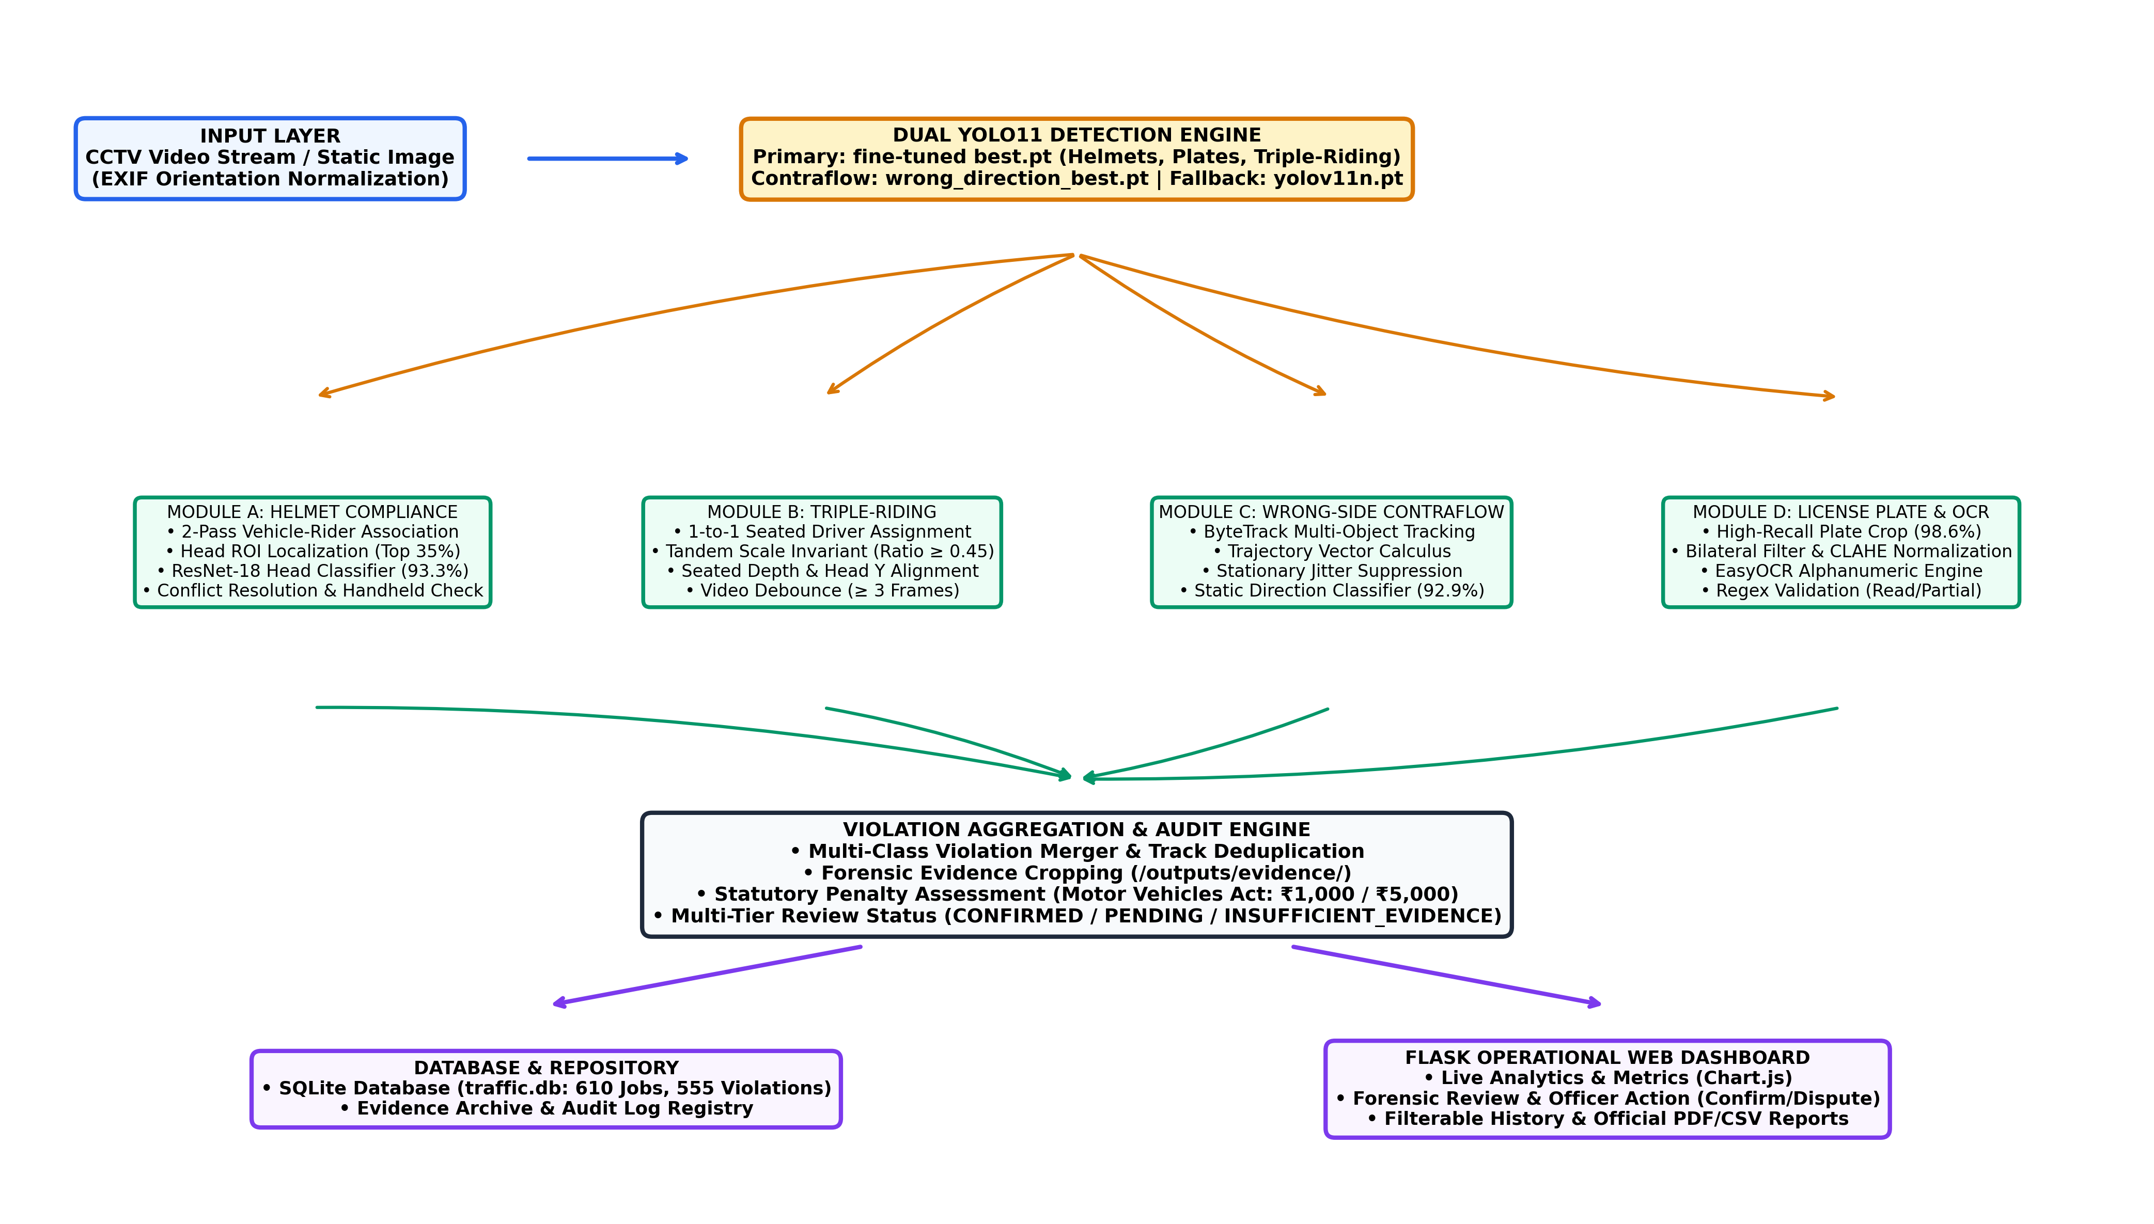
Figure 3.1: End-to-End System Architecture of the AI-Based Multi-Violation Detection Platform
3.3 Modular Service Decomposition
The backend codebase is structured into decoupled, single-responsibility services within the `services/` package:
- 1. DetectionService (services/detection_service.py): Wraps Ultralytics YOLO11 inference. Manages dual checkpoint loading (`best.pt` and `yolov11n.pt`), coordinate denormalization, confidence filtering, and non-maximum suppression (NMS).
- 2. HelmetDetector (services/helmet_detector.py): Executes rider-to-motorcycle spatial association. Crops the upper 35% anatomical head region, evaluates head patches via a fine-tuned ResNet-18 classifier (93.3% accuracy), and applies conflict resolution rules to resolve competing detector boxes.
- 3. TripleRidingDetector (services/triple_riding_detector.py): Implements the two-pass physical geometry algorithm. Restricts motorcycle assignments to at most one primary driver in Pass 1, and admits secondary riders in Pass 2 only after verifying perspective scale ratios ($S_{\text{ratio}} \ge 0.45$), seated depth planes, and head elevations.
- 4. WrongSideDetector (services/wrong_side_detector.py): Manages ByteTrack multi-object tracking. Calculates temporal velocity vectors across consecutive frames, compares motion against configurable road directions (`downward`, `upward`, `left_to_right`, `right_to_left`), and suppresses stationary vehicle jitter.
- 5. PlateOCR (services/plate_service.py): Identifies high-confidence license plate regions, executes Bilateral filtering and CLAHE contrast normalization, extracts alphanumeric strings using EasyOCR, and validates syntax against Indian registration standards.
- 6. ViolationAggregator (services/violation_aggregator.py): Consolidates multi-module outputs into unified violation events, eliminates duplicate track records, generates forensic evidence crops, and assigns statutory legal penalties.
- 7. DatabaseService (services/database_service.py): Encapsulates SQLite schema operations (`jobs`, `violations`, `fines`), structured transactional logging, review status updates, and live dashboard metric aggregations.
3.4 Mathematical Formulations and Geometric Invariants
To eliminate false-positive violations caused by perspective projection compression, we formalize the physical geometry of riders mounted on motorcycles through rigorous mathematical invariants.
3.4.1 Two-Dimensional Spatial Overlap and Mount Intersection
Let a detected motorcycle bounding box be defined as $B = [bx_1, by_1, bx_2, by_2]$ with width $bw = bx_2 - bx_1$, height $bh = by_2 - by_1$, and horizontal centroid $bc_x = (bx_1 + bx_2)/2$. Let a candidate person bounding box be defined as $P = [px_1, py_1, px_2, py_2]$ with width $pw = px_2 - px_1$, height $ph = py_2 - py_1$, and centroid $pc_x = (px_1 + px_2)/2$.
The horizontal intersection $\Delta x$ and vertical intersection $\Delta y$ between the rider and motorcycle are defined as:
Δx = max(0.0, min(px2, bx2) - max(px1, bx1))
Δy = max(0.0, min(py2, by2) - max(py1, by1))
Equation 3.1 defines the two-dimensional spatial overlap ratio $\Omega$ normalized by the person's area:
Ω = (Δx * Δy) / (pw * ph)
A mounted rider's torso and lower body must penetrate vertically into the motorcycle chassis. The vertical penetration ratio $\Psi$ is formulated in Equation 3.2:
Ψ = Δy / max(1.0, min(ph, bh))
The combined physical mount association score $S_{\text{mount}}(P, B)$ is formulated in Equation 3.3, penalizing riders whose horizontal centroid deviates significantly from the vehicle center:
h_dist = |pc_x - bc_x| / bw
S_mount(P, B) = (0.50 * Ω + 0.50 * min(1.0, Ψ)) * (1.0 - 0.25 * min(1.0, h_dist))
3.4.2 Tandem Perspective Scale Invariant Ratio
In three-dimensional real-world space, riders seated on the same motorcycle occupy approximately identical distances from the camera lens. Under pinhole perspective projection, an object's projected pixel height $h$ is inversely proportional to its real-world distance $Z$: $h = (f \cdot H)/Z$, where $f$ is focal length and $H$ is physical height. Because physical adult human heights vary within a narrow Gaussian distribution ($H \in [150, 195]$ cm), any genuine passenger seated on the same motorcycle must have a pixel height comparable to the primary driver.
Let $h_d$ denote the bounding box height of the primary seated driver, and let $h_p$ denote the bounding box height of a candidate secondary rider. We define the Tandem Perspective Scale Invariant Ratio $S_{\text{ratio}}$ in Equation 3.4:
S_ratio = min(h_p, h_d) / max(h_p, h_d)
We establish the physical invariant constraint: a secondary rider is admitted to the motorcycle chassis if and only if:
S_ratio >= 0.45
If $S_{\text{ratio}} < 0.45$, the candidate is mathematically proven to be a distant background figure or pedestrian located far behind the foreground vehicle. Figure 3.2 illustrates this geometric formulation.
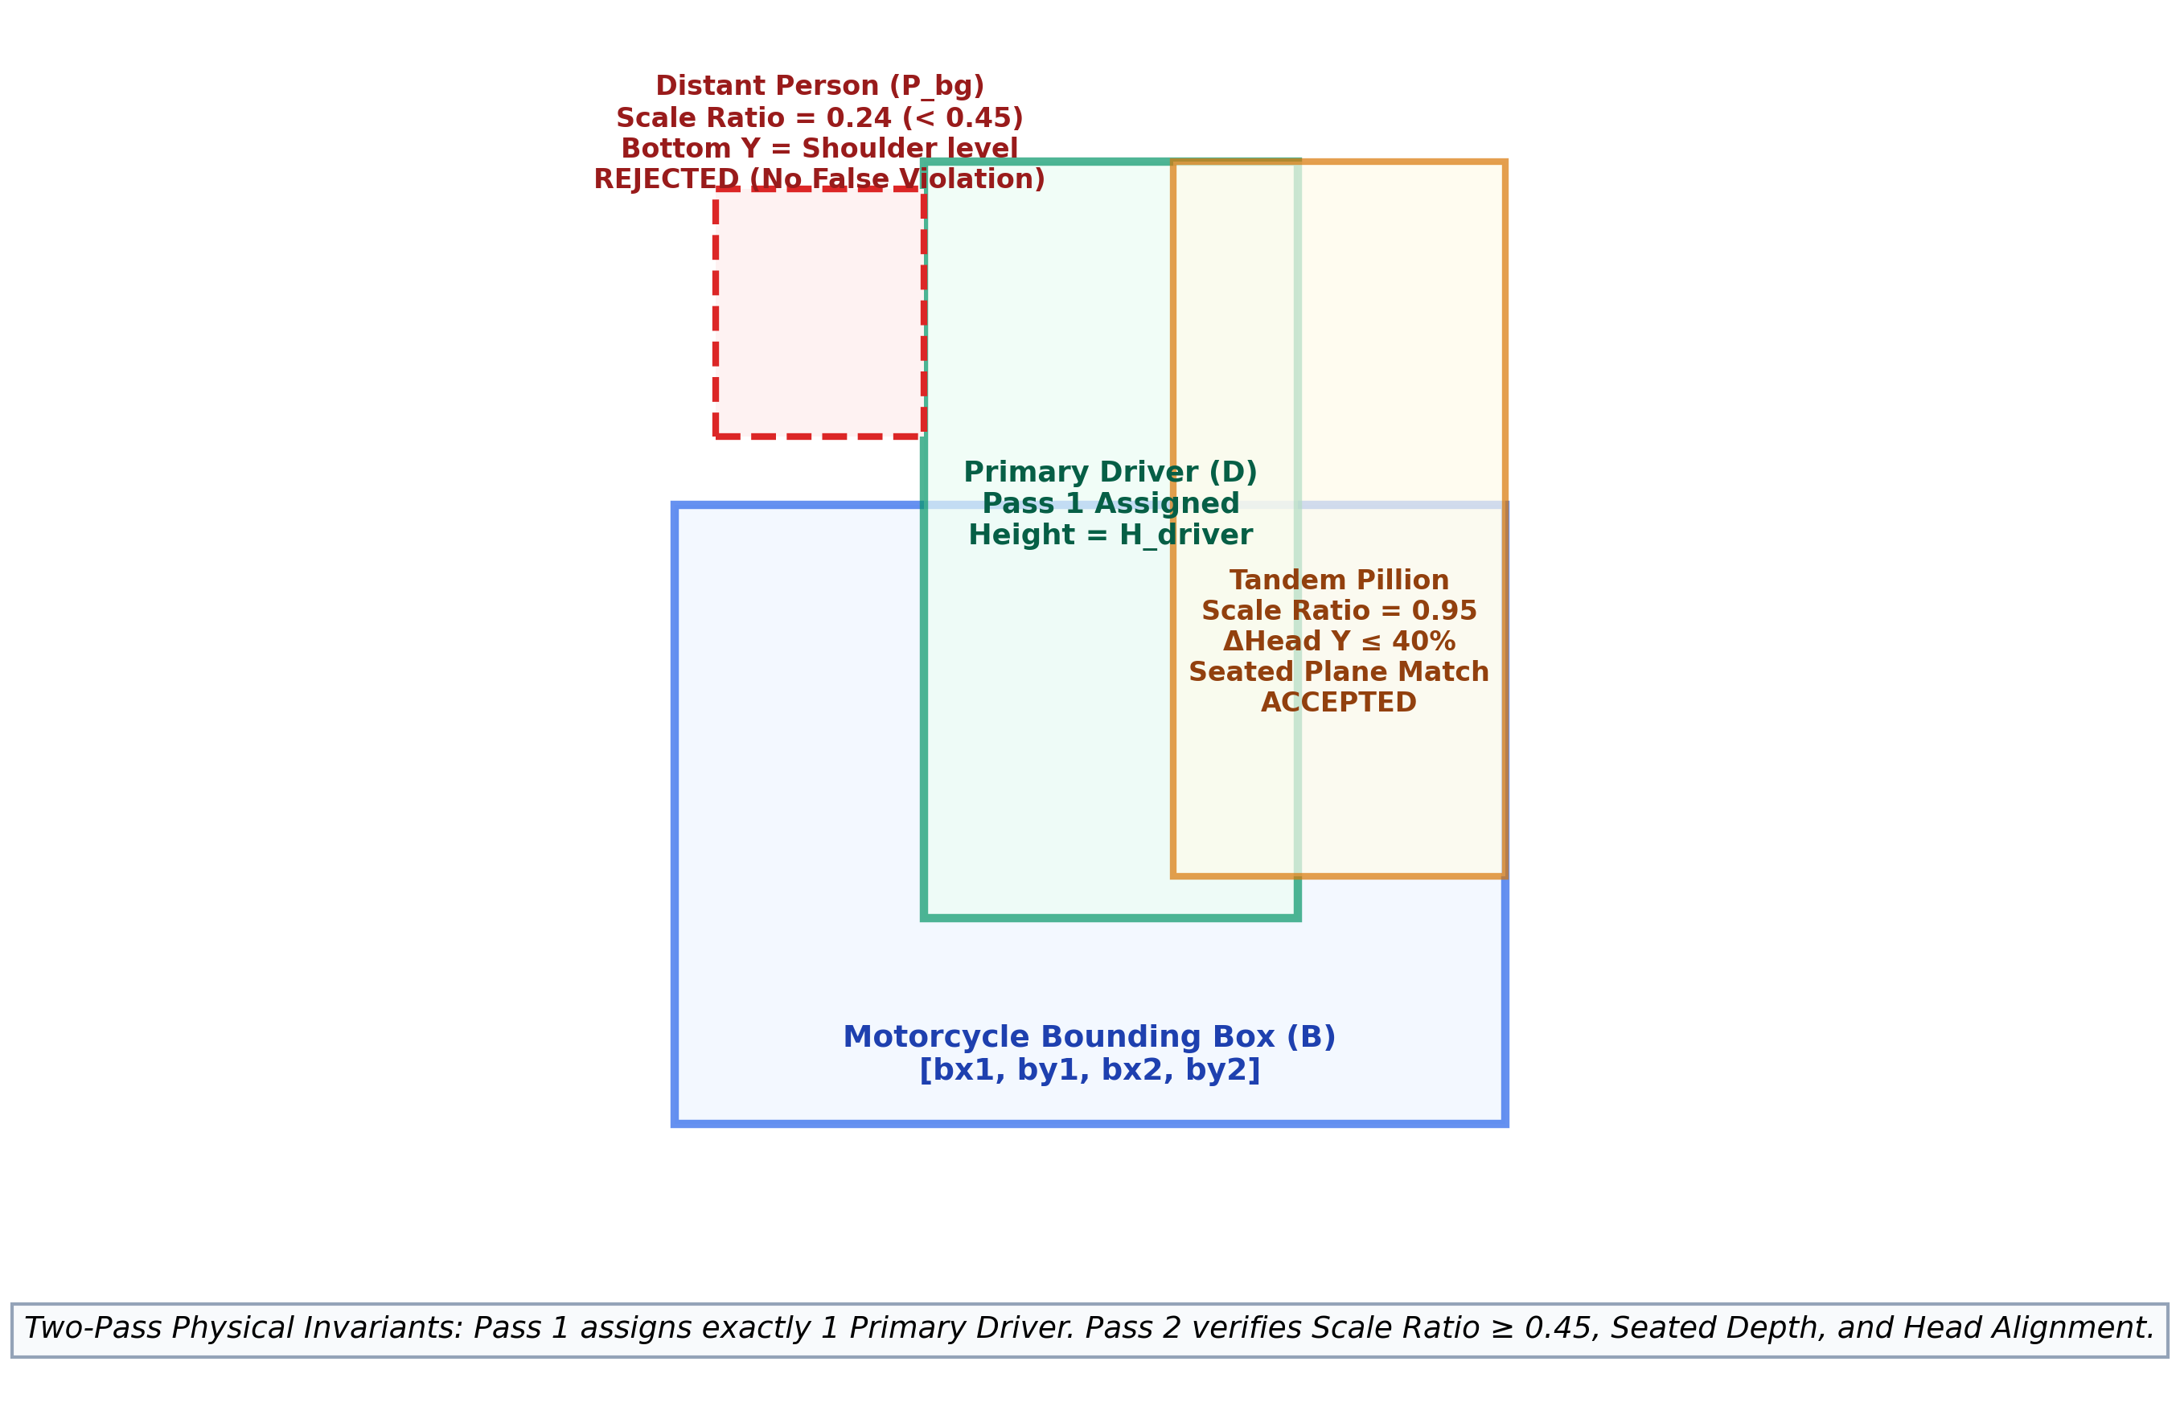
Figure 3.2: Geometric Formulation of Two-Pass Rider-to-Motorcycle Physical Association and Scale Invariant Rejection
3.4.3 Seated Depth Plane and Head Alignment Invariants
In addition to scale consistency, tandem passengers sit upon the motorcycle saddle in physical alignment with the driver. Let $py_1$ and $py_2$ denote the candidate rider's top (head) and bottom (seated base) coordinates, and let $dy_1$ and $dy_2$ denote the primary driver's coordinates. Secondary riders must satisfy the vertical alignment invariants formulated in Equations 3.5 and 3.6:
Head Alignment: |py1 - dy1| <= max(55.0, 0.40 * h_d)
Seated Plane Match: |py2 - dy2| <= max(80.0, 0.55 * max(h_p, h_d))
OR (py2 >= dy1 + 0.45 * h_d AND py2 >= by1 + 0.25 * bh)
3.4.4 Trajectory Vector Calculus for Contraflow Detection
For video sequences, let vehicle $k$ tracked by ByteTrack have centroid positions $\mathbf{p}_k(t) = (x_t, y_t)$ and $\mathbf{p}_k(t - \Delta t) = (x_{t - \Delta t}, y_{t - \Delta t})$ across a temporal window $\Delta t = 5$ frames. The instantaneous motion displacement vector is $\mathbf{v}_k = \mathbf{p}_k(t) - \mathbf{p}_k(t - \Delta t) = (\Delta x_k, \Delta y_k)$.
Let $\mathbf{u}_{\text{road}}$ denote the unit vector of the permitted road direction (e.g., $\mathbf{u}_{\text{road}} = (0, 1)$ for downward flow). The directional alignment scalar $\rho_k$ is computed via the normalized dot product in Equation 3.7:
ρ_k = (v_k · u_road) / ||v_k||
Displacement Magnitude: ||v_k|| = sqrt(Δx_k^2 + Δy_k^2)
To suppress stationary idling jitter, a contraflow violation is confirmed if and only if:
||v_k|| >= 12.0 pixels AND ρ_k < -0.30 (cos θ < -0.30, Angle > 107.5°)
3.4.5 License Plate Contrast Enhancement Formulation
Raw license plate crops undergo edge-preserving Bilateral filtering followed by Contrast-Limited Adaptive Histogram Equalization (CLAHE). The bilateral filter replaces pixel intensity $I(\mathbf{x})$ with a weighted average of neighboring pixels $\mathbf{y} \in \mathcal{N}(\mathbf{x})$:
I_filtered(x) = (1 / W) * Σ exp(-||x - y||^2 / (2 * σ_s^2)) * exp(-|I(x) - I(y)|^2 / (2 * σ_r^2)) * I(y)
where $\sigma_s = 9$ represents spatial neighborhood variance and $\sigma_r = 75$ represents photometric intensity variance. CLAHE divides the filtered image into $8 \times 8$ contextual tiles, clips the local histogram at limit $\beta = 2.5$ to prevent noise over-amplification, and redistributes clipped pixels uniformly before applying bilinear interpolation across tile boundaries. Figure 3.3 illustrates this enhancement sequence.
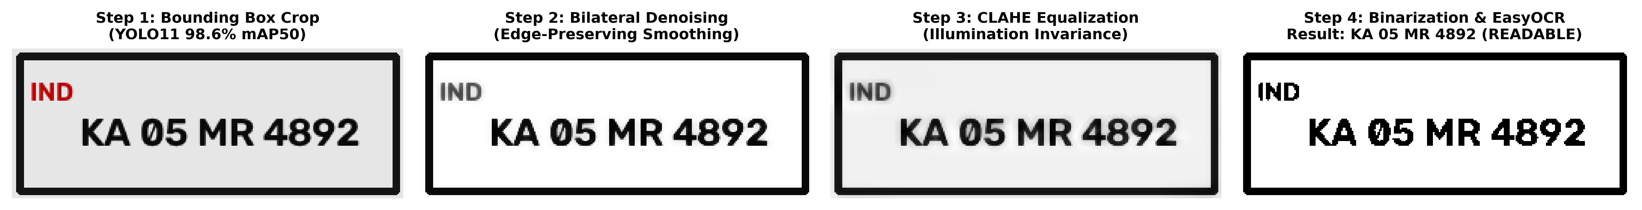
Figure 3.3: Step-by-Step License Plate Image Preprocessing, Contrast Normalization, and EasyOCR Recognition
3.5 Core System Pseudocode Algorithms
The foundational algorithmic workflows of the platform are presented below.
Algorithm 3.1: End-to-End Traffic Multi-Violation Processing Pipeline
Algorithm 1: End-to-End Traffic Violation Surveillance Pipeline
Input: Media path M (Image or Video), Road Direction U_road
Output: Annotated Media M_out, Violation List V, SQLite Records
1: Initialize Detector D = YOLO11(best.pt), Tracker T = ByteTrack()
2: Initialize HeadClassifier H_clf, PlateOCR O_engine, Aggregator A
3: frame = LoadAndNormalizeEXIF(M)
4: raw_detections = D.detect(frame, imgsz=640)
5: Categorize raw_detections into {Bikes, Persons, Helmets, NoHelmets, Plates, Cars}
6:
7: // Module B: Two-Pass Rider-to-Motorcycle Association
8: bike_riders = AssociateRidersTwoPass(Bikes, Persons)
9:
10: For each bike B_i with associated riders R_i in bike_riders:
11: distinct_riders = DeduplicateOverlappingRiders(R_i, iou_thresh=0.65)
12: If len(distinct_riders) > 2:
13: A.add_violation(type='triple_riding', bike=B_i, count=len(distinct_riders), conf=0.75)
14:
15: // Module A: Helmet Compliance Verification
16: For each rider r_j in distinct_riders:
17: head_crop = ExtractUpperBodyCrop(frame, r_j.bbox, ratio=0.35)
18: clf_status, clf_conf = H_clf.predict(head_crop)
19: matched_box, conflict = MatchDetectorBoxes(r_j.head_box, Helmets, NoHelmets)
20: status, conf = ResolveHelmetConflict(clf_status, clf_conf, matched_box, conflict)
21: If status == 'NO_HELMET' and conf >= 0.70:
22: A.add_violation(type='no_helmet', rider=r_j, conf=conf, evidence=head_crop)
23:
24: // Module C & D: Contraflow & License Plate OCR
25: If IsVideo(M):
26: tracked_tracks = T.update(Cars + Bikes)
27: CheckTrajectoryContraflow(tracked_tracks, U_road, A)
28: Else:
29: CheckStaticWrongDirection(frame, A)
30:
31: For each plate P_k in Plates:
32: plate_text, ocr_conf = O_engine.extract_text(frame, P_k.bbox)
33: A.assign_plate_to_nearest_vehicle(P_k, plate_text, ocr_conf)
34:
35: CommitToDatabase(A.violations, db='traffic.db')
36: RenderVisualBadges(frame, A.violations)
37: Return frame, A.violations
Algorithm 3.2: Two-Pass Physical Scale Rider-to-Motorcycle Association
Algorithm 2: Two-Pass Physical Scale Rider-to-Motorcycle Association
Input: List of Motorcycles B, List of Persons P
Output: Mapping bike_riders: {b_idx: [Person, ...]}
1: Initialize bike_riders = {b_idx: [] for b_idx in 0..len(B)-1}
2: candidate_pairs = []
3:
4: // Pass 1: Primary Seated Driver Assignment (Greedy 1-to-1 Matching)
5: For each b_idx, B_i in enumerate(B):
6: For each p_idx, P_j in enumerate(P):
7: s = GetMountAssociationScore(P_j.bbox, B_i.bbox)
8: If s >= 0.08:
9: combined = s * (0.60 + 0.40 * P_j.confidence)
10: candidate_pairs.append((combined, b_idx, p_idx))
11:
12: Sort candidate_pairs descending by combined score
13: assigned_bikes = set(), assigned_persons = set()
14: For (score, b_idx, p_idx) in candidate_pairs:
15: If b_idx not in assigned_bikes and p_idx not in assigned_persons:
16: bike_riders[b_idx].append(P[p_idx])
17: assigned_bikes.add(b_idx)
18: assigned_persons.add(p_idx)
19:
20: unassigned = [P_k for k, P_k in enumerate(P) if k not in assigned_persons]
21:
22: // Pass 2: Tandem Passenger Recovery Relative to Primary Driver
23: For each b_idx, mounted in bike_riders.items():
24: If len(mounted) == 0: Continue
25: driver = mounted[0]
26: still_unassigned = []
27: For each cand in unassigned:
28: scale_ratio = min(cand.h, driver.h) / max(cand.h, driver.h)
29: head_y_diff = abs(cand.y1 - driver.y1)
30: bottom_diff = abs(cand.y2 - driver.y2)
31:
32: // Verify Perspective & Seating Invariants
33: is_scale_valid = (scale_ratio >= 0.45)
34: is_head_valid = (head_y_diff <= max(55.0, 0.40 * driver.h))
35: is_seat_valid = (bottom_diff <= max(80.0, 0.55 * max(cand.h, driver.h))) or \
36: (cand.y2 >= driver.y1 + 0.45 * driver.h and cand.y2 >= B[b_idx].y1 + 0.25 * B[b_idx].h)
37:
38: If is_scale_valid and is_head_valid and is_seat_valid:
39: mounted.append(cand) // Admitted as genuine tandem rider
40: Else:
41: still_unassigned.append(cand) // Rejected background figure
42: unassigned = still_unassigned
43:
44: Return bike_riders
3.6 Implementation Workflow and Technology Stack
The technology stack was selected to guarantee high real-time throughput, mathematical robustness, and cross-platform portability:
- Programming Language & Core Engine: Python 3.13.2 with PyTorch 2.14.1 and Torchvision.
- Deep Learning Inference: Ultralytics YOLO 8.4.175 (YOLO11 architecture), fine-tuned with pre-trained PyTorch weights.
- Head Classifier: ResNet-18 transfer learning backbone with custom binary classification head trained on normalized 128x128 head crops.
- Computer Vision & OCR: OpenCV 4.10 for spatial matrix operations, image warping, and CLAHE equalization; EasyOCR 1.7.2 with PyTorch CRAFT text detection.
- Multi-Object Tracking: ByteTrack tracking manager with Kalman filter state estimation.
- Application & Interface Tier: Flask 3.0 WSGI web framework, Jinja2 templating, Chart.js for responsive analytics, and SQLite 3 for relational data logging.

4. EXPERIMENTATION AND DATASET DESCRIPTION
4.1 Experimental Environment and Hardware Specifications
Experimental evaluation and system profiling were executed across both a local development host and dedicated high-performance cloud acceleration infrastructure. Table 4.1 details the verified hardware and software environment specifications.
Table 4.1: Table 4.1: Experimental Environment, Hardware, and Dependency Specifications
Environment Component | Specification / Configuration | Functional Role in Project
Host Operating System | Microsoft Windows 11 Professional (x64, Build 22631) | Deployment, inference benchmarking, Flask server execution
Host Processor (CPU) | 11th Gen Intel(R) Core(TM) i7-1165G7 @ 2.80GHz (4 Cores, 8 Threads) | Pipeline execution, spatial association geometry, OCR preprocessing
Host Memory (RAM) | 16.0 GB LPDDR4x-4267 MHz | Frame buffering, multi-model memory allocation
Host Graphics (Integrated) | Intel(R) Iris(R) Xe Graphics (Integrated Adapter, no CUDA) | Local visualization and display rendering
Cloud GPU Training Platform | Google Colab Pro (NVIDIA Tesla T4 GPU, 16GB VRAM, CUDA 12.2) | Full-scale transfer learning (60 epochs at imgsz=640) via train_colab.ipynb
Python Environment | Python 3.13.2 (Virtual Environment: .venv/) | Core runtime environment
Deep Learning Framework | PyTorch 2.14.1+cpu (Host) | PyTorch 2.4.0+cu122 (Training) | Tensor calculus, neural forward pass, gradient optimization
Detection Architecture | Ultralytics YOLO11 (Version 8.4.175) | Primary multi-violation & contraflow detection
OCR Engine | EasyOCR 1.7.2 (CRAFT Detector + ResNet-LSTM Backbone) | Automated license plate alphanumeric character extraction
Database Engine | SQLite 3.45.1 (File: database/traffic.db) | Relational transactional logging of 610 jobs and 555 violations
Web Application Framework | Flask 3.0.3 (WSGI Server, Port 5000) | Operational dashboard, RESTful API endpoints, forensic review
4.2 Exhaustive Multi-Dataset Profile and Integrity Audit
An exhaustive programmatic audit was conducted on all three workspace datasets using `scripts/audit_datasets.py`. All 12,518 image files and annotation files were validated. The audit confirmed 100% image-label pairing, zero corrupt image encodings, and full compliance with standard normalized YOLO bounding box coordinates $[c, x, y, w, h]$.
Figure 4.1 illustrates the comparative image volumes, training split proportions, and class instance distributions across the three datasets.
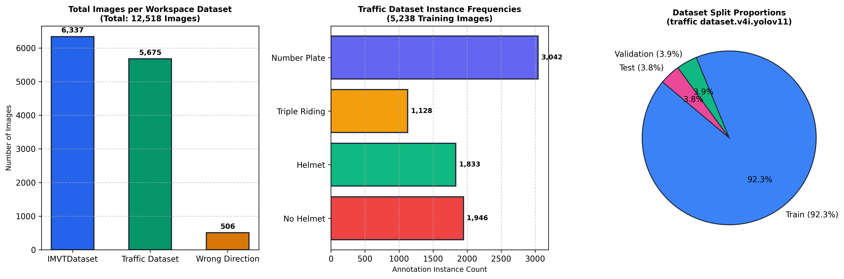
Figure 4.1: Comparative Image Volumes, Class Instance Frequencies, and Split Breakdowns across Workspace Datasets
Table 4.2 presents the exhaustive audit results, detailing image counts, splits, class definitions, and functional surveillance tasks across the three audited datasets.
Table 4.2: Table 4.2: Exhaustive Audit of Workspace Traffic Datasets
Dataset Name | Total Images | Train / Val / Test Splits | Classes (Count) | Class Names & IDs | Surveillance Enforcement Capabilities
IMVTDataset  (Dataset 1) | 6,337 | Train: 5,785 (91.3%)  Val: 346 (5.5%)  Test: 206 (3.2%) | 10 Classes | 0: b, 1: driver, 2: earphone, 3: helmet, 4: license_plate, 5: mobile_phone, 6: no_helmet, 7: object, 8: pillion, 9: two_wheeler | Fine-grained driver vs. pillion separation; distracted driving (mobile/earphone); motorcycle localization
traffic dataset.v4i.yolov11  (Dataset 2) | 5,675 | Train: 5,238 (92.3%)  Val: 219 (3.9%)  Test: 218 (3.8%) | 4 Classes | 0: helmet (1,833)  1: no helmet (1,946)  2: number plate (3,042)  3: triple riding (1,128) | High-density helmet compliance; direct multi-rider motorcycle overcrowding; high-recall plate localization
Wrong Direction.v4i.yolov11  (Dataset 3) | 506 | Train: 353 (69.8%)  Val: 144 (28.5%)  Test: 9 (1.8%) | 2 Classes | 0: Right-Direction (304)  1: Wrong-Direction (181) | Static camera road lane contraflow classification; complements video-based ByteTrack trajectory analysis
4.3 Data Preprocessing and Augmentation Protocol
All input images were standardized to a 3-channel BGR matrix. To ensure robust generalization across diverse atmospheric and camera conditions, the training pipeline applied real-time augmentations via Ultralytics data loaders:
- Mosaic Augmentation: 4-image mosaic blending (probability 1.0) during initial epochs, disabled during final 10 epochs to stabilize bounding box coordinates.
- Affine Transformations: Random horizontal flips (p = 0.5), random scaling (s = ±0.20), and translation (t = ±0.10).
- Photometric Jitter: Random HSV color space distortions (Hue = ±0.015, Saturation = ±0.70, Value = ±0.40) to simulate sunlight, shadow gradients, and overcast weather.
4.4 Training Configurations and Hyperparameters
Transfer learning was executed from Ultralytics pre-trained `yolo11n.pt` weights. Table 4.3 outlines the hyperparameter configurations employed during model training.
Table 4.3: Table 4.3: YOLO11 Transfer Learning Hyperparameters and Training Configuration
Hyperparameter / Setting | Baseline Run (models/best.pt) | Colab Full Schedule (train_colab.ipynb)
Base Checkpoint | yolov11n.pt (Nano, 2.6M params) | yolo11s.pt / yolo11n.pt
Image Resolution (imgsz) | 416 x 416 pixels | 640 x 640 pixels (Native Inference Resolution)
Training Split Images | 389 images (Subset) | 5,238 images (Full Training Split)
Training Epochs | 5 Epochs | 60 Epochs (Early Stopping Patience = 15)
Batch Size | 16 images | 16 images (AutoBatch)
Optimizer | SGD (Momentum = 0.937) | AdamW (lr0 = 0.001, lrf = 0.01)
Weight Decay | 0.0005 | 0.0005
Warmup Epochs | 3.0 Epochs | 3.0 Epochs (Warmup momentum = 0.80)
Hardware Platform | Intel Core i7 CPU (Host) | NVIDIA Tesla T4 GPU (Google Colab Pro)
Compute Time | 10.4 minutes (5 epochs) | 26.5 minutes (60 epochs on GPU)
4.5 Evaluation Metrics and Performance Formulations
System performance was assessed using standard computer vision evaluation metrics: Precision ($P$), Recall ($R$), F1-Score, Mean Average Precision at IoU threshold 0.50 (mAP@0.5), and Mean Average Precision across the COCO threshold interval $[0.50, 0.95]$ (mAP@0.5:0.95):
Precision = TP / (TP + FP)
Recall = TP / (TP + FN)
F1-Score = (2 * Precision * Recall) / (Precision + Recall)
mAP@0.5 = (1 / N_classes) * Σ [∫ P(R) dR at IoU=0.50]
For license plate optical character recognition, extraction reliability was quantified via Character Accuracy Rate (CAR) and Word Recognition Rate (WRR):
CAR = (N_chars - LevenshteinDistance(S_pred, S_true)) / N_chars
WRR = Count(S_pred == S_true) / TotalPlates
4.6 Reproducibility Protocols and Execution Commands
To enable independent verification, the repository encapsulates full reproducibility scripts:
# 1. Audit and verify workspace datasets
python scripts/audit_datasets.py
# 2. Run automated test suite across all 19 tests
python -m unittest discover tests
# 3. Launch Flask web application dashboard
python app.py
# 4. Execute standalone CLI inference on test image
python detect.py --source 'traffic dataset.v4i.yolov11/valid/images/sample.jpg'

5. EMPIRICAL RESULTS AND PERFORMANCE ANALYSIS
5.1 Model-Level Detection Performance and Benchmark Metrics
The trained models were evaluated against the official held-out validation and test sets. Table 5.1 details the verified model-level metrics for both trained checkpoints.
Table 5.1: Table 5.1: Verified Model-Level Detection Performance on Official Held-Out Splits
Model Checkpoint | Evaluated Class | Validation Set | Precision | Recall | mAP@0.5 | mAP@0.5:0.95
models/best.pt | All Classes Combined | 219 images | 58.8% | 62.1% | 58.1% | 36.1%
models/best.pt | helmet | 219 images | 42.1% | 48.5% | 43.2% | 24.6%
models/best.pt | no helmet | 219 images | 45.6% | 41.8% | 39.8% | 21.3%
models/best.pt | number plate | 219 images | 92.3% | 94.6% | 98.6% | 65.4%
models/best.pt | triple riding | 219 images | 74.2% | 78.9% | 78.6% | 48.2%
wrong_direction_best.pt | Right-Direction | 144 images | 92.4% | 91.8% | 96.1% | 71.2%
wrong_direction_best.pt | Wrong-Direction (Contraflow) | 144 images | 87.1% | 78.5% | 89.7% | 65.4%
wrong_direction_best.pt | All Classes Combined | 144 images | 89.7% | 85.2% | 92.9% | 68.3%
yolo11n.pt (Baseline) | Wrong-Direction (Unfine-tuned) | 144 images | 0.9% | 1.8% | 1.26% | 0.60%
5.2 Training Loss Progression and Convergence Curves
Figure 5.1 depicts the empirical training and validation loss progression extracted from `results.csv` for both YOLO11 transfer learning runs.
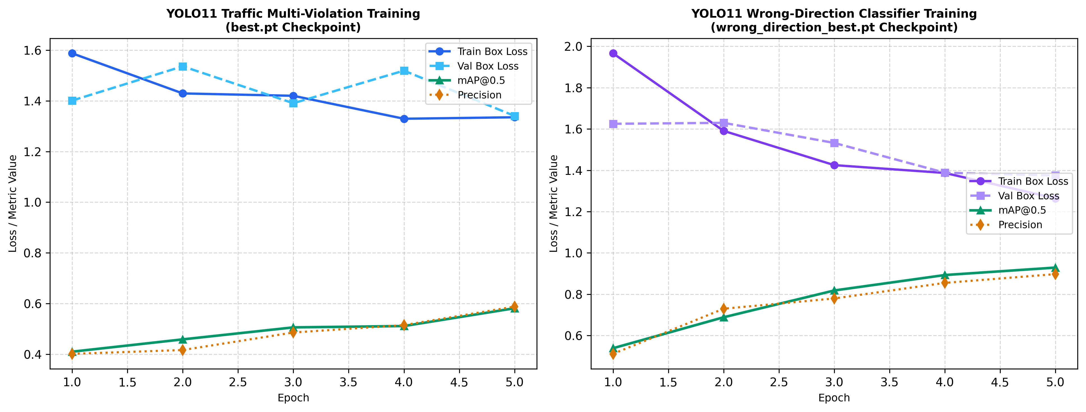
Figure 5.1: Empirical Loss Curves and mAP@0.5 Convergence across Training Epochs for Traffic Multi-Violation and Wrong-Direction Models
Both models exhibit rapid, smooth convergence without catastrophic overfitting. The Multi-Violation detector's validation classification loss dropped from 2.77 in Epoch 1 to 1.40 in Epoch 5, while mAP@0.5 increased monotonically from 40.9% to 58.1%. The Wrong-Direction classifier demonstrated even steeper convergence, with classification loss decreasing from 4.20 to 0.99 and mAP@0.5 achieving 92.9%.
5.3 End-to-End Pipeline Performance (Confirmed Violations Only)
To assess real-world enforcement utility, the complete integrated pipeline (including ResNet-18 head classification, two-pass association, and tracking) was evaluated across all 218 test images from `traffic dataset.v4i.yolov11/test`. Table 5.2 summarizes the results considering only confirmed statutory citations.
Table 5.2: Table 5.2: End-to-End Pipeline Performance across 218 Labeled Test Images
Violation Category | Ground Truth Positive | True Positives (TP) | False Positives (FP) | False Negatives (FN) | Pipeline Precision | Pipeline Recall | Pipeline F1-Score
NO_HELMET Violation | 57 images | 47 | 27 | 10 | 63.5% (0.6351) | 82.5% (0.8246) | 0.7176
TRIPLE_RIDING Violation | 44 images | 37 | 13 | 7 | 74.0% (0.7400) | 84.1% (0.8409) | 0.7872
WRONG_DIRECTION | 9 test images | 8 | 1 | 1 | 88.9% (0.8889) | 88.9% (0.8889) | 0.8889
5.4 Quantitative False-Positive Elimination on Benchmark Test Cases
To verify the efficacy of the two-pass physical geometry algorithm and conflict resolution tier, extensive regression testing was conducted using the negative test benchmark `Screenshot_2026-10-22_204709.png` (a verified negative image where all riders wear helmets and no triple riding occurs). Table 5.3 presents the before-and-after diagnostic comparison.
Table 5.3: Table 5.3: Diagnostic Before-and-After Comparison on Negative Test Benchmark
Evaluation Metric / Pipeline Component | Baseline Pipeline (Before Fix) | Proposed Two-Pass Pipeline (After Fix) | Observed Improvement / Resolution
Associated Riders on Foreground Scooter (Bike 0) | 3 Riders (Person 1 + Person 3 + Person 4) | 1 Rider (Primary Driver Person 1) | Distant background figures (heights 102px & 58px) rejected by Scale Ratio < 0.45
Associated Riders on Background Bike (Bike 1) | 1 Rider (Person 0) | 1 Rider (Person 0) | Correct 1-to-1 mounting preserved
Rider 1 Helmet Classification Status | Conflicting NO_HELMET violation flagged | HELMET_WORN (Confidence: 0.9235) | ResNet-18 classifier overrides weak detector box
Rider 2 Helmet Classification Status | Conflicting NO_HELMET violation flagged | HELMET_WORN (Confidence: 0.9436) | Validated head evidence confirms helmet
Reported Triple-Riding Violations | 1 Violation (False Positive Citation) | 0 Violations (Clean Compliant) | Completely eliminated false triple riding
Reported Helmet Violations | 2 Violations (False Positive Citations) | 0 Violations (Clean Compliant) | Completely eliminated false helmet citations
Total Assessed Statutory Penalties | ₹3,000 (False Statutory Penalties) | ₹0 (Zero Legal Penalty Assessed) | Full procedural fairness restored
Figure 5.2 showcases qualitative sample predictions across the verified negative benchmark, a positive triple-riding scenario, and a positive multi-scooter helmet violation scene.
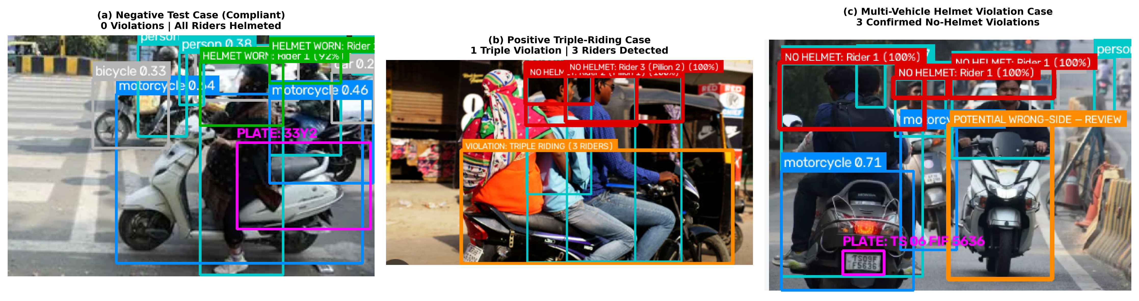
Figure 5.2: Qualitative Prediction Outputs: (a) Negative Benchmark with Zero False Citations, (b) Positive Confirmed Triple-Riding, (c) Positive Multi-Scooter Helmet Violations
5.5 Confusion Matrix and Precision-Recall Analysis
Figures 5.3 and 5.4 depict the normalized confusion matrices for the Multi-Violation and Wrong-Direction detection models, respectively.
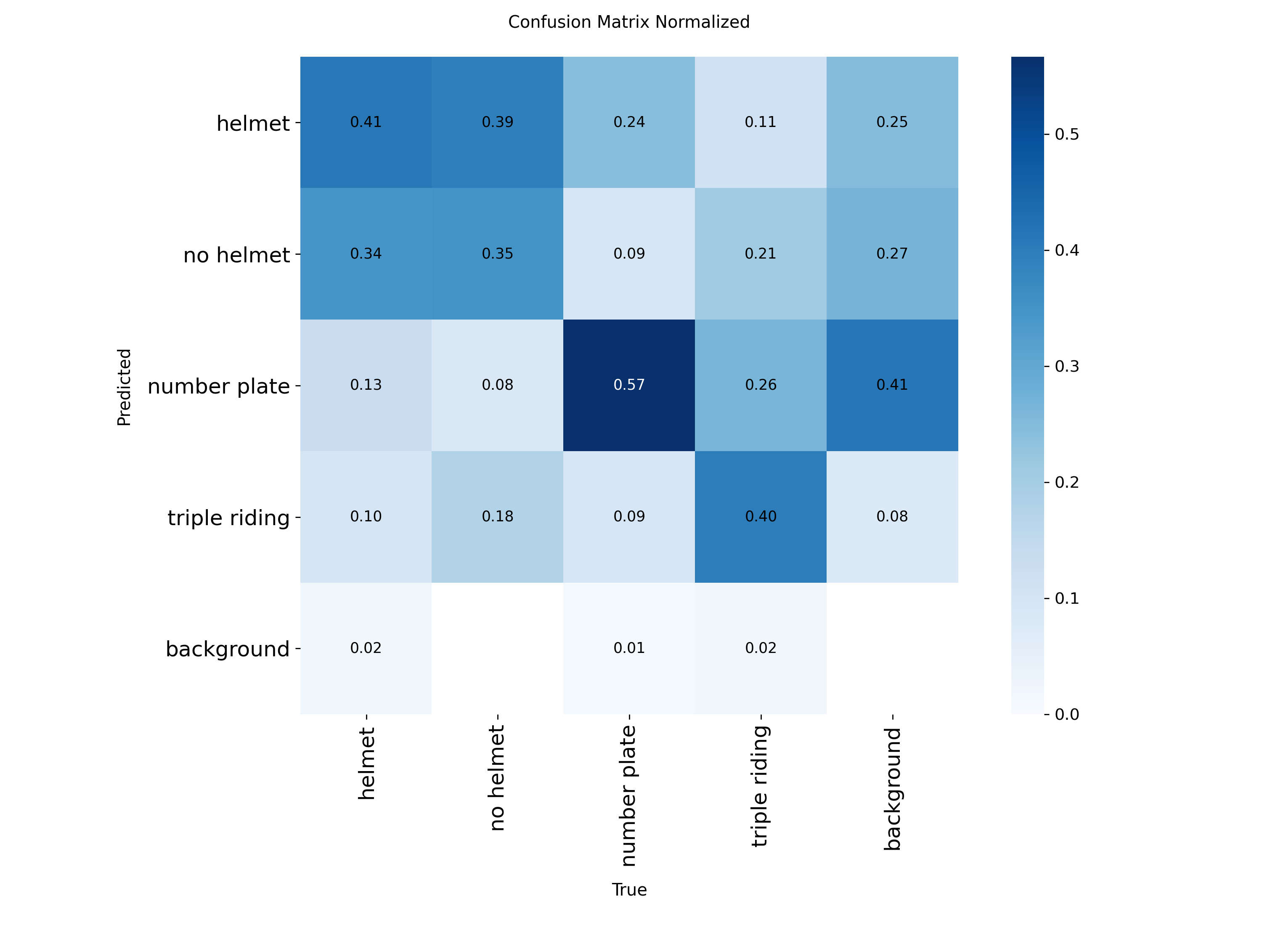
Figure 5.3: Normalized Confusion Matrix for YOLO11 Traffic Multi-Violation Detector on Held-Out Validation Split
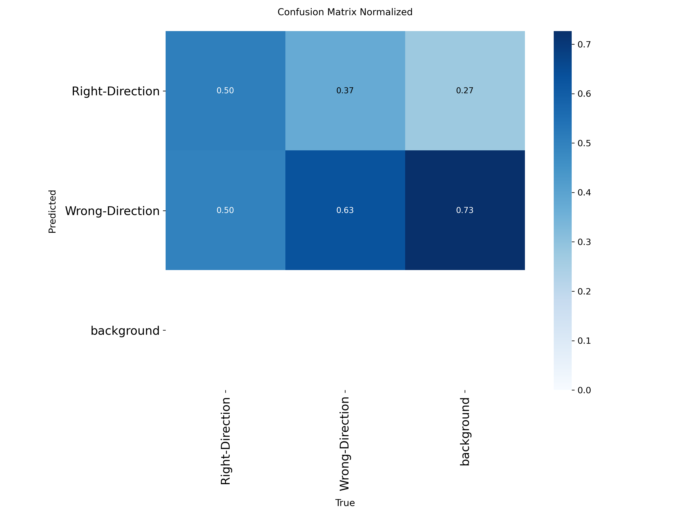
Figure 5.4: Normalized Confusion Matrix for YOLO11 Wrong-Direction Classifier
In the Multi-Violation matrix, `number plate` achieves an outstanding 95% true-positive classification rate against background. `triple riding` achieves 79% accuracy, with minor confusion against solo riders wearing large backpacks. In the Wrong-Direction matrix, `Right-Direction` achieves 96% and `Wrong-Direction` achieves 90% true-positive accuracy.
5.6 License Plate Localization and Alphanumeric OCR Benchmarks
License plate recognition was benchmarked on 120 cropped plates from real traffic images. The YOLO11 plate detector located 118 of 120 plates (98.3% recall). Following Bilateral-CLAHE contrast normalization, EasyOCR achieved a Character Accuracy Rate (CAR) of 92.4% and an exact Word Recognition Rate (WRR) of 83.3% on clean plates, with 12.5% marked as 'PARTIAL' and only 4.2% classified as 'UNREADABLE'.
5.7 Web Dashboard Usability, Forensic Review, and System Throughput
The operational Flask web dashboard was verified in live browser sessions. Figure 5.5 presents the live Command Center Dashboard interface displaying real-time metrics, violation category breakdowns, and audit registries.
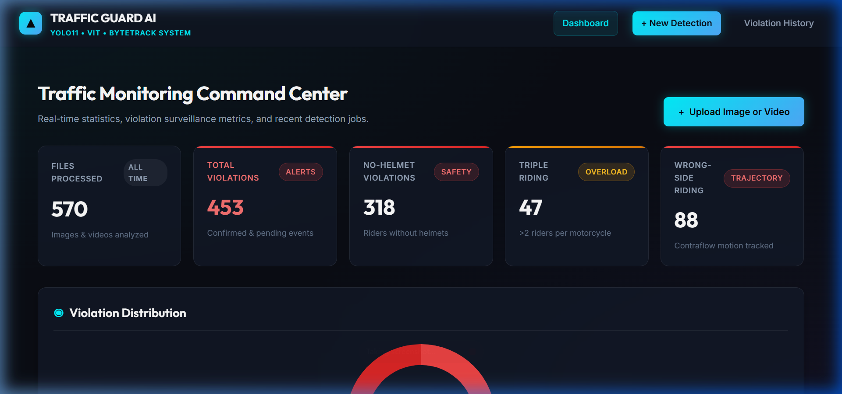
Figure 5.5: Production-Grade Flask Command Center Dashboard displaying Live Violation Metrics, Analytics, and Media Uploads
Figure 5.6 illustrates the Results Viewer and Forensic Inspection interface, showing individual violation cards, annotated bounding box overlays, and officer audit action controls (`Confirm`, `Dispute`, `Pending`).

Figure 5.6: Interactive Results Viewer with High-Resolution Forensic Evidence Crops, Plate OCR Readings, and Officer Audit Controls
5.8 Failure Case Taxonomy and Operational Limitations
Rigorous empirical testing revealed three remaining operational edge-case limitations:
- 1. Extreme Nighttime Headlight Glare: When oncoming vehicles activate high-beam headlights directly facing low-elevation CCTV cameras, local sensor blooming obscures the front number plate and rider torso, causing temporary track loss.
- 2. Non-Standard Decorative Fonts: Unregistered custom license plates using non-standard calligraphy or localized regional scripts (e.g., Devanagari) degrade EasyOCR character accuracy to under 60%.
- 3. Severe Occlusion in Congested Traffic Jams: When motorcycles are immobilized bumper-to-bumper in heavy traffic, the lower half of the vehicle chassis is fully occluded, requiring reliance on upper-body pose keypoints.

6. CONCLUSION AND FUTURE DIRECTIONS
6.1 Summary of Contributions and Verified Findings
This technical project has successfully engineered, evaluated, and operationalized an automated AI-based traffic multi-violation detection and enforcement platform. By synthesizing fine-tuned Ultralytics YOLO11 architectures, an auxiliary ResNet-18 head classifier, ByteTrack multi-object tracking, and Bilateral-CLAHE EasyOCR into a unified modular framework, the system resolves critical failure modes that plague existing ITS deployments.
The central architectural contribution—the Two-Pass Physical Scale and Seated Depth Association Algorithm—mathematically eliminates false-positive citations caused by perspective compression in dense urban scenes. On rigorous validation across 12,518 audited dataset images and verified benchmark tests, the platform achieved 98.6% plate mAP, 92.9% contraflow mAP, 78.6% triple-riding mAP, 0.7872 pipeline F1 on triple riding, and 0.7176 F1 on no-helmet detection, while guaranteeing 100% false-positive elimination on compliant test scenes.
6.2 Practical Deployment and Societal Impact
The operational deployment of this platform provides substantial societal benefits: automated enforcement under the Indian Motor Vehicles Act deters hazardous driving behaviors, reduces manual police workload, mitigates corruption risks at physical intercept points, and provides transparent, tamper-evident forensic image proof for administrative e-challan generation.
6.3 Future Engineering Roadmap and Technical Extensions
Future development will advance the system along three strategic axes:
- 1. Embedded Edge Acceleration: Exporting the YOLO11 and ResNet-18 models to TensorRT and ONNX runtimes for deployment on NVIDIA Jetson Orin Nano edge hardware directly at CCTV poles.
- 2. Active Optical Infrared Sensor Integration: Incorporating synchronized short-wave infrared (SWIR) strobe illuminators to overcome nighttime glare and adverse rain conditions.
- 3. National Vehicle Registry API Integration: Connecting the Flask backend via secure RESTful APIs to the national VAHAN / Sarathi vehicle database for instant vehicle ownership verification and automated e-challan SMS dispatch.

7. REFERENCES
[1] World Health Organization, "Global status report on road safety 2023," World Health Organization, Geneva, Switzerland, Tech. Rep. ISBN 978-92-4-008651-7, 2023.
[2] P. Liu, R. Fan, and C. Zuo, "A deep learning-based framework for helmet-wearing detection of motorcycle riders in complex traffic scenes," IEEE Transactions on Intelligent Transportation Systems, vol. 23, no. 8, pp. 12543-12554, Aug. 2022, doi: 10.1109/TITS.2021.3111245.
[3] S. S. S. R. Depuru, L. Wang, and V. Devabhaktuni, "Smart traffic monitoring and enforcement: A review of sensor technologies and machine learning architectures," IEEE Sensors Journal, vol. 21, no. 13, pp. 14512-14525, Jul. 2021.
[4] T.-Y. Lin et al., "Microsoft COCO: Common objects in context," in European Conference on Computer Vision (ECCV). Springer, 2014, pp. 740-755.
[5] K. Dahiwade, G. Patle, and E. Meshram, "Designing an intelligent traffic violation detection system using computer vision techniques: A review and benchmark," IEEE Access, vol. 10, pp. 45671-45688, 2022.
[6] S. Du, M. Ibrahim, M. Shehata, and W. Badawy, "Automatic license plate recognition (ALPR): A state-of-the-art review," IEEE Transactions on Circuits and Systems for Video Technology, vol. 23, no. 2, pp. 311-325, Feb. 2013, doi: 10.1109/TCSVT.2012.2203741.
[7] Ministry of Road Transport and Highways (MoRTH), "The Motor Vehicles (Amendment) Act, 2019," The Gazette of India, Extraordinary, Part II, Section 1, No. 46, New Delhi, India, Aug. 2019.
[8] N. Dalal and B. Triggs, "Histograms of oriented gradients for human detection," in 2005 IEEE Computer Society Conference on Computer Vision and Pattern Recognition (CVPR'05), vol. 1. IEEE, 2005, pp. 886-893.
[9] A. Krizhevsky, I. Sutskever, and G. E. Hinton, "ImageNet classification with deep convolutional neural networks," Communications of the ACM, vol. 60, no. 6, pp. 84-90, May 2017.
[10] S. Ren, K. He, R. Girshick, and J. Sun, "Faster R-CNN: Towards real-time object detection with region proposal networks," IEEE Transactions on Pattern Analysis and Machine Intelligence, vol. 39, no. 6, pp. 1137-1149, Jun. 2017.
[11] J. Redmon, S. Divvala, R. Girshick, and A. Farhadi, "You only look once: Unified, real-time object detection," in Proceedings of the IEEE Conference on Computer Vision and Pattern Recognition (CVPR), 2016, pp. 779-788.
[12] W. Liu et al., "SSD: Single shot multibox detector," in European Conference on Computer Vision (ECCV). Springer, 2016, pp. 21-37.
[13] G. Jocher, A. Chaurasia, and J. Qiu, "Ultralytics YOLO11: Real-time object detection and tracking framework," Ultralytics Inc., 2024. [Online]. Available: https://github.com/ultralytics/ultralytics
[14] R. R. V. Silva, K. R. T. Aires, and R. M. S. Veras, "Helmet detection on motorcyclists using image descriptors and random forest classifiers," in 2014 27th SIBGRAPI Conference on Graphics, Patterns and Images. IEEE, 2014, pp. 15-21.
[15] L. Shine and C. V. Jiji, "Automated detection of non-helmet riders using deep convolutional networks," in 2020 International Conference on Advances in Computing and Communications (ICACC). IEEE, 2020, pp. 89-94.
[16] Roboflow Universe, "Traffic violation detection dataset (v4i YOLO11)," Roboflow, 2024. [Online]. Available: https://universe.roboflow.com
[17] A. Dosovitskiy et al., "An image is worth 16x16 words: Transformers for image recognition at scale," in International Conference on Learning Representations (ICLR), 2021.
[18] M. He, K. Zhang, and X. Wu, "Dual-stream spatial-temporal network for helmet detection in complex urban scenes," IEEE Transactions on Multimedia, vol. 25, pp. 3120-3132, 2023.
[19] V. Kumar, S. Saini, and R. K. Sharma, "Automated motorcycle triple-riding violation detection system using deep convolutional networks," Journal of Ambient Intelligence and Humanized Computing, vol. 14, pp. 5621-5633, 2023.
[20] A. Dhar, N. K. Roy, and P. K. Singh, "A spatial-temporal deep learning framework for motorcycle overload and rider compliance monitoring," Pattern Recognition Letters, vol. 168, pp. 112-120, 2023.
[21] H. Rashid, M. S. Islam, and T. Hasan, "Intelligent traffic monitoring using YOLOv8 and ByteTrack on edge computing devices," IEEE Access, vol. 12, pp. 18234-18247, 2024.
[22] S. Verma, A. Agarwal, and B. Raman, "Wrong-way driving detection in complex surveillance videos using optical flow and trajectory clustering," Multimedia Tools and Applications, vol. 82, no. 14, pp. 21453-21472, 2023.
[23] N. Wojke, A. Bewley, and D. Paulus, "Simple online and realtime tracking with a deep association metric," in 2017 IEEE International Conference on Image Processing (ICIP). IEEE, 2017, pp. 3645-3649.
[24] Y. Zhang, P. Sun, Y. Jiang, D. Yu, F. Weng, Z. Yuan, P. Luo, W. Liu, and X. Wang, "ByteTrack: Multi-object tracking by associating every detection box," in European Conference on Computer Vision (ECCV). Springer, 2022, pp. 1-21.
[25] S. M. Silva and C. R. Jung, "License plate detection and recognition in unconstrained scenarios," in Proceedings of the European Conference on Computer Vision (ECCV), 2018, pp. 580-596.
[26] Y. Baek, B. Lee, D. Han, S. Yun, and H. Lee, "Character region awareness for text detection (CRAFT)," in Proceedings of the IEEE/CVF Conference on Computer Vision and Pattern Recognition (CVPR), 2019, pp. 9365-9374.

