|  |  |
| --- | --- |
| **ID** | BCR-001 |
| **Title** | Lancia Make – Stratos Model web page is unresponsive |
| **Component/s:** | Overall Rating |
| **Environment:** | Test environment - https://buggy.justtestit.org/ |
| **Severity** | Critical |
| **Priority** | High |
| **Test Data** | * Lancia make - Stratos model |
| **Steps to Recreate** | * Login to Buggy Cars Rating webpage * Click Overall Rating image on the home page * Buggy Cars Rating page opens * Navigate to Lancia make - Stratos model * Click on the image presented against Lancia make - Stratos model |
| **Expected Results** | * Web page opens with Lancia Make – Stratos model details * User can navigate to home page and perform other actions on the page |
| **Actual Results** | * Web page opens with empty specification details and model image is not presented * Click on “Buggy Rating” link to navigate to home page * Home page is not presented and web page becomes empty * Browser is unresponsive and user can not navigate back using back arrow |

**Test Evidences:**

Lancia-Stratos model on overall rating page: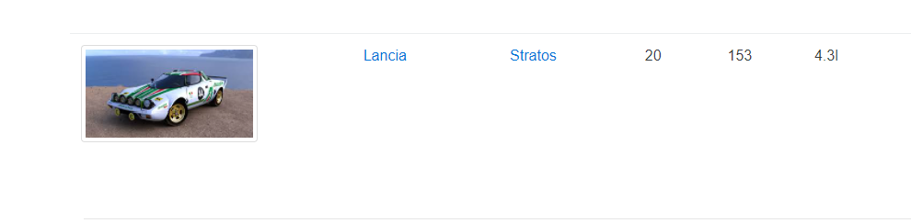

After clicking on the image

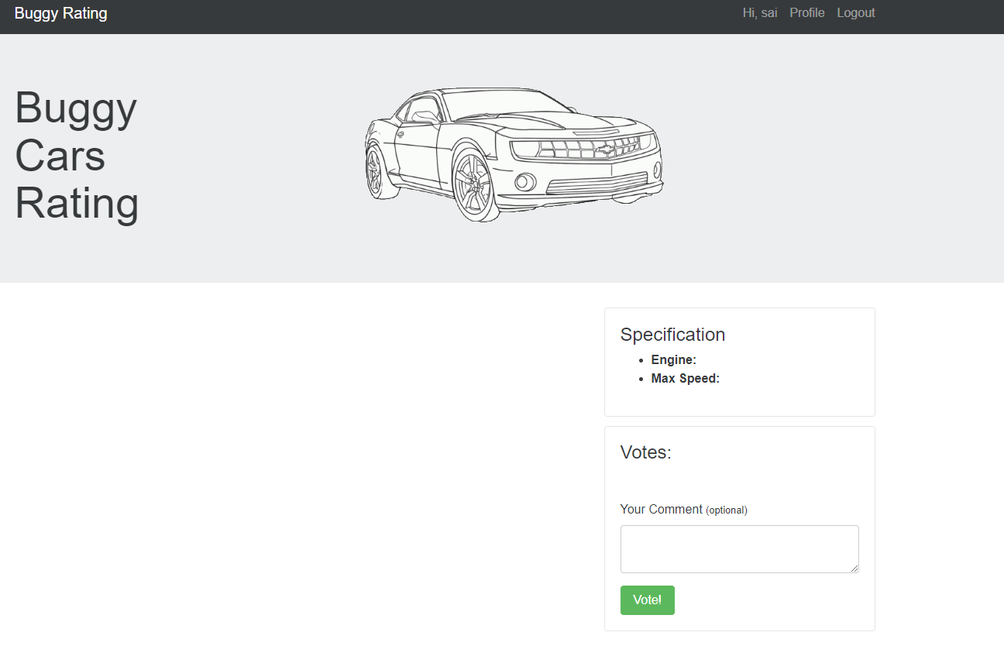

After clicking on the link – Buggy Rating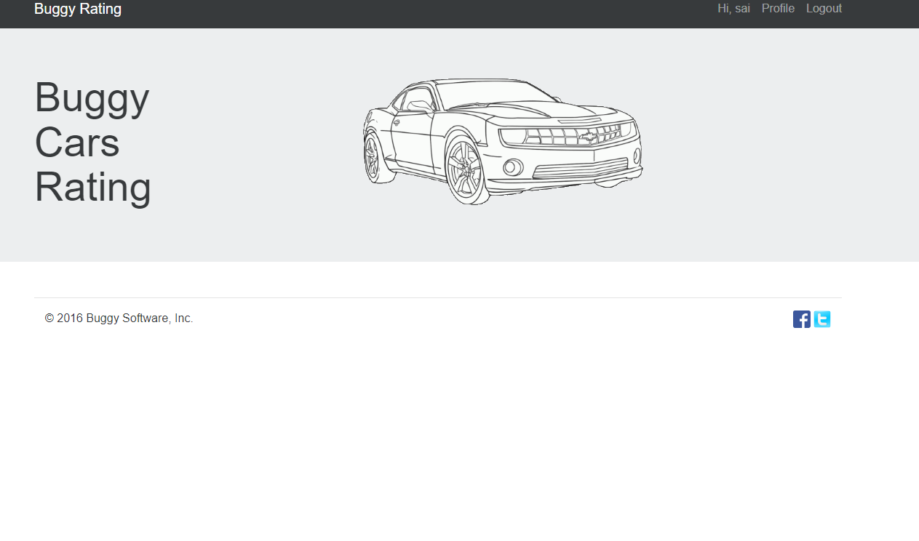

|  |  |
| --- | --- |
| **ID** | BCR-002 |
| **Title** | Cars ranking is incorrect when two cars have same number of votes |
| **Component/s:** | Overall Rating |
| **Environment:** | Test environment - https://buggy.justtestit.org/ |
| **Severity** | Critical |
| **Priority** | High |
| **Test Data** | * Bugatti Chiron model * Lamborghini HURACÁN model |
| **Steps to Recreate** | * Login to Buggy Cars Rating webpage * Click on Overall Rating image on the home page * Buggy Cars rating page opens * View cars ranking and votes count   Note: Bugatti Chiron has 226 votes and its ranking is 20  And Lancia Ypsilon has 226 votes and its ranking is 21 |
| **Expected Results** | * When voting for two cars is same, their ranking is same |
| **Actual Results** | When voting for two cars is same, their ranking is NOT same |

**Test Evidences:**

When both cars have same number of votes:

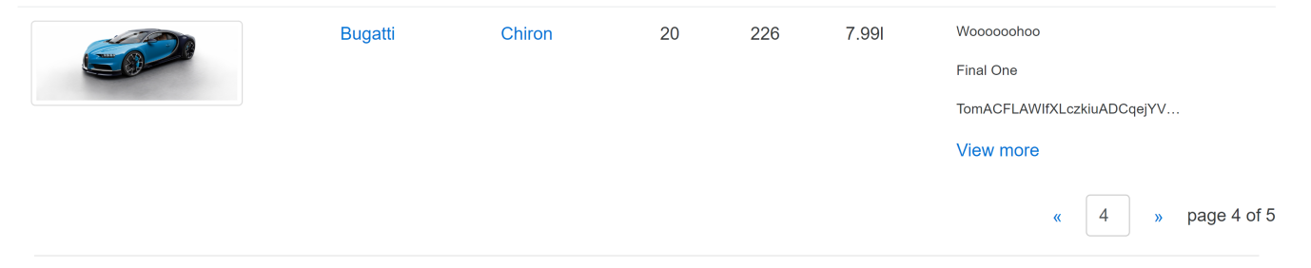

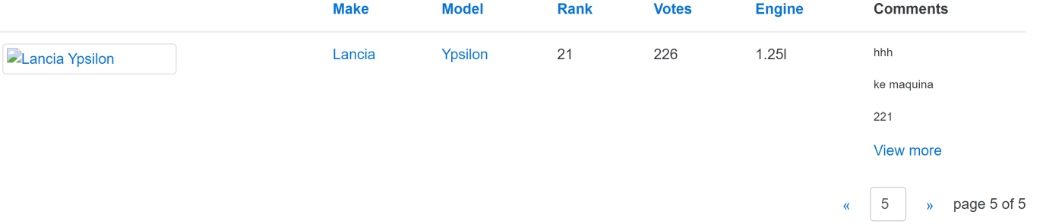

|  |  |
| --- | --- |
| **ID** | BCR-003 |
| **Title** | Buggy Rating link is broken from Popular Make page |
| **Component/s:** | Popular Make |
| **Environment:** | Test environment - https://buggy.justtestit.org/ |
| **Severity** | Critical |
| **Priority** | High |
| **Steps to Recreate** | * Login to Buggy Cars Rating webpage * Click on Popular Make image on the home page * Click “Buggy Rating” link to navigate to the home page |
| **Expected Results** | * Buggy Cars Rating home page is presented |
| **Actual Results** | * Home page is not presented |

**Test evidences:**

Buggy Cars Rating page after clicking on the link – Buggy Rating

