*NPFC Bottom Fisheries Small Working Group*

*2021-10-11*

# Splendid alfonsino (*Beryx splendens*)

**Common names:** Splendid alfonsino (English); 红眼金鲷 (Chinese); キンメダイ (Japanese); 빛금눈돔 (Korean); Низкотелый берикс (Russian)

## Biological Information

Global distribution ranges from tropical to temperate oceans. Historical catch records in the Emperor Seamount suggest the distribution from Nintoku (45 °N) to Hancock (30 °N). Settlement occurs following a certain period of the pelagic life stage. Adults show a vertical distribution from 200 to 800 m with diel vertical migration, feeding on crustaceans, cephalopods, and fish during the night. Limited information is available for recruitment and reproduction processes in the Emperor Seamounts, whereas the population in the Japanese coast shows 4–5 years to sexually mature and spawning occurs during summer (Shotton 2016).

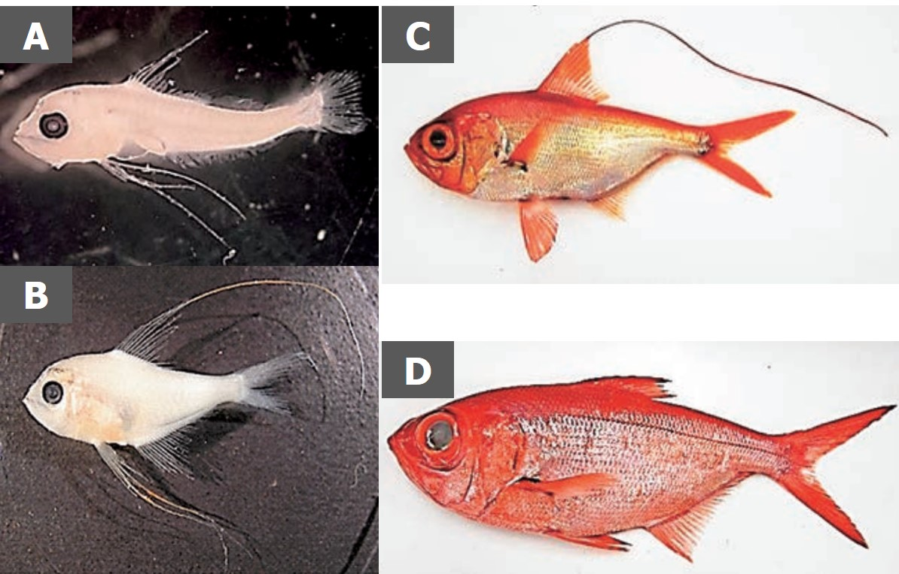

**Figure 1: Photographs of Beryx splendens on different developmental stages** A) postlarva, B) juvenile, C) young, D) adult (from Watari et al. 2017)

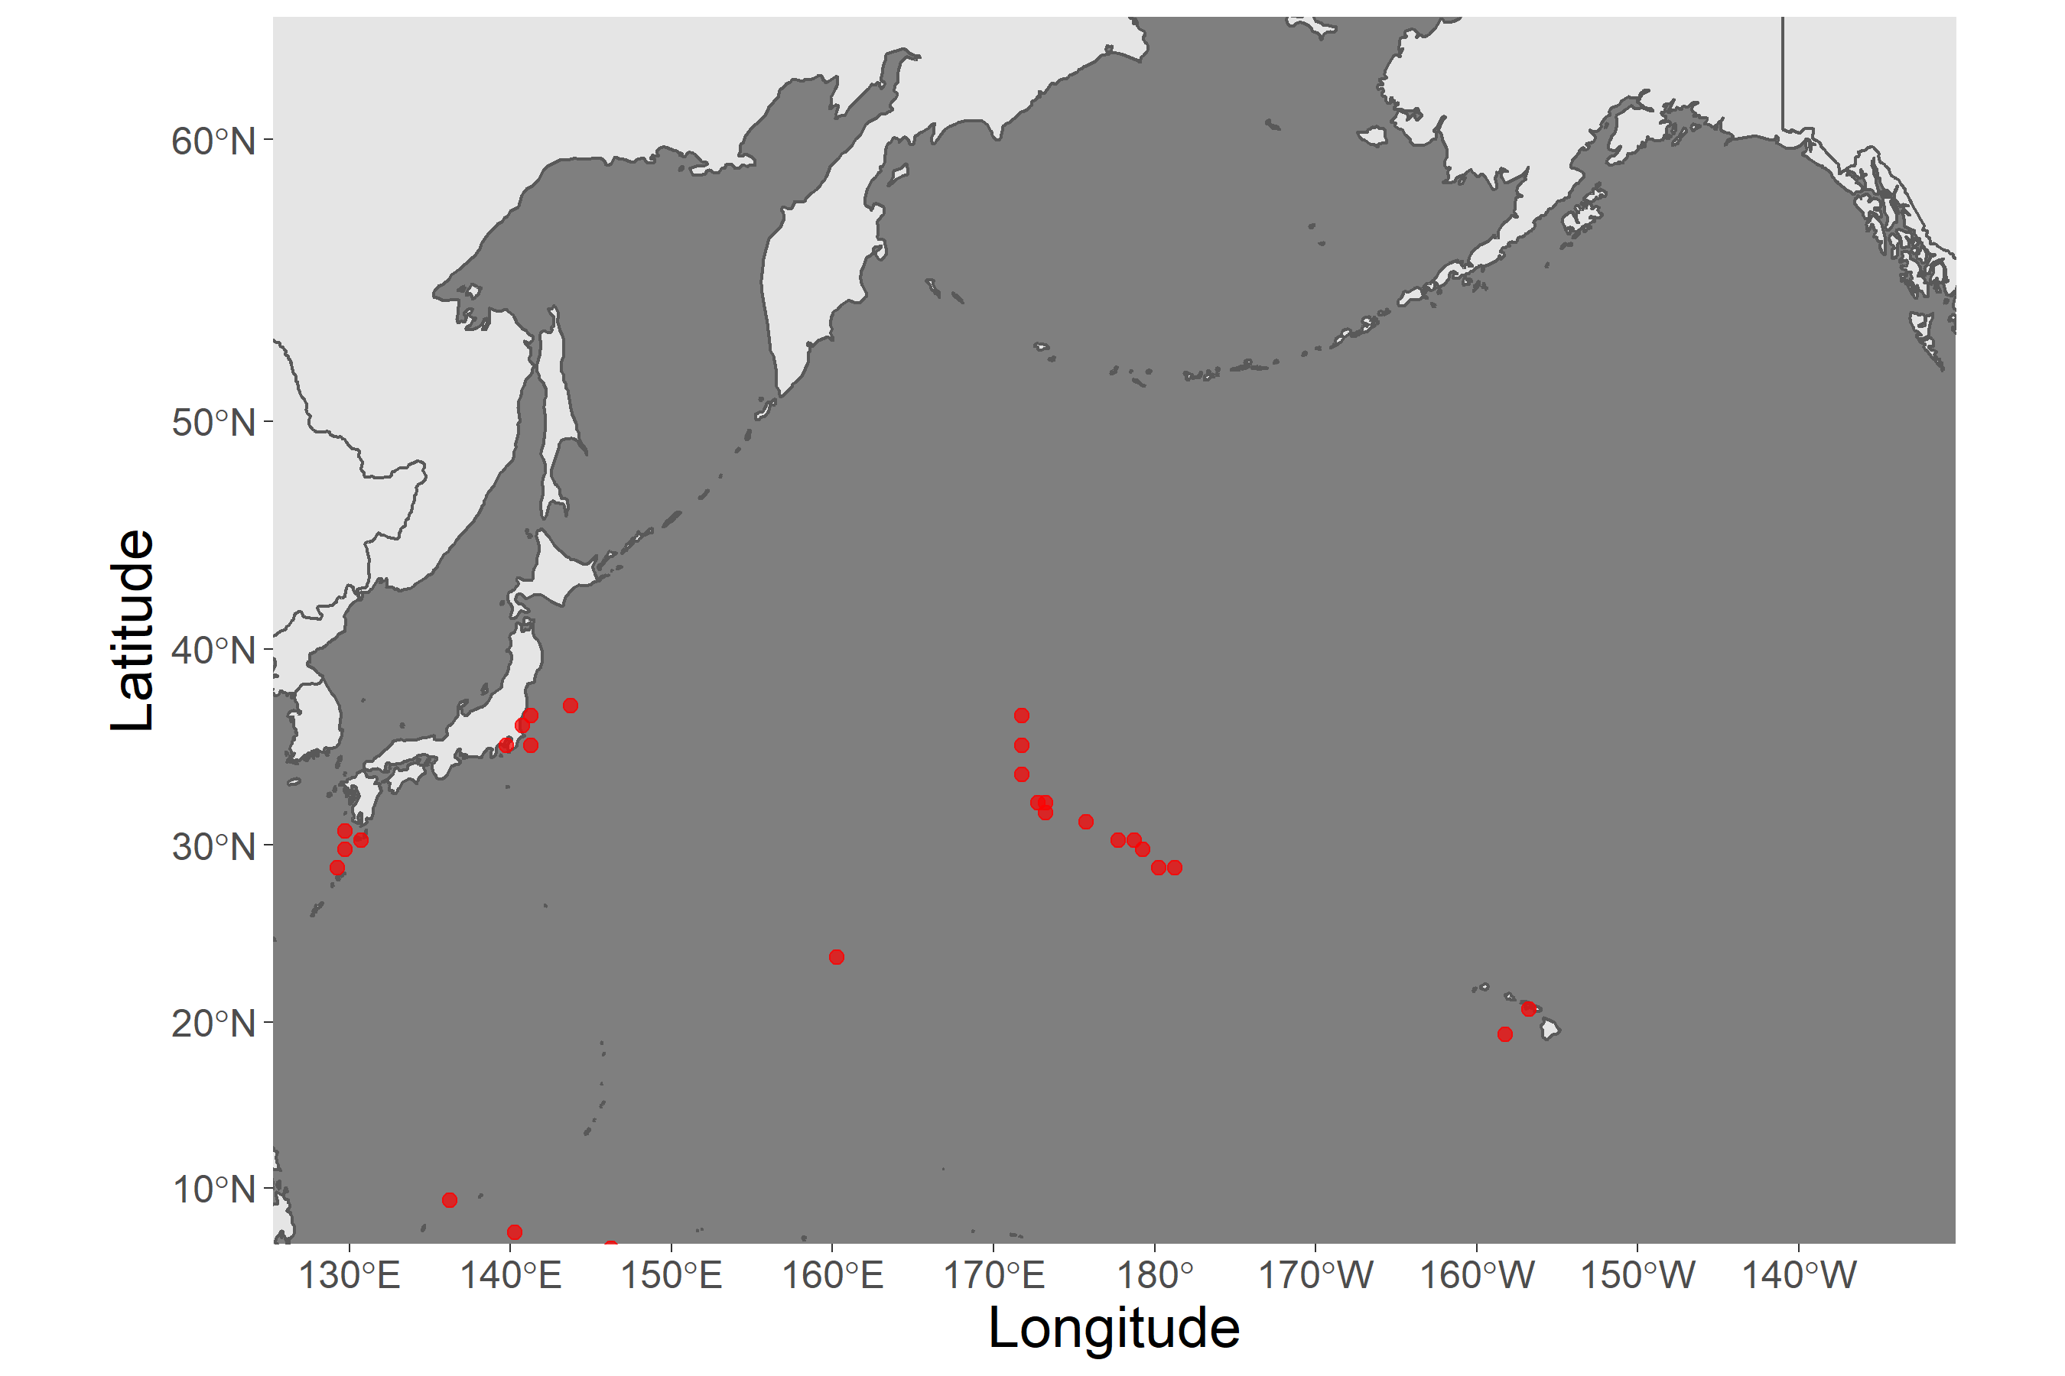

**Figure 2: Known distribution of Beryx splendens around NPFC waters.** Points indicate observation data from original sources (AquaMaps 2019, October)

## Fishery

Since the discovery of large populations of North Pacific armorhead in the Emperor Seamount in the late 1960s, Splendid alfonsino has been exploited as an alternative resource to the armorhead due to the large temporal fluctuation of the armorhead population. The main fishing methods are bottom trawls and gillnets.

Historical catch record (Figure 3) shows the highest catch proportion by Japan, followed by Korea and Russia. Russia terminated their fishery nearly a decade ago. Fishing pressure somewhat reflects the recruitment condition of North Pacific armorhead. In 2010 and 2012, when high recruitment of the armorhead occurred, the annual catch decreased below 1,000 tons, whereas it increased up to 4,000 tons ever since then.

Size composition analysis from the catch data by Japanese trawlers suggests the substantial decrease in size of fish in catches over the past decade, raising the concern about recruitment overfishing (Sawada et al. 2018).

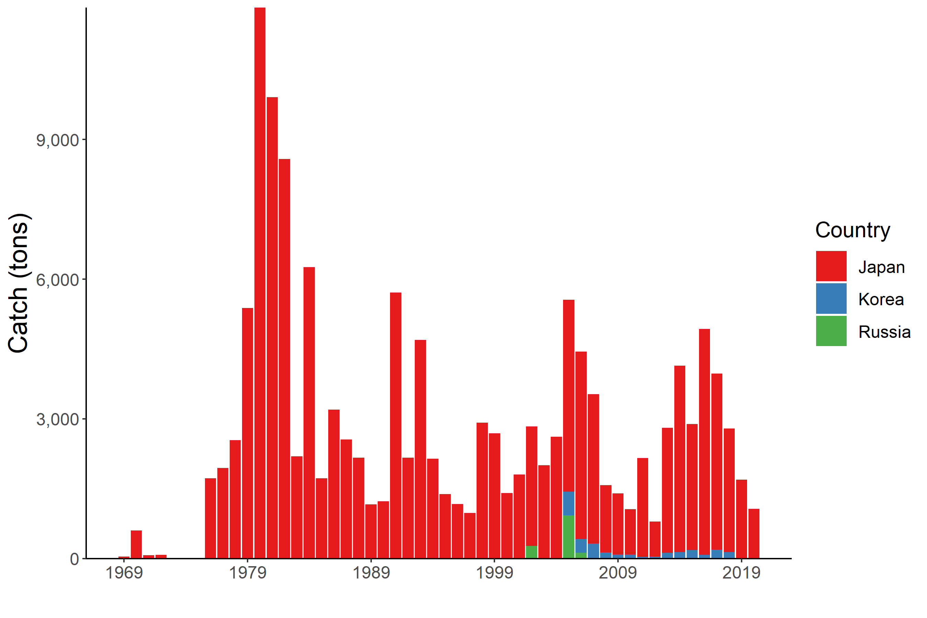

**Figure 3: Historical trends of Splendid alfonsino catches in NPFC waters.** The annual amounts of catch by each country are shown by the bar plot.

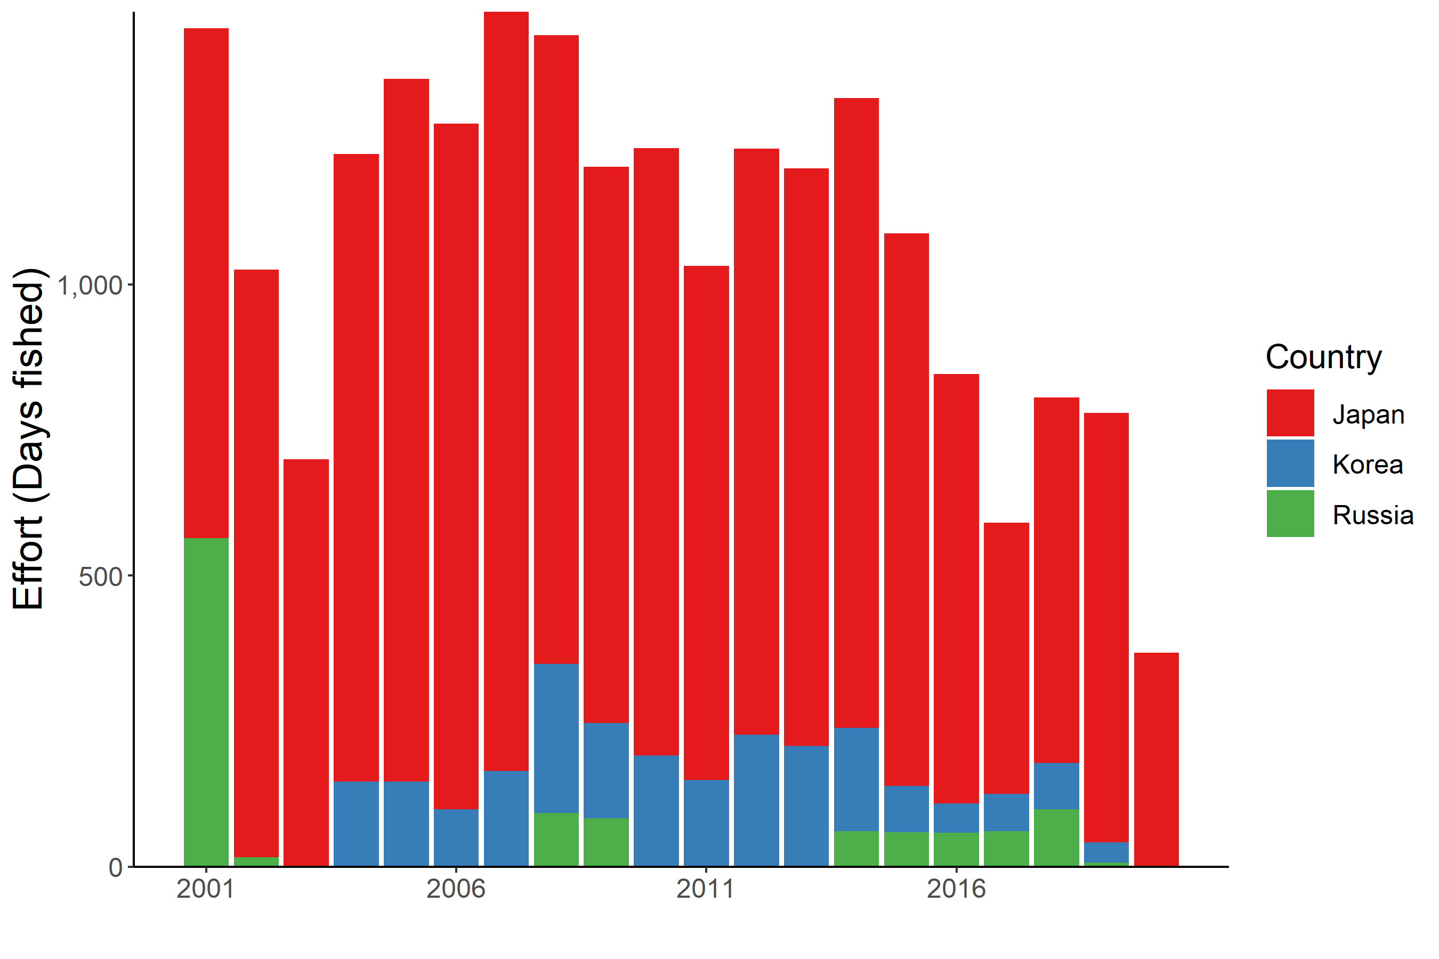

**Figure 4. Historical fishing efforts for Splendid alfonsino.** The annual fishing efforts by each country are shown by barplot. The efforts are calculated by the total fishing days operated during the year

## Assessment

There are no biomass estimates available for Splendid alfonsino in NPFC waters.

An age- or length-structured stock assessment may be feasible given the life history of this species. Surplus production models developed by Japan in 2008 showed that the average fishing mortality is 20–28 % higher than the MSY level (Nishimura and Yatsu 2008). This analysis, however, remains unreliable as the estimated CPUE is biased due to target shifts between North Pacific armorhead and Splendid alfonsino and the estimated intrinsic population growth rate parameter was too high for long-lived deep-sea fish.

Data limited approaches, such as YPR or SPR analysis that do not require detailed resource parameters or fishing data, should be explored in the future.

## Management

**Active Management Measures**

The following NPFC conservation and management measures pertain to this species:

* CMM 2021-05 For Bottom Fisheries and Protection of VMEs in the NW Pacific Ocean
* CMM 2019-06 For Bottom Fisheries and Protection of VMEs in the NE Pacific Ocean

Available from <https://www.npfc.int/active-conservation-and-management-measures>

Currently, there is no accepted harvest control rule for this species.

In 2016, the management measures were implemented, which includes limiting the fishing effort to the 2007’s level, prohibiting fisheries from November to December (which corresponds to the spawning season for North Pacific armorhead) and not allowing fisheries in C-H Seamount and the southeastern part of Koko Seamount (for the protection of VMEs)

In 2019, an additional measure was adopted, which includes the regulation of the mesh size (trawl: > 10 cm) to protect juvenile fish. Still, this measure may be insufficient as the substantial catch of young fish has been reported by trawlers even after being implemented.

## Data Summary

## References

Watari, S., Yonezawa, J., Takeuchi, H., Kato, M., Yamakawa, M., Hagiwara, Y., & Ochi, Y. (2017). Fisheries biology and resource management of Splendid alfonsino Beryx splendens. Bulletin of Japan Fisheries Research and Education Agency, 44, 1-46.

Kaschner, K., Kesner-Reyes, K., Garilao, C., Segschneider, J., Rius-Barile, J. Rees, T., & Froese, R. (2019, October). AquaMaps: Predicted range maps for aquatic species. Retrieved from <https://www.aquamaps.org>.

Shotton, R. (2016). Global review of alfonsino (Beryx spp.), their fisheries, biology and management. FAO Fisheries and Aquaculture Circular, (C1084), I.

Sawada, K., Nishida, K., Yonezaki, S. and Kiyota, M. (2018). Review of biology and fisheries of Splendid alfonsino Beryx splendens, especially in the Emperor seamounts area. NPFC-2018-SSC- BF01-WP03. 26 pp.

Nishimura, A., & Yatsu, A. (2008, October). Application of surplus-production models to splendid alfonsin stock in the Southern Emperor and Northern Hawaiian Ridge (SE-NHR). In Fifth Intergovernmental Meeting on Establishment of New Mechanism for Management of High Seas Bottom Trawl Fisheries in the North Western Pacific Ocean (NWPBT/SWG-05), Tokyo, 17-18 October 2008 (pp. 1-11).