

Database Management system
Assignment -3

SQL-Query Practice

Name : Rooopesh G
reg no : 732924CSR130
- Write an SQL query to display all student records from the Student table.
QUERY 3:

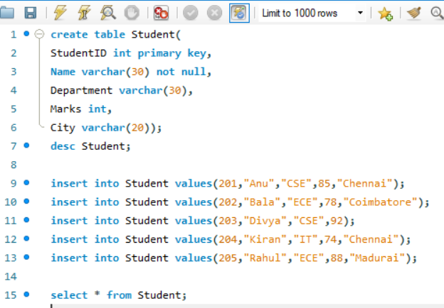

output:
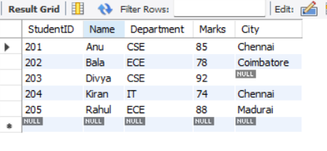

- Write a query to display the Name and Marks of all students.

QUERY 2 :

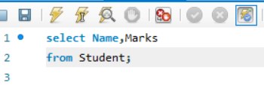

output:
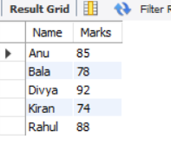

- Write a query to display students who scored more than 80 marks.
QUERY 3:
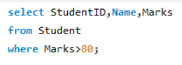

output:
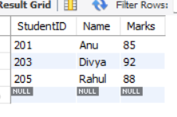

- Write a query to display students belonging to the CSE department.

QUERY 4:
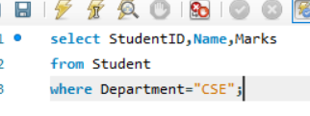

output:
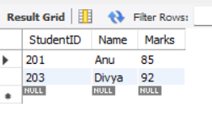

- Write a query to display students whose city is Chennai.

QUERY 5:

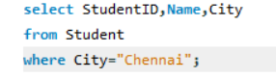

output:

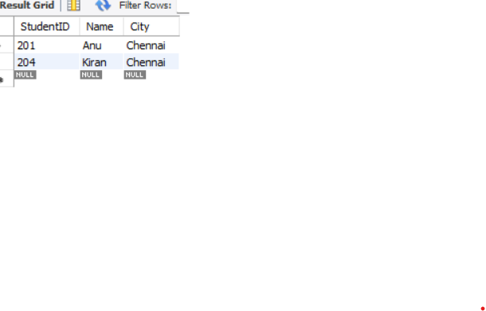

- Write a query to display students whose marks are between 70 and 90.

QUERY 6 :

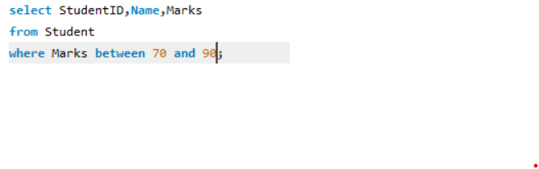

output:

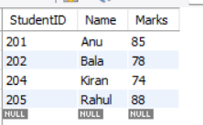

- Write a query to display student names that end with the letter ‘a’ using the LIKE operator.

QUERY 7:

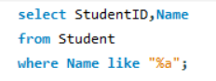

output:

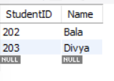

- Write a query to display distinct departments from the Student table.

QUERY 8 :

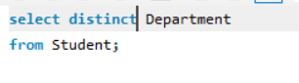

output:

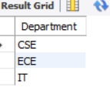

- Write a query to display students whose City value is NULL.
QUERY 9 :

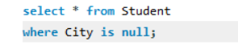
output:

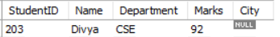

- Write a query to find the highest marks obtained by a student using an aggregate function.

QUERY 10 :
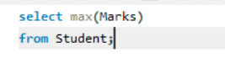
output:
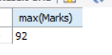

- Write a query to find the average marks of students in the ECE department.
QUERY 11 :

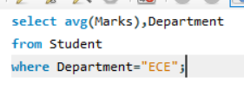
output:
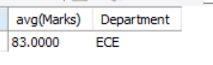

- Write a query to count the number of students in each department using GROUP BY.

QUERY 12:

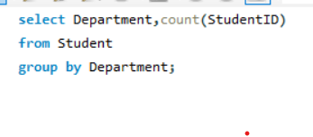

output:
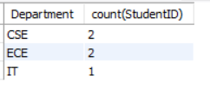

- Write a query to display students whose marks are greater than the average marks of all students (nested subquery).

QUERY 13 :

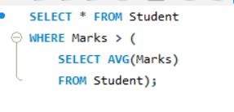
output:

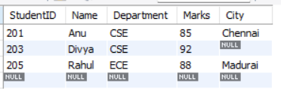
- Write an SQL statement to insert a new student record into the Student table.

QUERY 14:

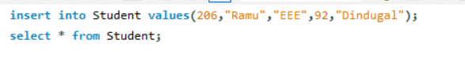
output:

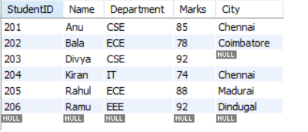

- Write an SQL query to delete the student with StudentID = 205.

QUERY 15 :
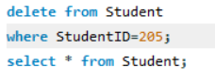
output:
