**PNC ADMIN**

The admin panel looks like this:

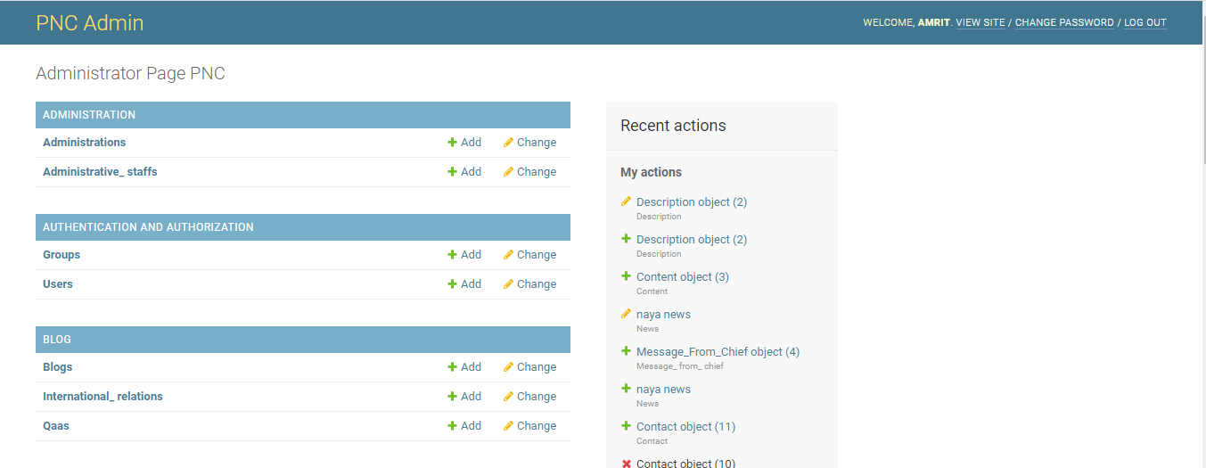

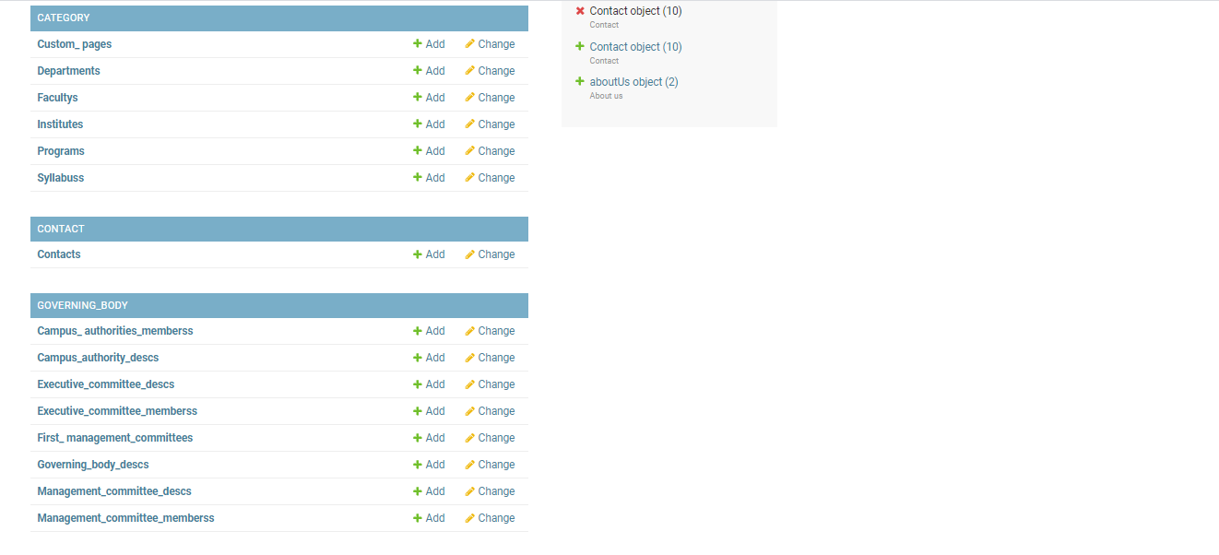

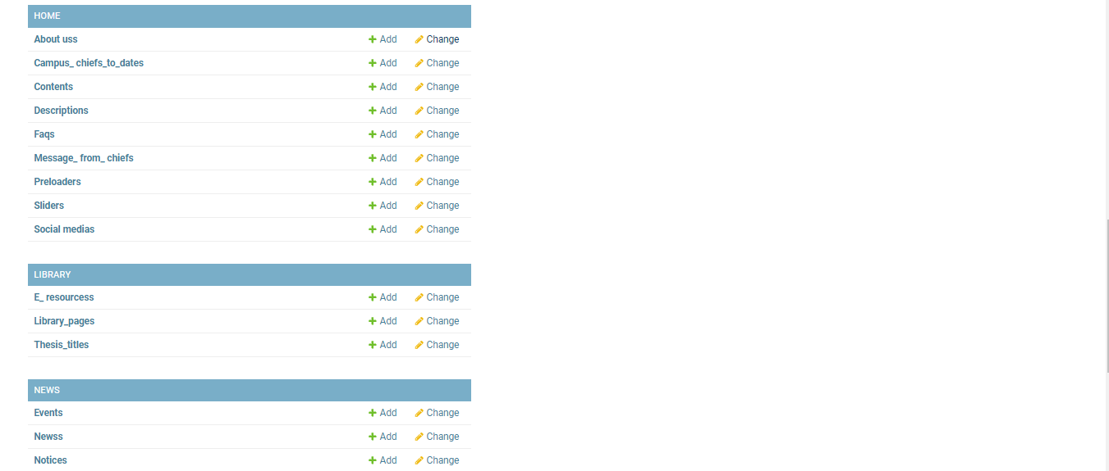

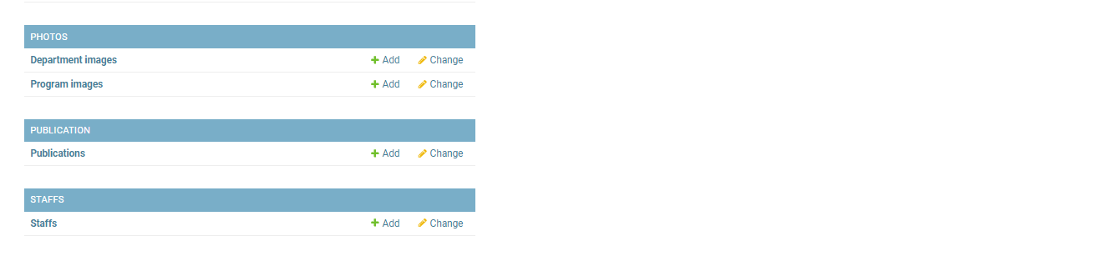

1. **CATEGORY**

In category there are following options:

* **Faculties**

Admin can add, change, and delete faculties here.

Admin should enter the following details:

Name, dean, dean image, header, content, feature image, and active or in-active

* **Institutes**

Admin can add, change, and delete institutes here.

* **Departments**

Admin can add, change, and delete departments here.

* **Programs**

Admin can add, change, and delete programs here.

* **Syllabus**

Admin can add subjects to their respective department or program and later on can change or delete it.

* **Custom pages**

Admin can add, change and delete custom pages here.

1. **Home**

In home there are following options:

* **About uss**

Admin can update the content, image and page images of about us page from here.

* **Campus_chiefs_to_dates**

Admin can add/change the chief name and his/her duration from here.

* **Contents**

Admin can add/change/delete content of the campus. Admin can add email, phone address, contact, logo image, header text from here.

* **Descriptions**

Admin can add/change/delete the description here. Admin can add header and content from here.

* **Faqs**

Admin can add/change/delete faqs here. Admin can add question and respective answer from here.

* **Message_from_chiefs**

Admin can add/change/delete message from chief here. Admin can add chief name, message and image from here.

* **Preloaders**

Admin can add/change/delete the preloader here. Admin can add title and image of preloader here.

* **Sliders**

Admin can add/change/delete slider from here. Admin can add head, content and photo of slider.

* **Social medias**

Admin can add social media link here.

1. **News**

In news there are following options:

* **events**

Admin can add/change/delete the event here. Admin has option to add title, content, date/time, feature image, file and event image.

* **Newss**

Admin can add/change/delete news here. Admin has the option to add title, content, date/time, department /program, feature image, file and news images.

* **Notices**

Admin can add/change/delete notice here. Admin has the option to add title, content, date/time, department /program, feature image, file and news images.

1. **Administration**

In administration there are following options:

* **Administrations**

Admin can add/change/delete administrations here. Admin can add title, content and page images.

* **Administrative_staffs**

Admin can add/change/delete administrative staffs here. Admin can add name, post, administrative offices, email and profile.

* **Governing_Body**

In governing body admin can add/cnange/delete the followings:

* Campus_authorities_members
* Campus_autthority_descs
* Campus_committe_members
* First_management_committes
* Governing_body_descs
* Management_comitee_descs
* Management_committe_members
* **Administrative staffs**

Admin can add/change/delete administrative staffs here. Admin can add name, post, administrative offices and profile.

* **Publication**

There is publications option in publication where admin can add/change/delete the publication here. Admin can add title, content, date/time, department/program, feature image, file, and publication images.

* **Staffs**

There is staffs option in staffs where admin can add/change/delete the staffs. Admin can add name, address, email, phone, department, program, role, admin role, image, bio data and is active.

* **Alumnis**

Admin can add/change/delete alumni here. Admin can add title, content, is active, and alumni images.

1. **Photos**

In photos there are following options:

* **Department images**

Admin can add/change/delete department images here.

* **Program images**

Admin can add/change/delete program images here.

1. **Contact**

In contact there is contacts option where admin can add/change/delete the contacts.

1. **Blog**

In blog there are following options:

* **Blogs**

Admin can add/change/delete blogs here.

* **International_relations**

Admin can add/change/delete the campus international relation from here.

* **qaas**

Admin can add/change/delete qaa from here

1. **library**

In library there are following options:

* **e-resources**

Admin can add/change/delete e-resources here. Admin can add title and link.

* **Library_pages**

Admin can add/change/delete library pages here. Admin can add content, contact info, page and page images.

* **Thesis_title**

Admin can add/change/delete thesis from here. Admin can add thesis title and file.