EXP.NO: 10 | FIFO & LRU Page Replacement
DATE: 17/04/2026

AIM:

To implement and compare CPU page replacement algorithms (FIFO and LRU) to determine their efficiency by calculating the total number of Page Faults and Page Hits for a given sequence of memory requests.

ALGORITHM:
- Input: Accept the total number of page requests, the sequence of pages (reference string), and the number of available memory frames.
- Memory Initialization: Initialize the memory frames to an empty state (e.g., -1).
- Traverse Reference String: For each page requested:
- * Search: Check if the page is already present in the frames.
- * Hit: If found, increment the Page Hit count. (In LRU, also update the "last used" time for that page).
- * Fault: If not found, increment the Page Fault count and replace a page:
- * FIFO: Replace the page at the current pointer position and move the pointer forward (circularly).
- * LRU: Replace the page that has the oldest timestamp (the one not used for the longest time).
- Output: Display the final counts for Page Faults and Page Hits.
CODE:

FIFO

#include <stdio.h>
int main() {
int n,f,pf=0,ph=0,ptr=0;
scanf("%d",&n);
int p[n]; for(int i=0;i<n;i++) scanf("%d",&p[i]);
scanf("%d",&f);
int fr[f]; for(int i=0;i<f;i++) fr[i]=-1;

for(int i=0;i<n;i++){
int found=0;
for(int j=0;j<f;j++)
if(fr[j]==p[i]) { found=1; ph++; break; }

if(!found){
fr[ptr]=p[i];
ptr=(ptr+1)%f;
pf++;
}
}
printf("Page Faults: %d\nPage Hits: %d",pf,ph);
}

LRU

#include <stdio.h>
int main() {
int n,f,pf=0,ph=0,t=0,c=0;
scanf("%d",&n);
int p[n]; for(int i=0;i<n;i++) scanf("%d",&p[i]);
scanf("%d",&f);

int fr[f],lu[f];
for(int i=0;i<f;i++) fr[i]=lu[i]=-1;

for(int i=0;i<n;i++){
int idx=-1;
for(int j=0;j<f;j++)
if(fr[j]==p[i]) { idx=j; break; }

if(idx!=-1){
ph++; lu[idx]=t++;
} else {
pf++;
if(c<f){
fr[c]=p[i]; lu[c++]=t++;
} else {
int lru=0;
for(int j=1;j<f;j++)
if(lu[j]<lu[lru]) lru=j;
fr[lru]=p[i]; lu[lru]=t++;
}
}
}
printf("Page Faults: %d\nPage Hits: %d",pf,ph);
}

OUTPUT:

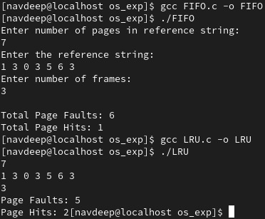

RESULT:
The program successfully simulates process synchronization. The producer is restricted from adding items when the buffer is full (e=0), and the consumer is restricted from removing items when the buffer is empty (f=0), maintaining data integrity within the shared resource.

