EXP.NO: 4 | System Calls
DATE: 03/02/2026

AIM:

To study and implement basic UNIX system calls such as process creation, execution, process identification, and directory handling using C programs.

ALGORITHM:
- Start the program and include necessary headers (stdio.h, unistd.h, dirent.h).
- Identify Process: Use getpid() and getppid() to fetch ID numbers from the Kernel.
- Process Creation: Invoke fork(). Branch execution based on return value (0 for child, positive for parent).
- Process Replacement: Use exec() family functions to replace current process image with a new executable.
- Directory Access: Initialize a DIR pointer with opendir().
- Read Entries: Use a while loop with readdir() to iterate through file entries until NULL is reached.
- Cleanup & Stop: Close directory streams and terminate the program.

CODE:

Process Execution:

#include <stdio.h>
#include <unistd.h>

int main() {
printf("Before exec()\n");
execl("/bin/ls", "ls", NULL);
printf("After exec()\n"); // This line will not execute on success
return 0;
}

Process Creation:

#include <stdio.h>
#include <unistd.h>

int main() {
if (fork() == 0) {
printf("This is CHILD process\n");
} else {
printf("This is PARENT process\n");
}
printf("PID: %d\n", getpid());
return 0;
}

Process Identification:

#include <stdio.h>
#include <unistd.h>

int main() {
printf("PID: %d\n", getpid());
printf("PPID: %d\n", getppid());
return 0;
}

Directory Handling:

#include <stdio.h>
#include <dirent.h>

int main() {
DIR *dir;
struct dirent *entry;
dir = opendir(".");
if (dir == NULL) {
printf("Cannot open directory\n");
return 1;
}
printf("Files in directory:\n");
while ((entry = readdir(dir)) != NULL) {
printf("%s\n", entry->d_name);
}
closedir(dir);
return 0;
}

OUTPUT:

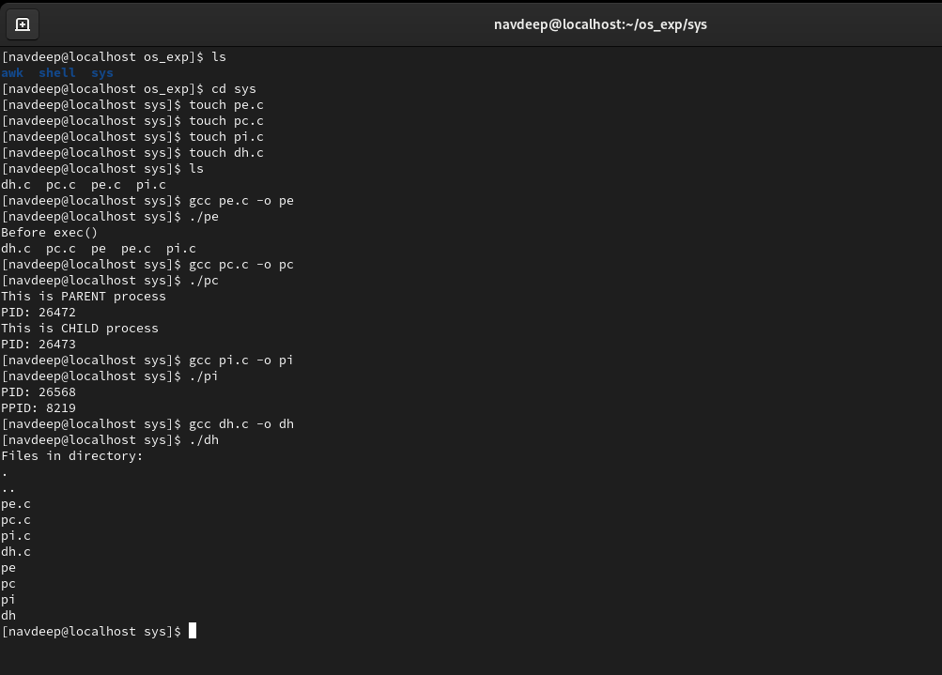

RESULT:
Thus, the basic UNIX system calls such as fork(), exec(), getpid(), and directory handling functions like opendir() and readdir() were successfully implemented and executed using C programs.

