EXP.NO: 5 | FCFS, SJF, Priority & Round Robin Scheduling
DATE: 13/02/2026

AIM:

To implement different CPO scheduling calgorithm (FCFS, SJF, Priority cand Round Robin) cand evaluate their performance by calculating Average Jurnaround Time and Average Maiting time.

ALGORITHM:
1. nitialization: Create a structure/class for Processes containing PID, AT, BT, and Priority.
2. Time Tracking: Maintain a global currentTime variable.
3. The Selection Loop: While processes remain:
4. Identify all processes that have arrived (AT ≤ currentTime).
5. Apply the specific Selection Criteria (e.g., Min BT, Max Priority).
6. Update the CPU clock and mark completion.
7. Calculation: Compute averages for TAT and WT across all processes.

CODE:

FCFS

#include <stdio.h>
int main() {
int n, ct = 0;
float tat = 0, wt = 0;
printf("Enter number of processes:\n");
scanf("%d", &n);

for (int i = 0, at, bt; i < n; i++) {
printf("Enter AT and BT for P%d:\n", i + 1);
scanf("%d %d", &at, &bt);

if (ct < at) ct = at;
ct += bt;

tat += (ct - at);
wt += (ct - at - bt);
}

printf("\nAvg TAT = %.2f\nAvg WT = %.2f\n", tat/n, wt/n);
return 0;
}

SJF

#include <stdio.h>

int main() {
int n, ct[20], tat[20], wt[20], at[20], bt[20], done[20] = {0};
printf("Enter number of processes:\n");
scanf("%d", &n);

for (int i = 0; i < n; i++) {
printf("Enter AT and BT for P%d:\n", i + 1);
scanf("%d %d", &at[i], &bt[i]);
}

int time = 0, completed = 0;

while (completed < n) {
int idx = -1;
for (int i = 0; i < n; i++) {
if (!done[i] && at[i] <= time &&
(idx == -1 || bt[i] < bt[idx]))
idx = i;
}

if (idx == -1) { time++; continue; }

time += bt[idx];
ct[idx] = time;
tat[idx] = ct[idx] - at[idx];
wt[idx] = tat[idx] - bt[idx];

done[idx] = 1;
completed++;
}

float avg_tat = 0, avg_wt = 0;
for (int i = 0; i < n; i++) {
avg_tat += tat[i];
avg_wt += wt[i];
}

printf("\nAvg TAT = %.2f\nAvg WT = %.2f\n", avg_tat / n, avg_wt / n);
return 0;
}

PS

#include <stdio.h>

int main() {
int n, t = 0, c = 0, idx;
float tw = 0, tt = 0;

scanf("%d", &n);
int at[n], bt[n], pr[n], d[n];

for (int i = 0; i < n; i++) {
scanf("%d%d%d", &at[i], &bt[i], &pr[i]);
d[i] = 0;
}

while (c < n) {
int best = 9999;
idx = -1;

for (int i = 0; i < n; i++)
if (!d[i] && at[i] <= t && pr[i] < best)
best = pr[i], idx = i;

if (idx == -1) { t++; continue; }

tw += t - at[idx];
t += bt[idx];
tt += t - at[idx];

d[idx] = 1;
c++;
}

printf("Avg TAT = %.2f\nAvg WT = %.2f", tt/n, tw/n);
}

RR

#include <stdio.h>
int main() {
int n, tq, time = 0, done = 0;
scanf("%d %d", &n, &tq);

int at[n], bt[n], rem[n], ct[n];
for (int i = 0; i < n; i++) {
scanf("%d %d", &at[i], &bt[i]);
rem[i] = bt[i];
}

while (done < n) {
int flag = 0;
for (int i = 0; i < n; i++) {
if (rem[i] > 0 && at[i] <= time) {
flag = 1;
if (rem[i] <= tq) {
time += rem[i];
ct[i] = time;
rem[i] = 0;
done++;
} else {
time += tq;
rem[i] -= tq;
}
}
}
if (!flag) time++;
}

float tat = 0, wt = 0;
for (int i = 0; i < n; i++) {
tat += ct[i] - at[i];
wt += ct[i] - at[i] - bt[i];
}

printf("Avg TAT=%.2f\nAvg WT=%.2f", tat/n, wt/n);
}

OUTPUT:

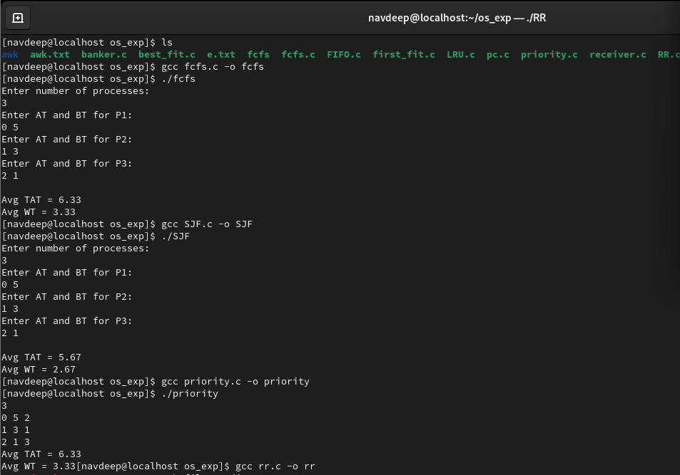

RESULT:
The implementation confirms that SJF is the mathematically "optimal" algorithm for minimizing wait times. However, in modern operating systems, Round Robin or a Multilevel Feedback Queue is preferred because they prevent "starvation" (where a long process never gets to run) and provide better responsiveness for the user.

