EXP.NO: 7 | Producer-Consumer (Semaphores)
DATE: 06/03/2026

AIM:

To implement the Producer-Consumer problem using semaphores, ensuring mutual exclusion and preventing buffer overflow (Full) or underflow (Empty) during process execution.

ALGORITHM:
• Initialize Controls: Start with a lock (m=1), 5 empty slots (e=5), and 0 full slots (f=0).
• Producer Step:
Check if space is available.
Lock the system, fill one empty slot, increase the full count, and then unlock.
• Consumer Step:
Check if items exist.
Lock the system, remove one full item, increase the empty slot count, and then unlock.
• Safety Check:
If e=0, production is blocked (Full).
If f=0, consumption is blocked (Empty).
• Repeat: Keep the process running in a loop until the user exits.
CODE:

#include <stdio.h>
#include <stdlib.h>

int m=1,f=0,e=5,x=0;

int wait(int s){ return --s; }
int signal(int s){ return ++s; }

void p(){
m=wait(m); e=wait(e); f=signal(f);
printf("\nProduced %d", ++x);
m=signal(m);
}

void c(){
m=wait(m); f=wait(f); e=signal(e);
printf("\nConsumed %d", x--);
m=signal(m);
}

int main(){
int ch;
while(1){
printf("\n1.P 2.C 3.E: ");
scanf("%d",&ch);
if(ch==1){
if(m==1 && e!=0) p();
else printf("\nFull");
}
else if(ch==2){
if(m==1 && f!=0) c();
else printf("\nEmpty");
}
else exit(0);
}
}

OUTPUT:

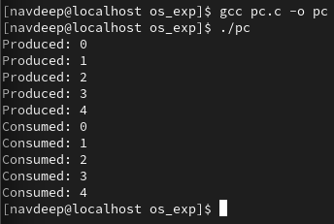

RESULT:
The program successfully simulates process synchronization. The producer is restricted from adding items when the buffer is full (e=0), and the consumer is restricted from removing items when the buffer is empty (f=0), maintaining data integrity within the shared resource.

