EXP.NO: 8 | Banker’s Algorithm
DATE: 13/03/2026

AIM:

To implement the Banker’s Algorithm for deadlock avoidance in C. The program aims

to determine if a system is in a safe state after resource allocation and to find a safe

sequence of process execution if one exists.

ALGORITHM:
1. Preparation: Calculate the Need for each process (Max - Allocation) and set all processes to "Not Finished."
2. Selection: Look for a process that is "Not Finished" and whose Need is less than or equal to the currently Available resources.
3. Release: If you find one, "pretend" it finishes. Add its current Allocation back into the Available pool and mark it "Finished."
4. Conclusion:
If all processes finish, the system is Safe.
If you get stuck and some are "Not Finished," the system is Unsafe.

CODE:

#include <stdio.h>

int main() {
int n, r;
scanf("%d %d", &n, &r);

int alloc[n][r], max[n][r], need[n][r], avail[r], finish[n], seq[n];

for (int i = 0; i < n; i++)
for (int j = 0; j < r; j++)
scanf("%d", &alloc[i][j]);

for (int i = 0; i < n; i++)
for (int j = 0; j < r; j++) {
scanf("%d", &max[i][j]);
need[i][j] = max[i][j] - alloc[i][j];
}

for (int j = 0; j < r; j++) scanf("%d", &avail[j]);

for (int i = 0; i < n; i++) finish[i] = 0;

int count = 0;
while (count < n) {
int found = 0;
for (int i = 0; i < n; i++) {
if (!finish[i]) {
int ok = 1;
for (int j = 0; j < r; j++)
if (need[i][j] > avail[j]) ok = 0;

if (ok) {
for (int j = 0; j < r; j++)
avail[j] += alloc[i][j];
seq[count++] = i;
finish[i] = 1;
found = 1;
}
}
}
if (!found) break;
}

if (count == n) {
printf("Safe\n");
for (int i = 0; i < n; i++) printf("P%d ", seq[i]);
} else {
printf("Not Safe");
}

return 0;
}

OUTPUT:

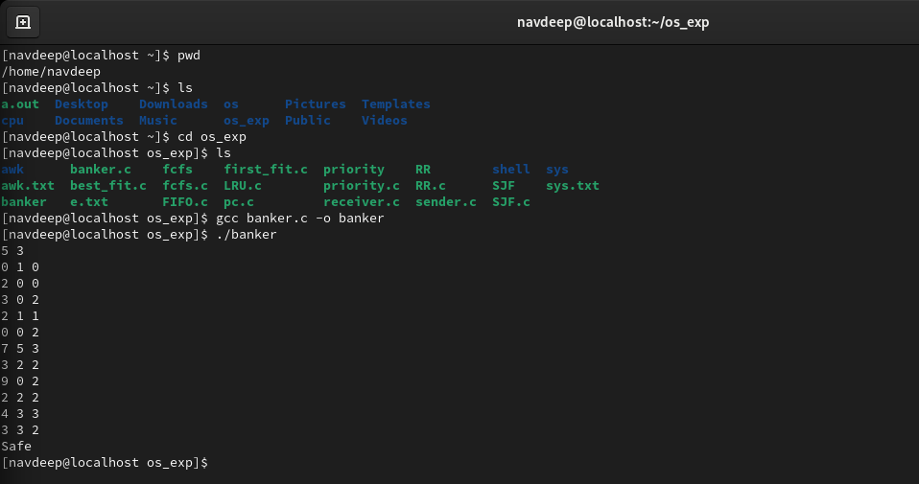

RESULT:
The program successfully takes inputs for n processes and r resources. It computes the Need matrix and simulates the Banker's safety check.

