EXP.NO: 9 | First Fit & Best Fit Memory Allocation
DATE: 20/03/2026

AIM:

To implement and compare the First Fit and Best Fit memory management schemes to understand how different strategies affect block utilization and fragmentation.

ALGORITHM:
Initialize: Define the number of memory blocks and their initial sizes. Define the number of processes and their requested memory sizes.
First Fit Logic:
Iterate through each process.
Traverse the memory blocks from the beginning.
Allocate the process to the very first block that satisfies the size requirement.
Update the block size by subtracting the process size to reflect internal fragmentation.
Best Fit Logic:
Iterate through each process.
Search all memory blocks to find the one that is large enough but results in the smallest leftover fragment.
Allocate the process to that specific block and update its remaining size.
Output: For both methods, print the process-to-block mapping and the resulting fragmentation, or a failure message if no block fits.
CODE:

FF

#include <stdio.h>
int main() {
int m,n;
scanf("%d",&m);
int b[m],p;
for(int i=0;i<m;i++) scanf("%d",&b[i]);

scanf("%d",&n);
for(int i=0;i<n;i++) {
scanf("%d",&p);
int f=0;
for(int j=0;j<m;j++) {
if(b[j]>=p) {
printf("P%d->B%d Frag=%d\n",i+1,j+1,b[j]-p);
b[j]-=p; f=1; break;
}
}
if(!f) printf("P%d not allocated\n",i+1);
}
}

BF

#include <stdio.h>
int main() {
int m,n;
scanf("%d",&m);
int b[m],p;
for(int i=0;i<m;i++) scanf("%d",&b[i]);

scanf("%d",&n);
for(int i=0;i<n;i++) {
scanf("%d",&p);
int bi=-1;
for(int j=0;j<m;j++)
if(b[j]>=p && (bi==-1 || b[j]<b[bi])) bi=j;

if(bi!=-1) {
printf("P%d->B%d Frag=%d\n",i+1,bi+1,b[bi]-p);
b[bi]-=p;
} else printf("P%d not allocated\n",i+1);
}
}

OUTPUT:

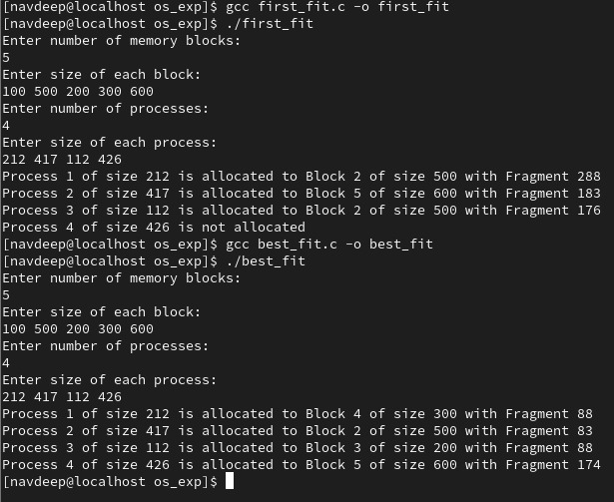

RESULT:
The program successfully simulates process synchronization. The producer is restricted from adding items when the buffer is full (e=0), and the consumer is restricted from removing items when the buffer is empty (f=0), maintaining data integrity within the shared resource.

