EXP.NO: 1 | Basic Unix/Linux commands
DATE: 06/01/2026

AIM:
To understand the fundamentals of the Unix/Linux operating system by practicing essential commands for file management, directory operations, permissions, and process handling.

ALGORITHM:
- Start the experiment.
- Open the Linux terminal.
- Display the current working directory using pwd.
- List files and directories using ls.
- Create a new directory using mkdir.
- Change directory using cd.
- Create a file using touch.
- Display file content using cat.
- Copy files using cp.
- Rename/move files using mv.
- Delete files using rm.
- Display hidden files using ls -a.
- Clear the screen using clear.
- Stop the experiment.

CODE:
# Display current directory pwd

# List files ls
ls -l ls -a

# Create directory mkdir MyProject

# Move into directory

cd MyProject

# Create file touch file1.txt

# Add content
echo "Hello Linux" > file1.txt

# View content cat file1.txt

# Copy file
cp file1.txt file2.txt

# Rename file
mv file2.txt newfile.txt

# Delete file rm newfile.txt

# Go back cd ..

# Remove directory rm -r MyProject

# Clear screen clear

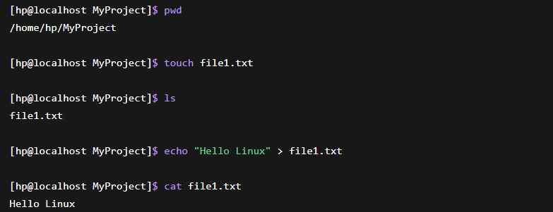
OUTPUT:

RESULT:
Thus, the basic Unix/Linux commands for directory navigation, file creation, viewing, copying, renaming, and deletion were successfully executed on the Oracle Linux system using the terminal.

