Computer Networks CSE5344

Project 1

Simple Web Server & Client

**Name**: Roopesh Kumar Krishna Kumar

**UT ID**: 1001231753

**Abstract:**

This is a simple implementation of the Server and Client model in python. Client connects to the server to request files just as any normal browser that exists. Server listen to the incoming connections and serve the clients by providing request file. If the file doesn’t exist, server sends out file not found exception to the client. Both server and client implement logging mechanism to log few information which are useful for debugging and knowledge purpose.

**Implementation of the Server:**

Implemented server is a multi-threaded server which uses a single port for listening and multiple ports to serve the client. Exception handling is implemented to ensure that the client is served better avoiding any deadlock or unexpected termination. Server has the queue length of 5 where it can queue up to 5 clients if all the ports or threads are busy serving other clients.

Server logs few information to the log file which are useful for debugging. Some of them are Client’s address, port, header and timestamp of the request.

Server gets the request from the client. Server checks for the file which the client had requested in its directory. If the requested file is present in its folder, it fetch the file and sends to the client as response to the clients request. In case the file is not presented in the server directory, it sends out a “404 File not Found” exception to the client.

As the server is multi-threaded, it can serve multi clients at a time (50 clients at time). As soon as the server receives the connection from the client, a thread is created and the client is assigned to the client. Thread serves the client with its request whereas the server continue listening to the port for other incoming requests from the other clients.

High level design of the server:

START

Listen to the port

Get request from client

Assign new thread

Requested file found?

Send file

Send file not found

STOP

Few code snippets of the server:

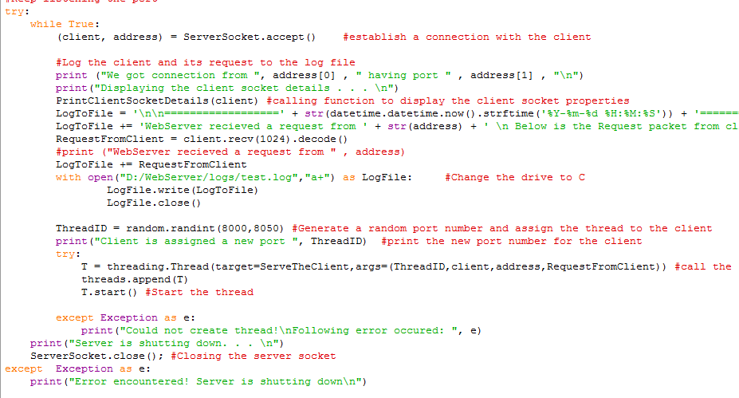

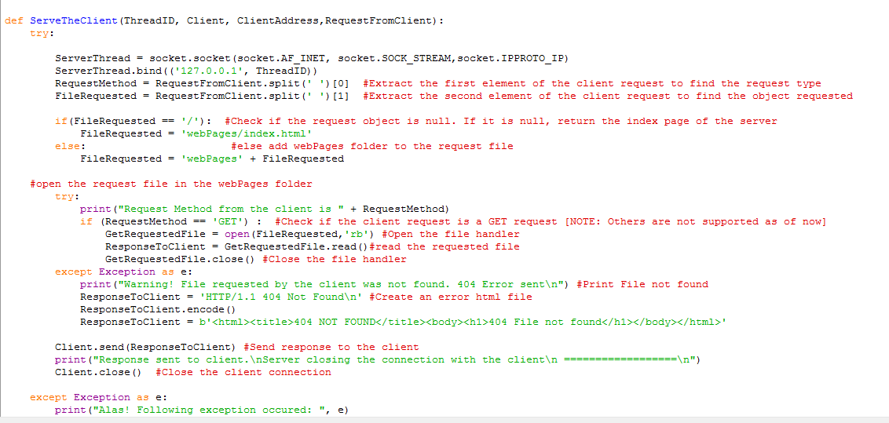

Snapshot of the server:

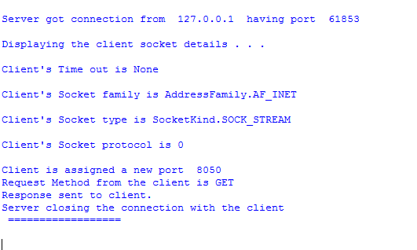

**Implementation of the Client:**

Implemented client is a single threaded client. It makes a connection to the server where the server address and port are provided by the user. Client takes the request from the user and creates the HTTP header and sends it to the server. Server process the client’s request and send the response to the client. Client displays all the server details and response sent from the server.

Code snippet of the client:

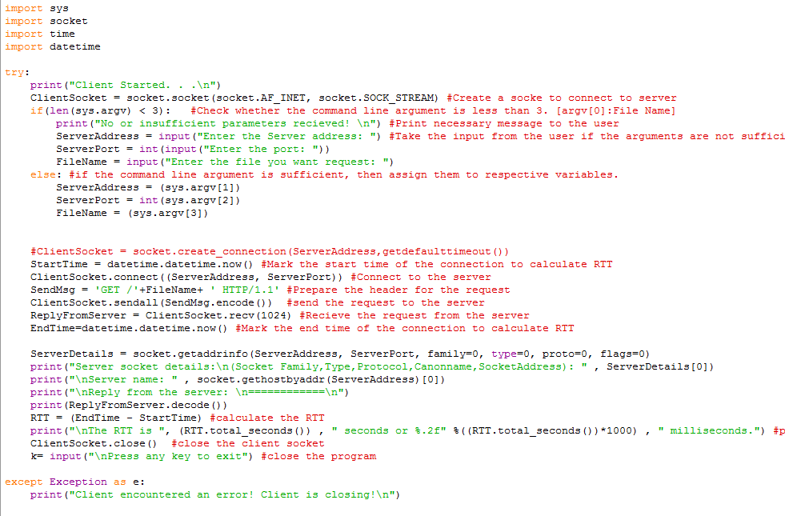

Snapshot of the Client:

