Coding file

import cv2
import numpy as np

# Load Yolo
net = cv2.dnn.readNet("yolov3_training_2000.weights", "yolov3_testing.cfg")
classes = ["Gun","Knife"]
# with open("coco.names", "r") as f:
# classes = [line.strip() for line in f.readlines()]

layer_names = net.getLayerNames()
output_layers = [layer_names[i[0] - 1] for i in net.getUnconnectedOutLayers()]
colors = np.random.uniform(0, 255, size=(len(classes), 3))

# Loading image
# img = cv2.imread("room_ser.jpg")
# img = cv2.resize(img, None, fx=0.4, fy=0.4)

# Enter file name for example "ak47.mp4" or press "Enter" to start webcam
def value():
val = input("Enter file name or press enter to start webcam : \n")
if val == "":
val = 0
return val

Design

2.2.4.1 Use Case Diagram

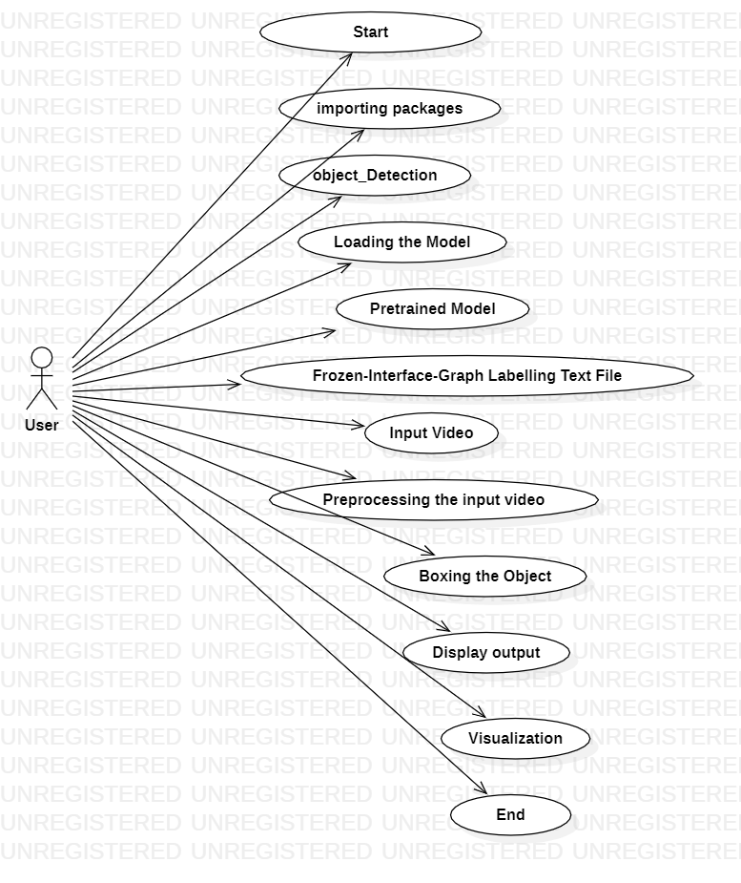

2.2.4.2 Class Diagram
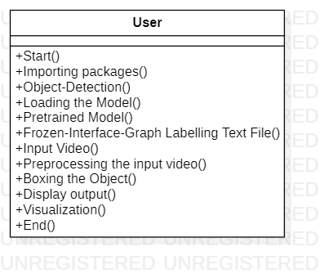

2.2.4.3 Sequence Diagram

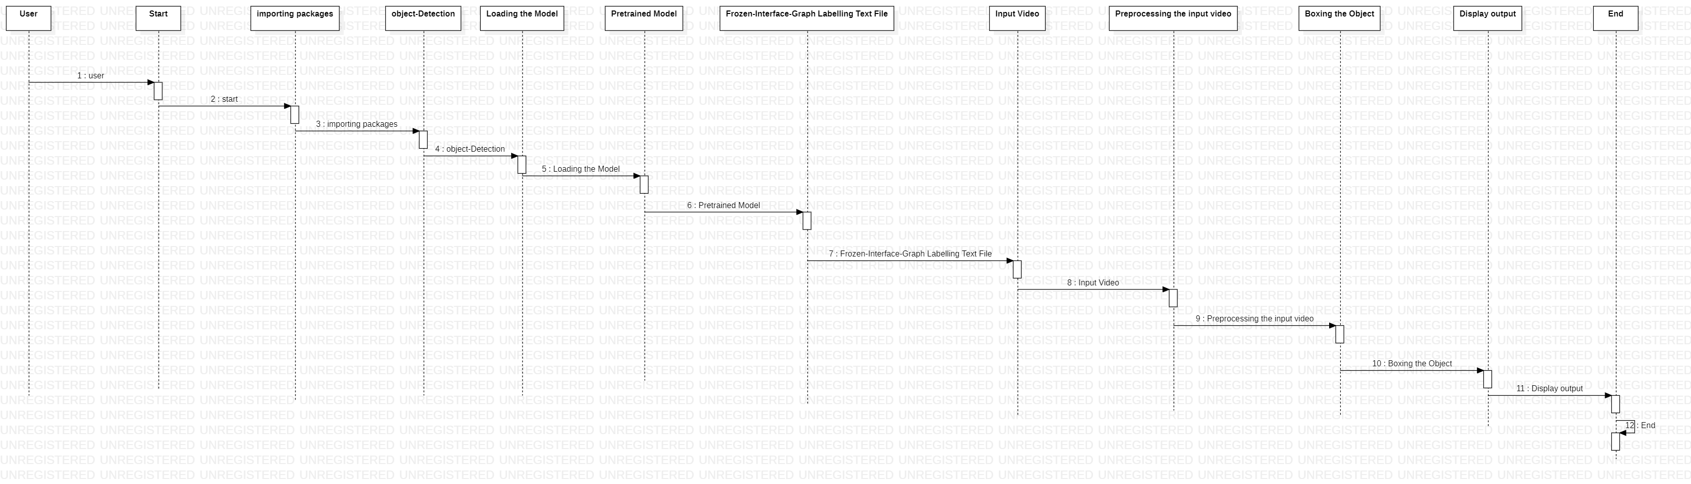

2.2.4.4 Activity Diagram

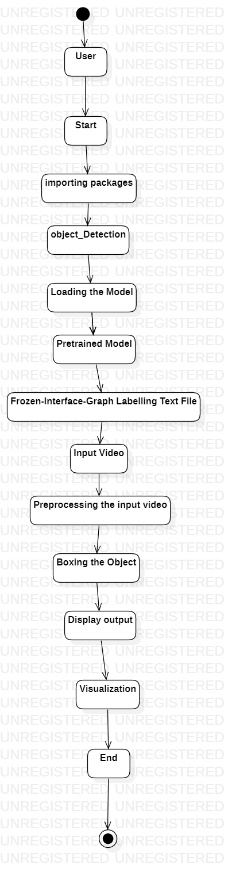

3. SCREENS

