STANDARD OPERATING PROCEDURE
Amadeus Cryptic - PNR Creation, Ticket Issuance, TST/Ticket Display & Exchange
Training SOP | Version 1.0 | 04 October 2026
Purpose | Provide a controlled, step-by-step reference for basic Amadeus cryptic ticketing activities.
Scope | PNR creation, pricing/TST review, e-ticket display, initial issuance and voluntary exchange using ATC.
Audience | Travel consultants, ticketing agents, SMEs and trainers.
Important | Use airline fare rules, client policy, BSP/ARC requirements and your office profile as the final authority.

CONTROL NOTE: The screenshots in this SOP are recreated training illustrations, not live Amadeus screens. Commands are based on Amadeus cryptic guidance; entries can vary by airline, market, office profile, passenger type and ticket scenario.

1. Command Quick Reference
Command | Use
AN15NOVDELBLR | Availability: 15 Nov, Delhi to Bengaluru
SS1Y1 | Sell 1 seat in Y class from availability line 1
NM1YADAV/ROOPINDERA MR | Add passenger name
AP +91XXXXXXXXXX | Add contact number
APE-TRAVELLER@EXAMPLE.COM | Add email
TKTL/10NOV | Add ticketing time limit (example only)
RF ROOPINDERA | Received-from element
ER | End transaction and retrieve PNR
RT ABC123 | Retrieve PNR by record locator
FXP | Price itinerary and create/store TST
TQT | Display TST list/details
TQT/T1 | Display TST number 1
TWD | Display e-ticket record from PNR
TWD/TKT098-1234567890 | Display e-ticket by ticket number
TTP/RT | Issue e-ticket and redisplay PNR
FXF | ATC informative reissue pricing - no TST/TSM creation
FXQ | ATC confirmed reissue pricing - creates TST/TSM
FXE / FXO | ATC Best Pricer informative / confirmed
TQM/M1 | Display a TSM when ATC creates one (e.g. penalty/residual)

2. Create a New PNR
Use this flow for a simple air booking. Client-specific fields, SSR DOCS/APIS, frequent-flyer data, corporate identifiers, remarks, OSI/SSR and form of payment may also be required.
1. Search availability: Enter AN<date><origin><destination>. Example: AN15NOVDELBLR.
2. Sell flight: From availability, sell the required seat/class. Example: SS1Y1.
3. Add passenger: Enter name exactly as required by airline/client policy. Example: NM1YADAV/ROOPINDERA MR.
4. Add contact: Example: AP +91XXXXXXXXXX. Add email with APE-... when required.
5. Add ticketing arrangement: Example: TKTL/10NOV for a time limit, or the appropriate TK element per process.
6. Add received-from: Example: RF ROOPINDERA.
7. Save PNR: Enter ER. Confirm the Amadeus record locator is generated and segment status is acceptable.
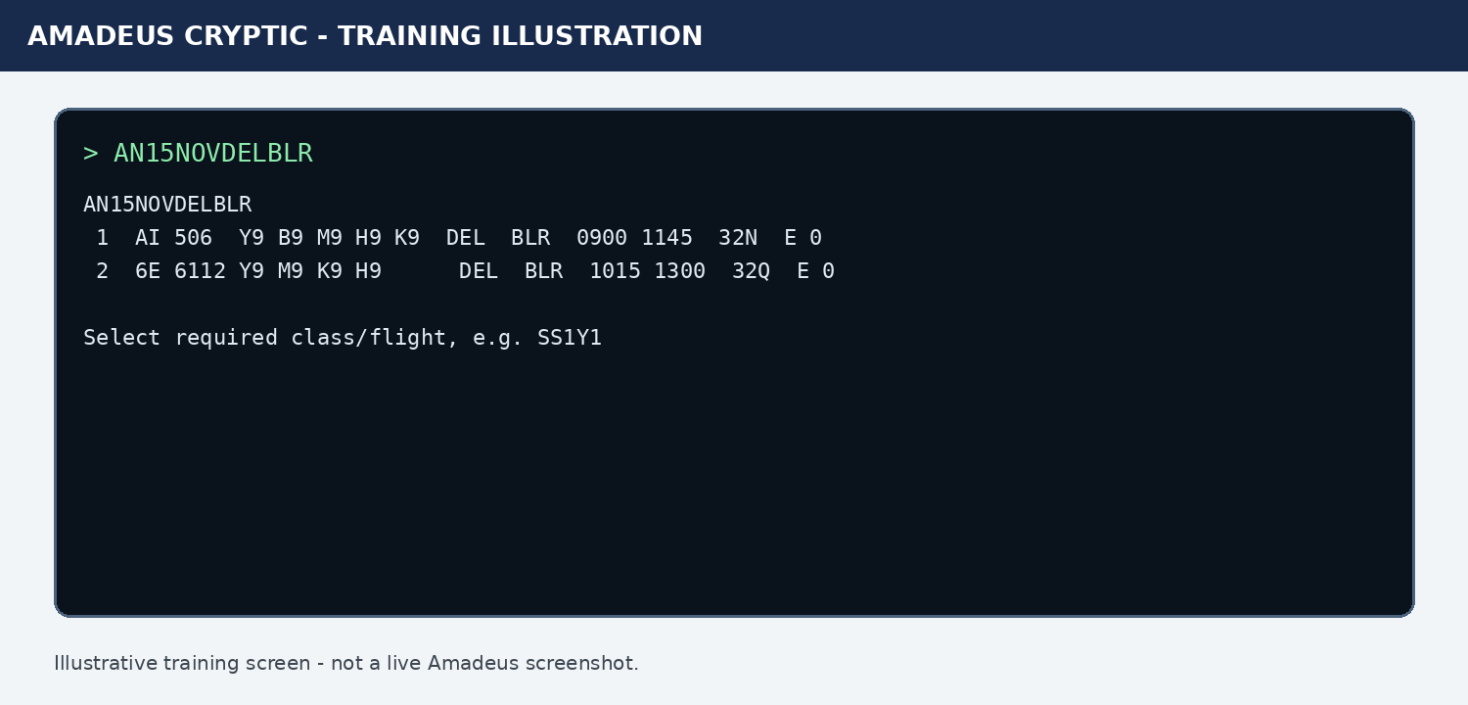
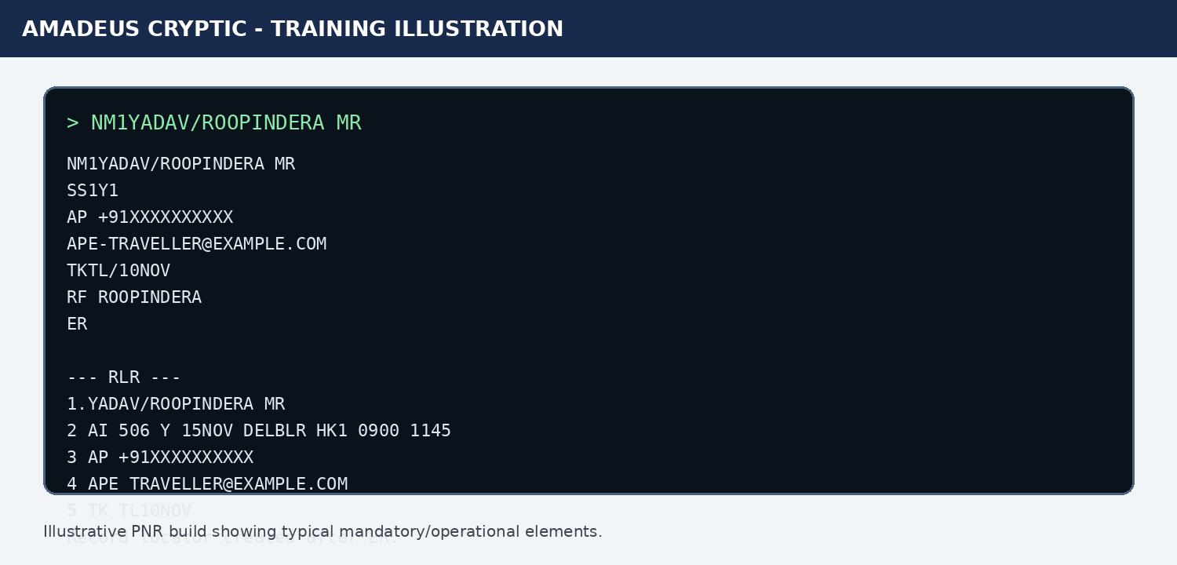

3. Price the PNR and Check the TST
After the itinerary is complete, price it and review the stored fare before ticketing.
- Enter FXP to price the booked itinerary and create/store a TST when pricing succeeds.
- Enter TQT to display the TST. If there are multiple TSTs, use TQT/T1, TQT/T2, etc.
- Check passenger association, segment association, fare basis, base fare, taxes, total, baggage/allowance where displayed, validating carrier, fare calculation, endorsements/restrictions and form of payment.
- If the itinerary or name was changed after pricing, do not ignore a TST change flag. Reprice or correct the TST according to your authorized process before issuance.
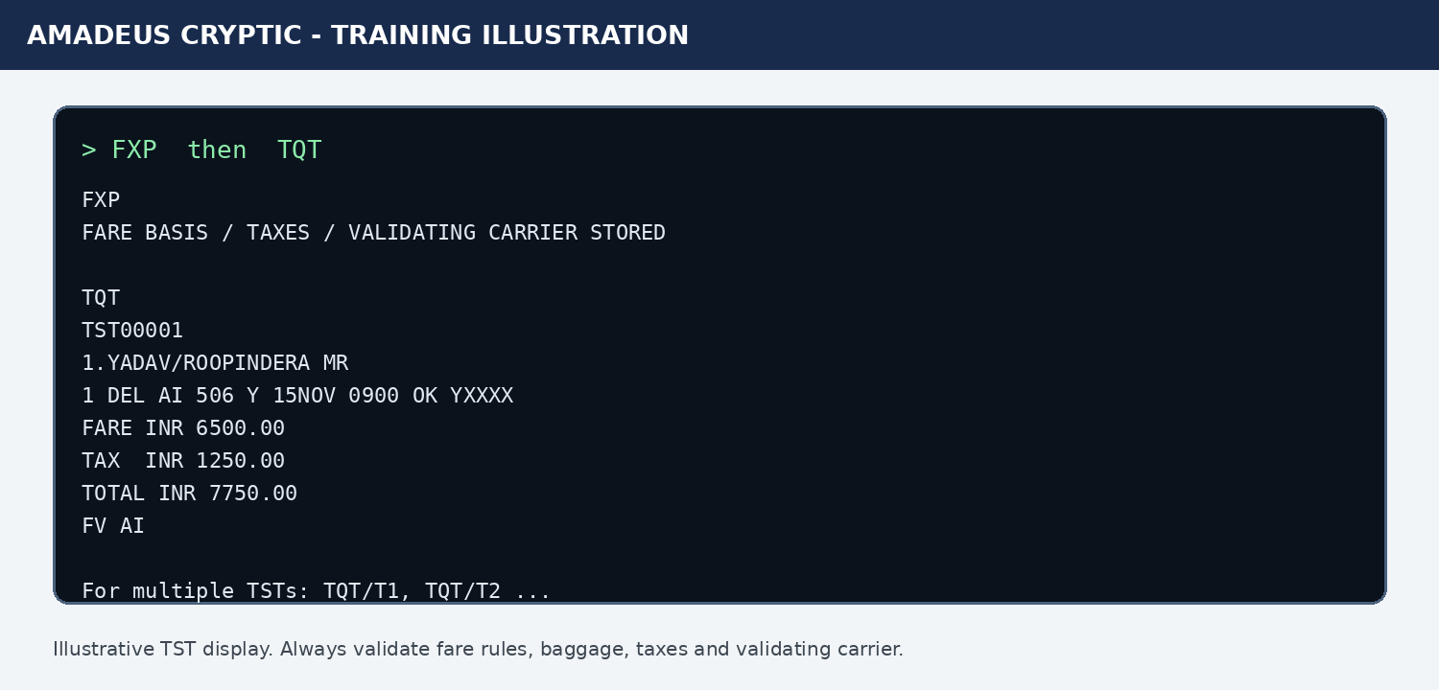

4. Open / Display the E-ticket Image
In Amadeus cryptic, the electronic ticket record is displayed with TWD. This is commonly referred to operationally as opening the 'ticket image'.
- With the correct PNR active and an FA/FHE ticket reference present, enter TWD.
- To display directly by ticket number, use TWD/TKT<ticket number>, for example TWD/TKT098-1234567890.
- Review passenger name, ticket number, issue date/place, itinerary, coupon status, fare/tax/total, endorsements and original form of payment information where available.
- For exchange/revalidation, coupon status is critical. Do not proceed if the coupon status or ownership does not permit the intended action.
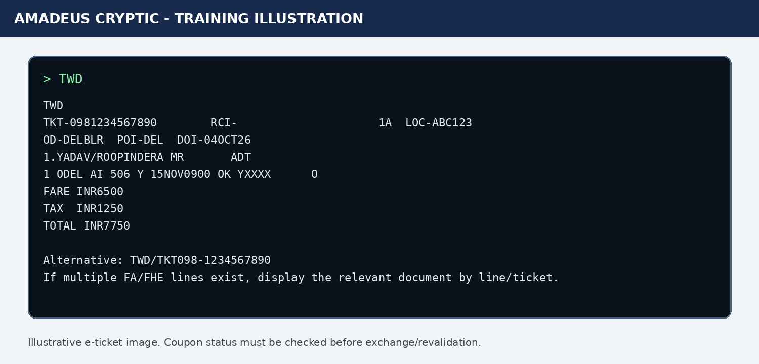

5. Ticket Issuance
Before TTP, perform a final quality check. Ticketing is a financial transaction and can create ADM/debit risk if the fare, validating carrier, taxes or conditions are wrong.
- Passenger name and passenger type correct
- Dates, sectors, flight numbers, class and status correct
- TST reviewed and still applicable
- Fare rule/ticketing deadline/client policy checked
- Validating carrier correct
- Form of payment correct
- Required SSR/APIS/remarks present
- No duplicate ticket already issued
Typical issuance entry: TTP/RT. After issuance, confirm the system returns OK ETICKET and that an FA line/ticket number is present in the PNR.
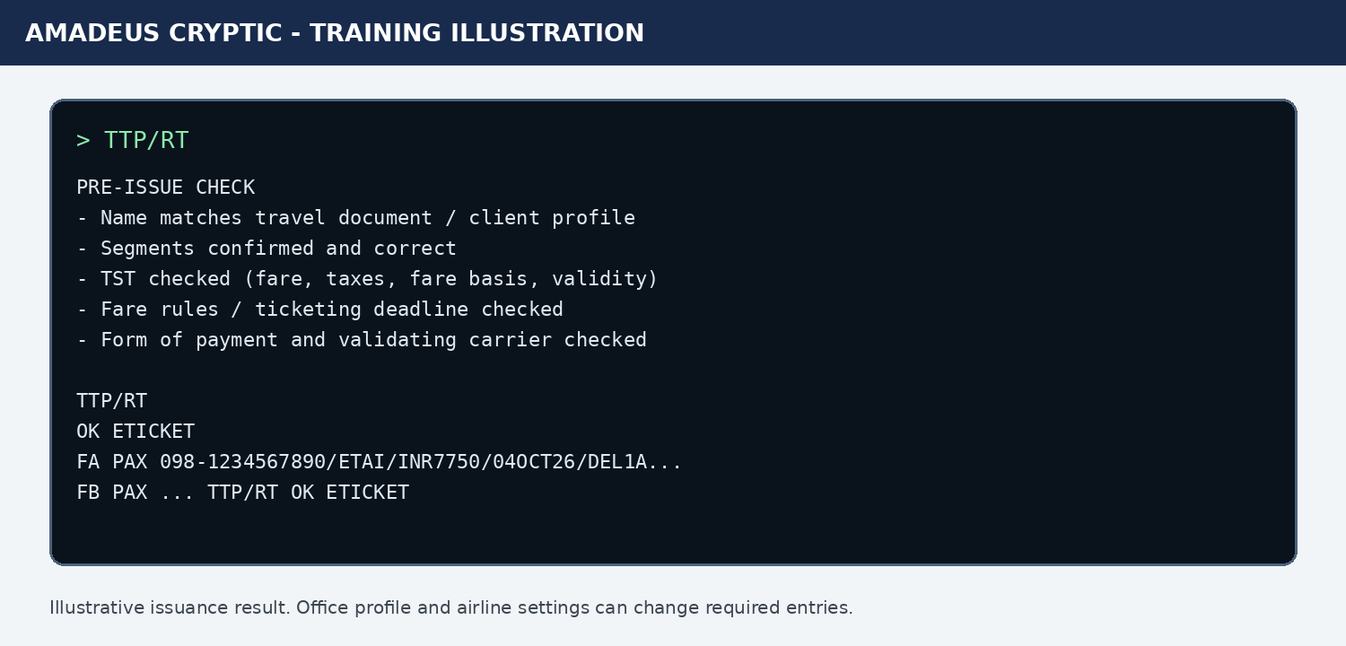

6. Voluntary Exchange / Reissue using Amadeus Ticket Changer (ATC)
Preferred high-level flow when ATC is available and the airline/fare is eligible:
1. Retrieve the booking: RT <record locator>.
2. Display original ticket: TWD. Confirm the correct ticket and coupon status.
3. Check fare conditions: Confirm voluntary change is permitted and identify change fee/no-show conditions as applicable.
4. Rebook new itinerary: Book the new flight/date/class using availability or SB/SS entries. Confirm status.
5. Price the reissue: Use FXF for informative ATC pricing, or FXQ to confirm/store ATC pricing. FXE/FXO are Best Pricer alternatives.
6. Review calculation: Check old vs new fare/taxes, additional collection, penalty and any residual value. Display TQT and, if created, TQM/M1 etc.
7. Review PNR financial elements: Check FO, FOP/FPO, FV, FE and associations. Add/update form of payment as required by the ATC response and office procedure.
8. Issue exchange: Use TTP for the e-ticket; where an EMD is required, follow the ATC/market instruction for combined ticket/EMD issuance.
9. Post-issue validation: Redisplay PNR and TWD. Confirm new ticket number, exchanged status of old ticket, coupon status and correct itinerary.
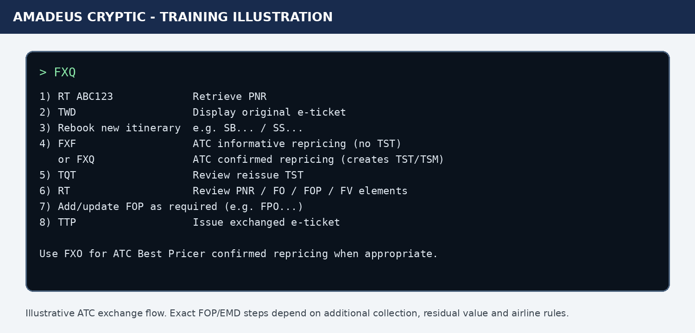

7. Manual Exchange - Escalation / Controlled Use
Manual reissue is more error-prone and should be limited to trained/authorized ticketing staff when ATC cannot be used. Amadeus guidance includes actions such as updating the TST itinerary (TTU), setting the TST to exchange mode (TTK/EXCH), creating the FO original-document reference, checking FOP/FV/FE, removing applicable TST flags and issuing the new ticket. The exact entries depend on the ticket, passenger/segment associations, fare construction, additional collection and market.
Do not use a generic manual-exchange command sequence as a substitute for the fare rule or your organization's ticketing policy.

8. Quality & Error-Control Checklist
- Never issue or exchange from an unverified PNR/ticket.
- Do not assume FXP/FXQ output is sufficient: read the TST/ATC result.
- Confirm passenger and segment associations in multi-passenger PNRs.
- Check coupon status before exchange/revalidation/refund.
- Verify additional collection and penalty collection method before issue.
- Check whether an EMD/TSM must be issued simultaneously.
- After issue/reissue, always redisplay PNR and e-ticket record.
- Escalate airline-specific, interline, involuntary, partially used, no-show or externally issued ticket scenarios when uncertain.

9. Source & Training References
- Amadeus Training Centre - Reservation and Ticketing (Cryptic): PNR mandatory elements, pricing and ticketing training.
- Amadeus Customer Service - User Guides: Ticketing (Cryptic).
- Amadeus Customer Service - ATC Reissue: FXF/FXQ/FXE/FXO and reissue workflow.
- Amadeus Customer Service - Revalidation: TWD and TTP/ETRV guidance.
- Amadeus Customer Service - BSP manual reissue examples.
Operational note: Amadeus commands and airline behavior can vary by market, airline, office profile and product configuration. Validate against HE pages / Amadeus Service Hub and your internal SOP before production use.

