**CONNECTIONLESS RPC PROGRAM - SERVER PART**

**OVERVIEW** In this program a RPC server has been designed that will provide the file requested by the client. RPC helps to locate another computer on a network without having to understand the network’s details. As it is a RPC, now the client would request for the specific file. The server would search for the file and if found it will return the file to the client.

**MAIN**

* The server receives the input that the client sends using the input argument **arpg** and a structure **svc_req** defined by the rpcgen.
* The protocol through which the communication is happening is set to “**udp**”.
* As the input from the client is received it is stored in the structure and the server must retrieve from the arg1.
* The filename received from the client is stored in the variable named ‘**file_name**’.
* The intended file required by the client is searched by the server whether it has the same file or not.
* If the file required by the client is present in the server then it would fetch the file using fread and store it a buffer, then transfer it to output structure.
* From there the client retrieves the file and displays the content.
* If the intended file is not present it would send a message stating the client that the required file is not present.

**OUTPUT & COMMANDS FOR EXECUTION.**

Arguments to be given while executing the program.

**Positive Case**

**Test Case 1- Replying with large file**

**Command Line for .xfile**

**rpc -a -C udp.x**

**Command Line on the server-2 ARGUMENTS AS INPUT**

**make -f Makefile.udp**

**sudo ./udp_server**

**Command Line on the client-3 ARGUMENTS AS INPUT**

**./udp_client localhost large.txt**

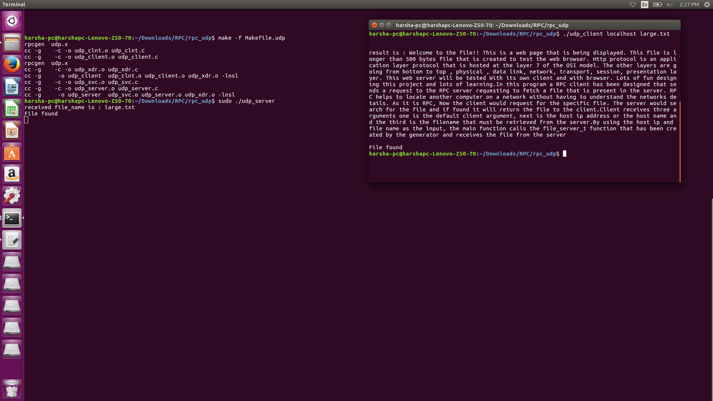

**Test Case 2: Replying with small file**

**Command Line for .xfile**

**rpc -a -C udp.x**

**Command Line on the server-2 ARGUMENTS AS INPUT**

**make -f Makefile.udp**

**sudo ./udp_server**

**Command Line on the client-3 ARGUMENTS AS INPUT**

**./udp_client localhost small.txt**

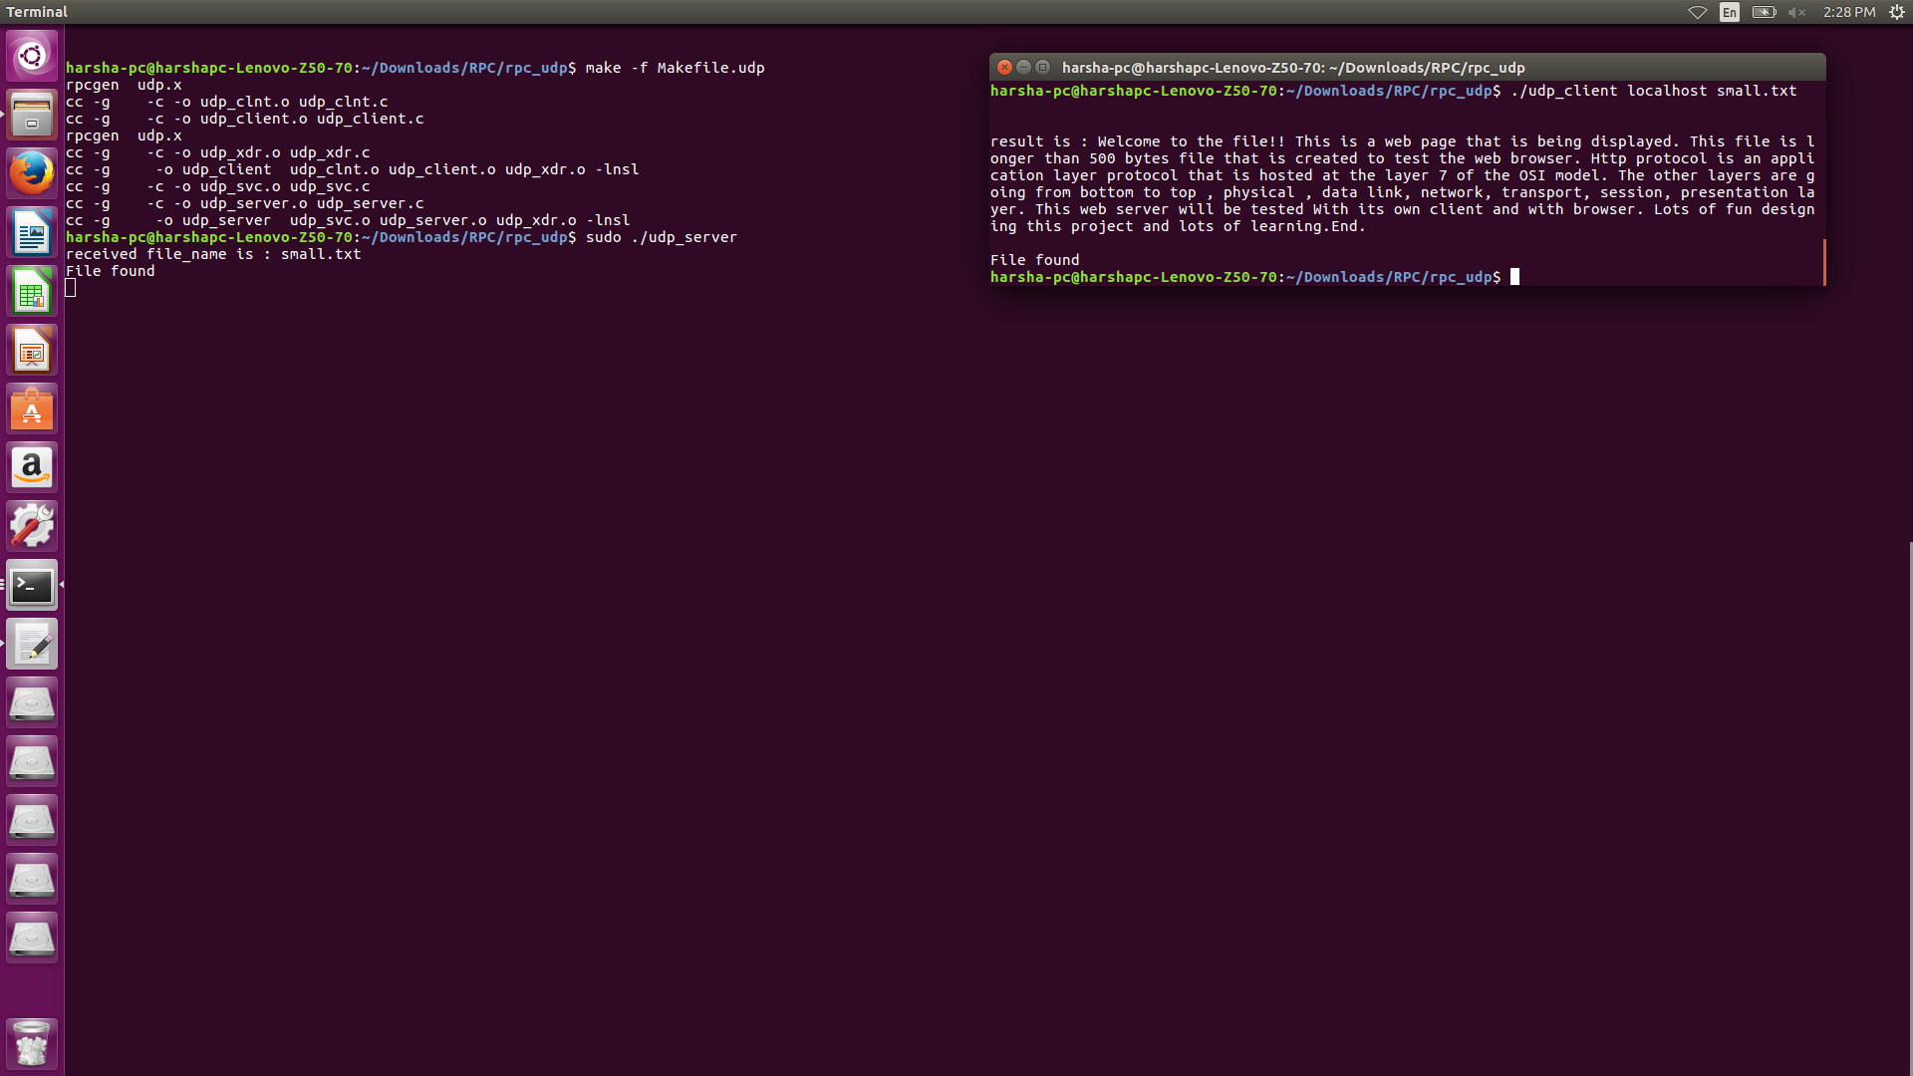

**Negative Case**

**Test Case 3: Repying with error message**

**Command Line for .xfile**

**rpc -a -C udp.x**

**Command Line on the server-2 ARGUMENTS AS INPUT**

**make -f Makefile.udp**

**sudo ./udp_server**

**Command Line on the client-3 ARGUMENTS AS INPUT**

**./udp_client localhost error.txt**

