**Roopneet singh ghuman 056-289509**

**SCALE:**

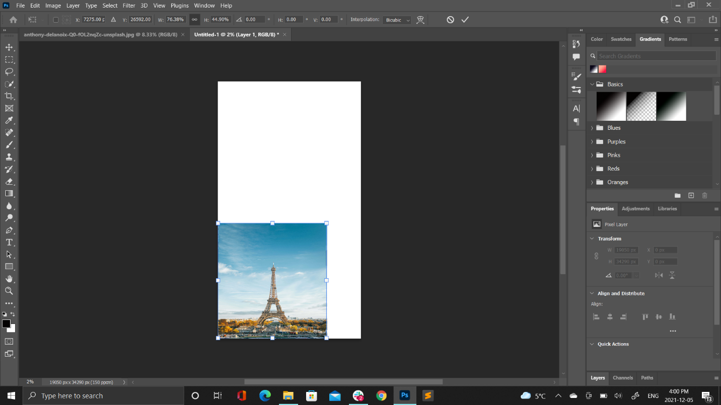

**ROTATE:**

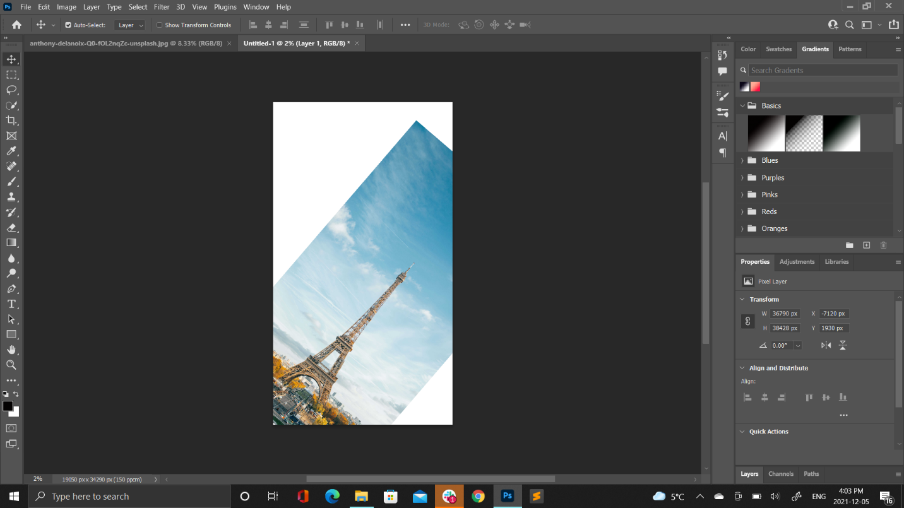

**SKEW:**

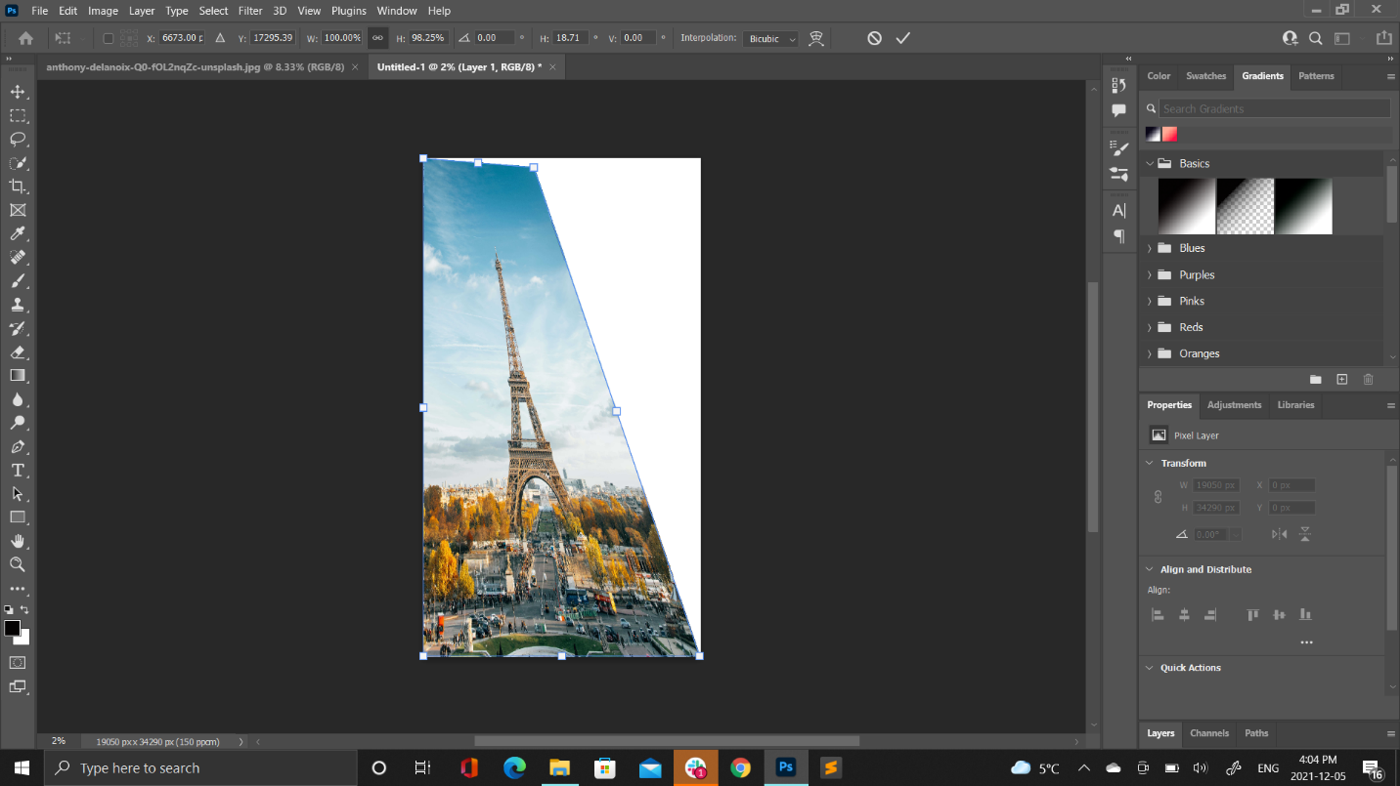

**DISTORT:**

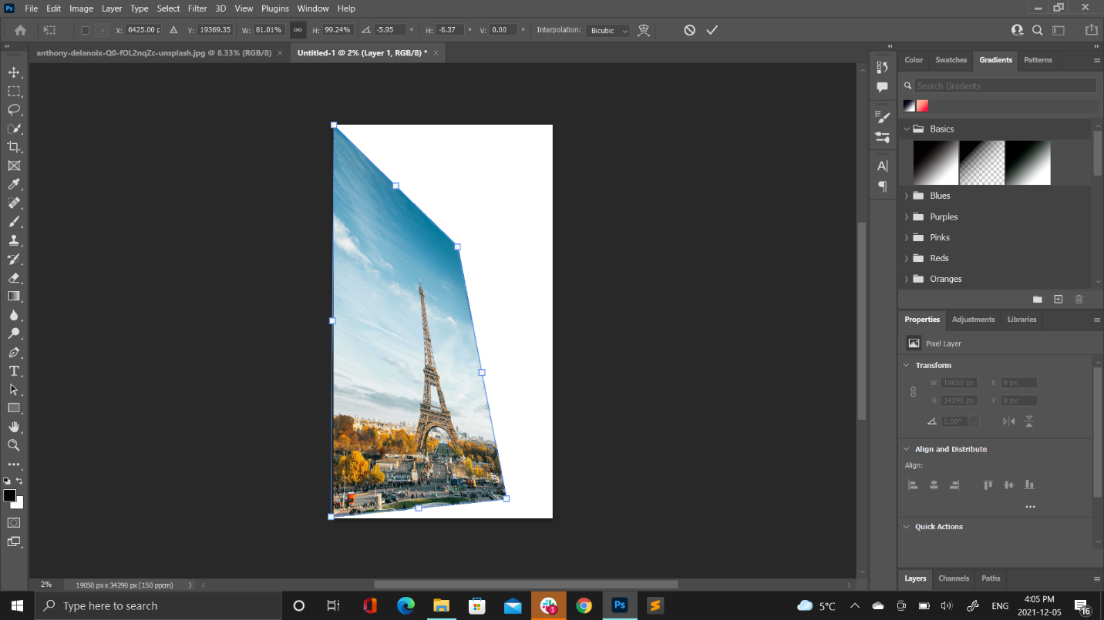

**PERSPECTIVE:**

