**Roopneet singh ghuman 056-289509**

**BRIGHTNESS/CONTRAST**

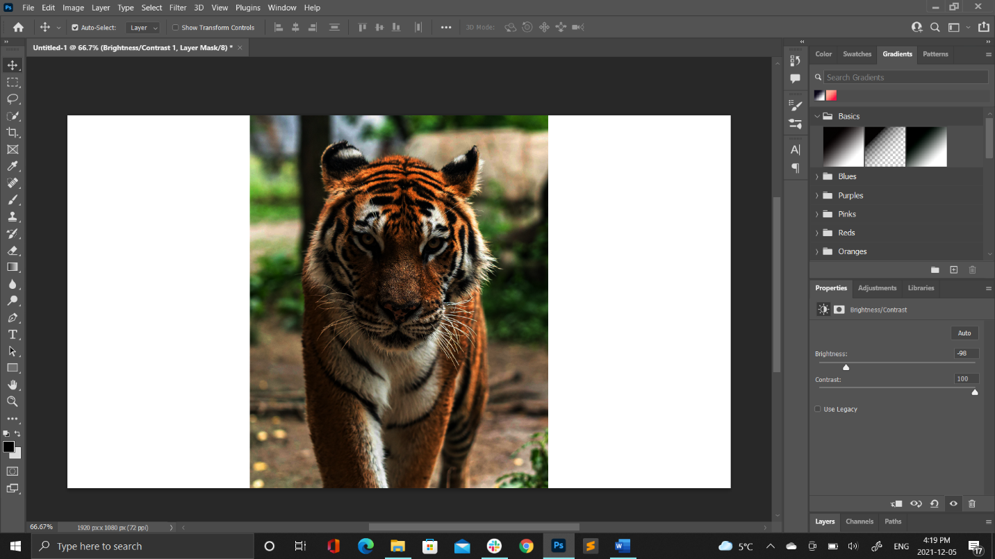

**LEVELS**

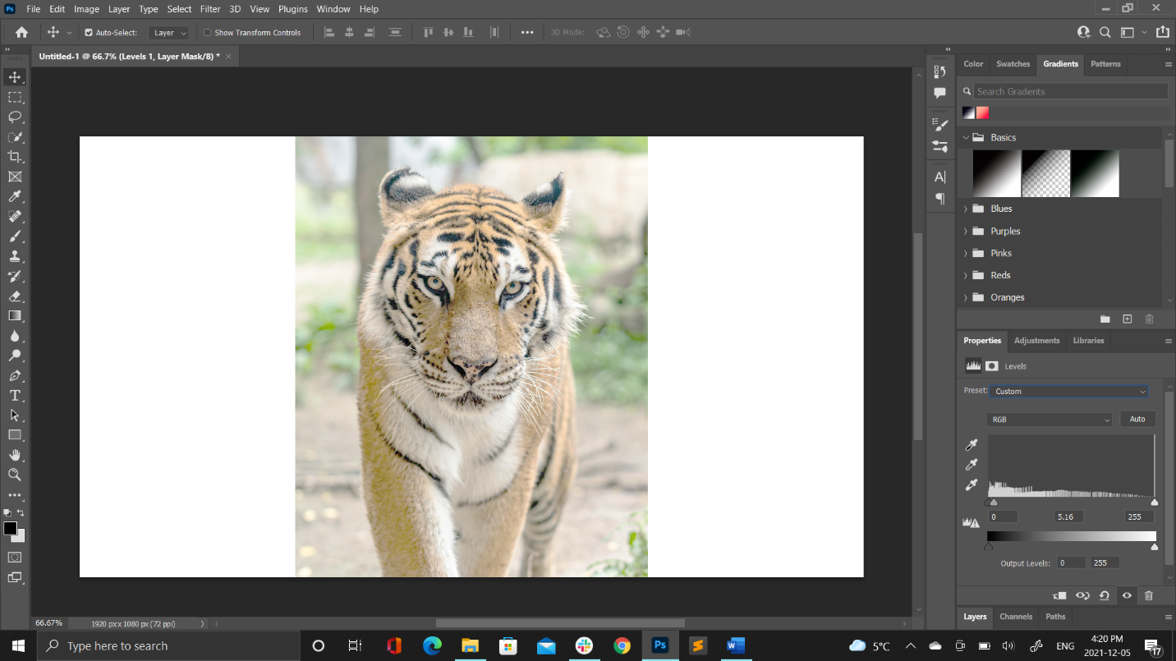

**CURVES**

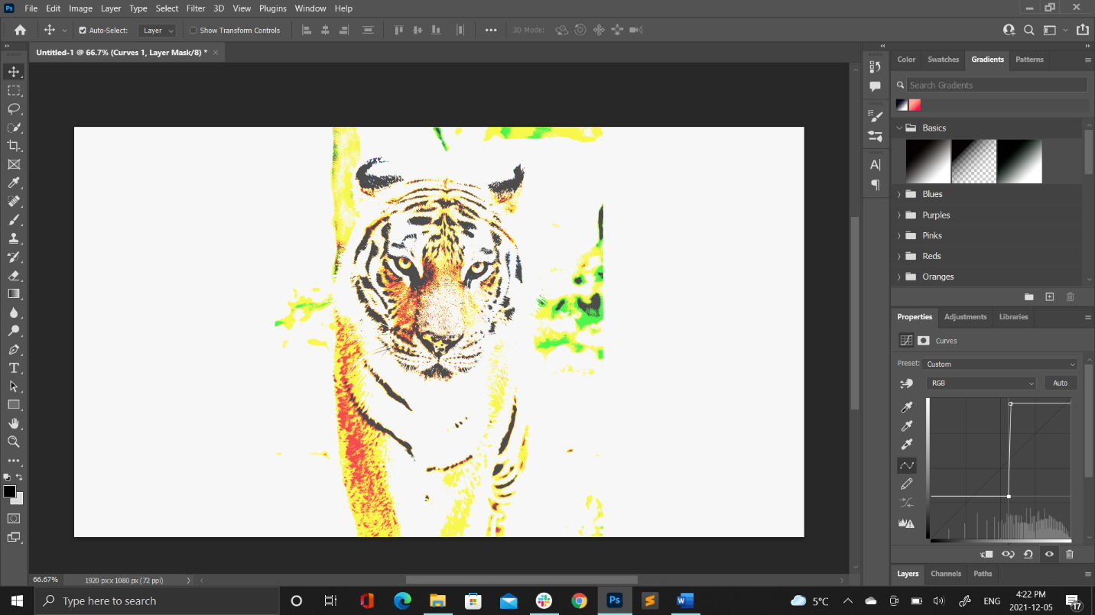

**EXPOSER**

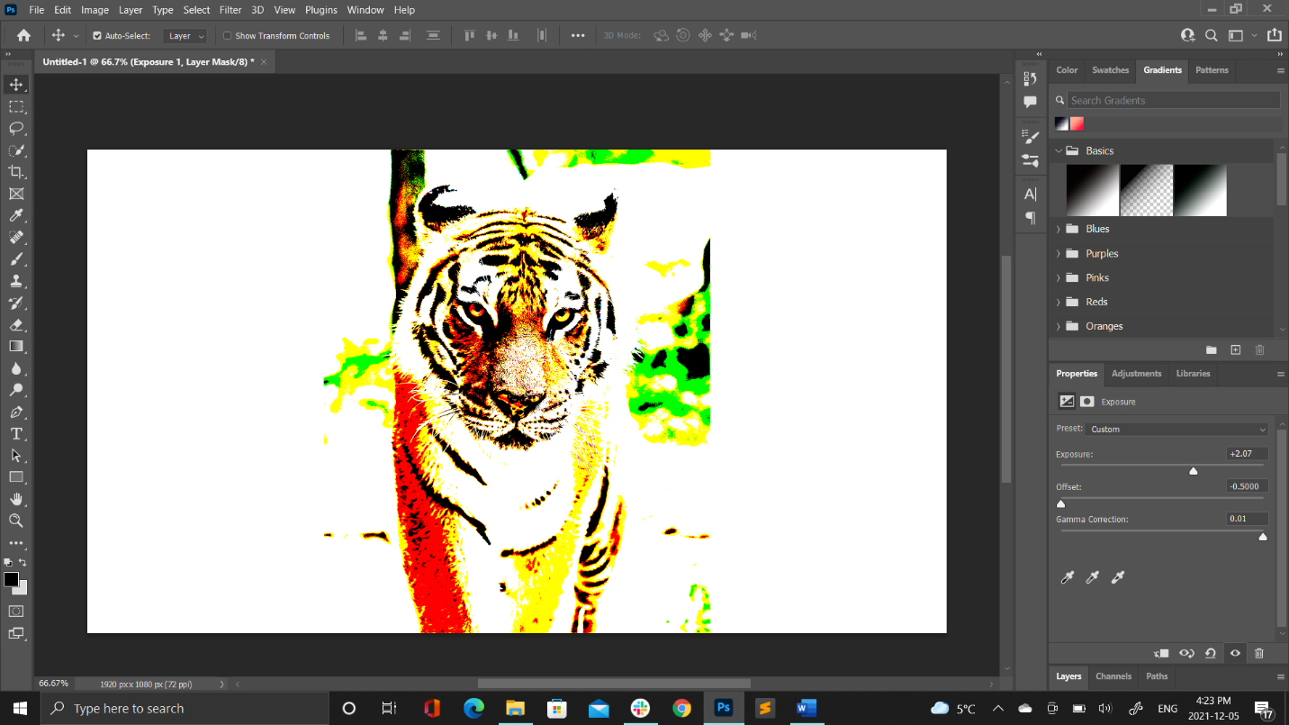

**VIBRANCE**

