**Project 3 Proposal**

**Group 1**

**Christian, Le, and Richard**

Topic: Natural Disasters (earthquakes, volcanoes, tsunamis)

Repository: https://github.com/rooprg/project_3.git

1. Topic and Rationale: Natural disaster tracking to visualize if there are any hotspots for natural disasters on Earth, and additionally, assessing damage and frequency within the 21st century [2000-present]. Our group began our discussion about climate change and furthered that discussion to how impactful natural disasters are in the current century (progression this century). We’d like to evaluate if there are any changes in damages over time that could be correlated.
2. Database: N.O. A. A. [API link: [www.ngdc.noaa.gov/view/about](http://www.ngdc.noaa.gov/view/about)]

1. Visualization Proposals:

* Death toll comparison between type of disaster as a function of time - Chart.js [Christian]

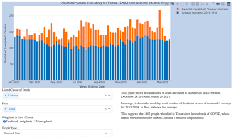

* Disaster locations map (define descriptors: average deaths, average damage) – Leaflet [Richard]

* Decades heat map – layers for the 00’s, 10’s, and 20’s – Leaflet [Le]

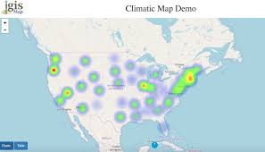

1. Data Visualization:
   1. Base language: javascript
   2. Database: Mongo