++Network Security Lab

Name: Rooshan Riaz
Reg No: 2022506

Lab-01:

Task-01

Listing open files using lsof

The lsof (List Open Files) command in Linux is used to display a list of all open files and the processes that have opened them.
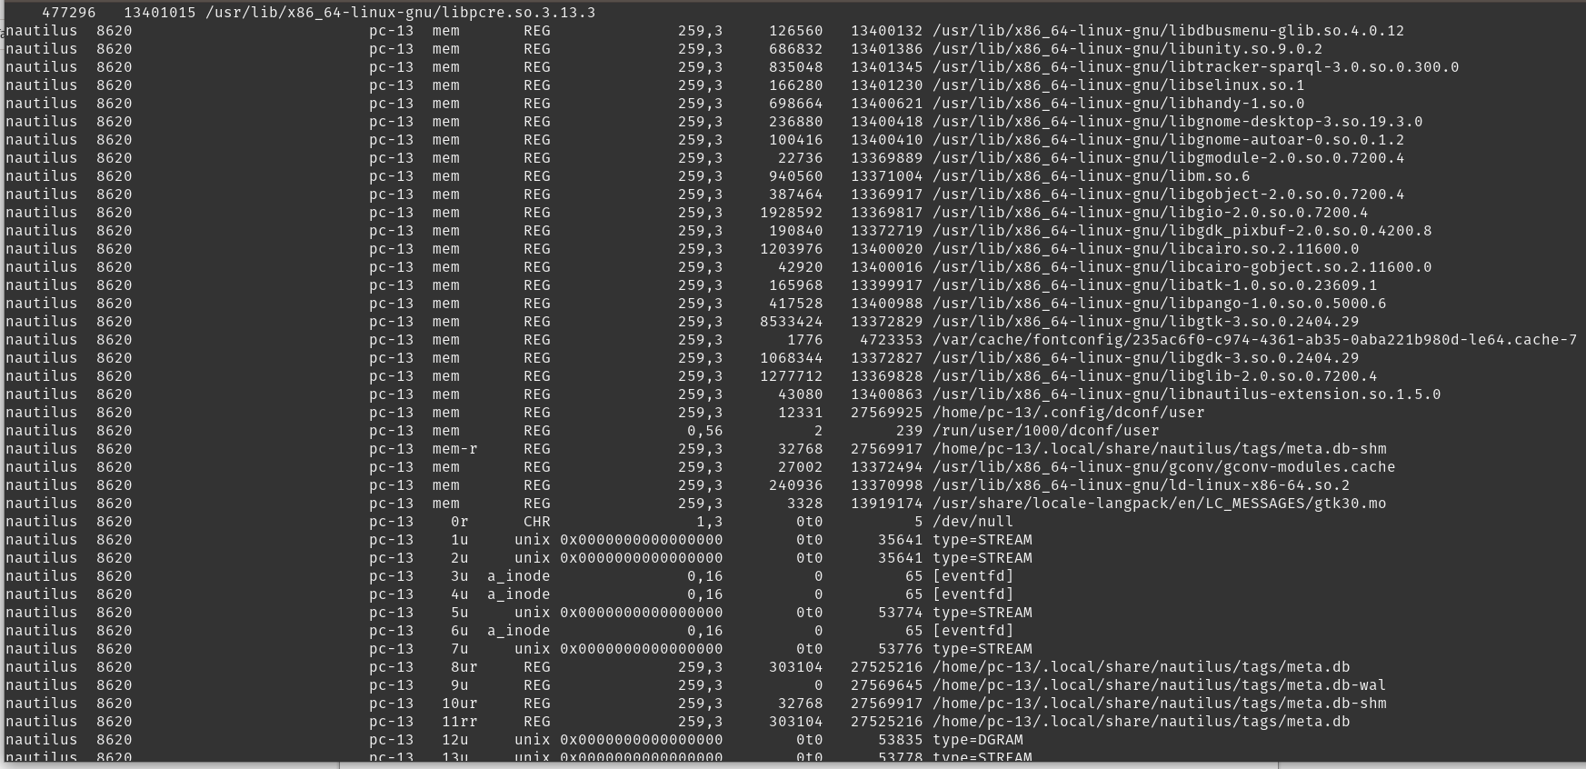

Running command to check which services are listening to machine

The command lists all the network services (processes) currently listening for incoming connections on the system.

Components:

- lsof -i: Lists all the open network files (network connections such as TCP/UDP).
- -P: Prevents lsof from converting port numbers to their service names (e.g., 80 would remain 80, instead of being converted to http).
- -n: Prevents lsof from resolving IP addresses to hostnames, speeding up the command.
- grep LISTEN: Filters the output to show only the lines where the process is in a LISTEN state, meaning it's actively listening for incoming connections.

Using Netstat to listen to open ports

Using ping to check network connectivity

