Network Security Lab

Name: Rooshan Riaz
Reg No: 2022506

Lab-01:

Task-01

Listing open files using lsof.

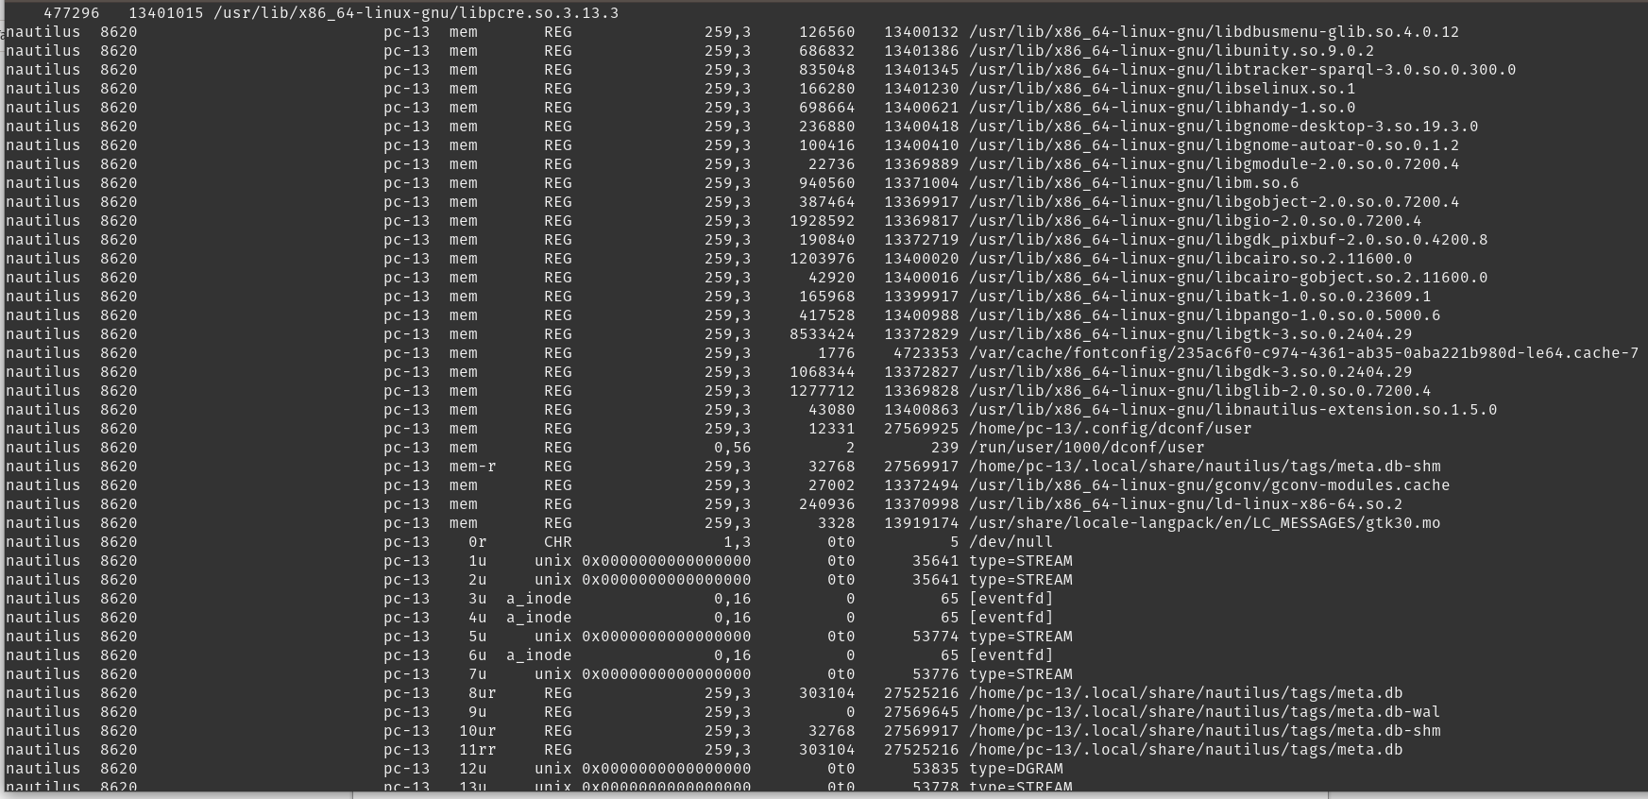
Running command to check which services are listening to machine.

Using Netstat to listen to open ports.

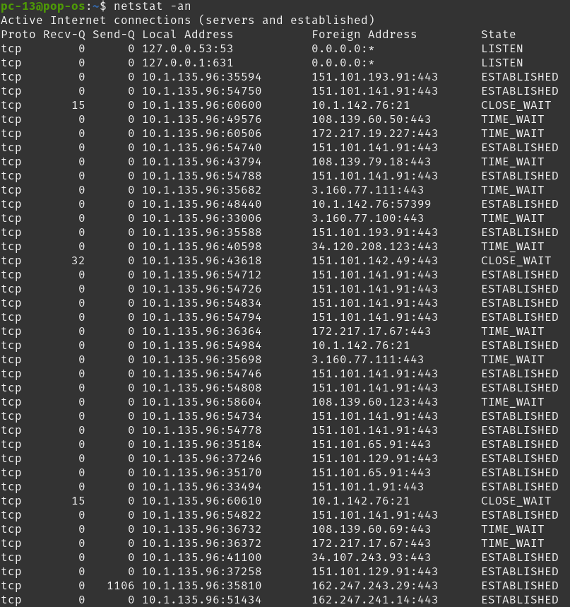

Using ping to check network connectivity

