
School of Electronics and Communication Engineering
Academic Year 2021 - 2022

T. Y. Mini Project - I
Trimester VIII
Synopsis Format

(Synopsis, preferably, should be of about 2-3 pages. The content should be as brief as is sufficient enough to explain the objective, methodology and implementation of the project that one is going to take up. The write up must adhere to the guidelines.)

Title of the Project: Covid 19 Bed slot booking webapp

Domain of Project: Database management and Web Development

Guide Name: Prajakta Pardeshi

Batch Coordinator Name:

Name of Students:

Sr. No. | PRN No. | Name of Student | Contact No. | Email ID | Basket
1 | 1032171415 | Rooshil Bhatia | 8793099748 | rooshil.bhatia@gmail.com | Communication

Introduction:
As in the peak pandemic time there was a chaos to book a bed for Covid-19 patients and Delhi Government initiated the need for a platform so that people can book their own hospital beds if needed in emergency. This motivated us to uplift and add some more features that may come in hand to keep track and store data of the covid 19 patients and have created some admin roles to manage the website it is also flexible in terms of adding a new hospital or removing one with real time updates and using triggers and commit methods to store data entered by the customer. As SQL is both DML(Data Manipulation Language) and DDL(Data Definition Language) we used the DDL component of SQL to create multiple databases which will include database for hospital details, database for admin details, database for patients information and database to store all the commit and trigger operations.

Objective/Aim:

- Building a webapp to help the society to keep track of all the medical services available in their city.
- To prevent concurrent booking of a single bed by row locking technique in dbms.
- Wrote queries in sql to reflect real time changes in the database directly on the web app.
- A separate database for admitted and discharged patients which can help in determining the recovery rate.

Block Schematic:

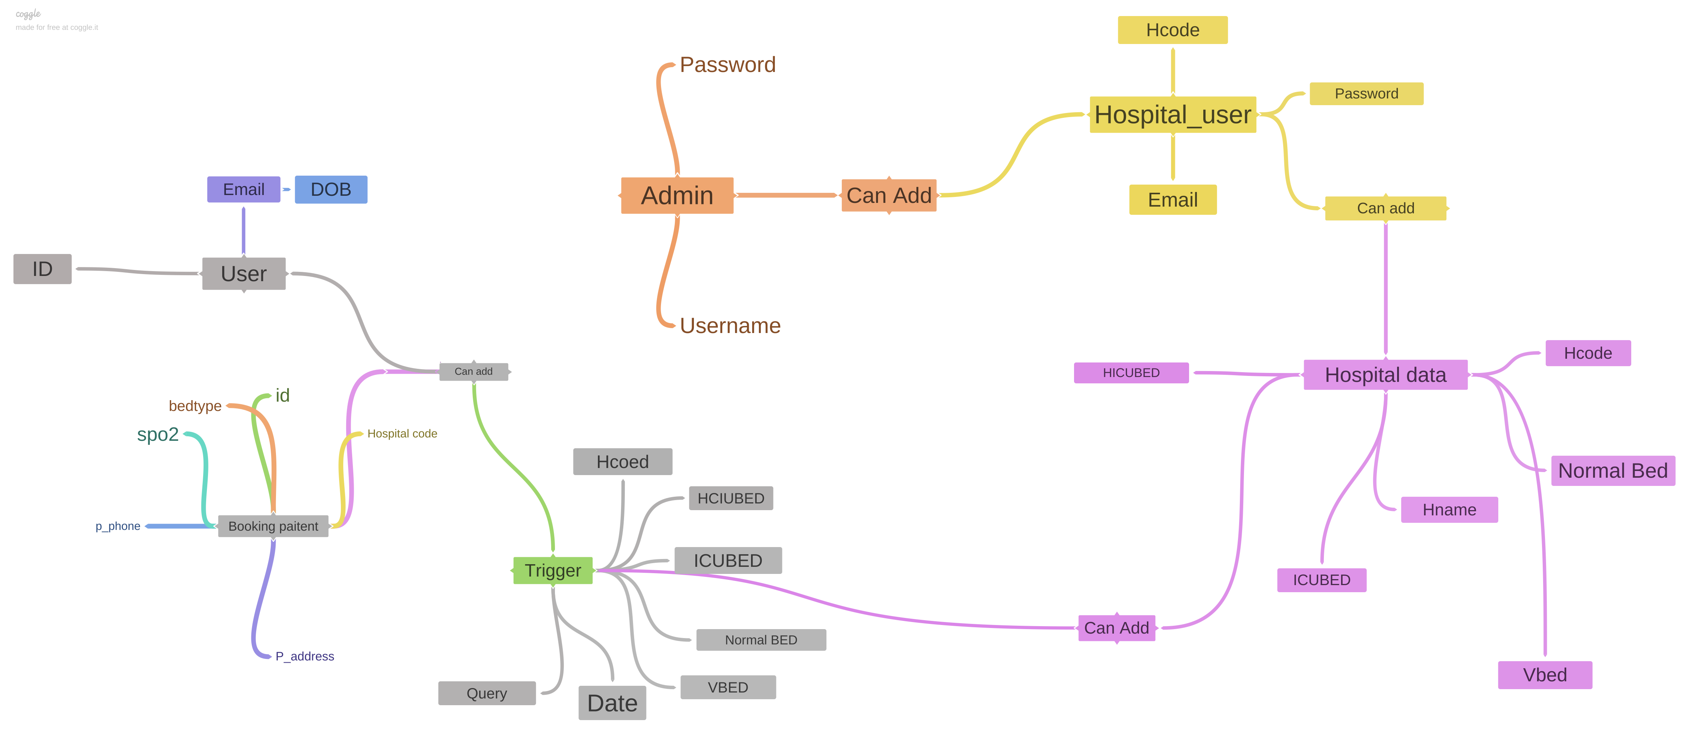

Methodology
- First we discovered the problem and it motivated us to build this project.
- Thought about minimum information required about the patient (such as patient id, which hospital to book, SPO2 levels, phone number etc) to get admitted.
- Created a block diagram on coggle to get more clarity.
- Created several databases and built a webapp using the Flask framework.
- Connected the databases to the webapp and tried to perform all the CURD (create, update, read, delete) operations.
- Optimized the overall project in 2-3 iterations.

- Hardware requirement: Laptop with minimum 4gb Ram and an Internet connection.

- Software Requirement: Vscode, Xampp server, Sublime text, Myphp admin, Google Chrome.

Specifications:
Python 3.4+ and all the latest versions of the software involved.

References:

Took references and inspiration from the Cowin Website(which is a vaccination booking website https://www.cowin.gov.in/)
Took references from w3 schools and udemy to style and design the front end.
Took references from Youtube and educational websites to get grab on DBMS more specifically on the DDL and DML component of DBMS.

Signature of Students Signature of Guide Signature of Batch Coordinator

