Custom Project Description Document
定制单号：DZP20260604103
Requirement Description
Individually mark whether a specific person is required to undergo an alcohol test. Extend the existing personnel ISAPI interface by adding a new field. No personnel configuration is required on the device side; all configuration will be performed by the third-party platform through the protocol.

Custom Function / Release Notes
The alcohol testing function reuses the value field in PersonInfoExtends of the personnel information ISAPI:
/ISAPI/AccessControl/UserInfo/Record?format=json
The value field in PersonInfoExtends is used to determine whether a person is required to undergo alcohol testing. For detailed usage, please refer to the following sections.

Configuration Instructions with Screenshots:
1. Alcohol Detection Configuration (Baseline Feature)
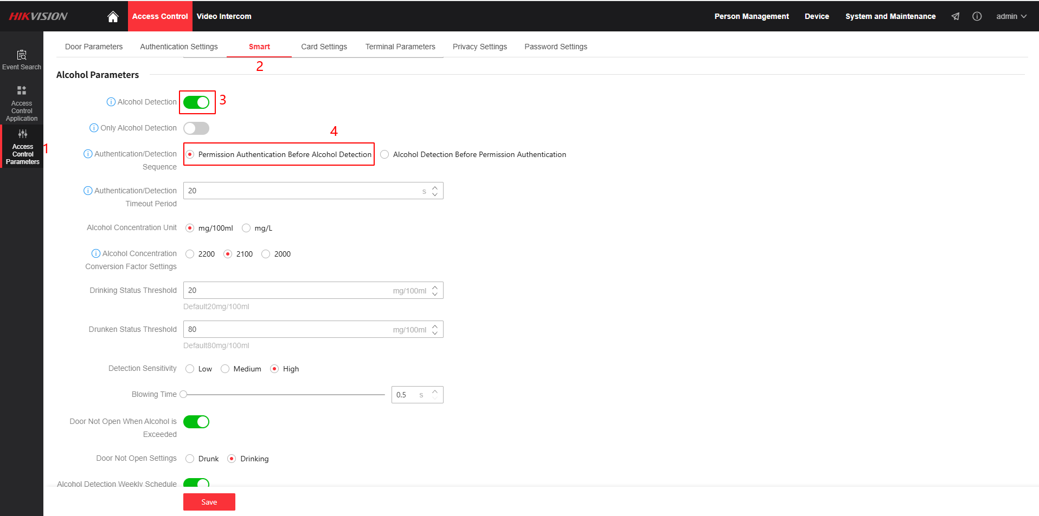
The alcohol detection feature must be enabled, and the authentication mode should be set to Authenticate First, Then Perform Alcohol Detection.
1. Configuration for Skipping Alcohol Detection
hen the Alcohol Detection feature is enabled on the device, a specific user can be configured to skip the alcohol test by setting the personnel extension field PersonInfoExtends.value to a predefined value. After successful face authentication, the user will bypass the alcohol detection process and the door will be unlocked directly.
API:
POST /ISAPI/AccessControl/UserInfo/Record?format=json
In the PersonInfoExtends array, set the value field to "skip_alcohol".
Example:
{
"UserInfo": {
"employeeNo": "10001",
"name": "Zhang San",
"userType": "normal",
"Valid": {
"enable": false,
"beginTime": "2026-01-01T00:00:00+08:00",
"endTime": "2027-01-01T00:00:00+08:00"
},
"PersonInfoExtends": [
{
"value": "skip_alcohol"
}
]
}
}

