# **8 – Point Algorithm**

### Code Explanation

The algorithm receives key points from 2 corresponding images.

**Parameters:**

N = 200

alpha = 2

beta = 0.2

gamma = 0.1

kappa = 0.15

Wline = 0.7

Wedge = 2.0

Wterm = 0.9

sigma = 0.5

Figure 1: Square initialization and final snake

### Circle

**Parameters:**

N = 200

alpha = 2

beta = 0.2

gamma = 0.1

kappa = 0.15

Wline = 0.7

Wedge = 1.0

Wterm = 0.9

sigma = 0.5

Figure 2: Circle initialization and final snake

### Brain – Outer Skull

**Parameters:**

N = 200

alpha = 3

beta = 0.2

gamma = 0.2

kappa = 0.15

Wline = 0.7

Wedge = 1.0

Wterm = 0.9

sigma = 0.5

Figure 3: Outer Skull initialization and final snake

### Brain – Brain matter

**Parameters:**

N = 200

alpha = 1

beta = 0.8

gamma = 0.1

kappa = 0.15

Wline = 0.7

Wedge = 1.0

Wterm = 1.5

sigma = 0.5

Figure 4: Inner brain matter initialization and final snake

### Brain – eye socket

**Parameters:**

N = 150

alpha = 5

beta = 1

gamma = 0.1

kappa = 0.15

Wline = 2.5

Wedge = 1.0

Wterm = 0.5

sigma = 0.5

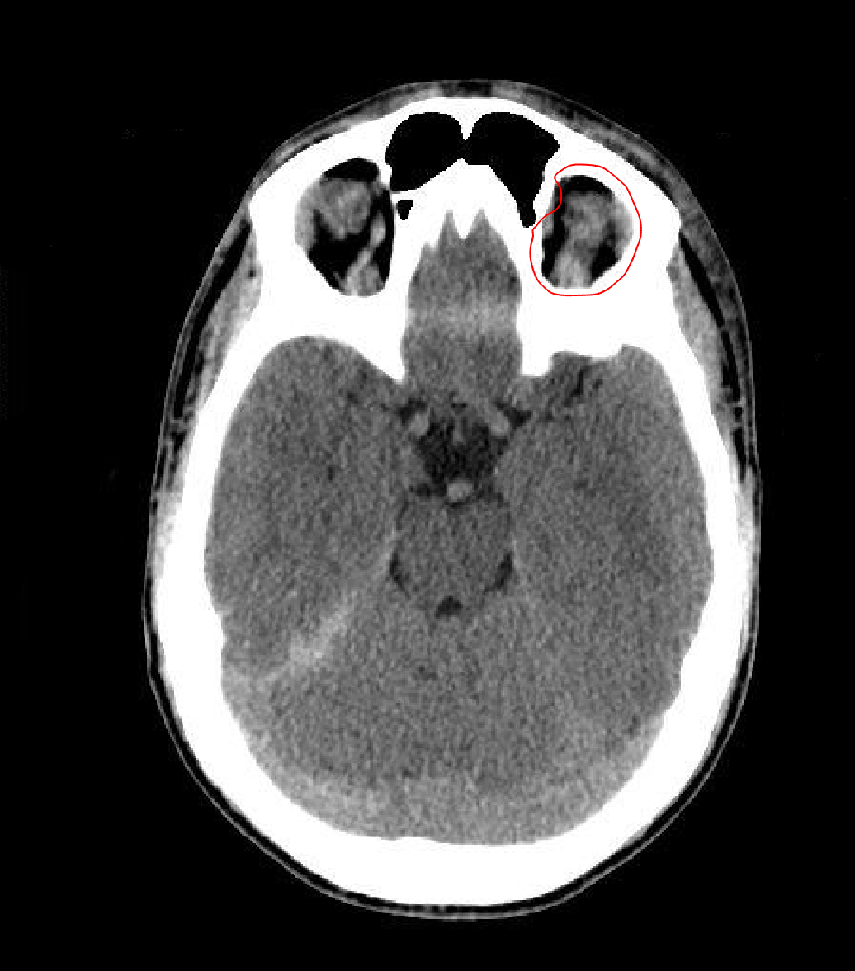

Figure 5: Eye Socket initialization and final snake

### Dental

**Parameters:**

N = 300

alpha = 2.5

beta = 3

gamma = 0.5

kappa = 0.45

Wline = 4

Wedge = 3

Wterm = -2

sigma = 0.5

Figure 6: Eye Socket initialization and final snake

### Shape

**Parameters:**

N = 100

alpha = 2

beta = 3

gamma = 0.2

kappa = 0.1

Wline = 1

Wedge = 2.0

Wterm = -.5

sigma = 0.5

Figure 7: Shape initialization and final snake

### Vase

**Parameters:**

N = 200

alpha = 3

beta = .5

gamma = 0.5

kappa = 0.3

Wline = 3

Wedge =1.0

Wterm = .2

sigma = 1.5

Figure 8: Vase initialization and final snake

### Star

**Parameters:**

N = 200

alpha = 1

beta = .5

gamma = 0.7

kappa = 0.3

Wline = 3

Wedge =1.5

Wterm = -2

sigma = .5

Figure 9: Star initialization and final snake