[talkpython] Up & Running with Git

- List 1
  - List 2 he request:
    - List 3
- @view_config decorator:
  - add_route(<route_name>, <url_pattern>): albums

THE 6 CORE GIT OPERATIONS
clone
- Copy of the remote repository into a local repo on your machine
- The clone is disconnected from the remote repo: local changes are only saved to the central repo once we merge them
status
git status
- Know the state of uncommitted work in your local repo = files that are modified or added or untracked or deleted
- Colors in PyCharm (green, red…)
add/commit
git add filename
- Say that local changes are ready to be incorporated in the local repository
- All local, the server is completely unaware of this

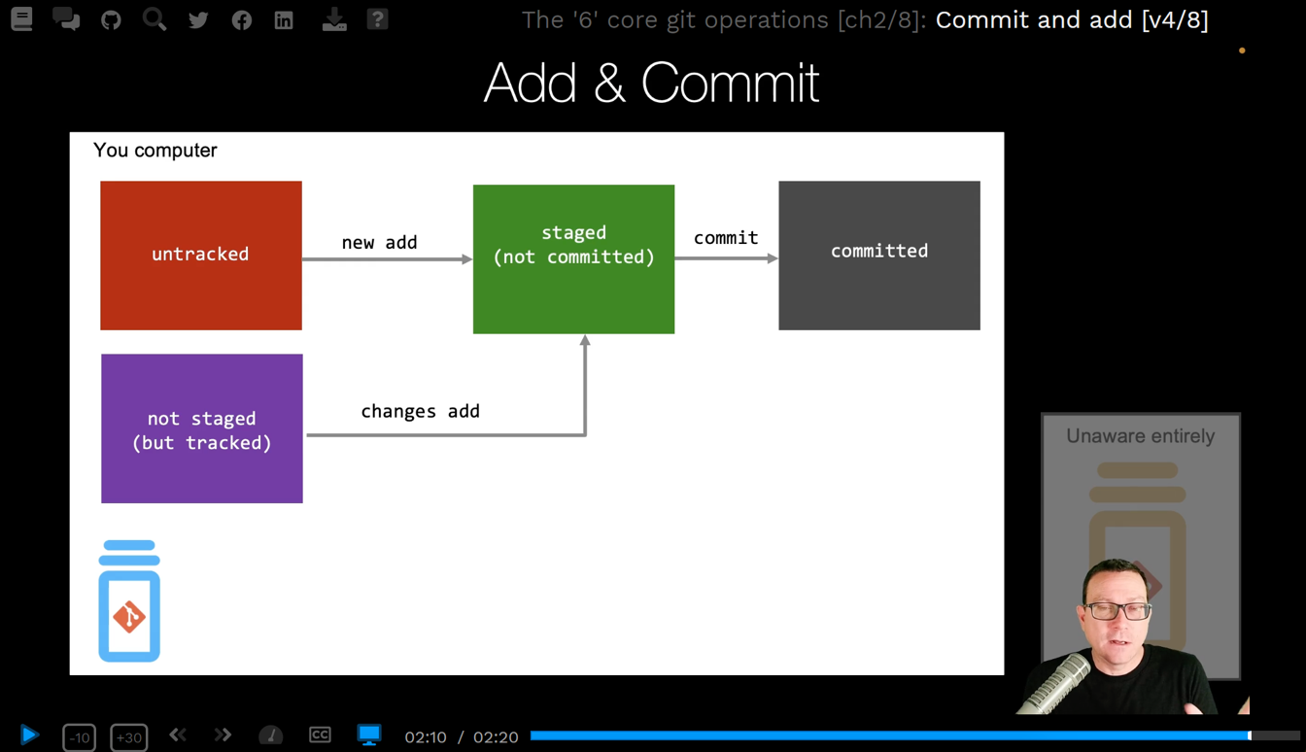
push/pull
- Take changes that we saved locally with add and commit and sync them in to remote repository
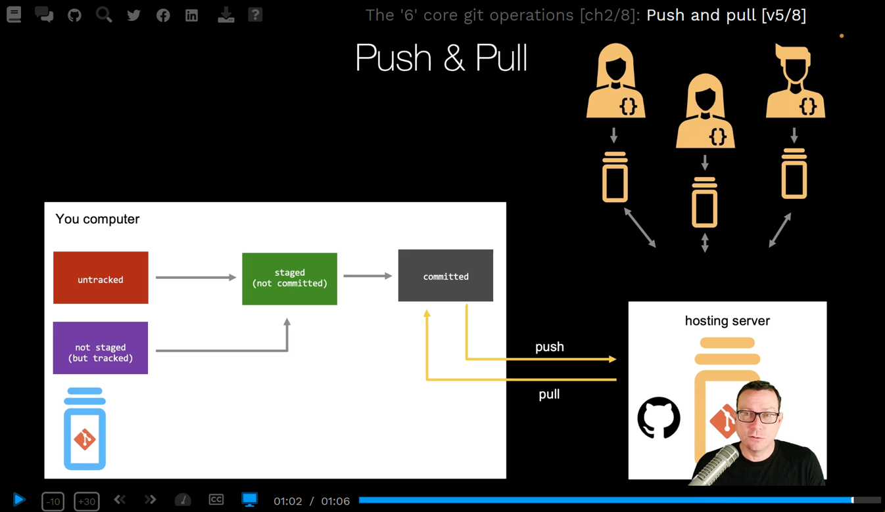
log
git log
- Know what happened recently on a branch
- Timeline tab in Visual Studio Code – Log tab in PyCharm

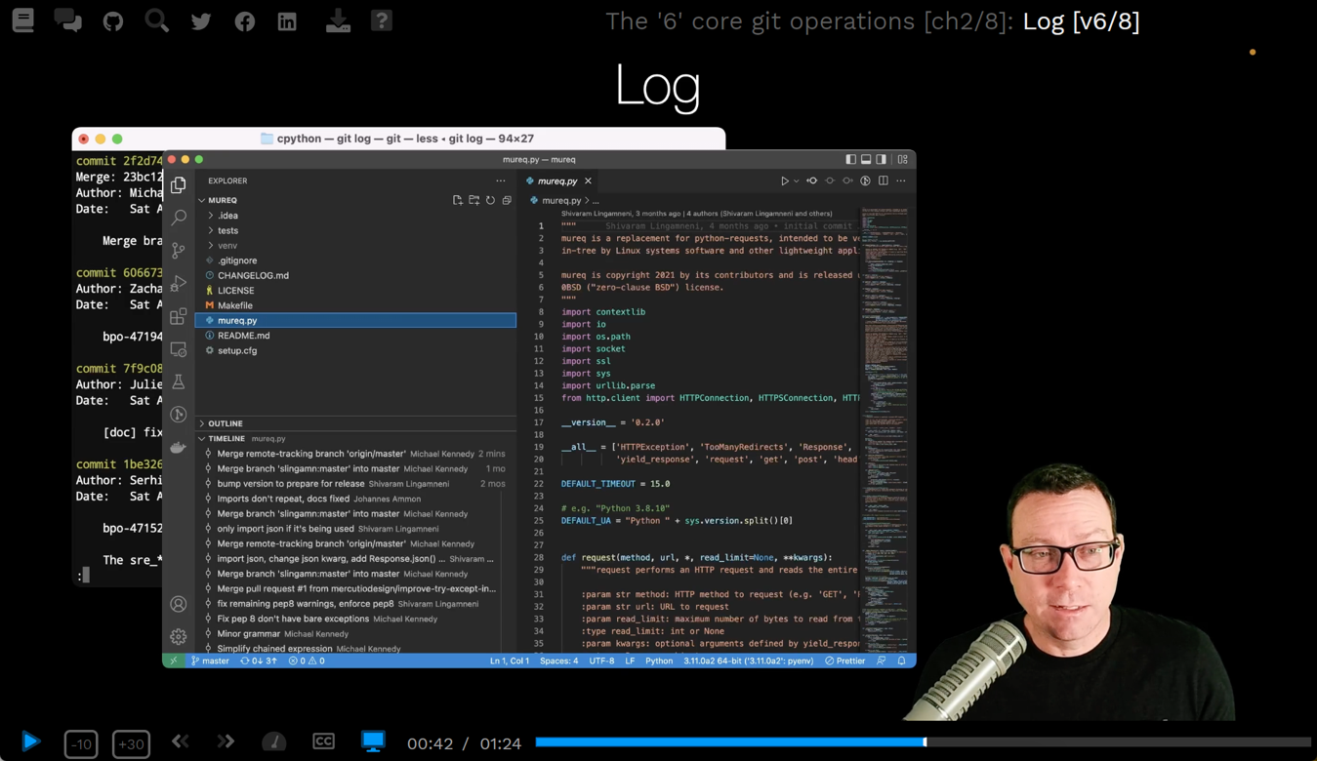

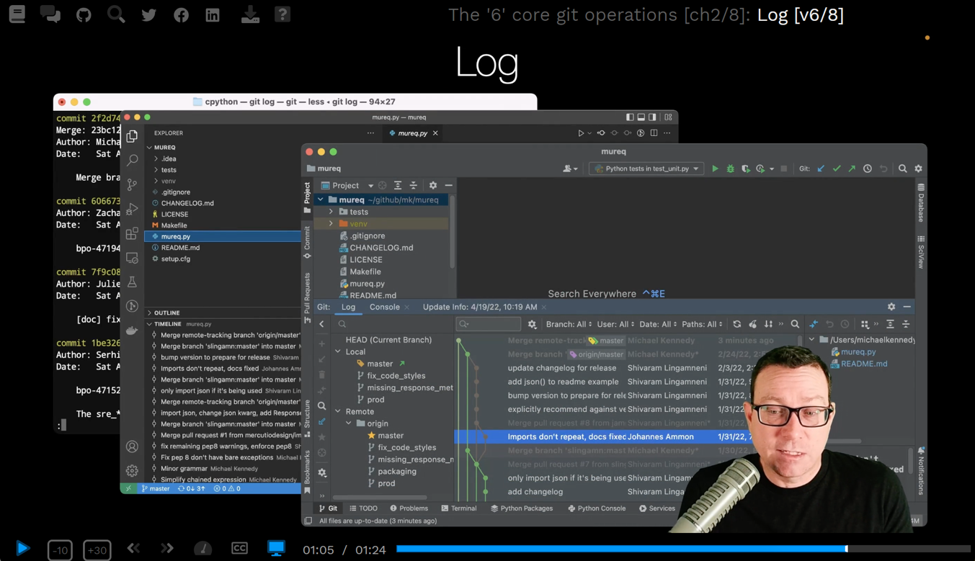
checkout, branch and merge
- Create a branch, switch to an existing branch, or branch changes from one branch into another branch

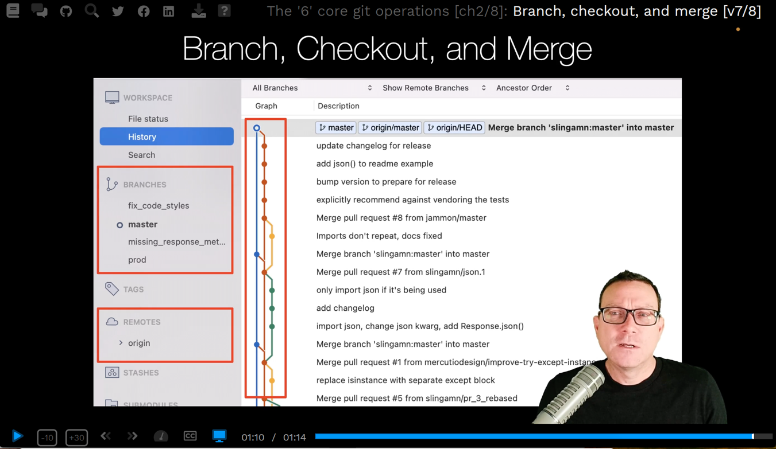
Folders
.git folder
- Root of a git repository:
  - Where all the tracking and management goes (history, alternate copies of the files, versions)
  - DO NOT DELETED IT
  - If you want to make a copy of this project, be sure to copy this hidden content
  - SEE: Get inside the .git folder (talkpython)
- On Mac: Shift+Cmd+. (dot) = show hidden files in the finder
On Windows: View options > show hidden items

OUR FIRST GIT REPOSITORY
What we will do
- Create a hosted git repo on GitHub
- Clone this repo locally
- Connect the local repo with the UI tools and editor
- Write some Python code
- Add externally created files
- Teach git (and our tools) to ignore unrelated files
- Commit some changes to our local repo
Creating a hosted repository
- Go to your repo git account > Click on profile image > Your repositories
- Click on button New:
  - Repository Name: gitupnrunning
  - Private
  - Add a Readme file
  - Certain files should never be checked in to source control (password files or just samples…)
Choose the gitignore template for your language:
Add gitignore > select gitignore template: Python
See: github.com/github/gitignore = if you want to know more about the .gitignore templates of all languages
  - Choose a license if you are not creating something open source, or open source but not authorized for free use: MIT License…
  - Click Create repository button
Local only repositories
cd path/to/app; git init # Initialize empty Git repo in /path/to/app/.git
See end of video for more on repo config…

Renew your git personal access token (PAT):
Source: https://docs.github.com/en/authentication/keeping-your-account-and-data-secure/creating-a-personal-access-token

Click on top-right image profile in github > Settings
Left sidebar: Developer Settings > Personal access tokens
Click Generate new token
Give your token a descriptive name
Select Expiration
Select scopes, permissions: to use your token to access repositories from the command line, select repo.
Click Generate token
Using it on the command line:

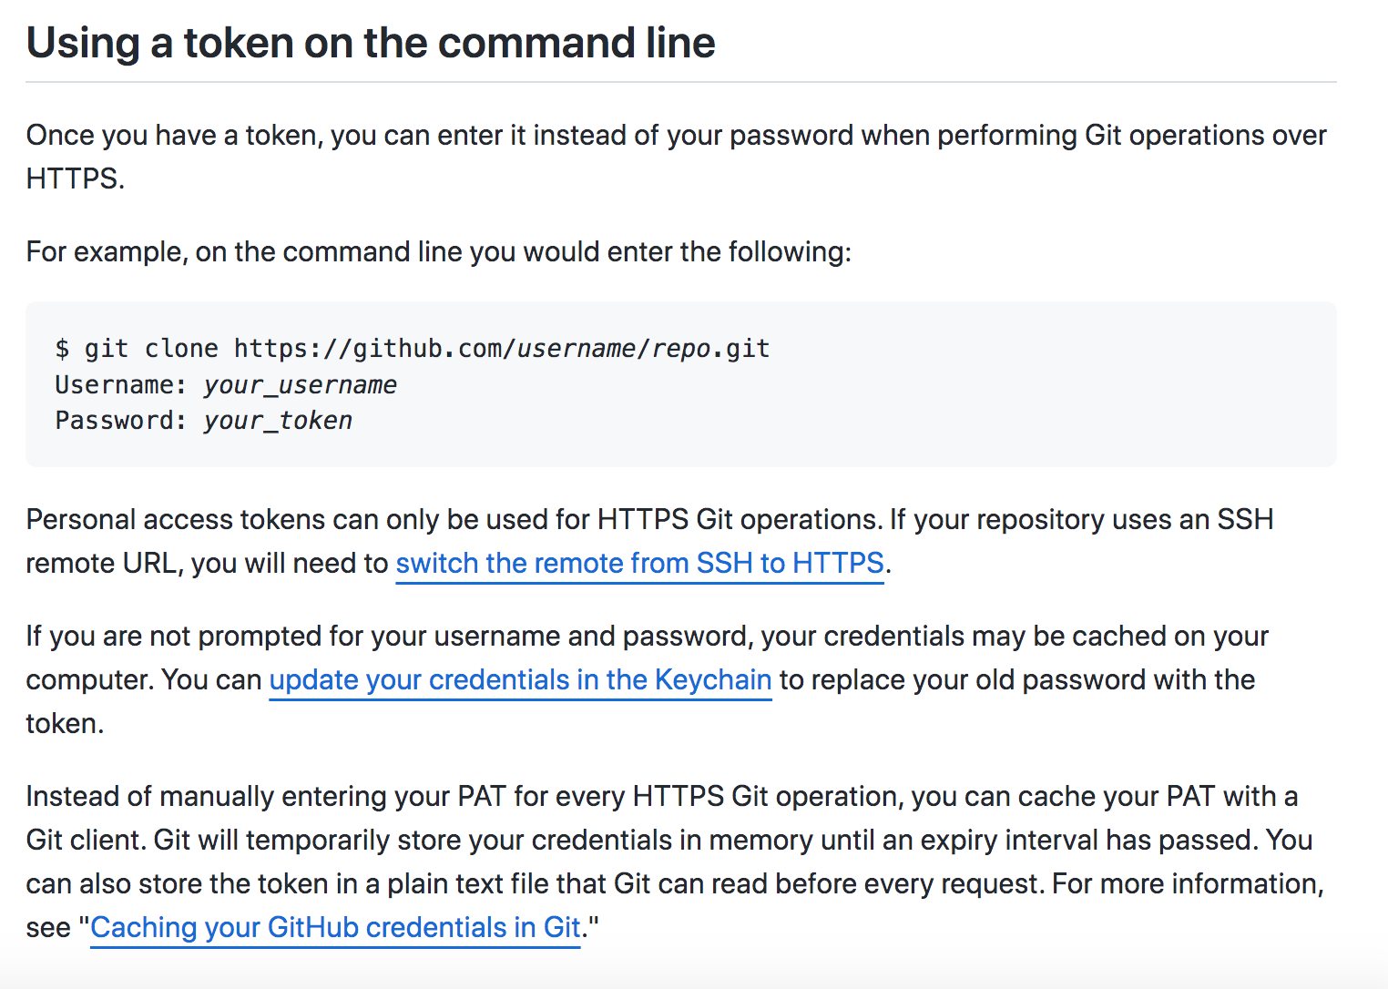

TEAMWORK: MERGING
- To push your changes up to the server, you need to be in sync with the server: need to get the latest source code from the server, with all changes done by the project contributors:
  - git pull
  - Did you all edit the same files? Or each edited different files?

git fetch: tells you what changes there are on the remote

!! Video Merging two change-sets together = about merge and rebase!! (in PyCharm and sourcetree)
+ next video Getting everyone back in sync
(in sourcetree: Fetch button refreshes the status)
+ next video Yikes! Merge conflict, now what?

Files comparison feature:
  - Sourcetree has a file comparison feature
  - Other commercial tools:
    - Beyond Compare: scootersoftware.com
    - Kaleidoscope.com (mac only) with merge tools
    - In the terminal: https://ryunpu.github.io/git-diff-with-beyond-compare: how to configure which tool is used by git diff in the terminal

TEAMWORK: BRANCHES
- Do parallel development
Reasons for branching
- Bug fixes (older version with different UI need a fix, not necessarily merged with latest versions)
- Bring more stability to the release branch (code in a parallel branch, merged periodically with the main branch)
- Experimentation (rewriting the frontend in a different language…, merged only if its confirmed that we want it)
- New feature (merged only once its confirmed that it works)
- Contribute to open source (fork the repo and use the fork as the main branch)

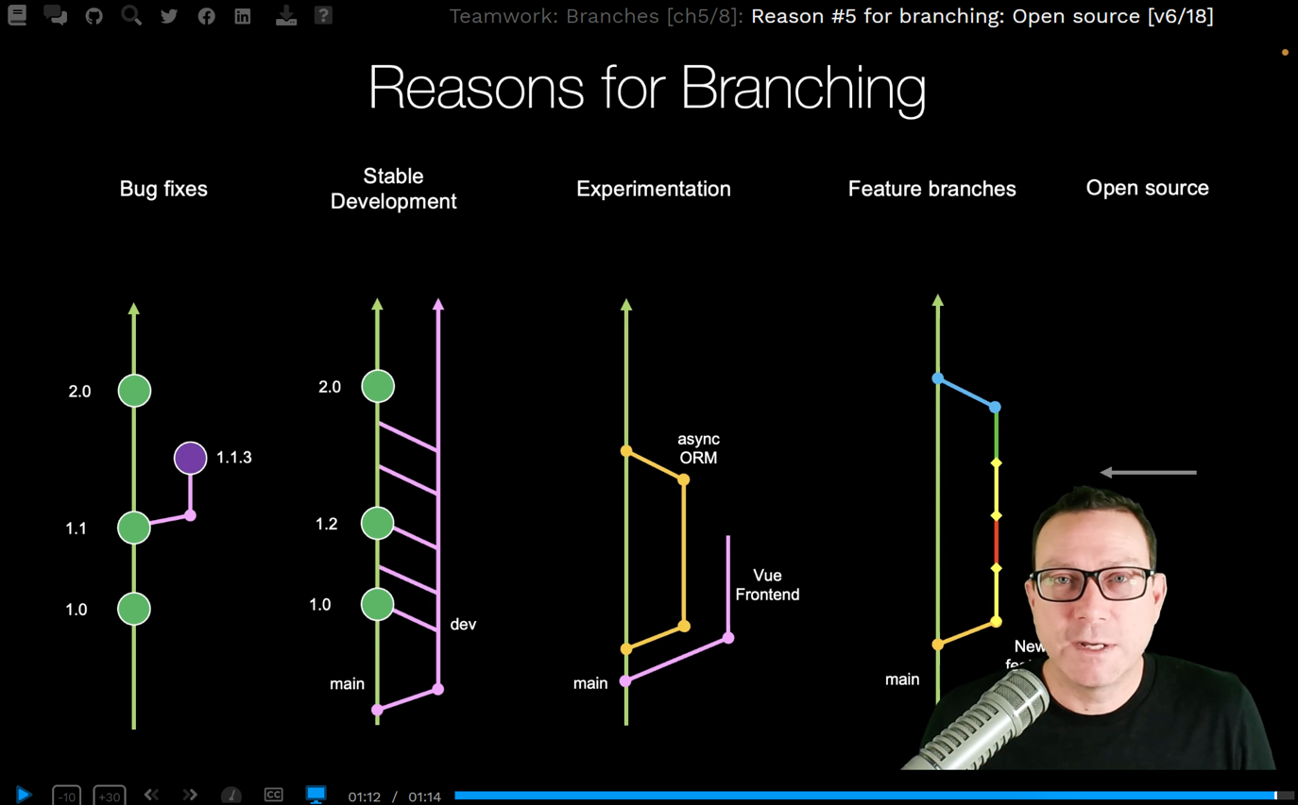

Case: Bug fix branch for older version
- Use version tags on main commits: 1.0, 2.0, etc.
- Some clients still have version 1.0. They don’t want the features from 2.0.
- There is a bug in version 1.0
- Create a new branch based on the commit tagged 1.0:
  - git checkout (from PyCharm or SourceTree or from Github)
  - See more in the Next: Fix the bug video
Case: Feature branch
- 4 ways to merge the feature branch into main:
See video Merging feature branch into main branch
  - From Github: Compare & Pull Request button
  - From Sourcetree: switch to main branch and merge the feature branch into it
  - in VSCode
  - In PyCharm:
    - First merge:
    - bottom-right ‘branches’ menu > main > Checkout
    - bottom-right ‘branches’ menu (again) > ‘feature-branch’ > Merge ‘feature-branch’ into ‘main’
    - Then push: Shift+Cmd+K (mac) or Ctrl+Shift+K (linux/windows)
Cleaning branches
- See video: Techniques for paying down merge/branch debt

TEAMWORK: OPEN SOURCE AND PULL REQUESTS
GitFlow branching style
- Feature branch flow VS Opensource branch flow

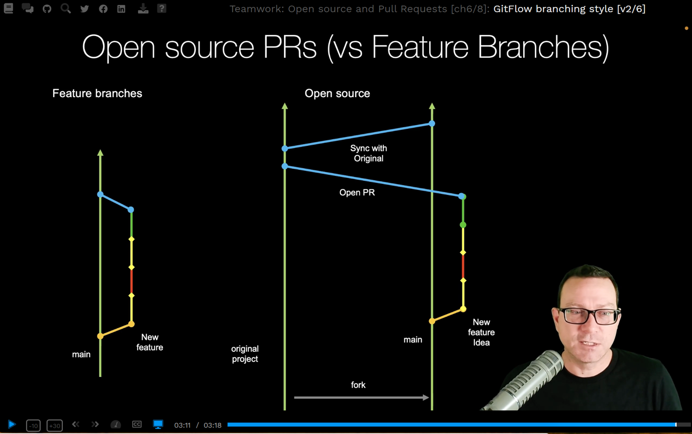
Forking and cloning an open repository
D
Making a change
D
Review and accept the PR
D
Hurray, your PR was accepted!
d

TIPS AND FIXING MISTAKES

- List 1

COURSE CONCLUSION

- List 1

