Title 0
A new paragraph having some bold and some italic

Title 1
Intense quote
- First list item
- First list item
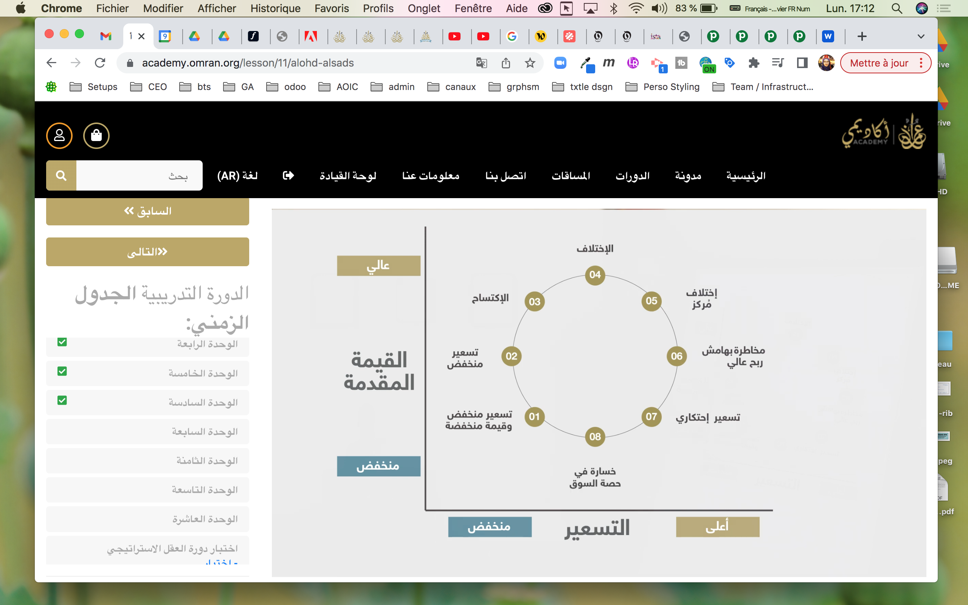
Qty | Id | Desc
3 | 101 | Spam
5 | 153 | Eggs
45 | 64 | Spam and eggs

