Chp. 4 – Pyramid building blocks

- ROUTES
  - Map URL patterns to views (= to view methods)
  - Take a web request and map it into the app

- VIEWS
  - Aka Controllers (view methods)
  - Process the request
  - Ex: show an HTML page, render a template, update the DB, do a redirect

- TEMPLATES
  - Aka Views
  - Dynamic HTML
  - Passes data into a dynamic template -> template takes data and turns it into HTML

- MODELS
  - Data and behavior passed to the views
  - Flows between views and templates

- STATIC
  - Cached assets (rich support in Pyramid)
  - Images, css stylesheets, js

- CONFIGURATION
  - Dev + test + prod config files
  - API keys and other config information

Section Get the back story: podcast with the creator of the Pyramid framework

VIEWS (MVC Controllers)

- Aka Controllers (or ‘view methods’)
- Process the request
- Ex: show an HTML page, render a template, update the DB, do a redirect

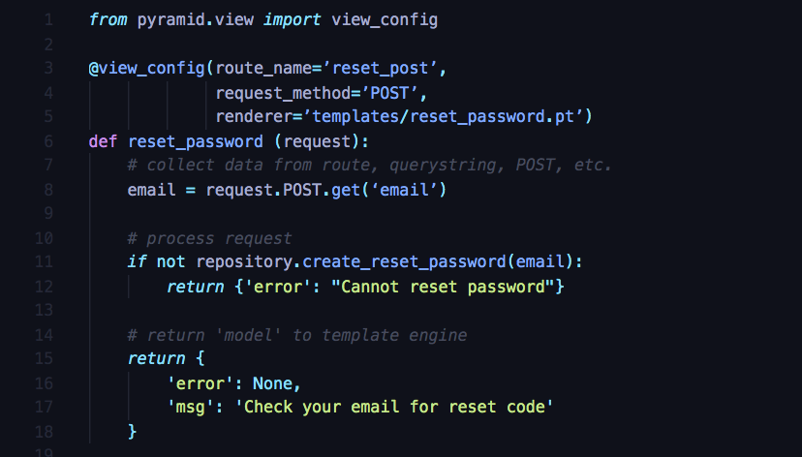

- @view_config decorator:
  - specify the route name
  - and the template that will be rendered from this view

- reset_password view method :
  - (recommended: same name as template name)
  - Takes a request object as argument
  - Handles the request:
    - First, collect data: get to the POST dictionary and get the email that was submitted in the form.
    - Then, get to the data layer and do the processing of the request
  - Often returns a model as dict
the data passed to the template specified in ‘renderer’.

ROUTES

- Map URL patterns to views (= to view methods)
- Take a web request and map it into the app

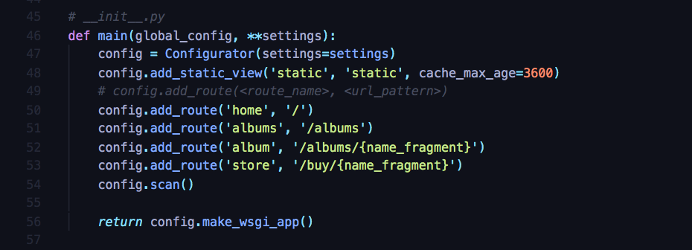

- __init__.py file:
  - The website is a package
  - This file is the entry point into the package/website

- main method will be run by Pyramid:
  - get a config: we will use it to define various routes
  - add_static_view:
    - map a static folder and set cache details on it (serve css, js, and images)
    - can drop anything in the static folder, content will be served without going through the python layer
    - onds = 1 hour
  - add_route(<route_name>, <url_pattern>):
    - maps URLS to actions with a unique name,
    - and a url pattern that can be static or contain optional route data (name_fragment)
when we get to the view method, name_fragment will be a variable passed to the view
  - config.scan:
    - tell Pyramid to go through all our files and look for the view methods
    - that have the right decorator
    - and the names of the routes
    - and wire them together
  - config.make_wsgi_app:
    - take this config and make a wsgi app
    - wsgi = the standard way in which all the different Python frameworks speak to the underlying web server
    - meaning: once we have configured everything, create the app and hand it off to the web server to be run
    - Pyramid handlers: easy way to create class driven urls =
- here is a class that I want to register as having views
- then it will be able to discover all the views on it automatically
- so that as you add methods, they can automatically be rendered
-> no need to go back to the class for every new method

CONFIGURATION

- Dev + test + prod config files
- API keys and other config information
- Specific details you want to keep out of the code:
  - To make them editable and configurable
  - Or to have different versions based on where the app is running (in development, in production, etc.)

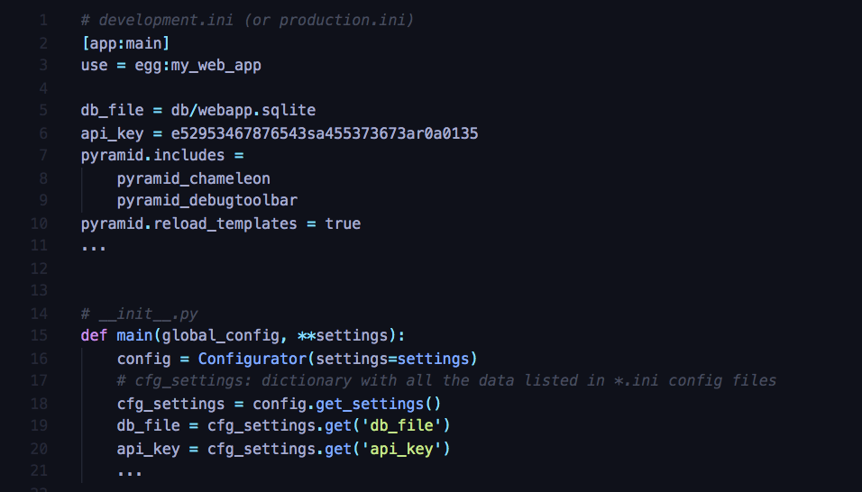

- development.py file: (sometimes production.ini, or other names)
  - Standard configuration file sent to the web server
  - Contains data that the application needs in order to work:
    - db_file: relative path to sqlite database file
    - api_key: API key (mailchimp, stripe…)
    - etc.
  - data passed to the application later

MODELS

- Data and behavior passed to the views
- Flows between views and templates
- A Python class
- A dictionary of data and behavior

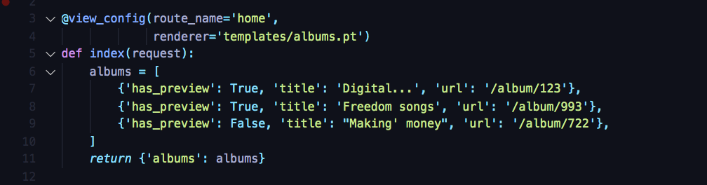

- In this code example, we are getting a list view of albums.
- return: a dictionary of data and behavior, later passed to templates.
  - We’ll be able to loop over those data in the templates

TEMPLATES (aka VIEWS)

- Data and behavior passed to the views
- Dynamic HTML
- Data -> Dynamic template -> HTML
Passes data into a dynamic template and the template takes data and turns it into HTML

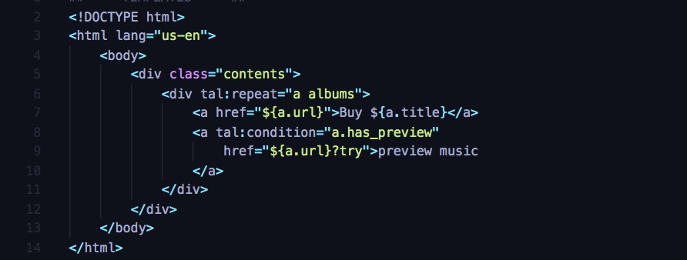

- Template language called Chameleon
  - Uses a Template Attribute Language: tal
  - tal:repeat=”a albums”:
    - tal:repeat is a loop command on an iterable
    - “a albums” = for each album a in the albums list
  - ${<python code here>}: can contain any Python code or expressions
  - tal:condition=”a.has_preview”:
    - if command
    - if has_preview is True

MANAGING OUTSIDE DEPENDENCIES

- pip and pycharm are only for Python dependencies, but web apps are not just about Python
- Users don’t even see Python, only JS, CSS…, the frontend interactive pieces
- Bower:
  - package manager for the web,
  - system to keep track of all packages, and make sure there are all up to date, or set to specific versions needed
  - HTML, CSS, JS, fonts, image files…

See next chapters of the course for more about how to use Bower commands and in which folder installs are done:
bower install bower --upgrade
bower install <package_name>
bower list
etc.

Install packages locally so that you can still work on you web app even if you are in a place with low wifi

Chp. 8 – Building web apps w/Pyramid

- Handler classes:
  - Improved routing
  - universal access to core features
    - ex: access to a user, or a particular authentication cookie while processing a request

- Templates and shared layout:
  - Understand and use dynamic templates, look and feel

- Forms
  - Accept user input, edits, admin sections, etc.

- View models
  - Move validation and data structure to a separate layer
  - Richer more intelligent class
    - that is tied to the template in which it is displayed
    - has the validation rules
    - and some of the data access rules that we might need
  - -> action methods that process the request: their job is much simpler
  - -> easier to test and to maintain the code

- Validation
  - Server side
  - client side:
    - most of the time, we don’t need to go back to the server,
    - users can get immediate feedback saying what they need to do to fill out a form

WHAT ARE HANDLERS (Controllers)

pip install pyramid_handlers

- Add-on package for Pyramid that maps routes to classes (not functions), thus allowing full OO programming power

- A different way to group and map routes to action methods (methods that process the request)

- Advantages of handlers:
  - Group common functionalities in classes
    - related web methods: action methods that are processing different requests on the same functionality
    - ex: class Account with action methods to create/delete accounts, create/change/reset passwords, etc.
  - Less “routing” work
instead of making a route every time you create a new action method, and applying it to as a decorator to that method
    - solution 1: “traversal”
    - solution 2: mapping the routes to classes,
and then we only have to create a route when we are adding a group functionality (a class)
(= one route for the whole class, instead of one route for each action method of the class)
  - Core web infrastructure always accessible
    - To all Controller (Handler) classes
By creating a base controller class and all the controllers will derive from it
-> some functionalities universally accessible
Ex: common check for a authentication cookie in the base controller
    - To all templates and shared layouts
Have a common look and feel in a simpler easy way

