**Assignment**

1. Search any publicly available Next.js sample application. This can be any static site build with Next.js. Backend is not really required.

>>> Created same repo URL> <https://github.com/root703/Assignment_next_js.git>

This repo for Next.js sample application called "Next.js Blog"

>>> Local build dependencies and deploy using

Command >> **npm install**

>>> Start the development server:

Command >> **npm run dev**

1. Clone this application code from step 1 in your GitHub repositor.

Using git clone command clone repo

>> git clone <https://github.com/root703/Assignment_next_js.git>

1. Deploy this application on AWS Amplify.
2. Provision Amplify infrastructure using terraform.

> Install Terraform on your local machine (https://www.terraform.io/downloads.html).

> Create a new directory for your Amplify infrastructure.

> Inside the directory, created a main.tf file and define your infrastructure using Terraform's configuration language. ( In this repo directory > terraformAmplify )

> Configure resources like AWS Amplify app, environment, and any necessary permissions.

> created **main.tf** terraform file for Amplify resource.

> Run **terraform init** to initialize the Terraform project.

> Run **terraform plan** to review the planned infrastructure changes.

> Run **terraform apply** to apply the changes and provision the Amplify infrastructure.

> After the terraform, deployment need to configure the Amplify Application with CICD.

b. Setup CI/CD pipeline with Amplify’s inbuilt functionality.

> Amplify App showing after the deploy the Amplify resource

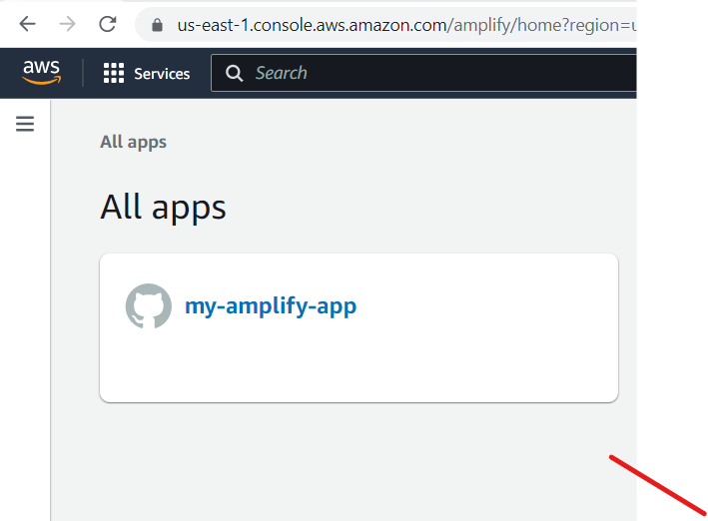

Step -1 Repo setup with branch

>> Click om “ my-amplify-app”

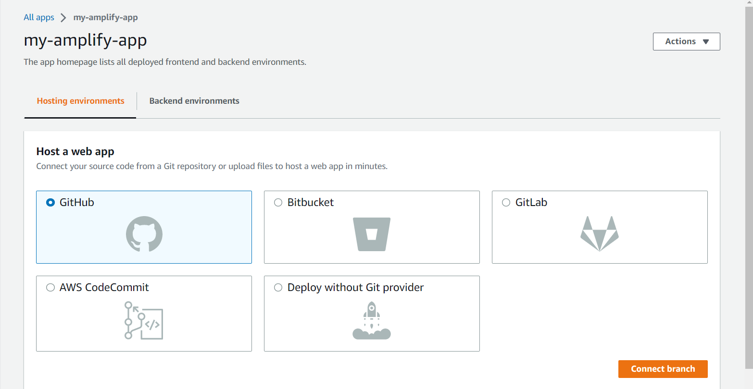> Click on **GitHub** and click on **connect branch**

>

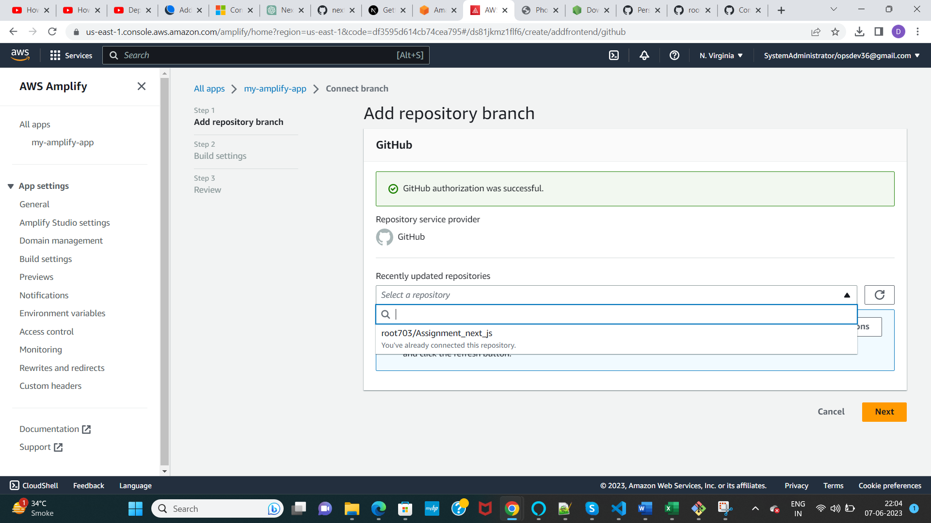

* Select the Repo.

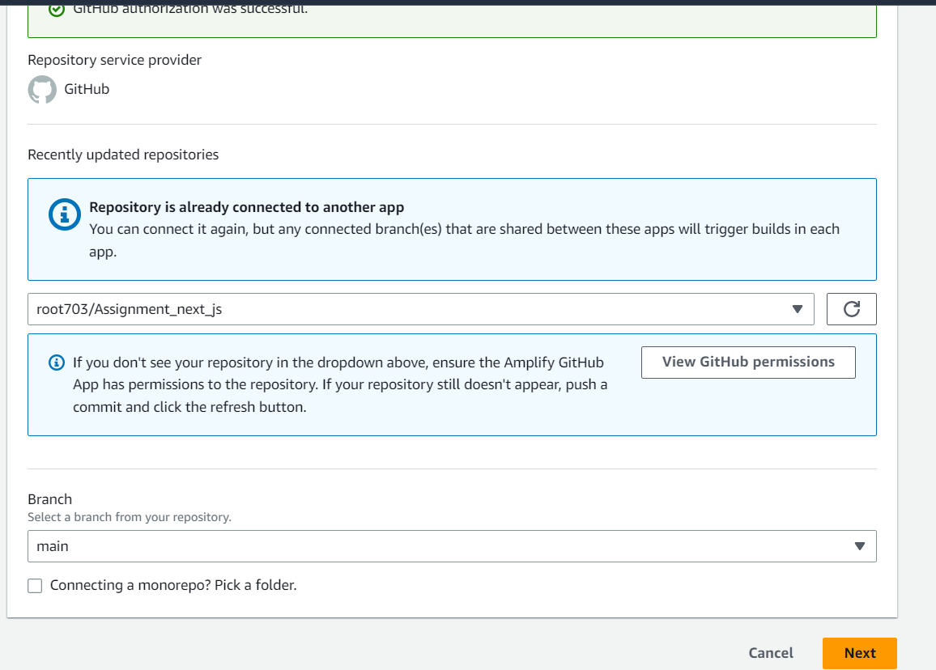

>> Select the Branch **“main” click on Next**

Step 2:- **Build settings**

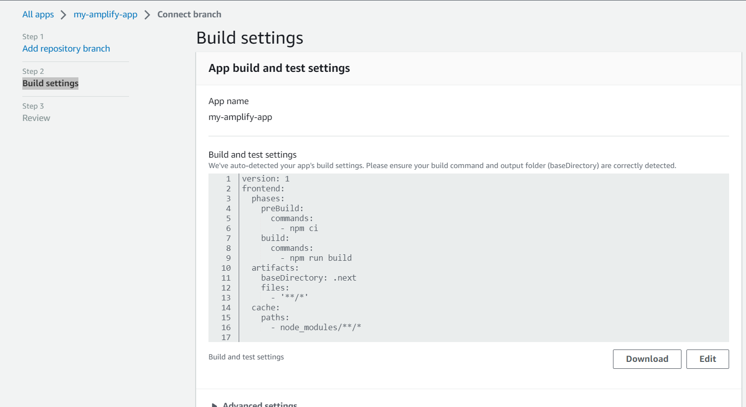

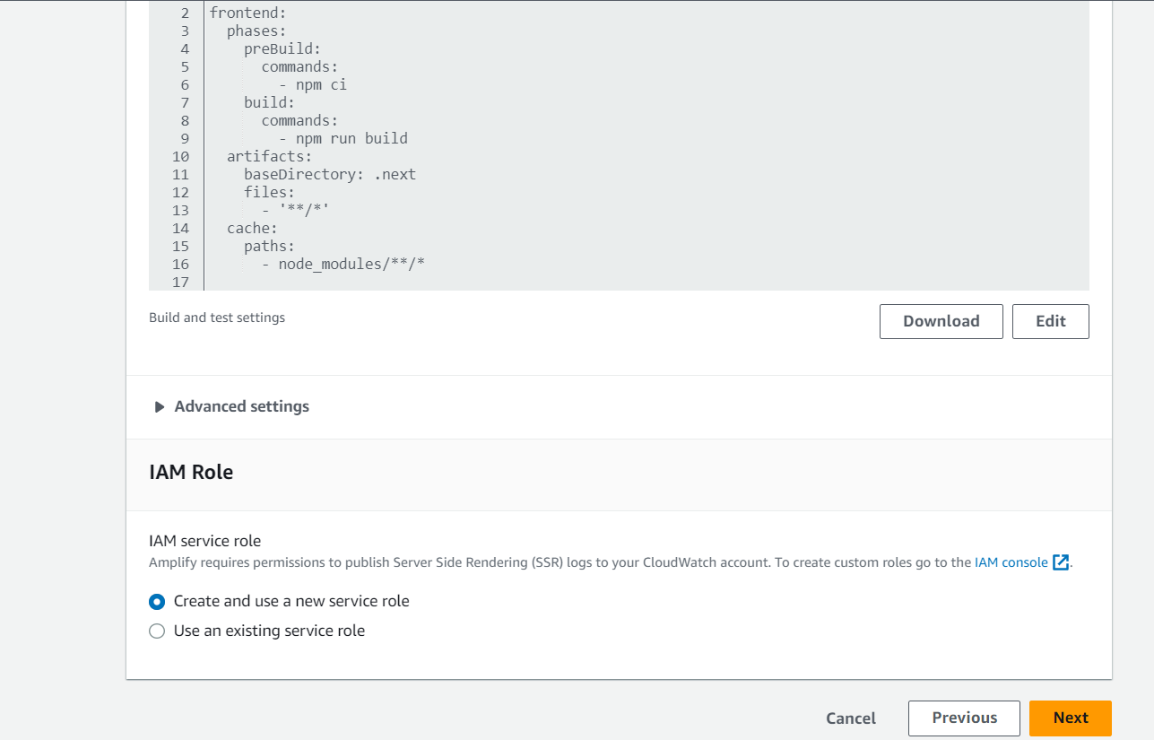

>> Select “Create and use a new service role” click on Next

Step 3: Review

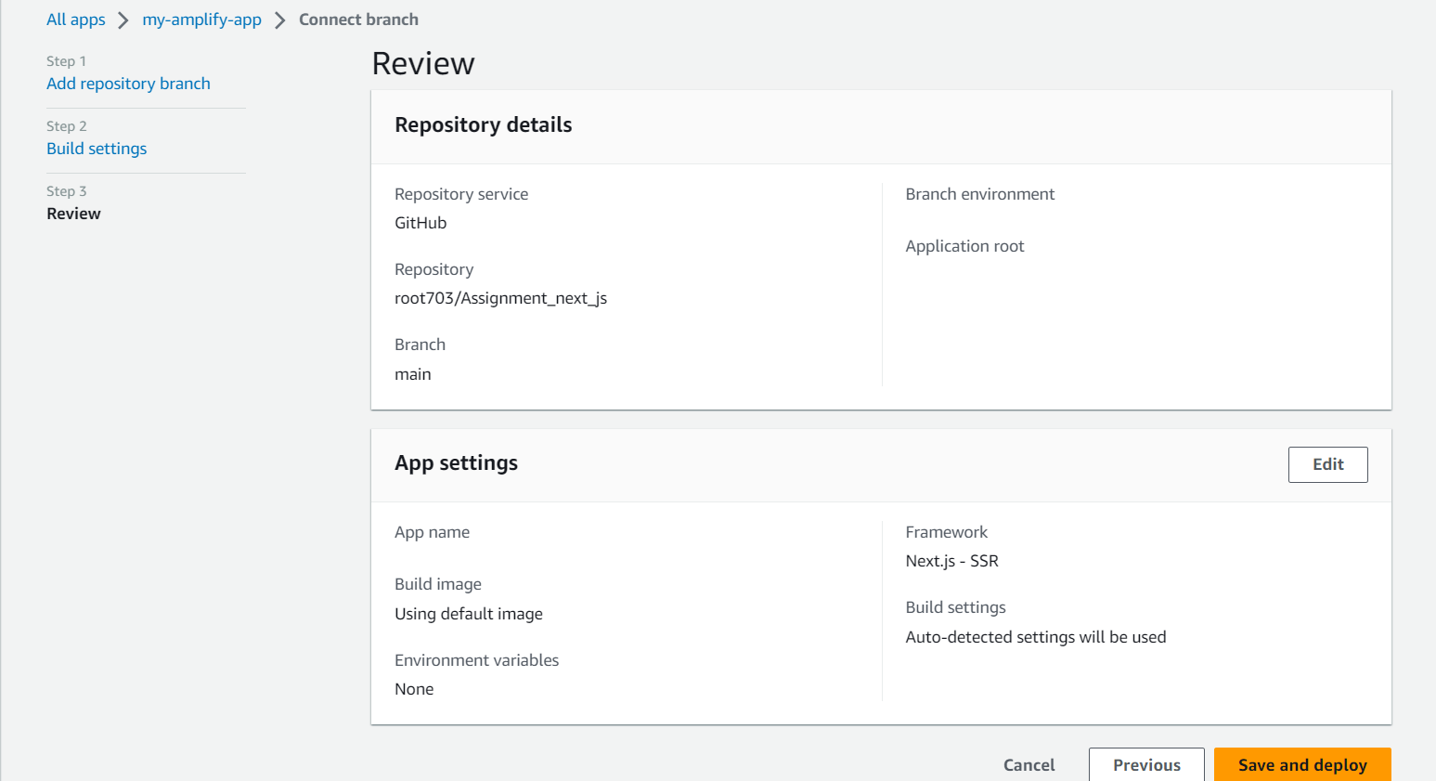

>> Review and Click on “**Save and Deploy**”

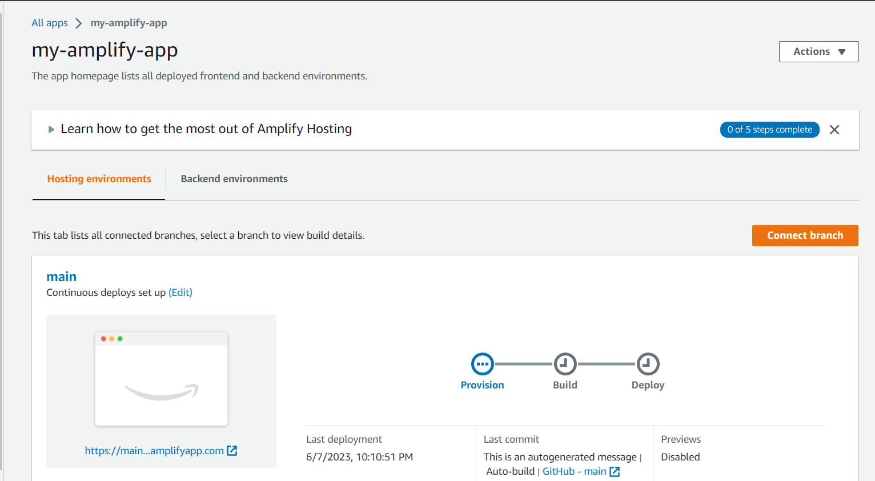

>> Provision and build process started

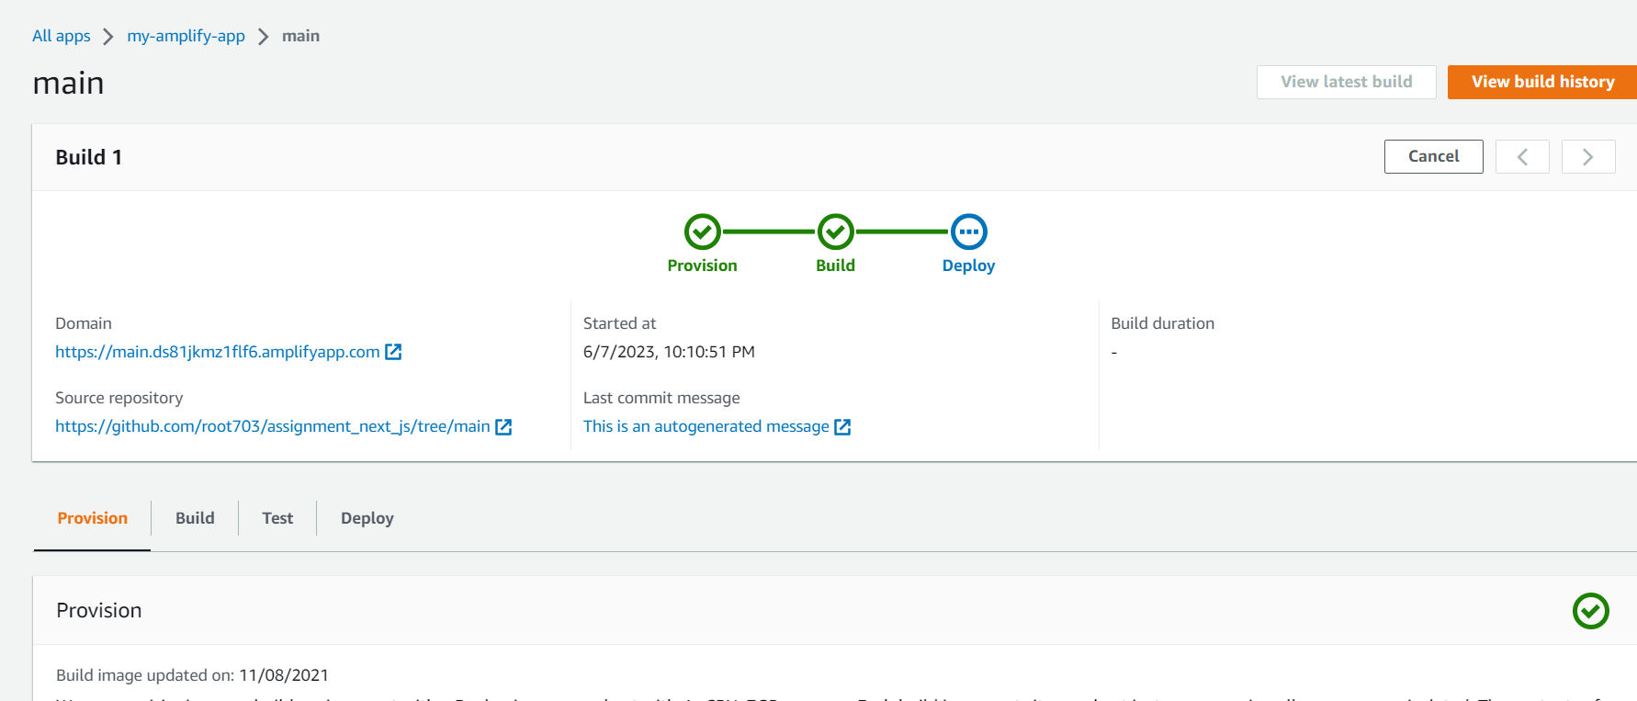

>> deploy started

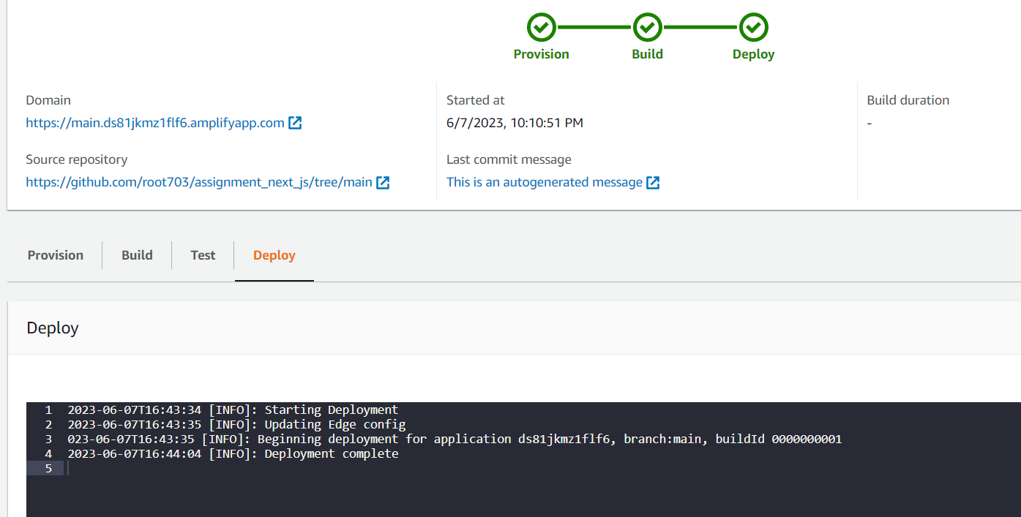

>> Deployment complete

1. Create a detailed README file of the steps you followed for this setup.

>> created README file and added in repo.